Homework # 9
Frank Pereira, Kyle Addie, Charles Frank, William Gould

THE PROCEDURE FOR IMPORT
Navigate to the database icon in Sequel Server and right click and click on All Tasks and then choose Import data.
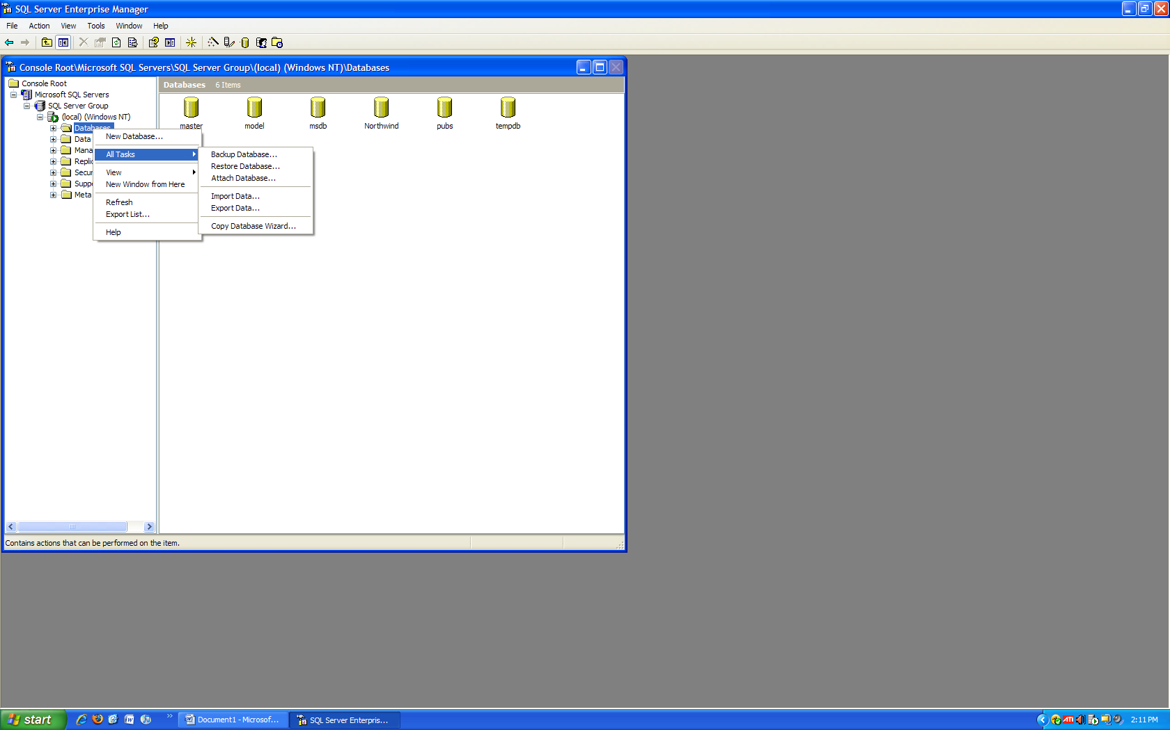
The import/export wizard will start. Then click Next.
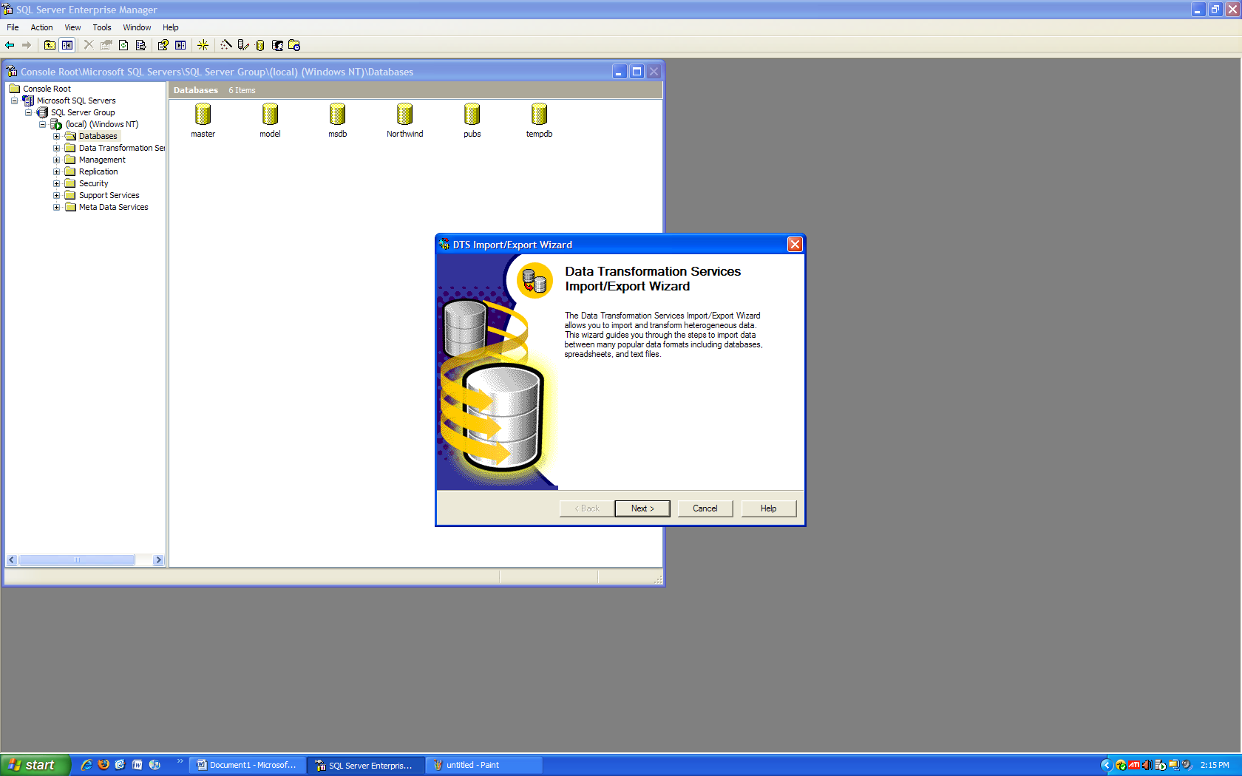

We will be importing an Access database so we need to change the Data Source to Access. Locate the file and enter it in File name and enter any password and user name needed to access the database. Then click Next.
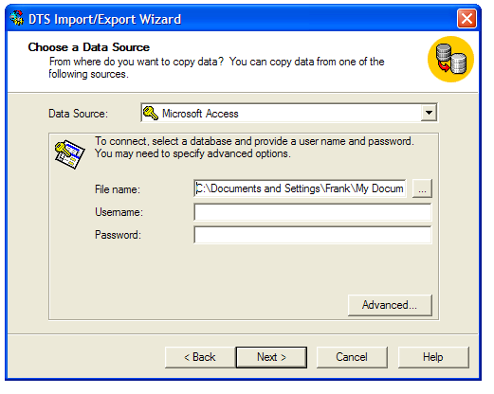

Choose a location to put the new database in. We will be using the local database on this machine. So Set the Destination to Microsoft OLE DB Provider for SQL Server. We must also choose which database to put it in. The default is master. We will be putting it in Northwind so set Database to Northwind. Then click Next.
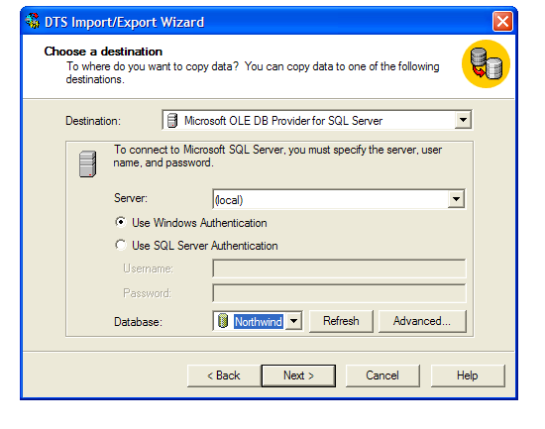
We will use the copy command to transfer the tables. Then click Next
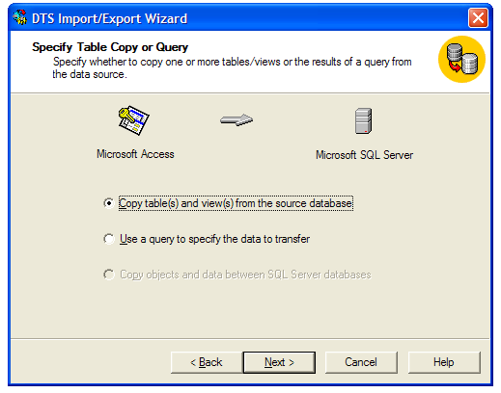

We want to import all so we select all. Then click Next.
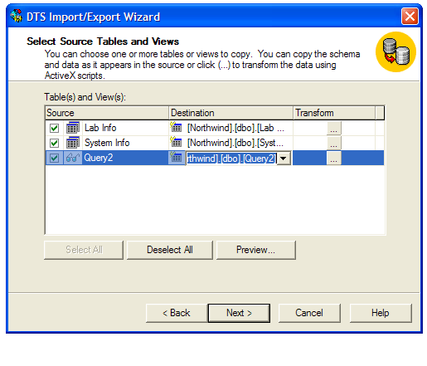

We want to run this immediately so we use that choice. Then click Next
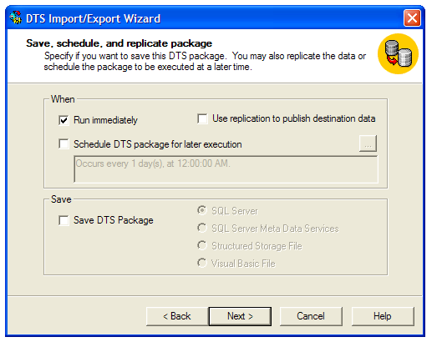

Then Finish
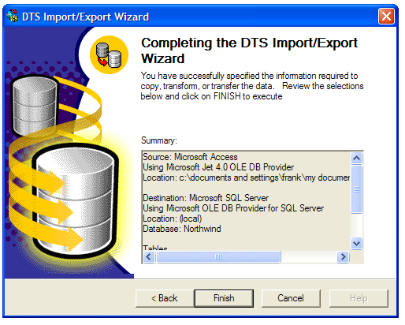

THE PROCEDURE FOR EXPORT
Navigate to the database icon in Sequel Server and right click and click on All Tasks and then choose Export data.
The import/export wizard will start. Then click Next.

We must choose from where to export the data. We will be using the local Sql Server, so we set the Data Source to Microsoft OLE DB Provider for SQL Server. We must also choose which database to export from. We will be using Northwind so we set Database to Northwind... Then click Next.
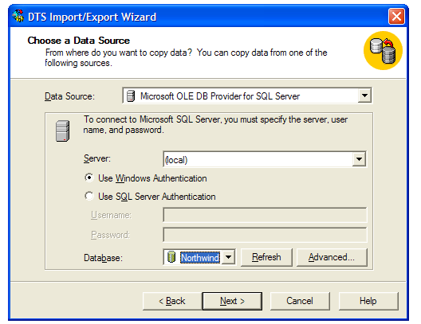

We must then choose a destination. We will be exporting to an access database so we set Destination to Microsoft Access. Locate the file and put it in File name and enter any user name or password needed to access it. Then click Next.
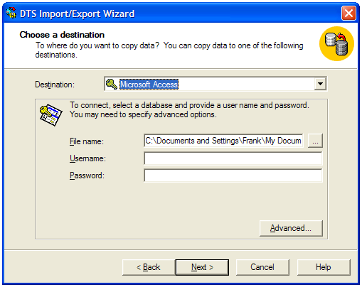

We want to use the copy feature to export the data. Then click Next.
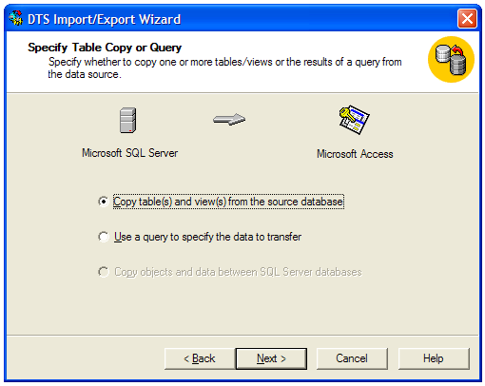
We want to import all so we select all. Then click Next.
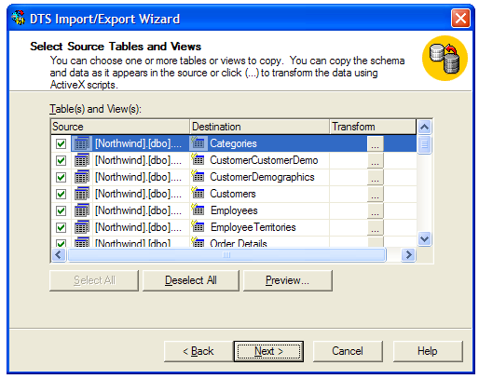
We want to run immediately so we choose that. Then click Next.
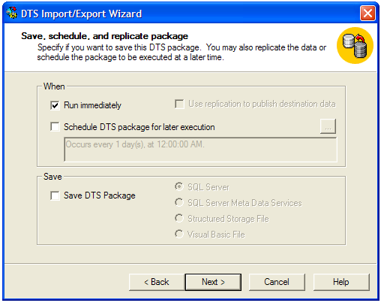

Then Finish.
