Sam Patteson
Cameron Emmart
Tommy Moumaw

How To Backup and Restore a Database in SQL Server
Performing a Database backup:

1) Open SQL Server, expand databases, and choose the database you wish to backup.



- Right click the database, point to Tasks and then click Backup.

- Verify the database name and choose “complete” for full backup.
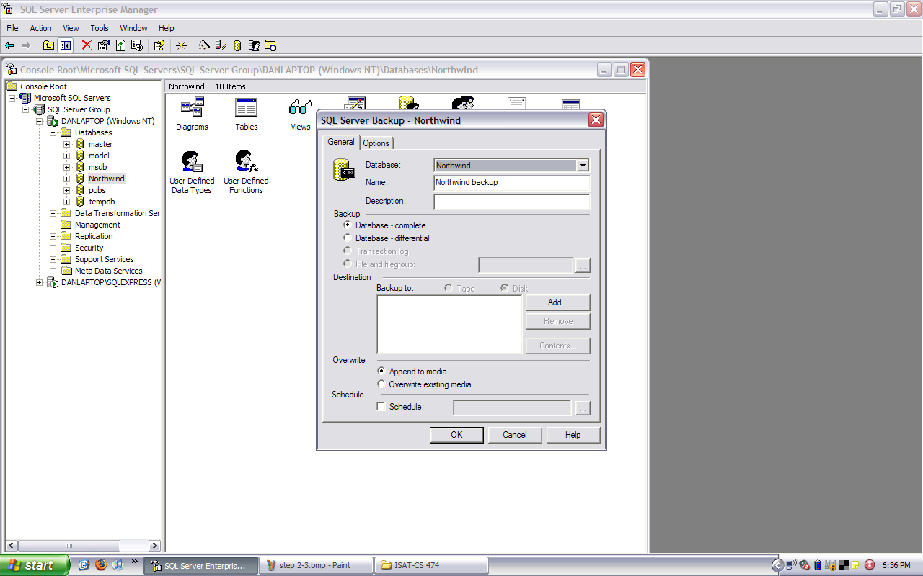
4) Click Add. In the next dialog box,choose the destination location.
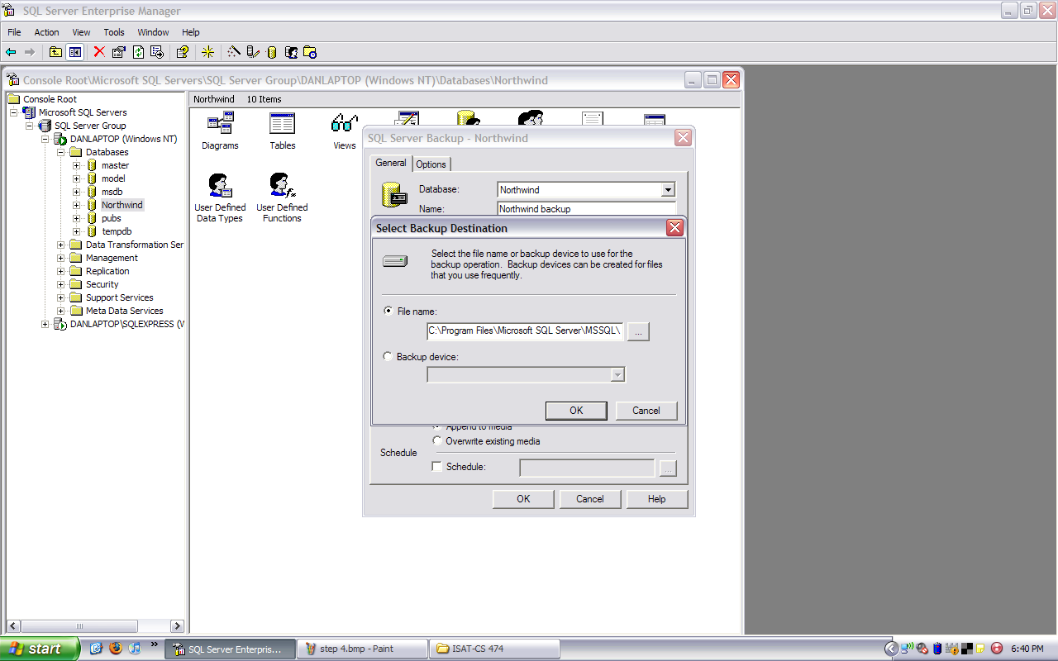
- Click OK to finish.
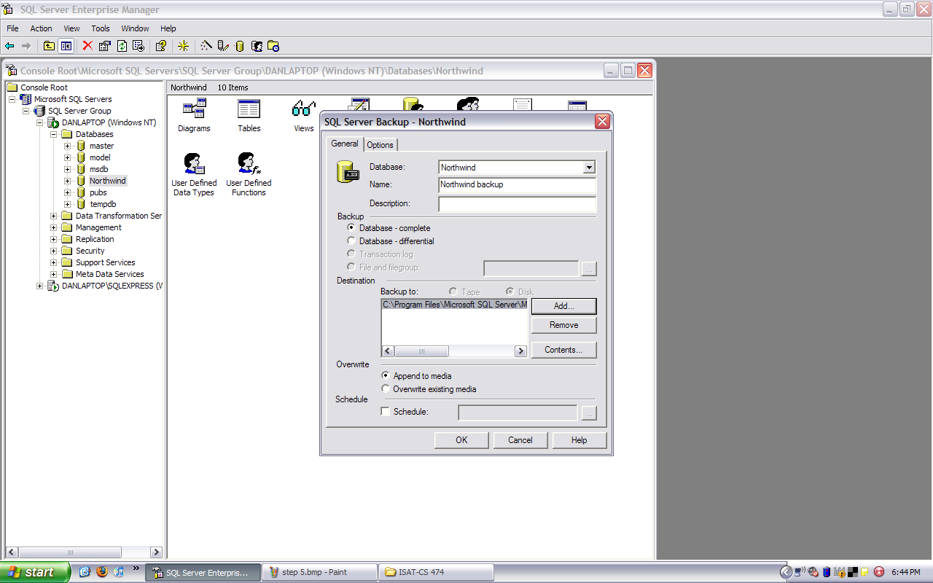

Performing a Database restore:

1) Redo step 1

- Right click on the database, point to Tasks, and click Restore


3) In the dialog box, choose the database you would like to restore. Then, choose the name of the backup file you previously created. Click OK.
