Backup Operation

- In the SQL Server Enterprise Manager, choose the database for backup.

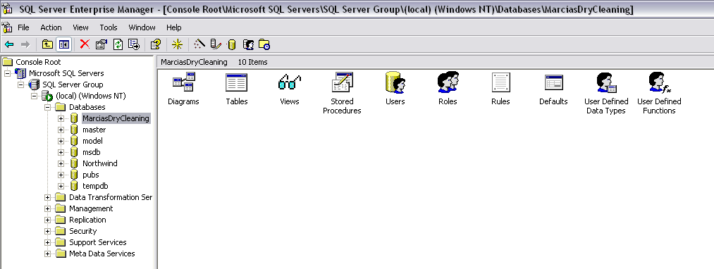

- Right-click on the database for backup, expand “All Tasks”, and click “Backup Database”.

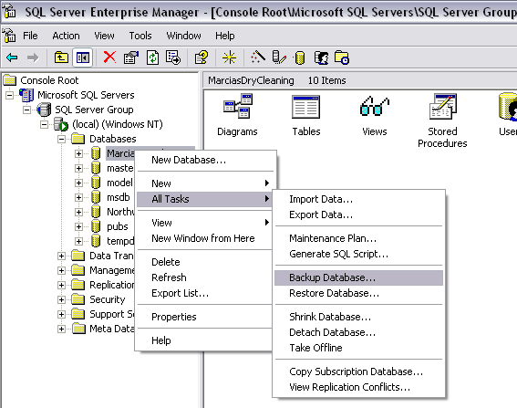

- Configuring backup options. Verify the Database, Name, and description for the backup operation. Specify backup options for complete/differential/log backup but in most cases you want to choose the “Complete” option. A differential database backup would be useful for large databases that are backed up several times a day for example (a database administrator may take one or two full backups daily, then take the backup of the differential changes that occur every two hours to reduce the size of the database backups. Specify the file Destination. Click the “Add” button.

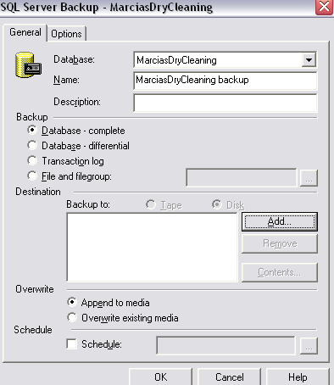

Verify the file path (destination). For a backup to a local disk, click the lookup button under file name.
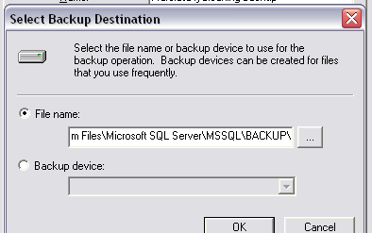

Next, enter a file name. Click “OK”.
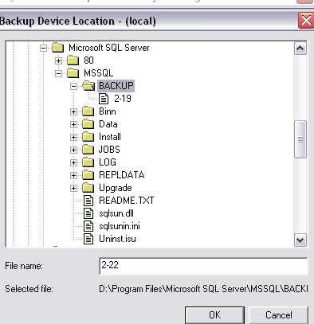

Click OK again to accept the backup path. The backup utility allows the administrator to append or overwrite existing backups, as well as schedule backups in the future. Click OK to begin the Backup. A progress bar will display, followed, by the result of the backup.

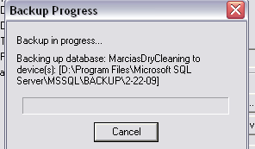

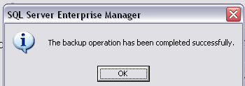
Restore Operation

- In the SQL Server Enterprise Manager, choose the database to restore from an existing backup.

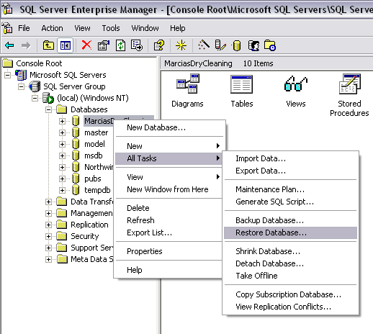
- Verify the database to be restored. From the restore options given by the program, choose which backups to show, and how far in the past you want to look for backups. The system will display a list of available backups that you may restore from. Choose the appropriate checkbox to restore the database backup. Click OK.

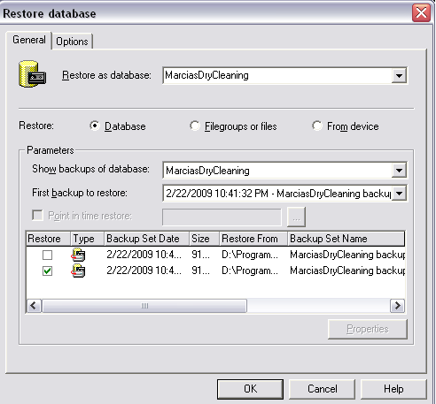
- The system will display a progress bar and a result of the restore operation.
