This document will discuss the steps needed to take in order to export information from a SQL Server 2000 table into a flat text file (*.txt). First, open Enterprise Manager and right click on the database with the table you would like to export. Next scroll to All Tasks \ Export Data…
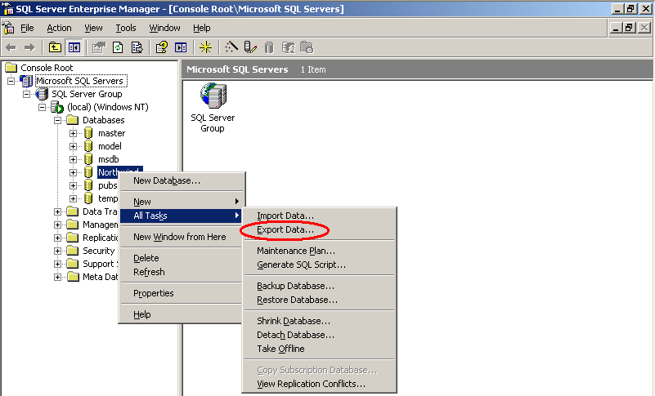
Click next on the screen that is displayed.
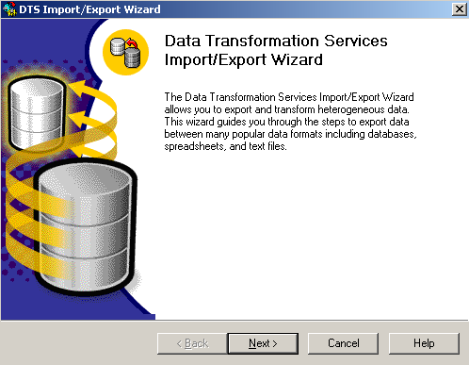

Next, select the type of authentication (Windows, unless you have specific security logins for the database), and the database you would like to export the information from (Northwind, in this example).
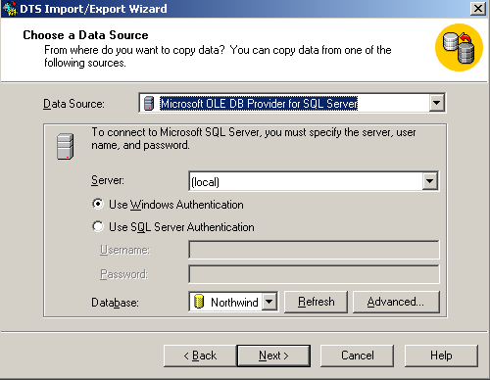
Now choose where you would like to send the information. This example demonstrates exporting to a text file, so set the destination to Text File. Click the … next to File Name to choose the name and location of the text file where you are sending the data.
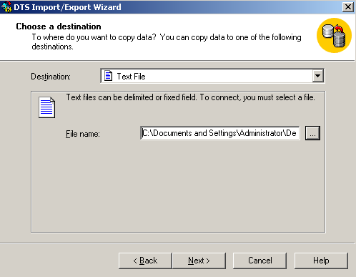

Select Copy table(s) and view(s) from the source database. Click next.
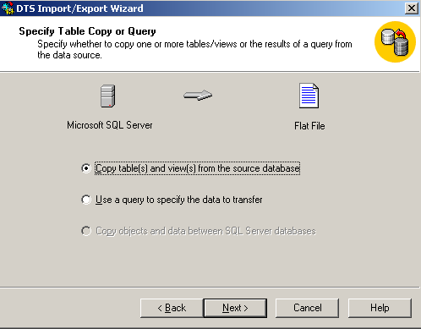
In the Source box, select which table you would like to export the information from, and check the box next to “First row has column names” so the text file will be easier to import later.
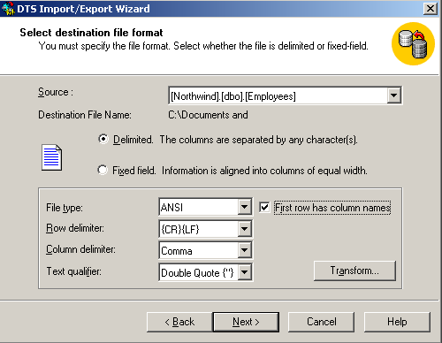

Select run immediately, and click next.
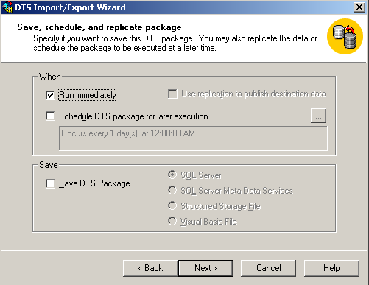
Click finish. The job will run now, and the information has been exported.
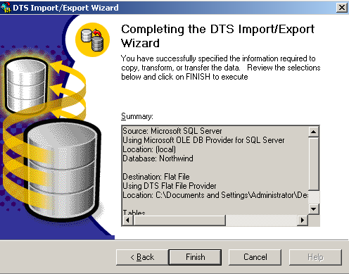
To import data from a text file to a table, you first open SQL Server 2000 Enterprise Manager. Then you right click on the database, scroll to All Tasks \ Import Data…
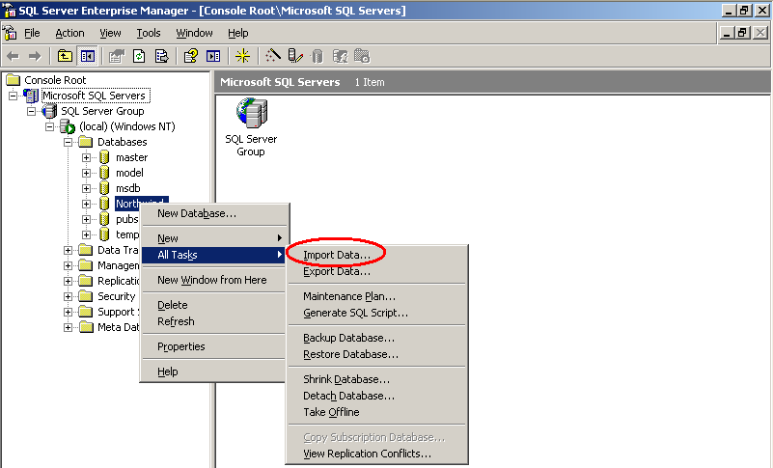
Click next.
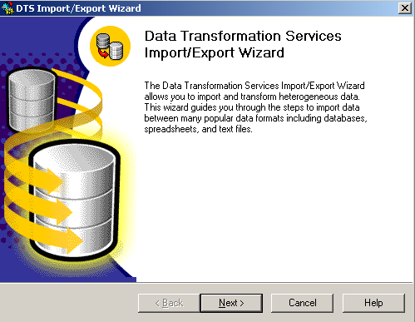

Since we are importing data from a text file, select Text File under Data Source, then click on the … box to browse to the file you want to import data from.
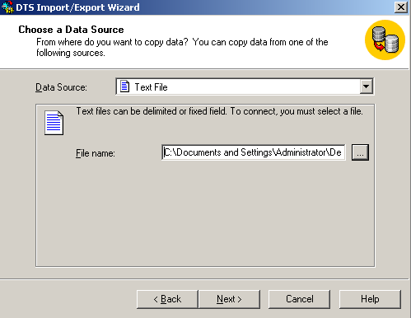
Next choose delimited if your text file has each field separated by commas or other characters. Click the check box next to “First row has column names” if the first row of the text file has the column names for the table.
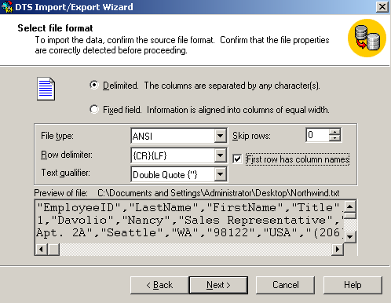
Next you need to specify what delimiter is used to separate the values in your text file (commas, tabs, semicolons, or others). Click next after doing that.
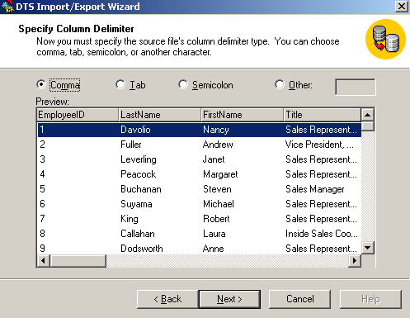
Now select the destination for the information being imported. Use Windows Authentication, unless you have other logins specified for your database, then select the database to import the data to from the dropdown box.
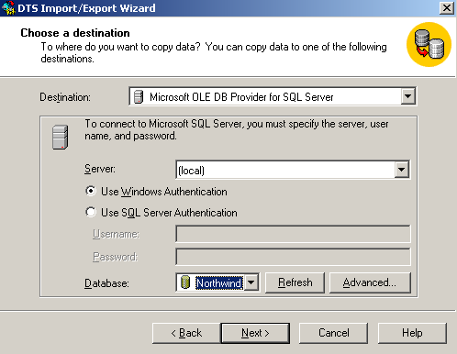
Click next, unless you need to change or remove some data that is being imported.
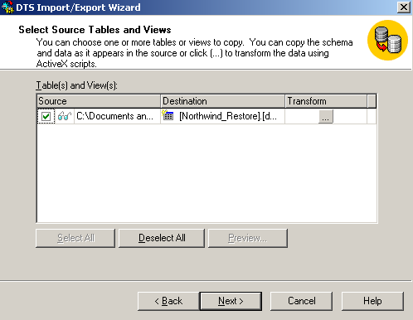
Select run immediately so the job will run now.
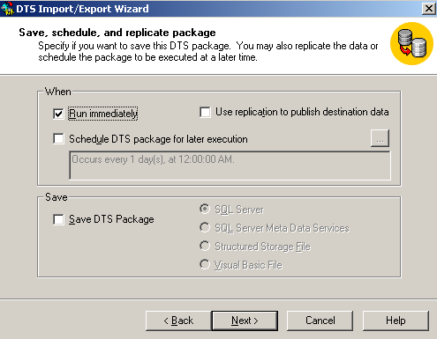
Click finish and the job will run. Your data is now imported.
