CS 474 Homework 09
2/24/2009
Team Farve:
Jacob Ewers
Krys Stultz
McCabe Weaver
Wes Wegner

Backing Up a Database
- Right Click on the database you want to back up, Hover over all tasks and select Backup Database. (For this example we will be backing up the Northwind database, so we will select this)
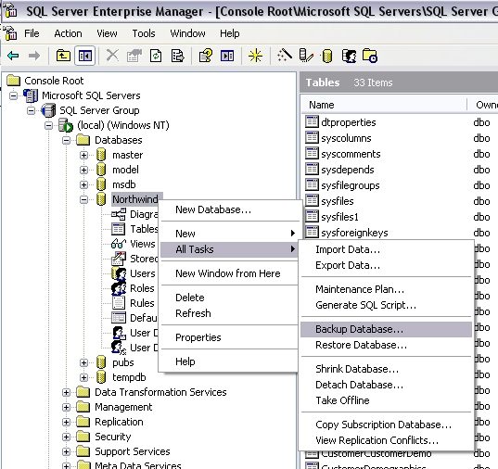
- The following screen will pop up. Under Destination select “Add…”
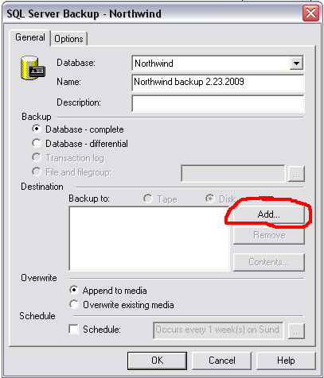
- The following screen will load. Add to the default the name of the database you are backing up.
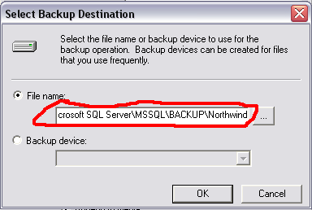
- Select OK to save the changes and continue
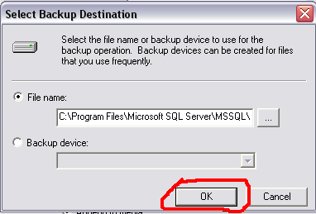

- Select OK
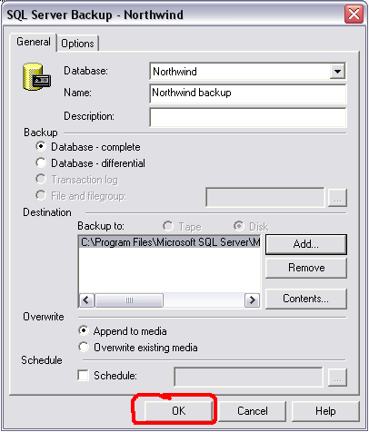
- If completed successfully the following screen will appear
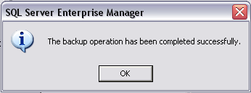

Restoring a Database from a backup
- Right Click on the database you want to back up, Hover over all tasks and select Restore Database. (For this example we will be restoring the Northwind database, so we will select this)
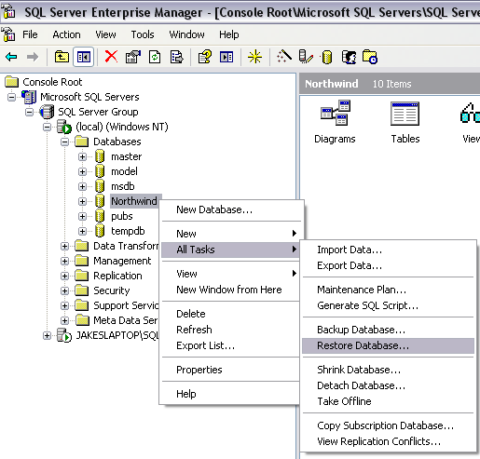
- The following screen will load, select OK
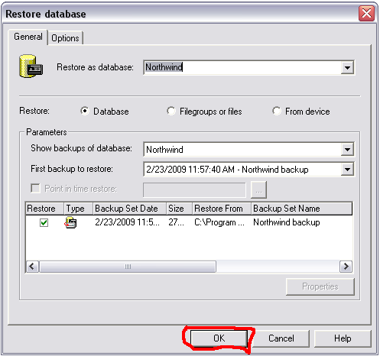
- If completed successfully the following screen will load.
