Justin Cruz, Eric Hartway, Timothy Michael Ward III

CS 474 - Section 2

2 - 24 - 09

Homework 9

Problem 2 - How do you backup and restore a database in SQL Server?To backup a database you must first have SQL opened to where you can view the database that you would like to backup:



In this example we will be backing up and restoring the Northwind database. First right click the database and move your mouse to “All Tasks” then select “Backup Database…”:

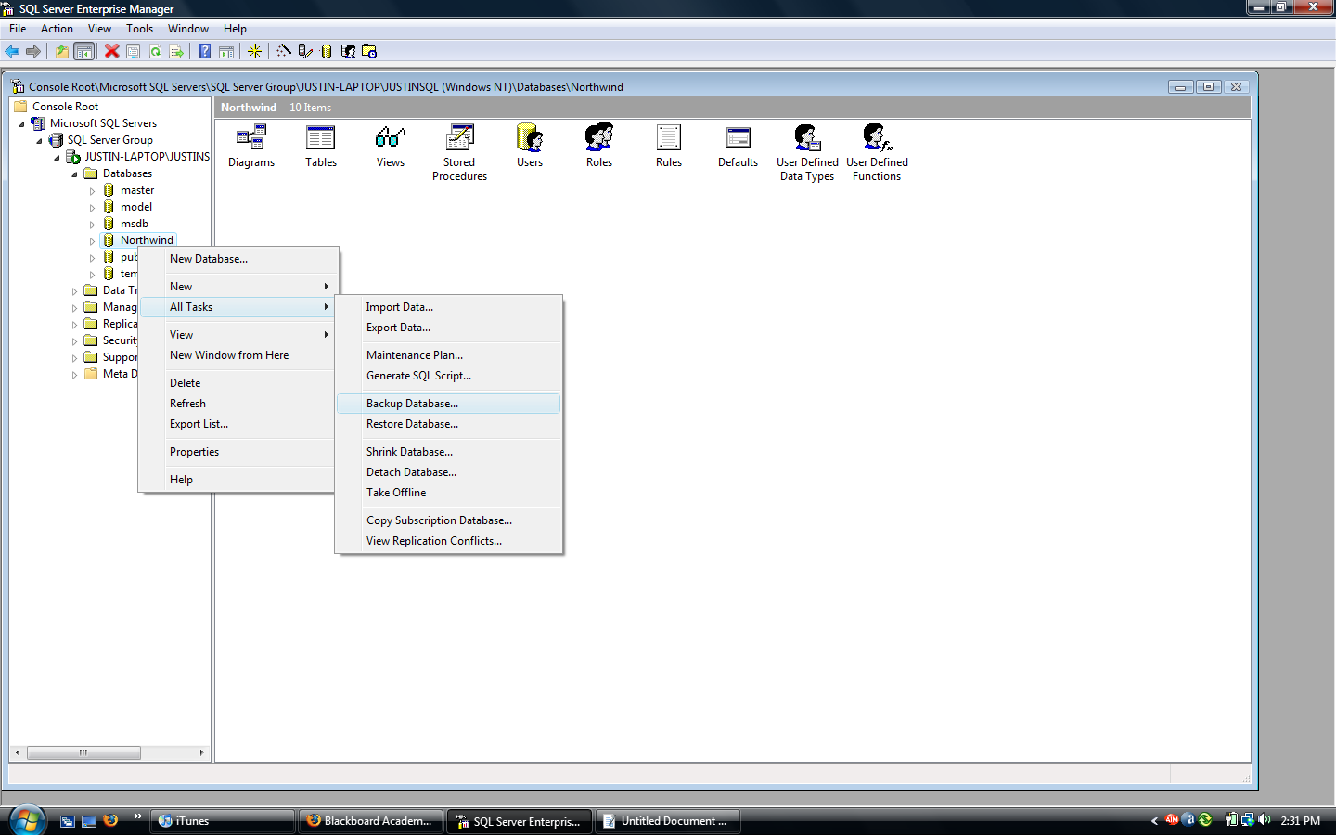

A window will then pop up giving you options for the backup. You can choose the database that you would like to backup, the name of the new backed up database, a description for the database, whether or not to backup the complete database or just sections, select multiple destinations to back up to, as well as whether to overwrite the existing database, and you can schedule it to occur on a weekly or monthly basis:

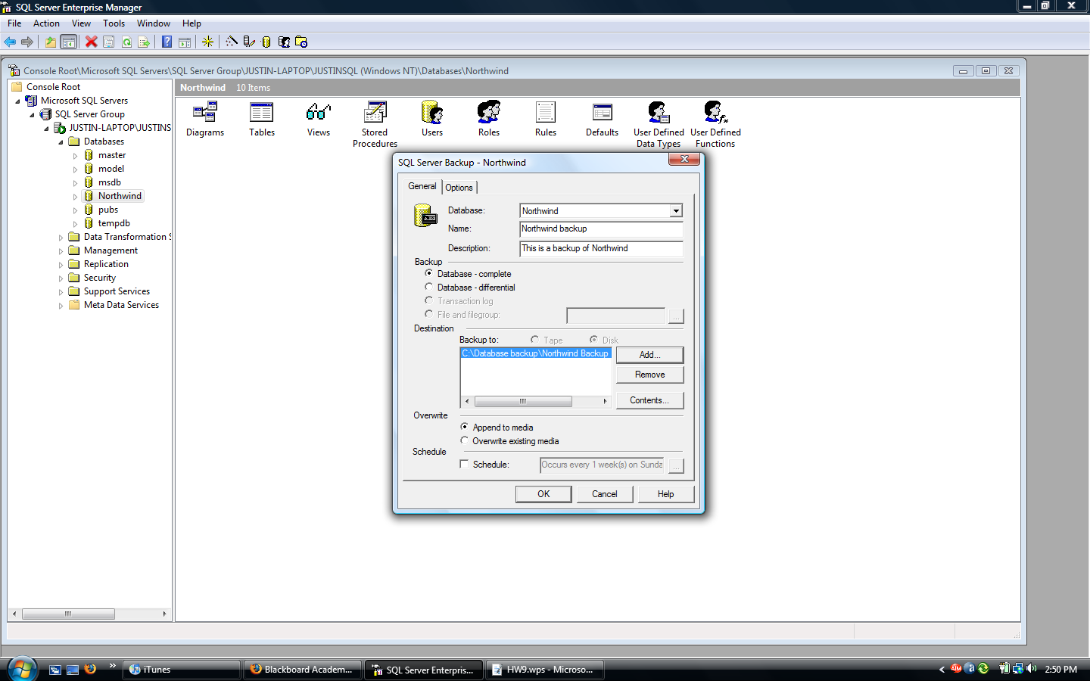

You may choose to select the options tab in which you will have the options to verify the backup upon completions, set expirations, and make labels:

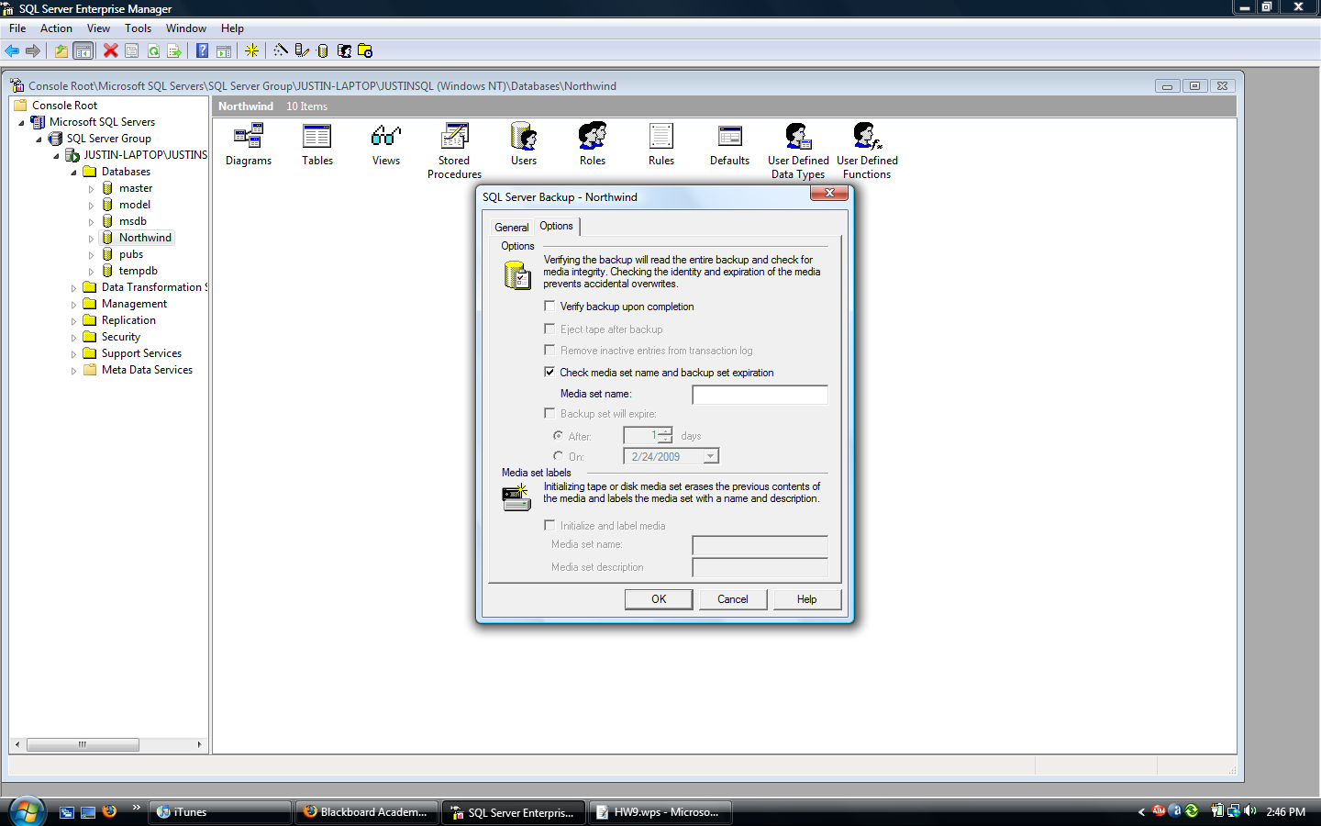

You will then be prompted with a confirmation saying whether the backup was successful or not. Click OK and the database has now been backed up. To restore this backed up database right click your database, move your mouse to “All tasks” and select “Restore Database…”:

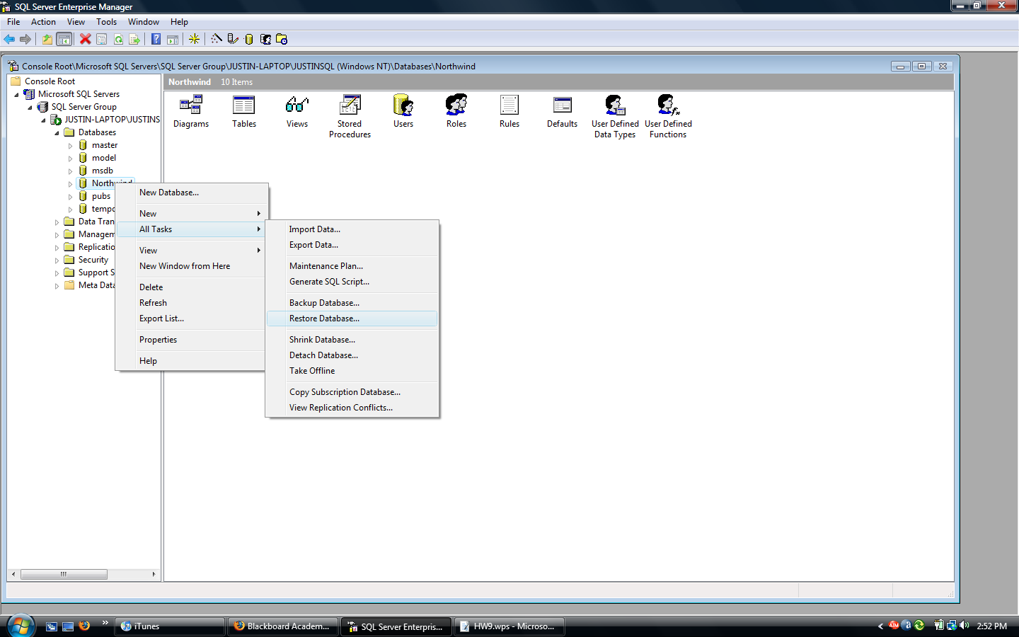

Now you can choose the restored database name, whether or not to restore everything, which database to backup as well as which backup if you have multiple backups of the same database.

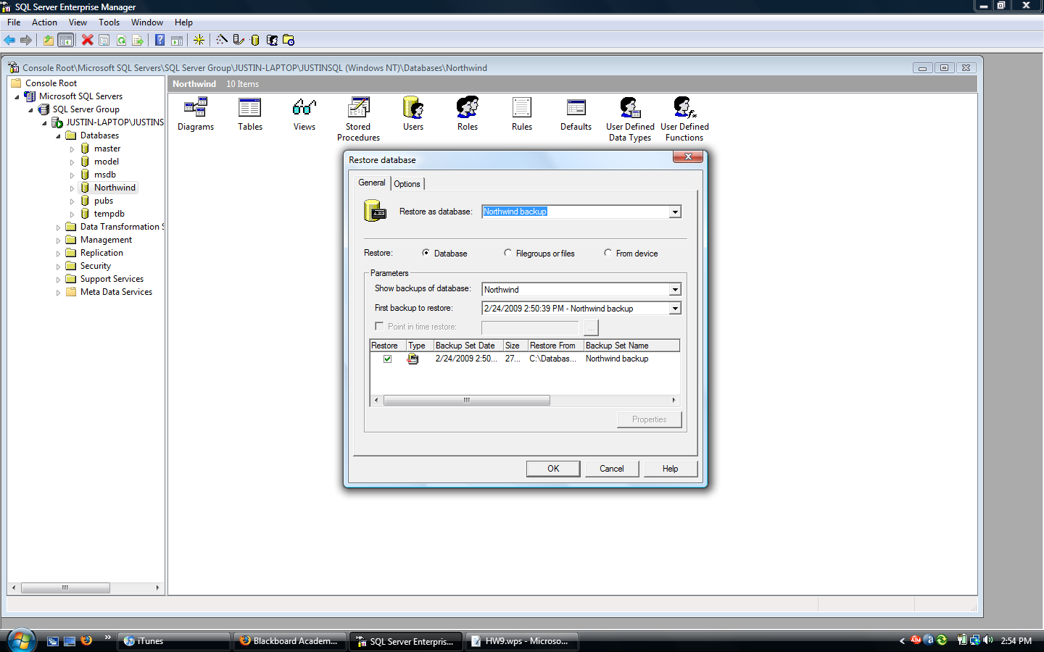

When you click OK the database will be restored and you will receive a conformation window. Click OK and you should see how your database is now backed up and restored:

