Kevin Bojarski
Dan Levitt
Andrew Cox
Joe Claus

To back up a database in Microsoft SQL Server 2005
- Right click the database you want to back up, then select Tasks > Backup
- From the dropdown menu, select full backup
- Click the Add button to backup the database the non-default location, and then select where you would like to save it
- Click Ok

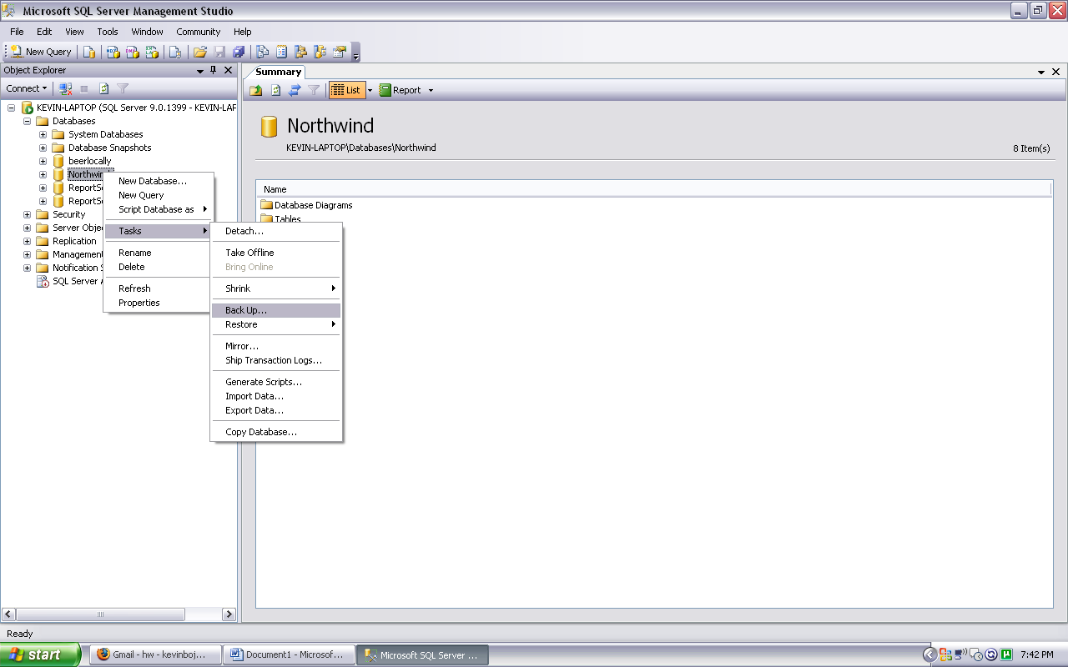
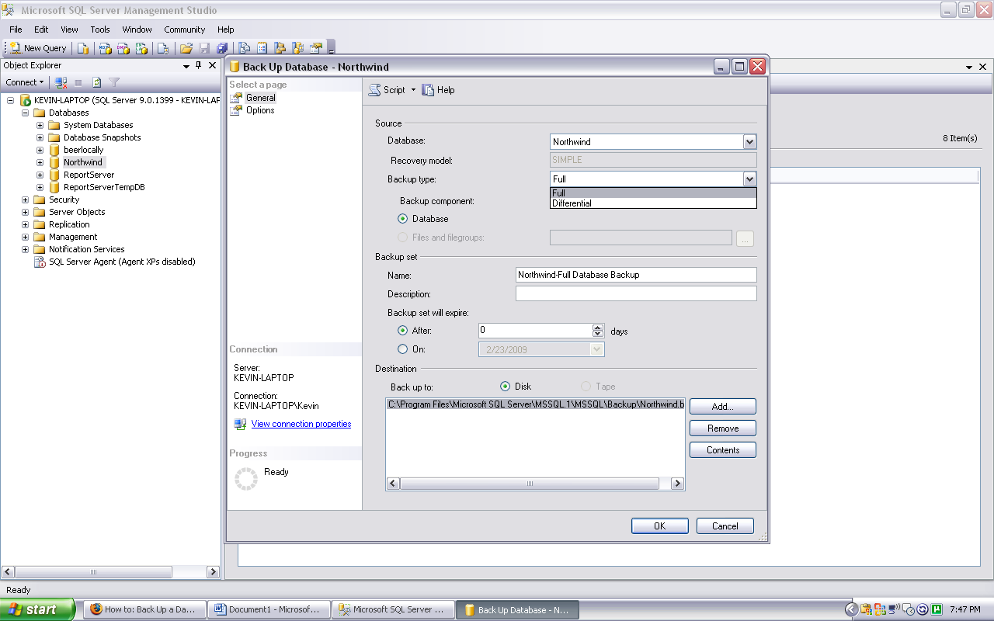
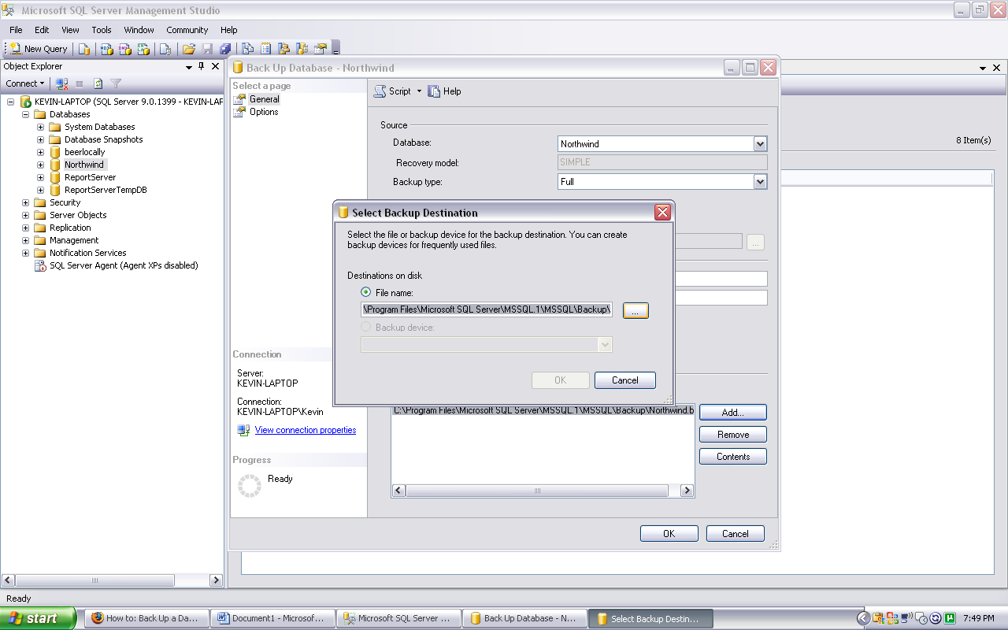
To restore a database in Microsoft SQL Server 2005
- Right-click databases and select Restore Database
- Select the database you are restoring
- Select From device: and navigate to the file you backed up the database to
- Click the checkbox of the most recent database that you have in that file
- Click Ok

