Homework #9
Tony Weber
Haroun Macalisang
Newton Campbell
Alex Bardas

Backup and Restore a Database
SQL Server offers convenient backup and restore options. First of all, start the “SQL Server Enterprise Manager” application by left-clicking the following series of menus: “Start” -> “All Programs” -> “Microsoft SQL Server” -> “Enterprise Manager”. In the “SQL Server Enterprise Manager” application, open a new “Console Root” window by pressing “Ctrl+W”, if the window is not yet open. In the left pane of the “Console Root” window, expand the following items in the item tree by left-clicking on the plus icon beside the item names: “Microsoft SQL Servers” -> “SQL Server Group” -> “(local) (Windows NT)” -> “Databases”. Select a database that needs to be backed up by left-clicking on the database name under the “Databases” item. In order to backup a database, either right-click on the database name or click the “Action” menu to bring up the Action pop-up menu. In the Action pop-up menu, left-click on All Tasks and another pop-up menu containing the list of tasks that includes the “Backup Database…” and “Restore Database…” tasks will appear. Left-click on the name of the desired task.

Backup Database…
Under the General tab the user has to choose the name of the backup and maybe the most important thing, the location where the backup will be stored. The user has to Add a backup location. It is very important to add besides the drive and folder, the name of the file where the backup will be located. Otherwise is will not work. There are two backup methods. One is a complete database backup while the other is a differential database backup where only the changes since the last complete backup are recorded.
The options tab offers different methods to verify if the backup was completed successfully and was reliable.
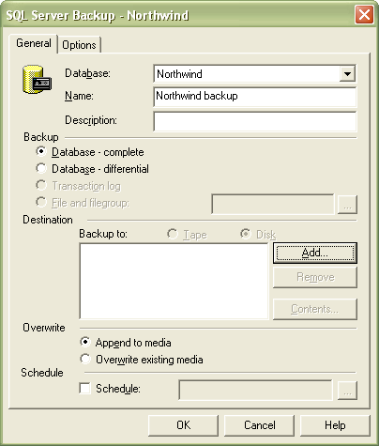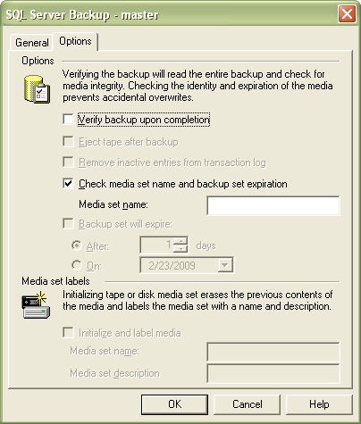

Restore Database…
After choosing the database the user wants to restore, the user is able to see all the backups performed on the database he wants to restore. A database can be also restored from Filegroups and Files and also From Device. In case the backup was performed on a different system it is possible to restore it on the current system from a device it was copied to (for instance a flash drive or an external hard drive).
Under the Options tab different restore options are available for the user (for instance Force restore over existing database).
Northwind database restore backup:
