IMPORT ACCESS FILE TO DATABASE
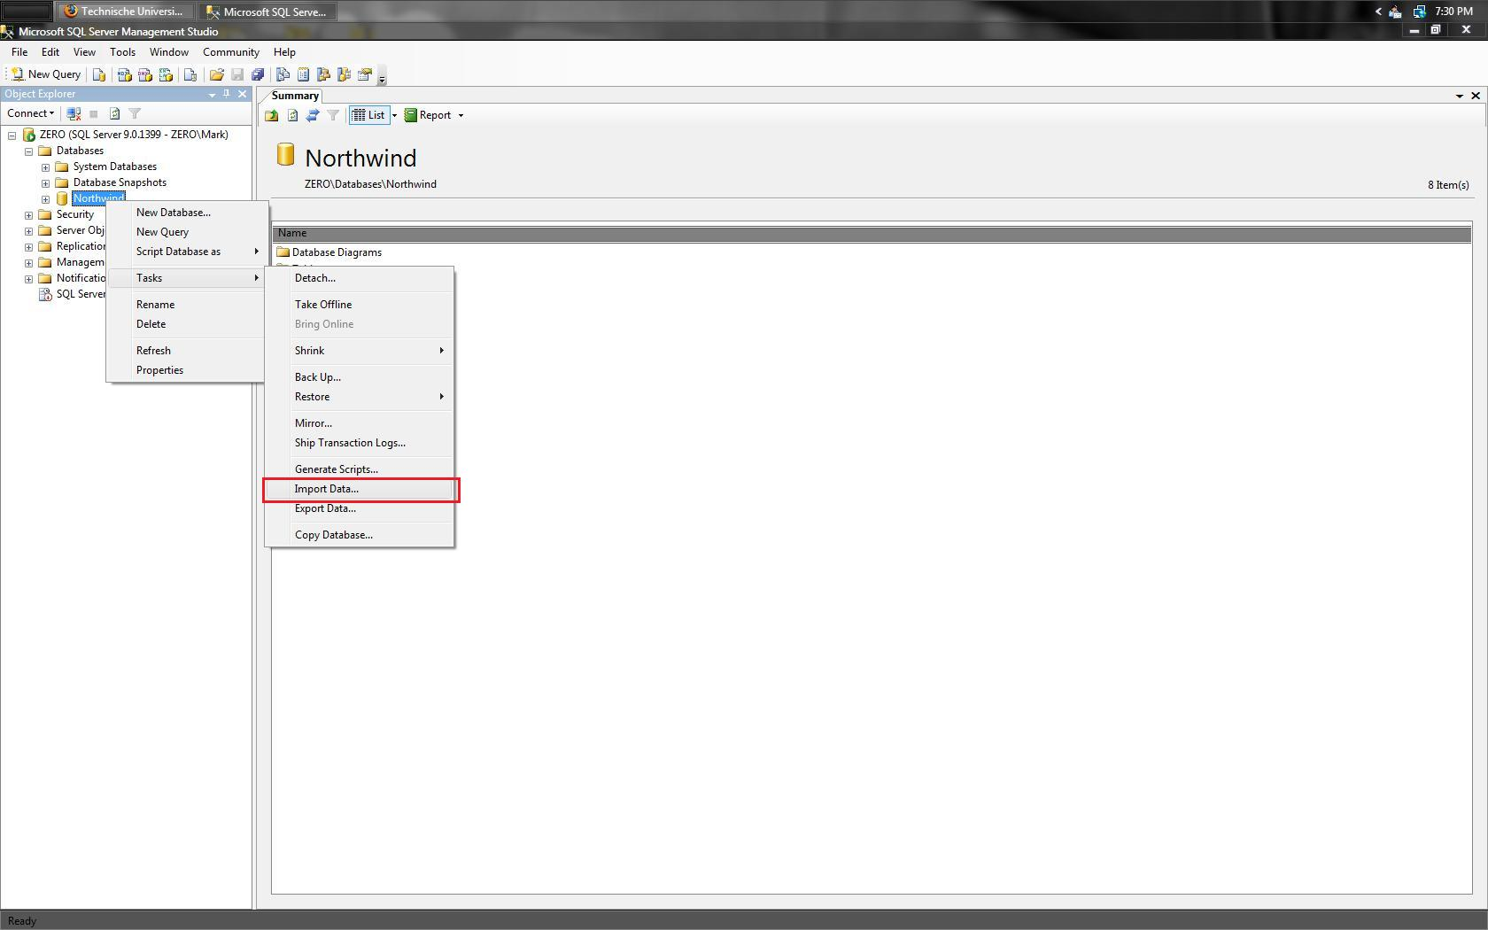 | Right click on any arbitrary database. Select “Tasks” and then “Import Data…”.
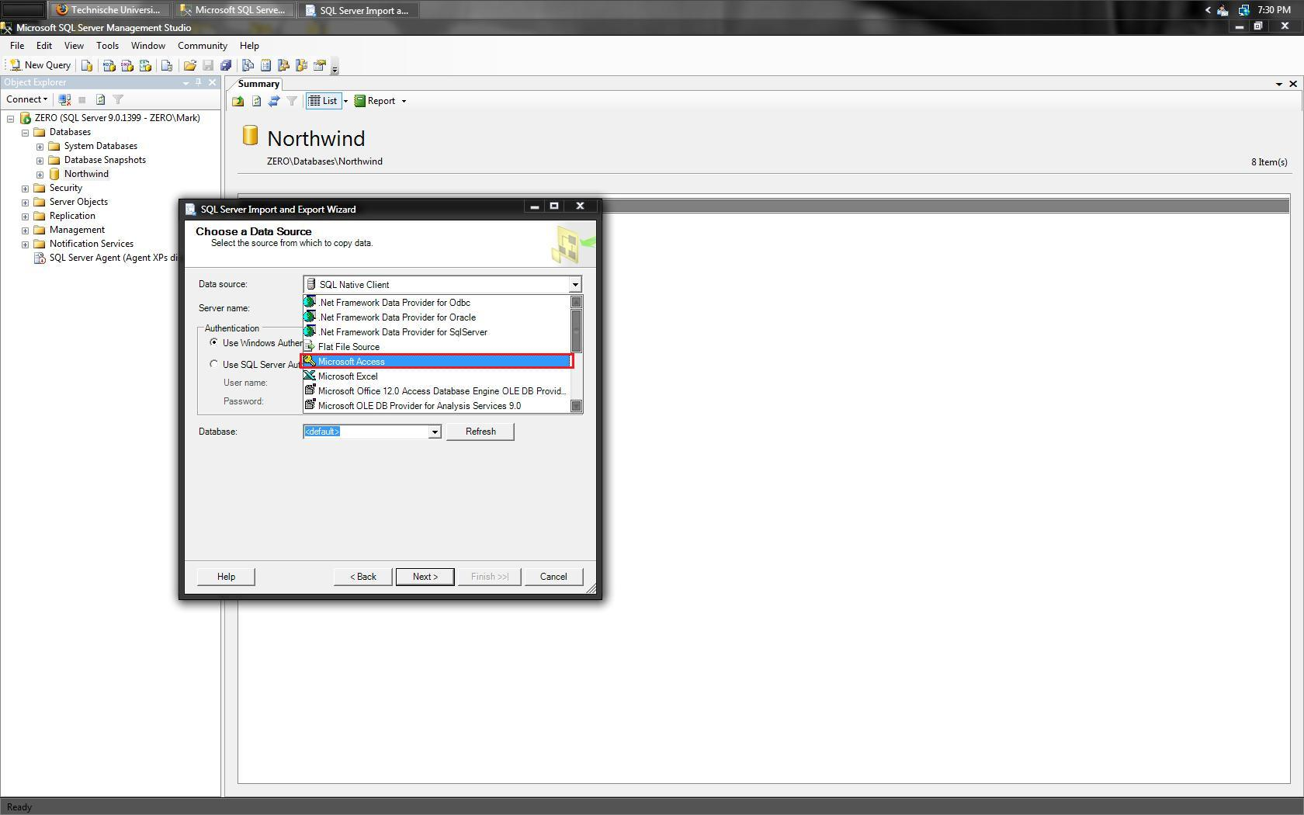 | Select the source file type by using the “Data source” drop down and selecting “Microsoft Access”.
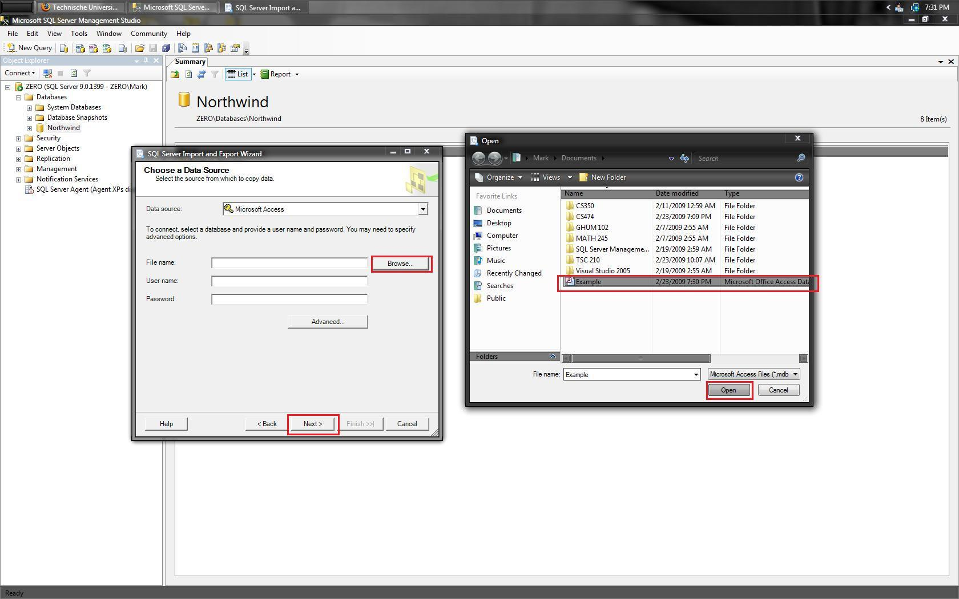 | Now click on “Browse” and navigate to the blank Access database that you wish to import. Select the file, click on “Open”, and then click on “Next”.
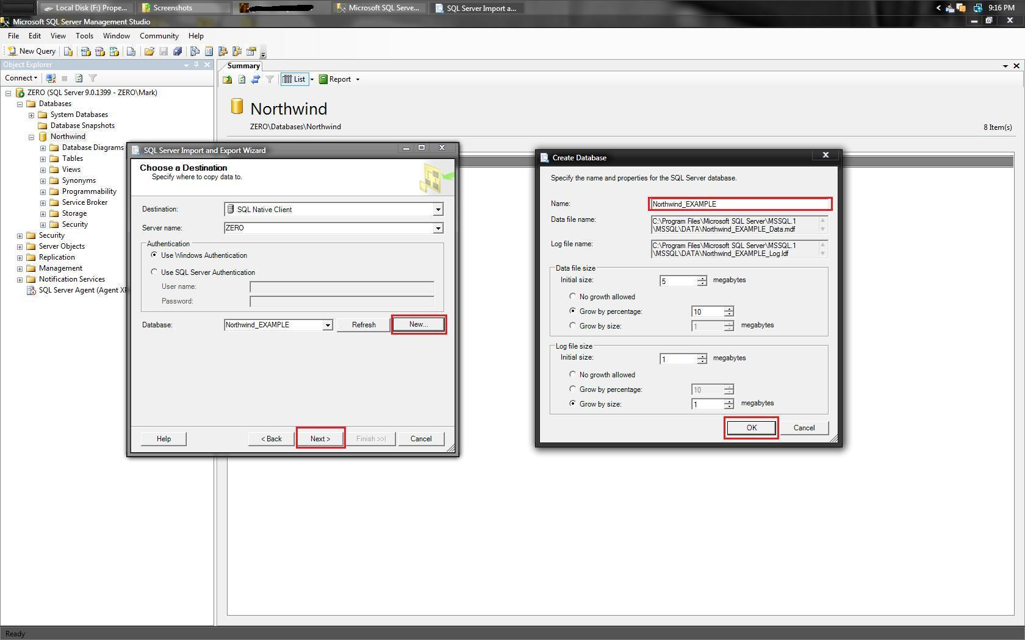 | Select the destination of the imported tables by selecting an already created database from the “Database” dropdown menu or click on “New”.  If creating a new database click on “New” and enter the desired database name under “Name” and then clicking on “OK”.  Click on “Next” when finished.
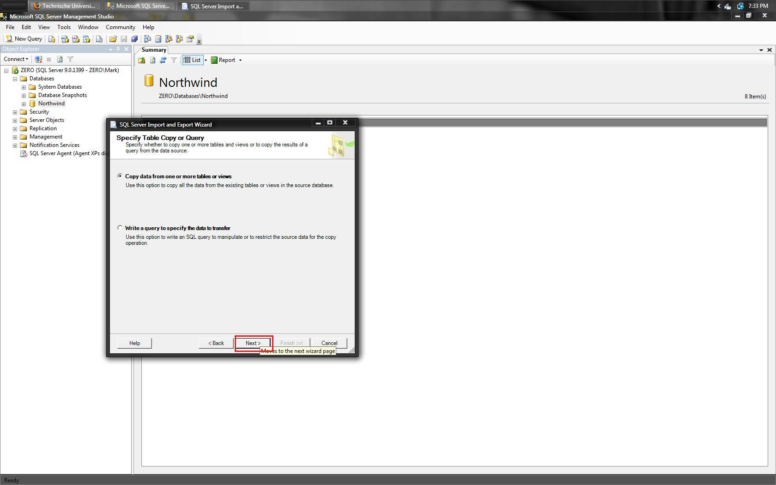 | Leave as default and click on “Next”.
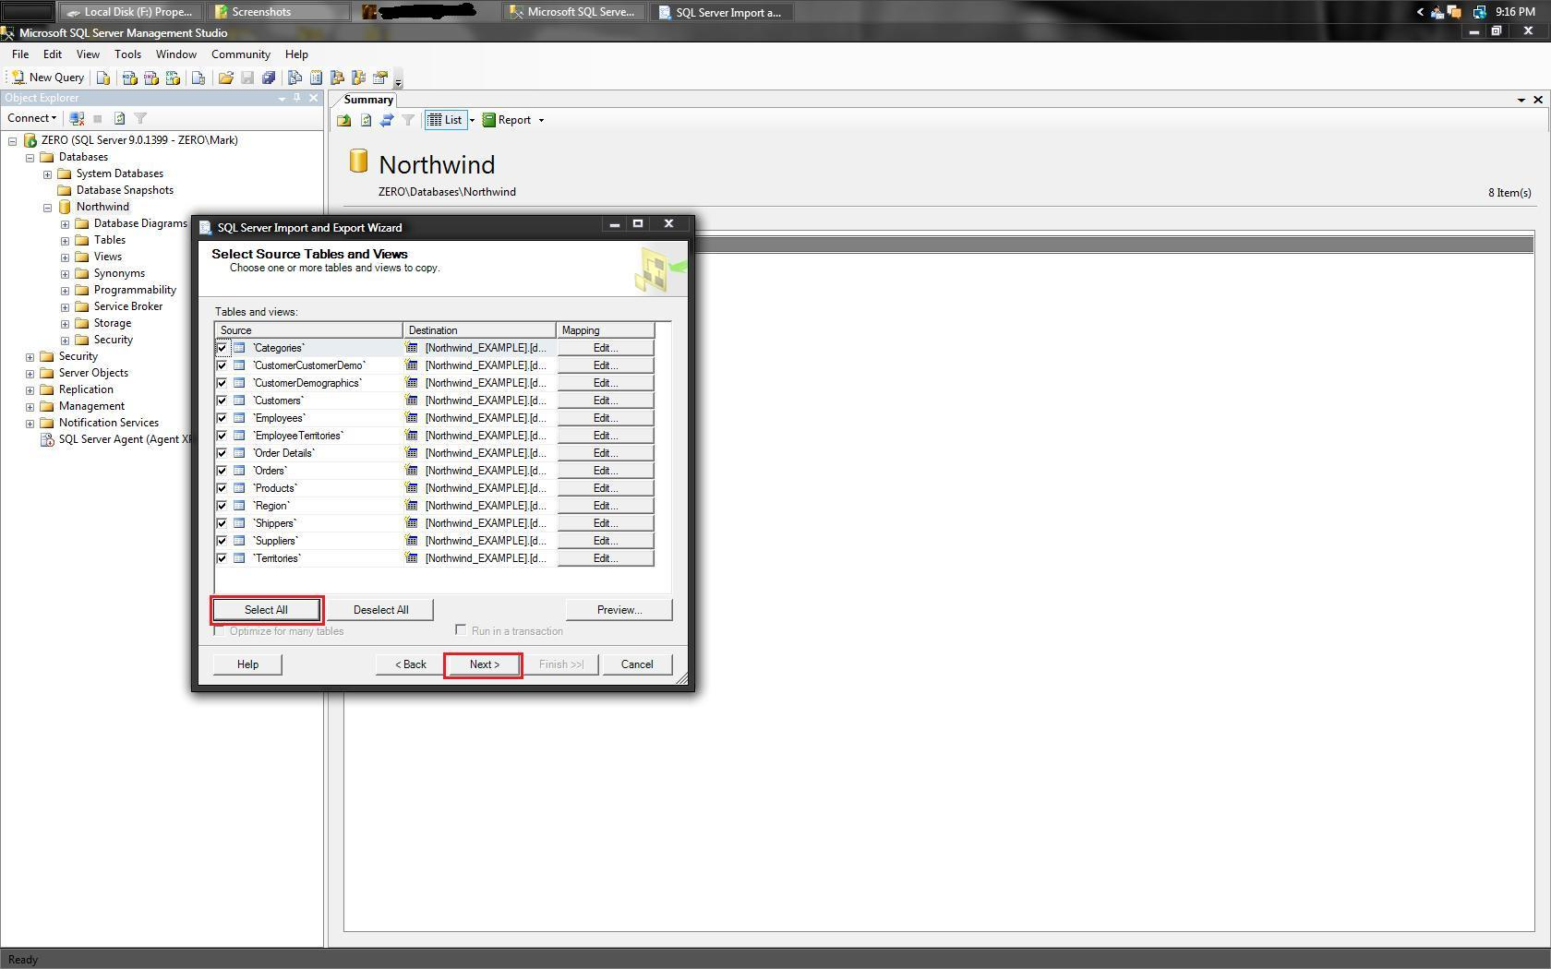 | Click on “Select All” to select all tables listed or select specific tables, then click on “Next”.
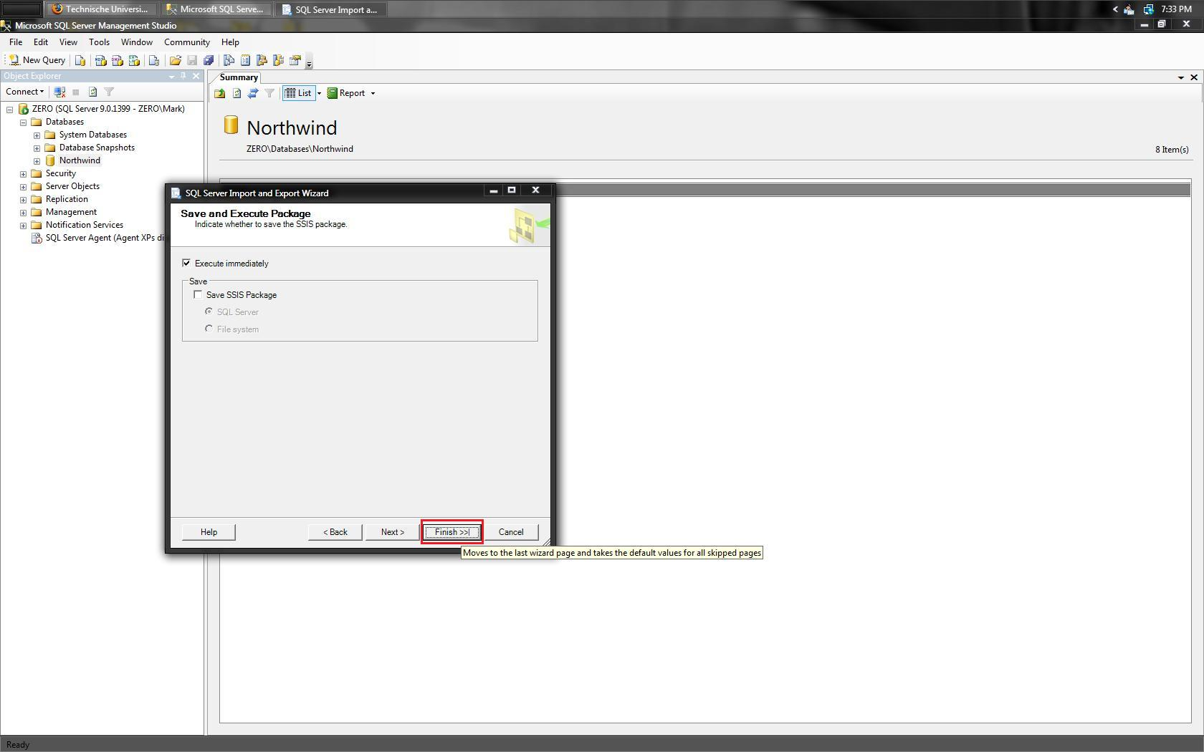 | Leave as default and click on “Finish”.
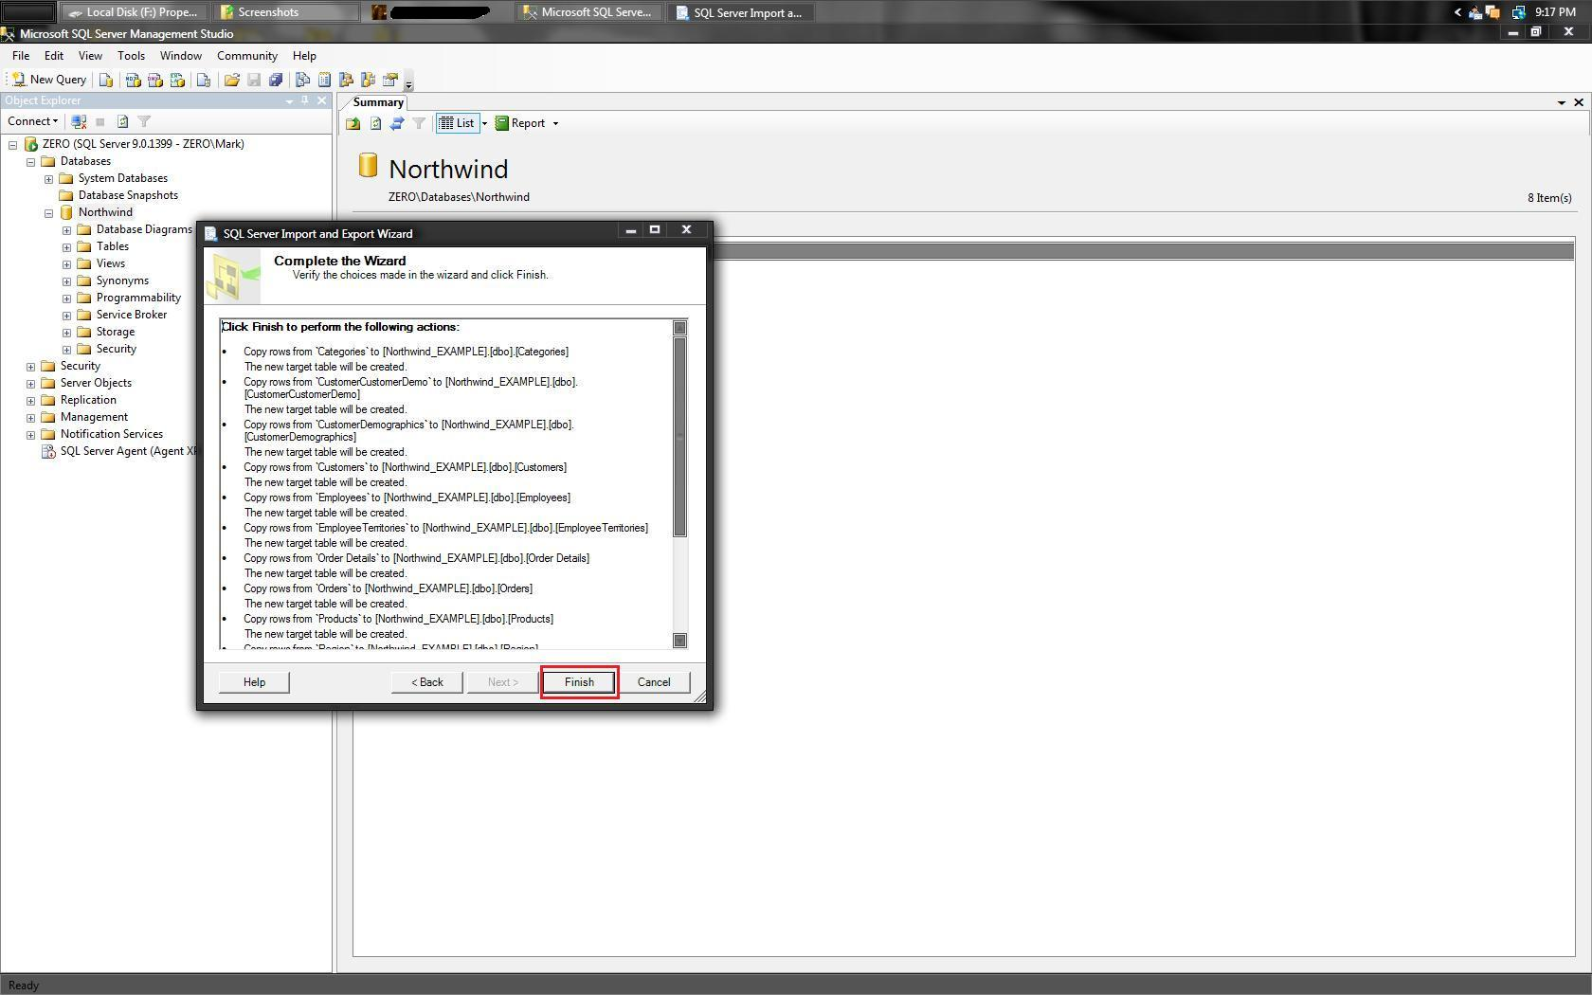 | Leave as default and click on “Finish”.
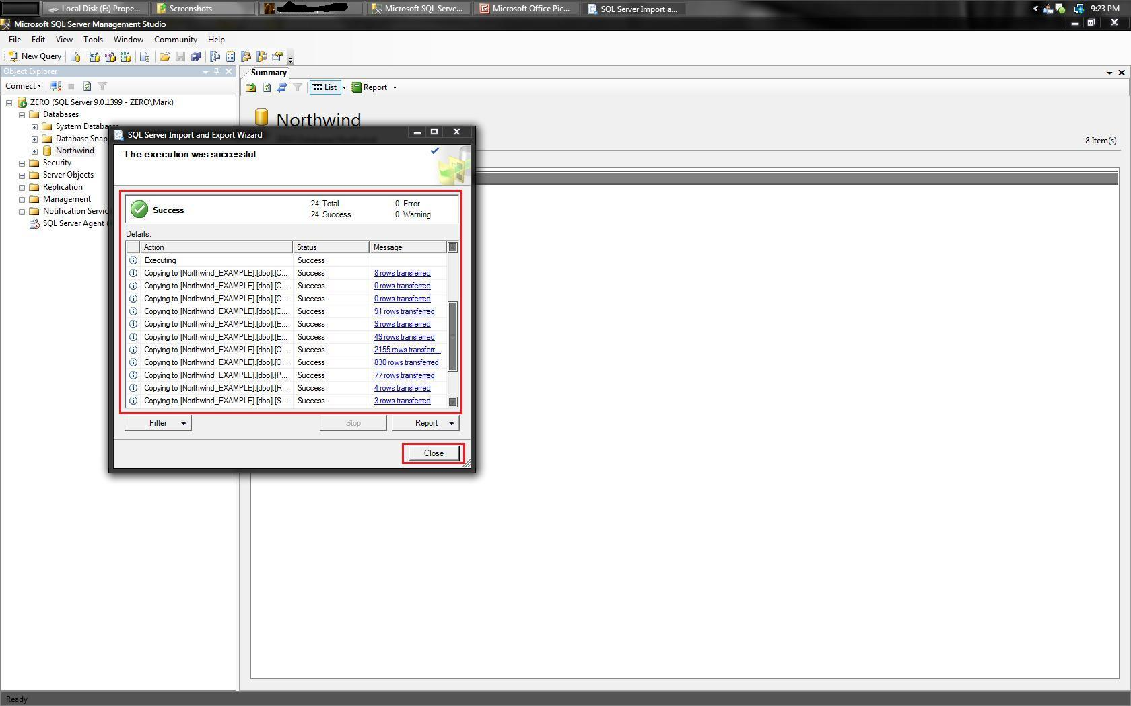 | The wizard will now import all tables into the SQL Server database. When finished a green checkmark along with the word “Success” will be presented. Click on “Close”.
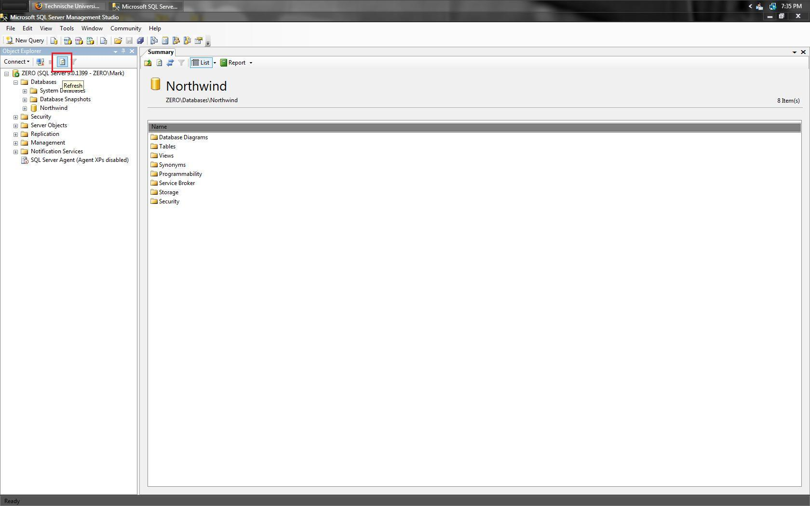 | Click on the REFRESH button to refresh the list of current databases.
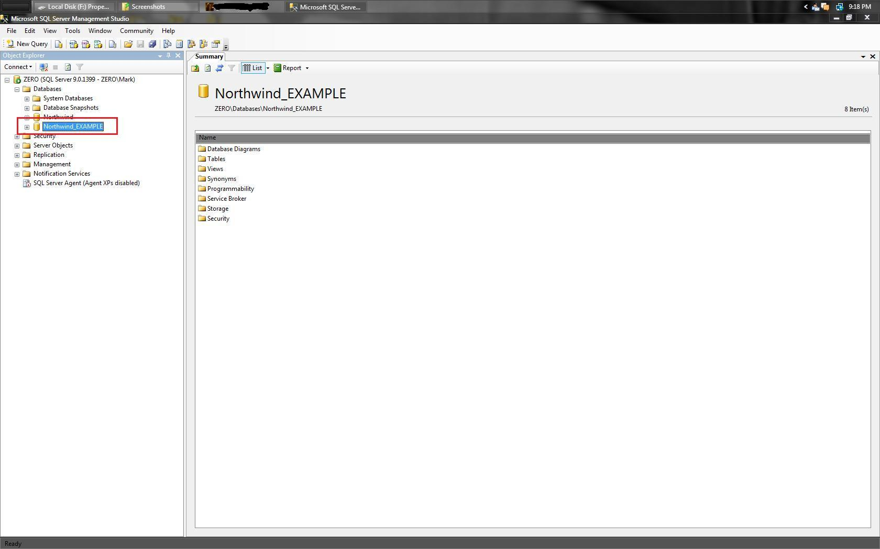 | The new database will now appear under the “Databases” dropdown.
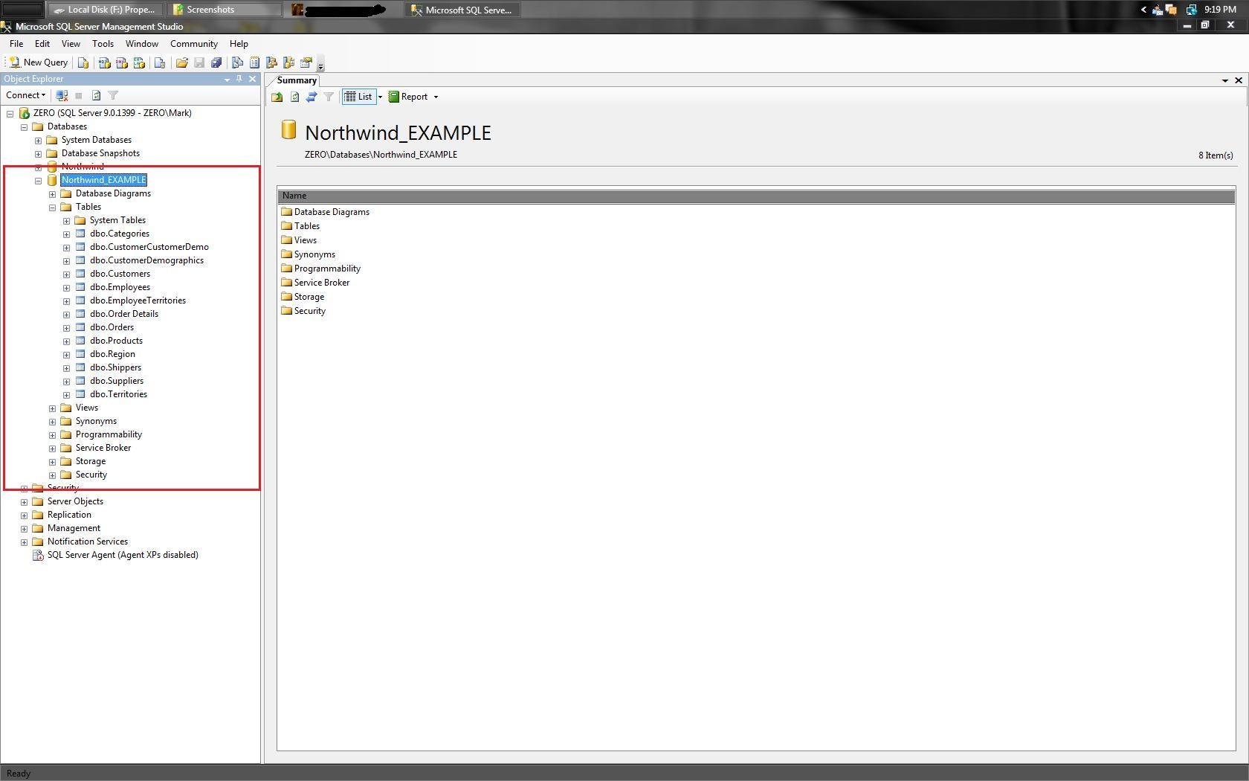 | Within the new database, all tables will appear if done correctly.

