EXPORT DATABASE TO ACCESS
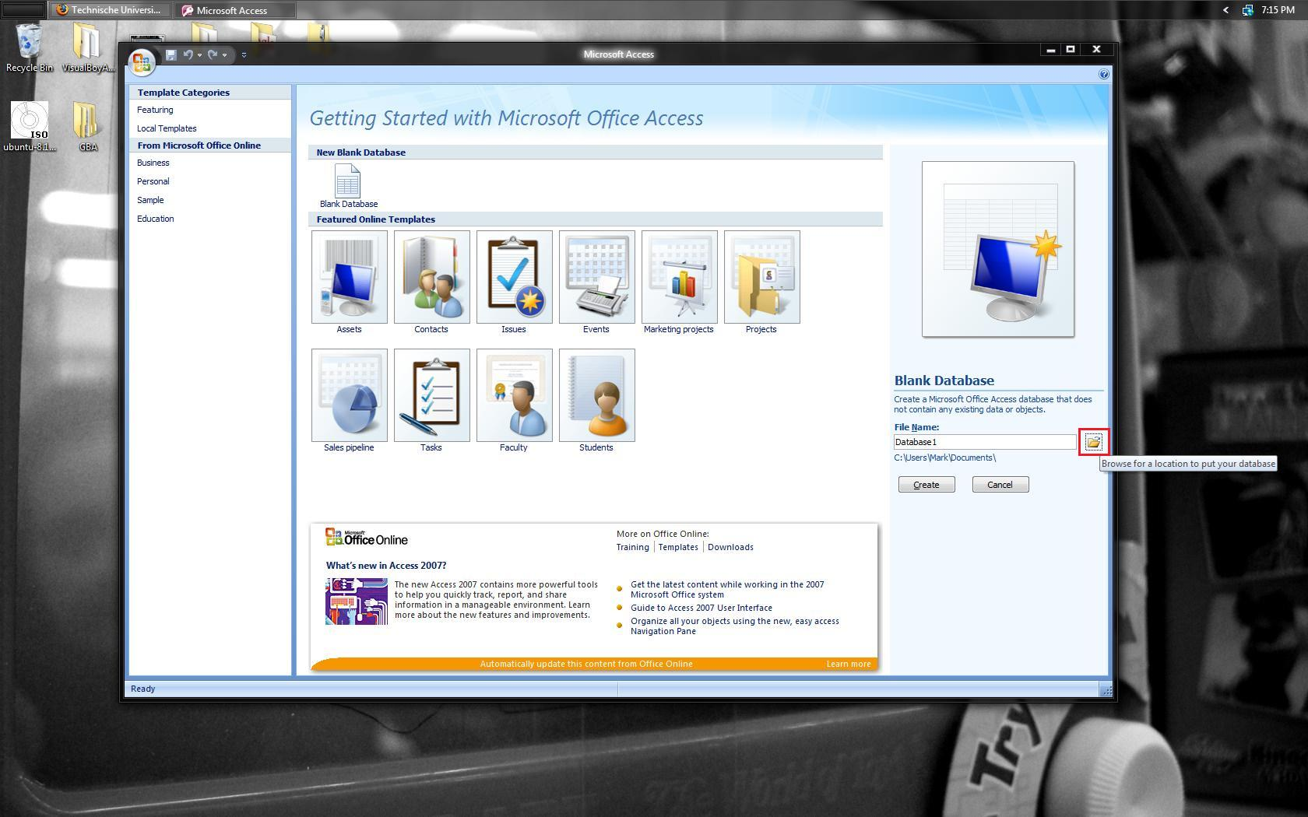 | Create blank Microsoft Access database.
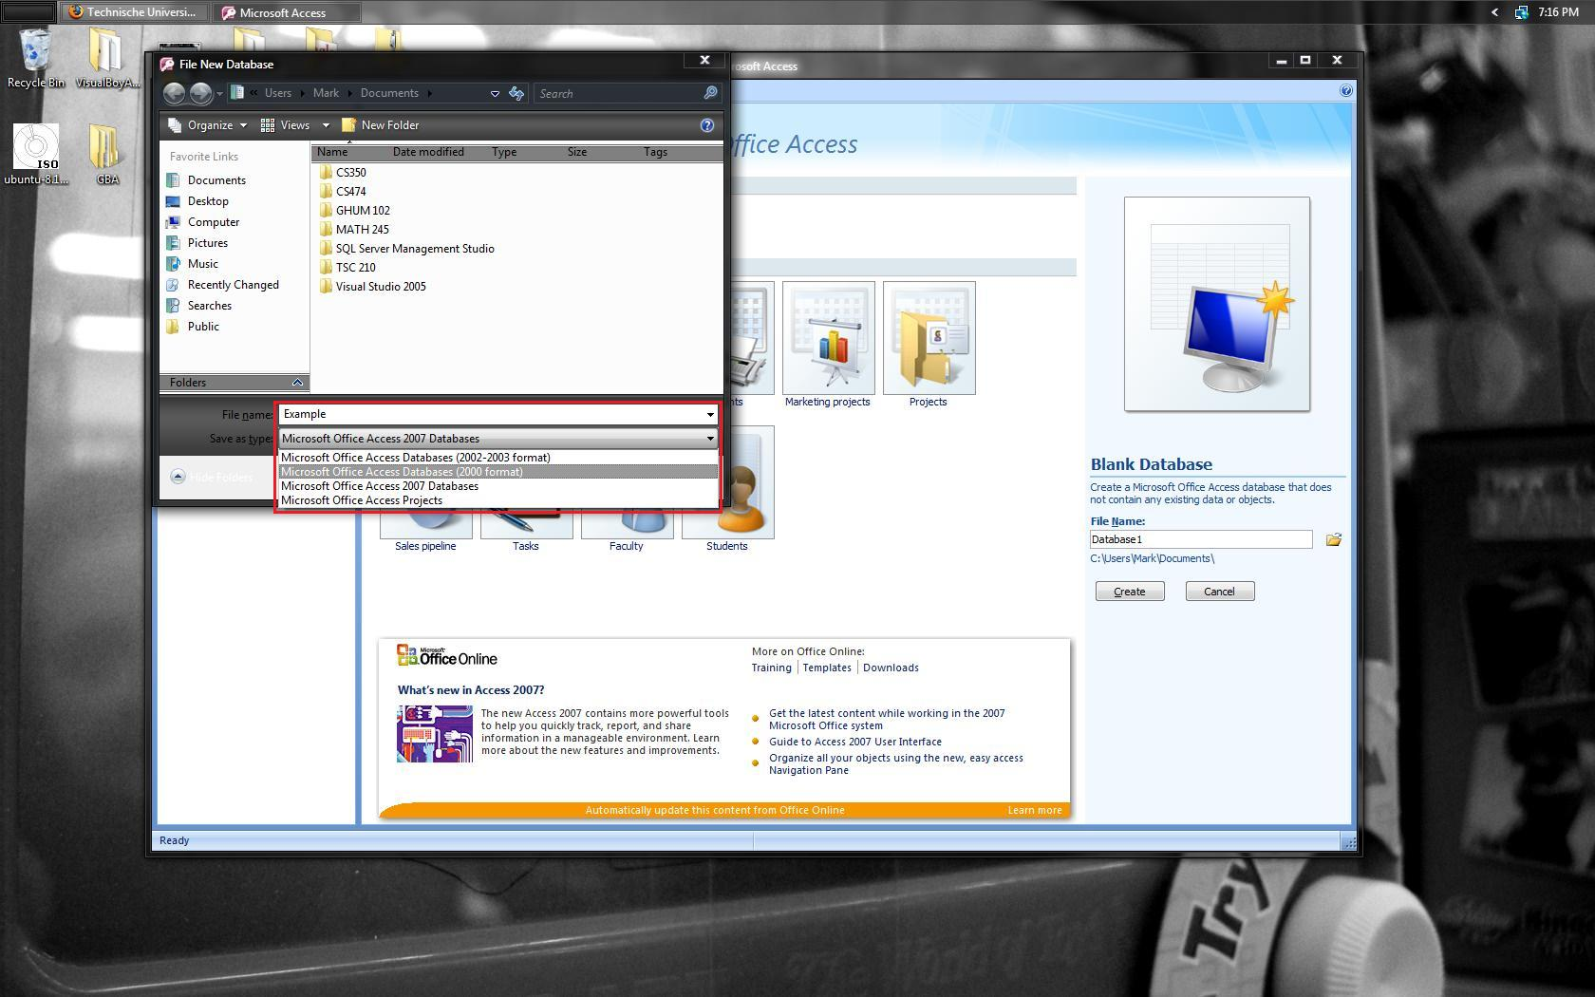 | Enter name file name and select “Microsoft Office Access Database (2000 Format)” to save as .mdb.
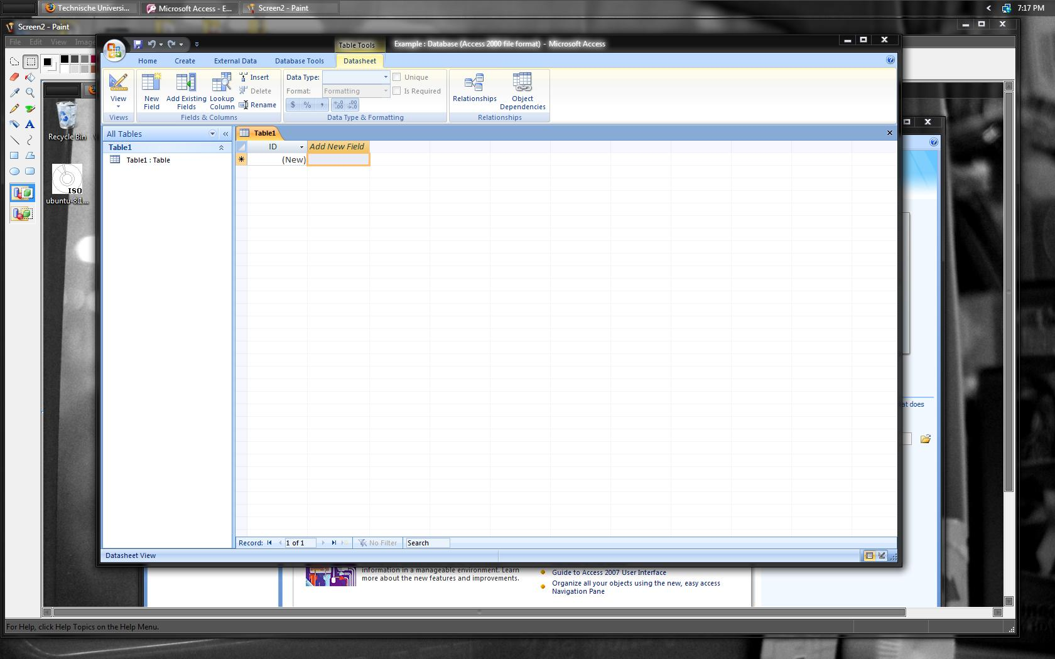 | New database should be as shown.
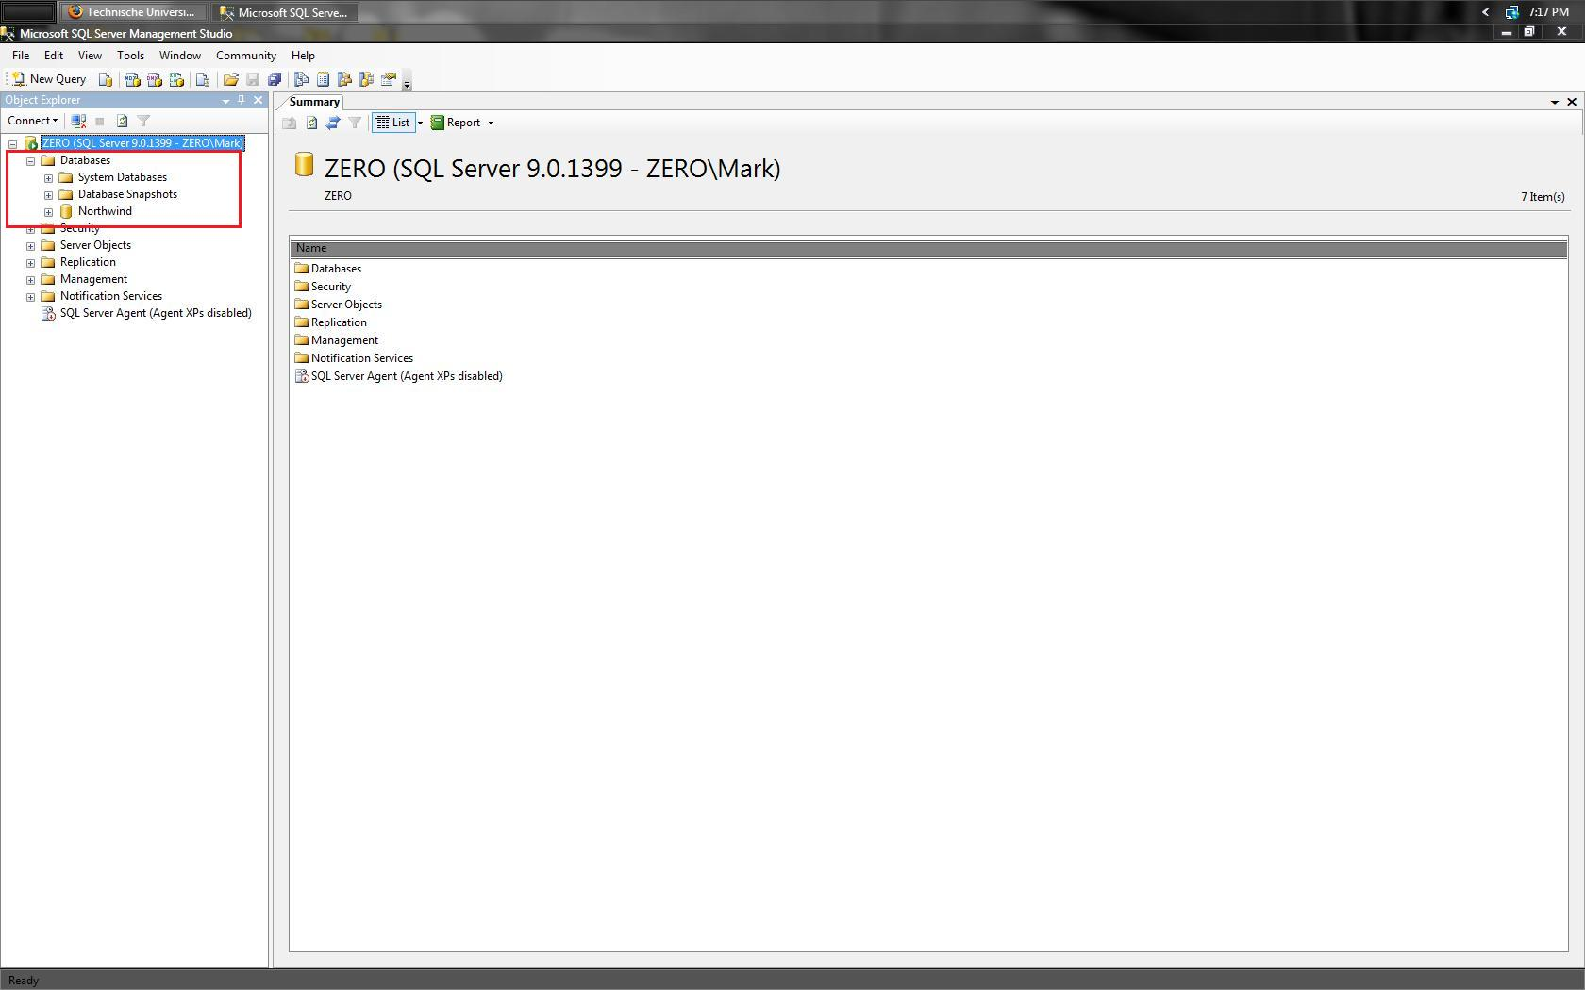 | Open “Database” drop down by clicking on + symbol.
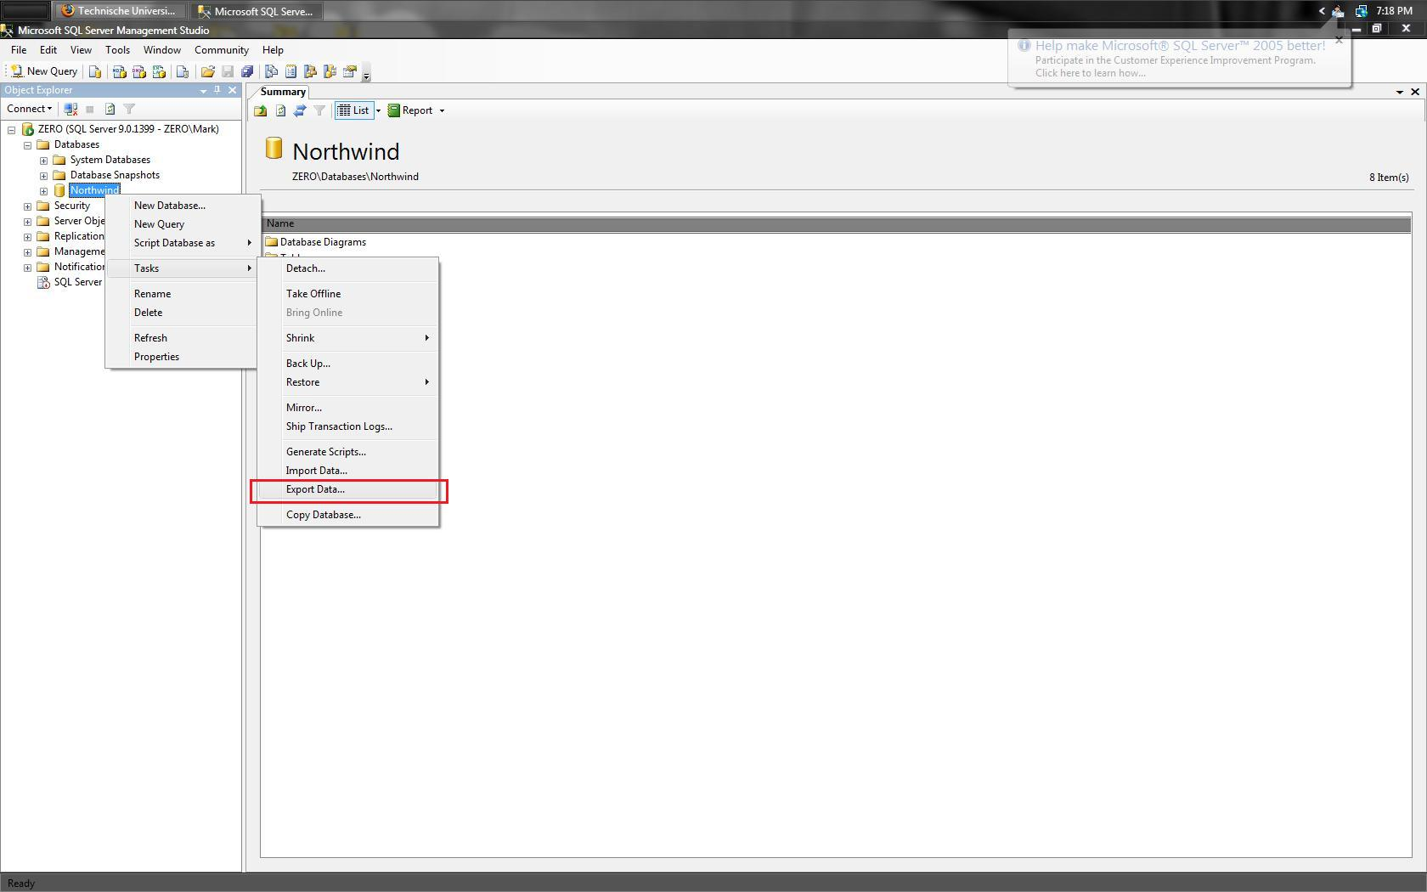 | Right click on the database that you wish to export. Select “Tasks” and then “Export Data…”.
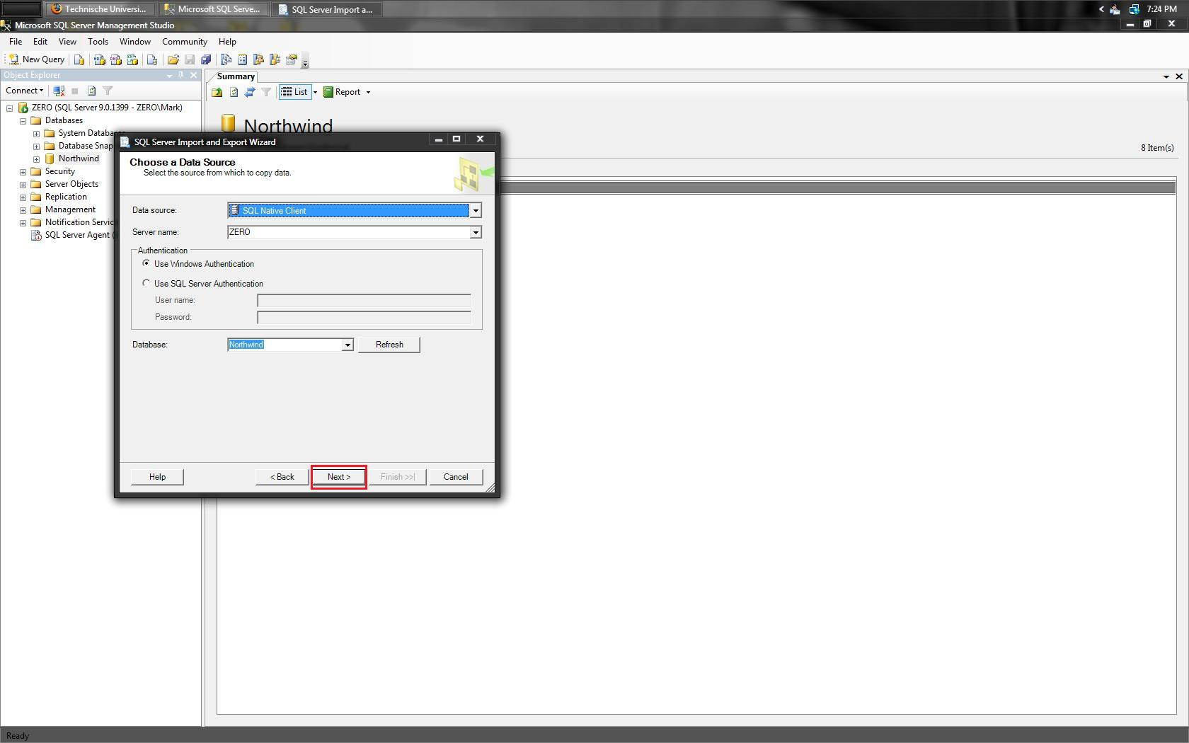 | You may change which database you to use as the source, but the default is the database that had previously been right clicked on. After selecting a database click on “Next”.
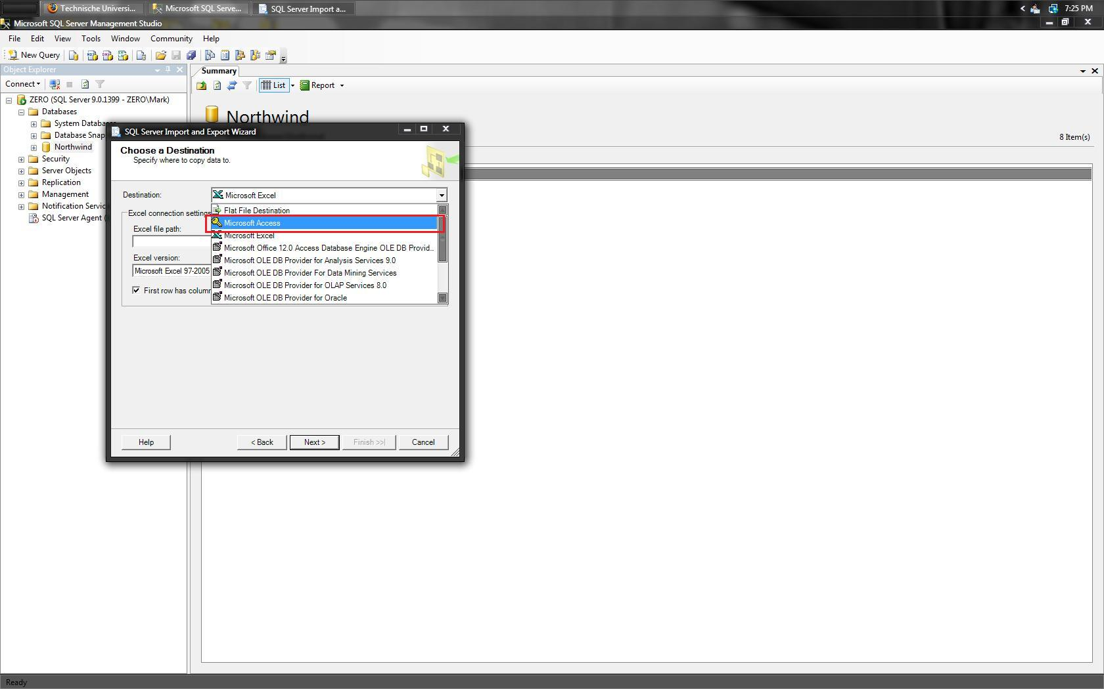 | Under the “Destination” drop down menu select “Microsoft Access”.
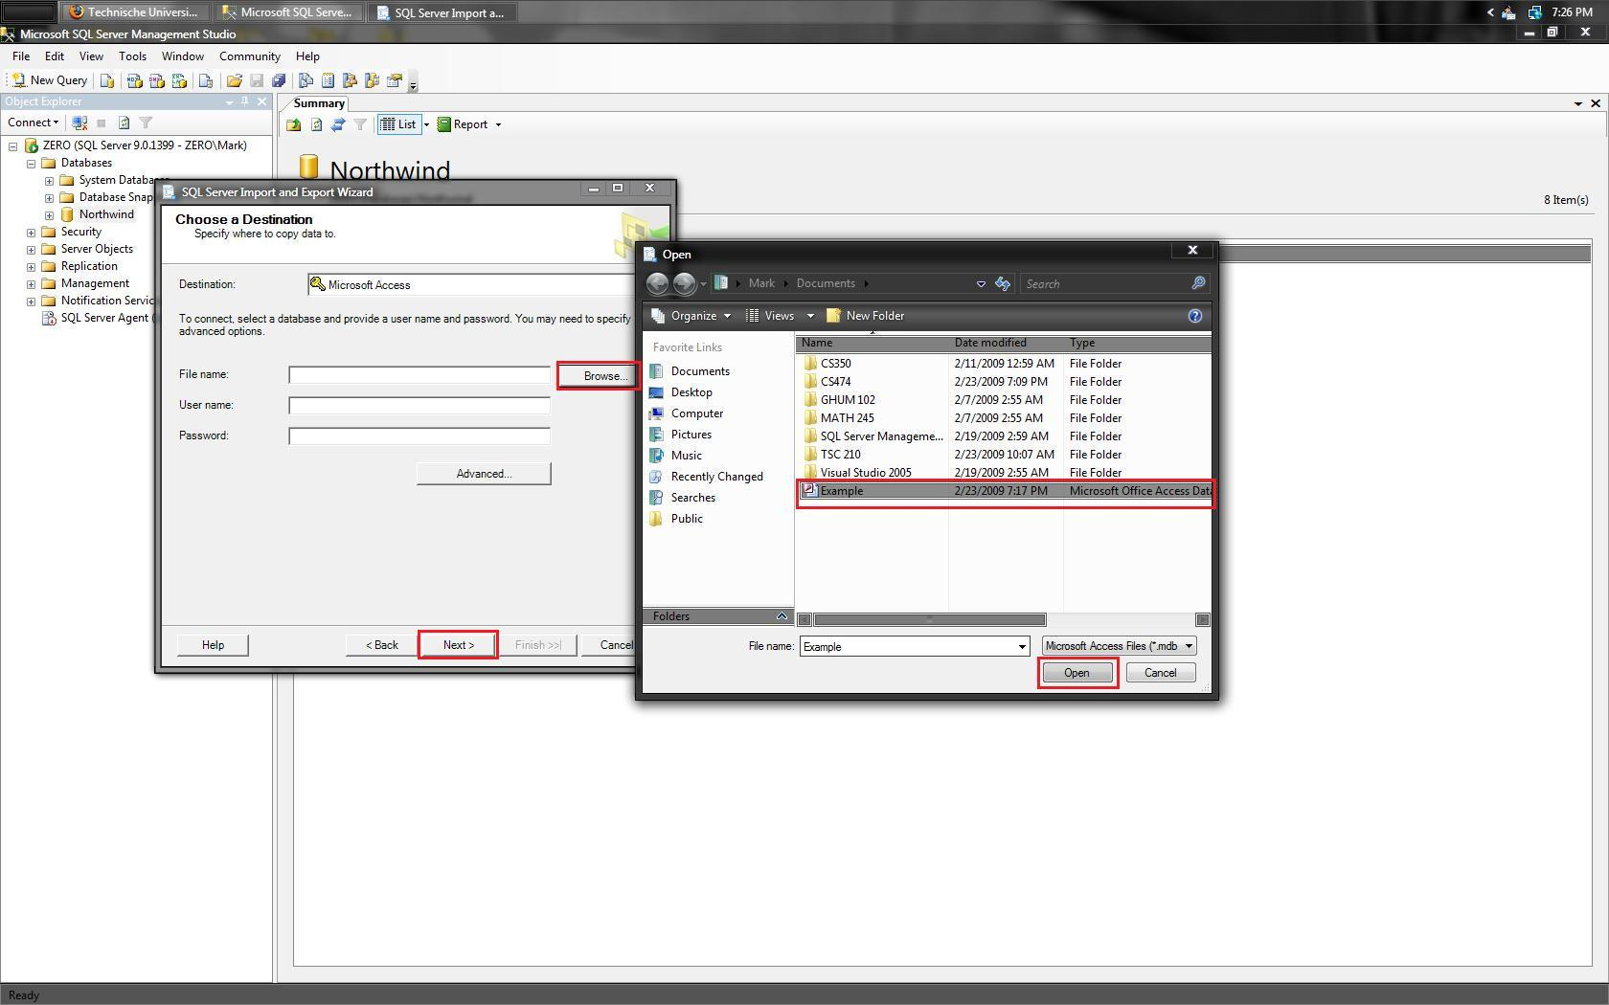 | Now click on “Browse” and navigate to the blank Access database that was created early. Select the file, click on “Open”, and then click on “Next”.
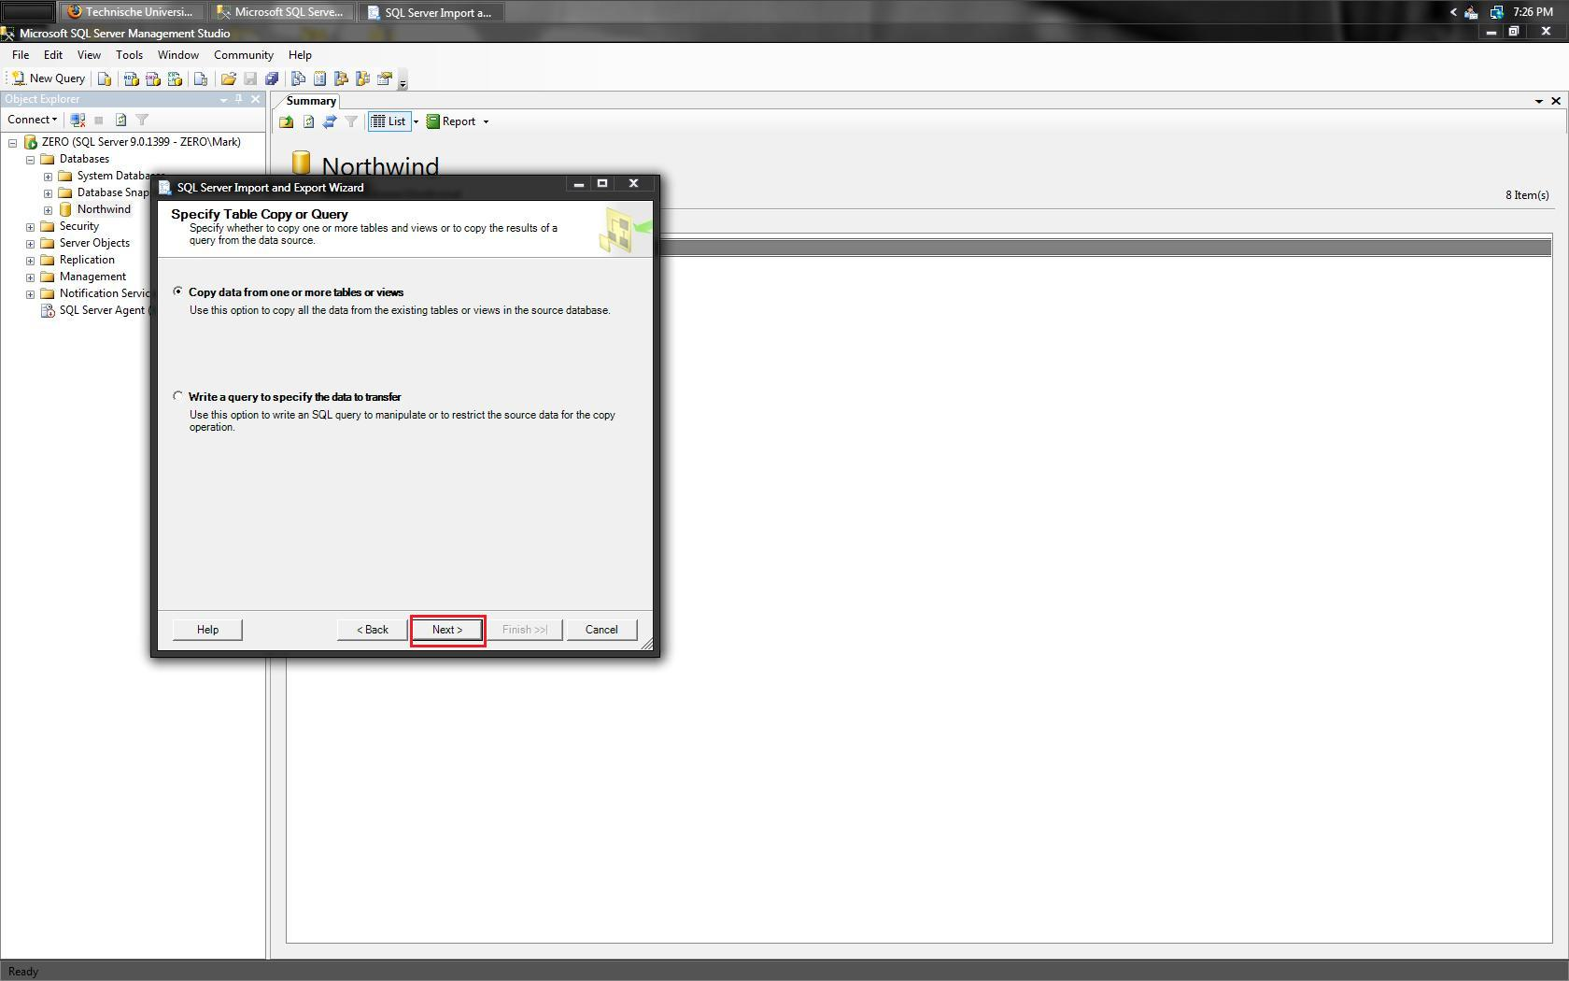 | Leave as default and click on “Next”.
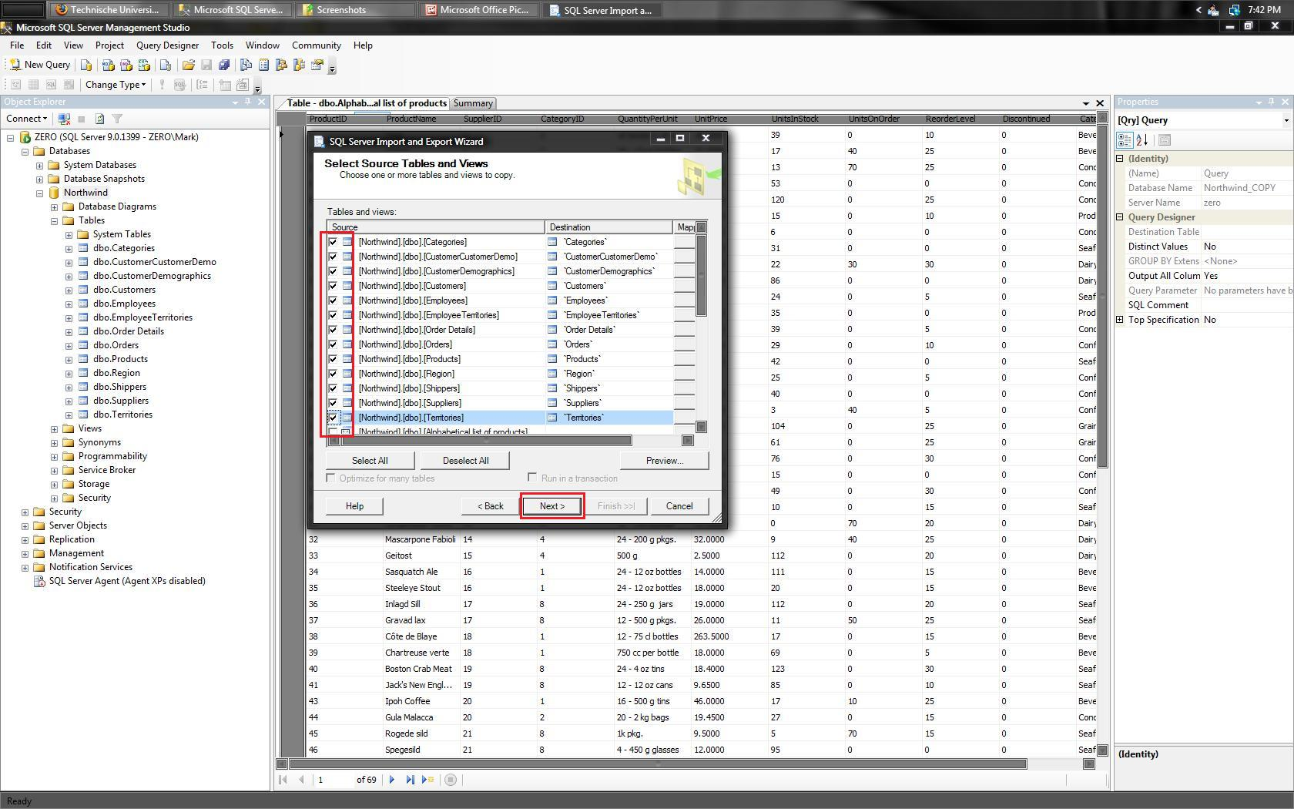 | From the list of tables provided, select any tables that you wish to export to the Access file, then click on “Next”.  NOTE: Of the tables listed views also appear as exportable tables.
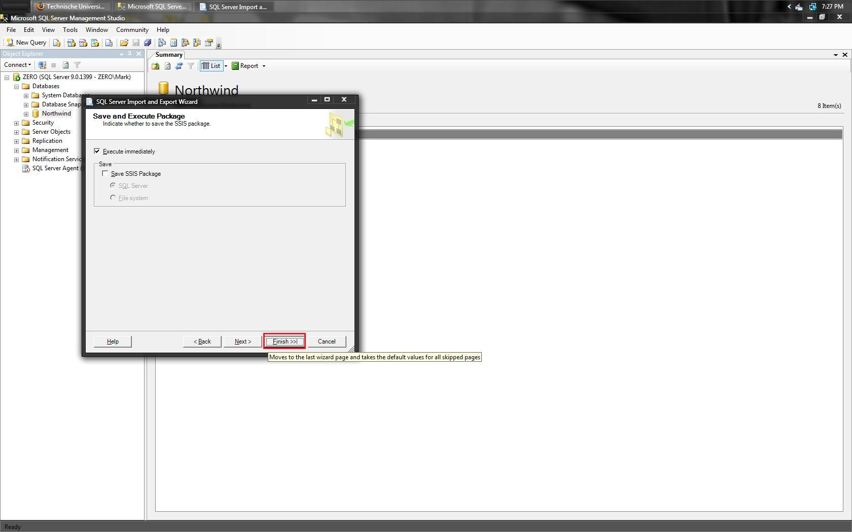 | Leave as default and click on “Finish”.
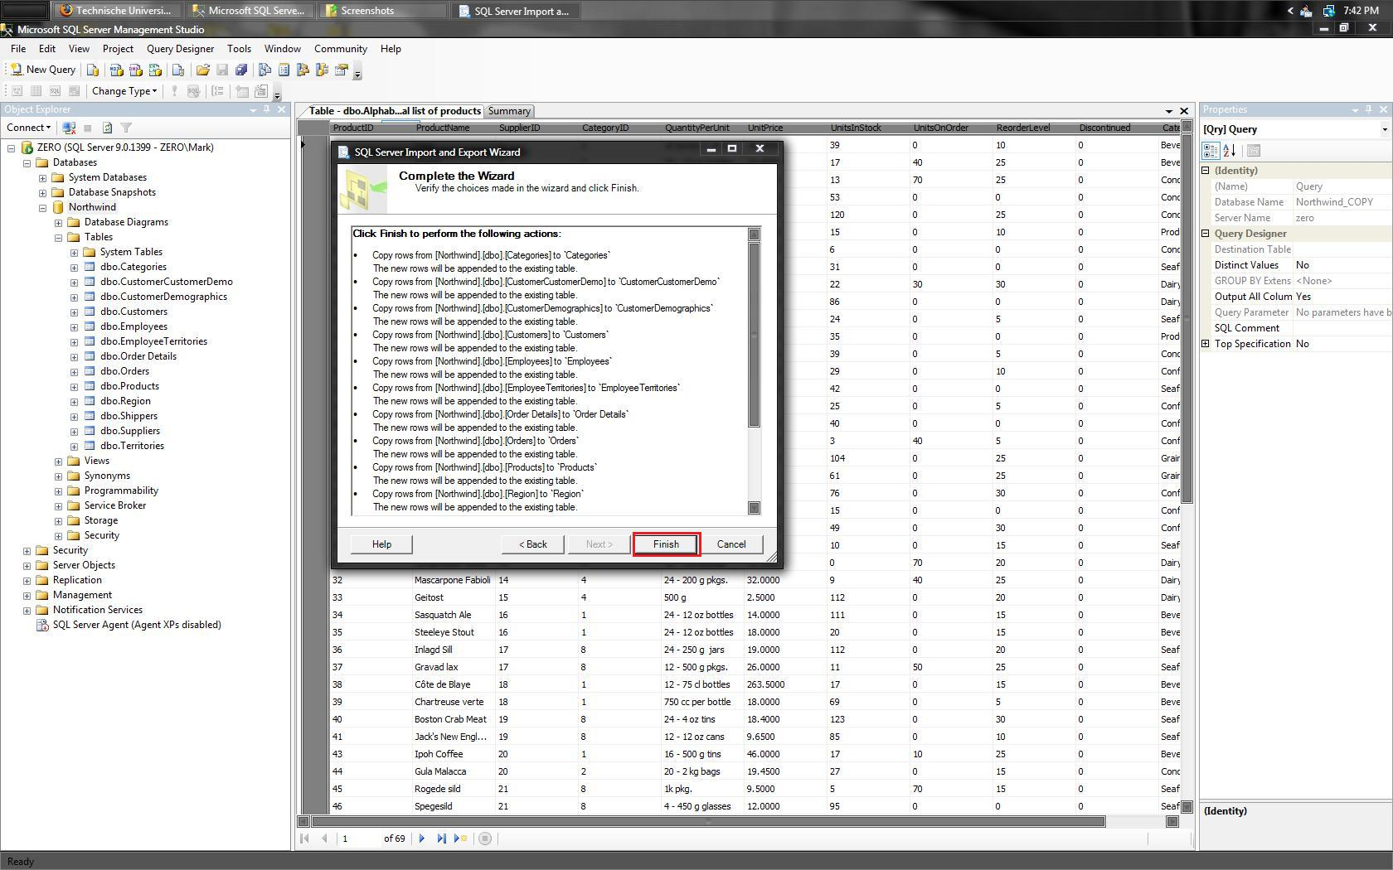 | Leave as default and click on “Finish”.
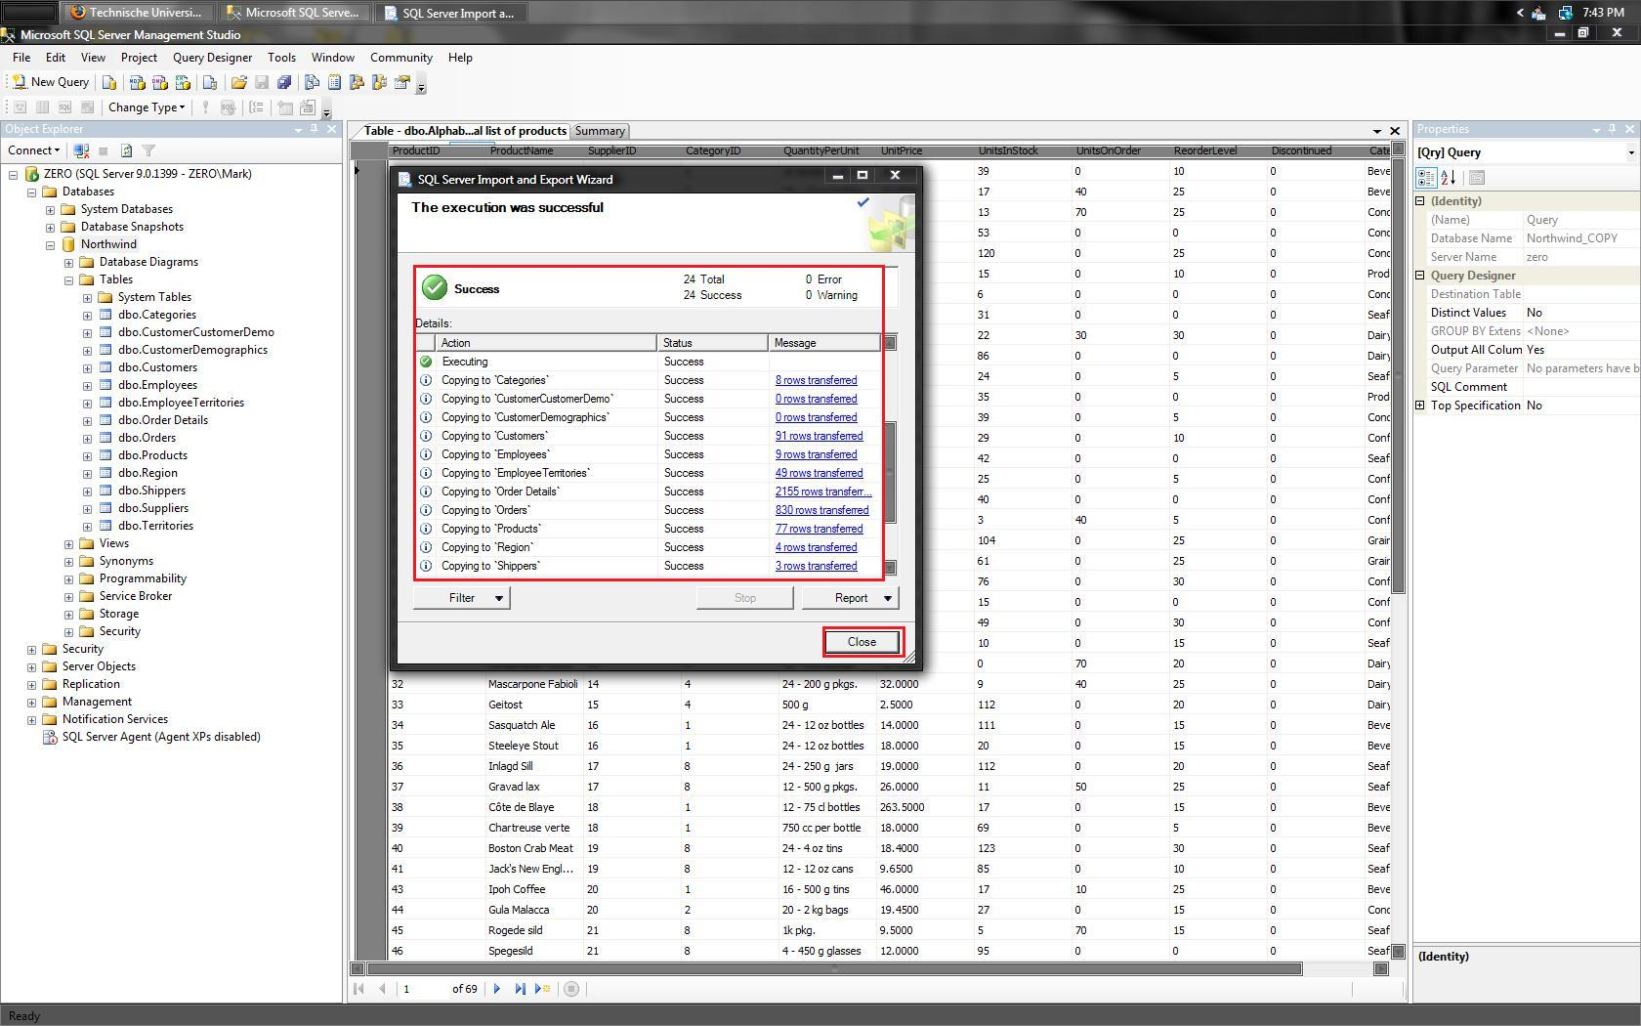 | The wizard will now export all tables into Access file. When finished a green checkmark along with the word “Success” will be presented. Click on “Close”.
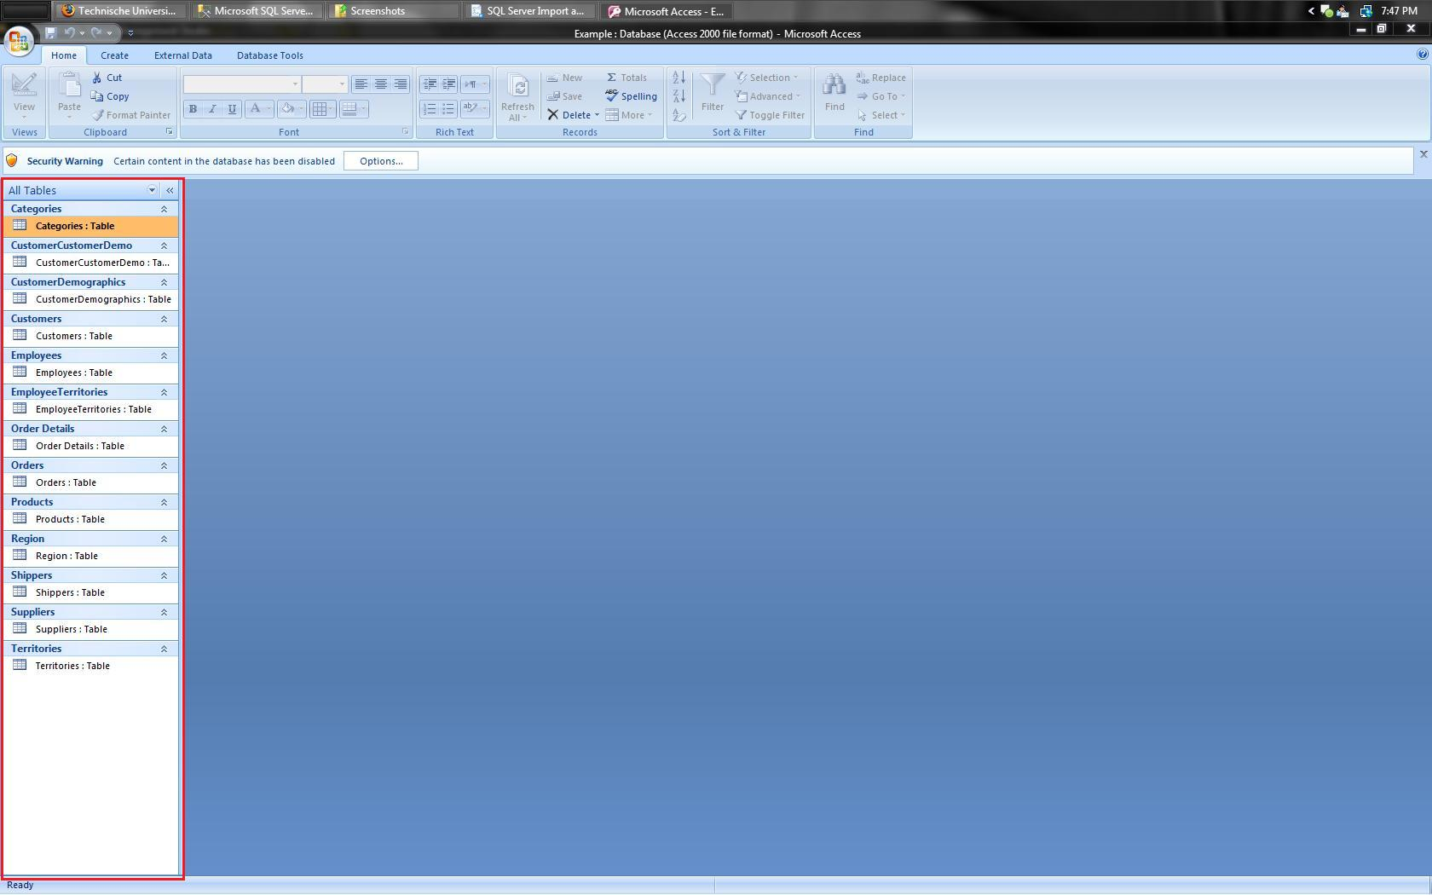 | Open Access file. If done correctly all tables that were previously selected should appear.

