From points west in Virginia:
Take 66 East. Take Exit 75 (Route 110). Route 110 will end and continue as Route 1 South into Crystal City. Get into the left hand lane and turn left on 20th Street. Turn left on South Bell Street; the Crystal City Marriott is on the corner. From this point, follow directions from D.C.
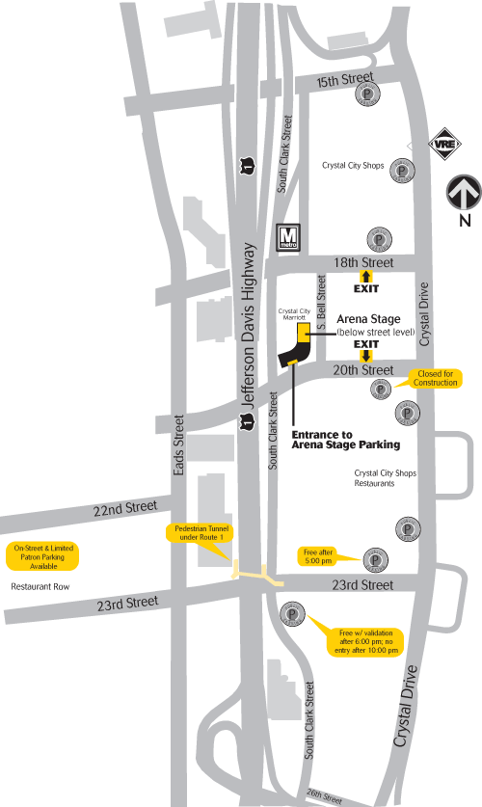
Half a block down South Bell Street on the left, you will see a staircase that leads to the theater’s courtyard entrance (below street level). Pedestrians can go down those steps and turn immediately to the left to enter the lobby.

