Microsoft Disk Operating System

CS 450
Section 1
Operating Systems
Fall 2005

Wellson Fung
Mike McLaughlin
Brian Singer
Steve Tran
Table of Contents

Introduction p. 3

1.0 Overview p. 3
1.1 History p. 3
1.2 General Information p. 3
1.2.1 COMMAND.com p. 3
1.2.2 IO.sys p. 4
1.2.3 MS-DOS.sys p. 4
1.3 MS-DOS’s Success p. 4

2.0 Processor Information p. 5
2.1 Processor Modes and Privileged Instructions p. 5
2.2 Uni-processor or Multiprocessor p. 5
2.3 SMP and Master/Slave p. 5

3.0 Processes p. 5
3.1 Child Processes p. 6
3.2 Process States p. 6
3.3 Creating Processes p. 7
3.4 Terminating Processes p. 7

4.0 Memory Management p. 8
4.1 Conventional Memory p. 8
4.2 Expanded Memory p. 8
4.3 Extended Memory p. 9
4.4 Upper Memory Blocks p. 10
4.5 The High Memory Area p. 10

5.0 Data Structures p. 11
5.1 Process Management Stacks and Vectors p. 11
5.2 Memory Management and Linked Lists p. 11
5.3 File Management’s Data Structures p. 12

Conclusion p. 12

Acronyms p. 13

References p. 14
Introduction

The purpose of this project is to clearly communicate our understanding of the Microsoft Disk Operating system and to add insight to its architecture. To do so, we have discussed an overview of the topic, processor modes and instructions, allowable process states, memory management details, and data structures used for different types of management.

1. Overview

  - History

In 1980, International Business Machines (IBM) was in the process of developing a personal computer suited for individual users when they approached Bill Gates. They learned from him what would be necessary to make the first PC, and what design methods he would use. At the time, Microsoft, the company that Bill was a part of, was not in the business of developing operating systems. Gates recommended that IBM look into CP/M. Digital Researched developed CP/M, which was the most popular operating system at the time. Gary Kindall is credited with the creation of CP/M. Mr. Kindall decided against signing a non-disclosure deal with IBM, so they returned to Microsoft and hired them to write the operating system for their new machine. MS-DOS, which was the operating system Microsoft gave to IBM, was based on QDOS. The Quick and Dirty Operating System was written by Tim Patterson at Seattle Computer Products. QDOS was written in six weeks by Patterson and it was based on the CP/M. QDOS is based on CP/M, and MS-DOS is based on QDOS, so in reality, IBM is getting the original OS it tried to use. Microsoft bought the rights for QDOS for $50,000, and arranged a deal with IBM to place MS-DOS on the new personal computers, while being allowed to market their new system independently as well (Bellis, 1996).

1.2 General Information

The Microsoft Disk Operating System was originally designed for a range of IBM computers. It was originally on a 5.25” and 3.5” diskette, and could be placed onto the hard drive in most computers. Designed to be a single user, single task system, it can only run one application at a time. Multiprogramming, however, creates the effect of a multi-tasking machine. Intended for a single user environment, ease-of-use and efficiency were among the more important design goals.
As with all operating systems, MS-DOS handles program, error, device control, and takes care of file and memory management. It also provides a user interface, called the shell. Three files make up the greater part of the system, which are COMMAND.com, IO.sys, and MSDOS.sys (Brown, 2000).

1.2.1 COMMAND.com

The shell of an operating system is what allows the user to call upon the services provided by the operating system. In the case of MS-DOS, there is a command line interpreter which will take commands from the user, interpret them, and run the necessary functions to complete the operation. COMMAND.com is the file that contains the internal commands and programs needed to run the shell (Brown, 2000). A list of various commands that MS-DOS offers, but not limited to is listed below.

- cd (change directory) – changes the directory as specified in the command
- dir (directory) – display all available files and folders listed in the directory
- copy – copies a file or a bunch of files into the chosen directory
- del (delete) – deletes the chosen file
- edit – allows you to create or change a file
- move – moves files from one directory to another chosen one
- ren (rename) – renames files to a specified name
- deltree (delete tree) – deletes chosen files or directories from the computer
- cls (clear screen) – clear everything on the screen
- format – clears a chosen disk or drive

1.2.2 IO.sys

The operating system is in charge of organizing and managing the hardware of a computer. At boot-up, the operating system needs to know what and where all of the computer’s devices are and what they need in order to be accessible. IO.sys contains the programs necessary for this to happen (Brown, 2000). MS-DOS provides these default device drivers: console display, keyboard, printer, serial communications, clock, and boot disk drive. The IO.sys controls all interaction between hardware and software.

1.2.3 MSDOS.sys

Interaction between user applications and the operating system’s functions are vital to the success and efficiency of a computer. Applications that are running refer to MSDOS.sys to be able to call on resources such as files in memory, devices, and others (Brown, 2000). It controls file and memory management, input and output calls, and program execution. These files contain programs that are imperative to MS-DOS but there are others such as back up, format, and print which are almost just as important.

1.3 MS-DOS’s Success

MS-DOS’s success cannot be attributed to any technical authority or innovativeness. Instead, the credit goes to the business side of its upcoming. Based on QDOS, it lacked any superiority over other systems. IBM had not planned on using MS-DOS for their new PC but due to a slowly developed first choice (CP/M) and unsuccessful business interactions, there was no other choice.

2. Processor Information

2.1 Processor Modes and Privileged Instructions

The first processor that MS-DOS was implemented on was the 8086. The original MS-DOS only had one mode known as real mode to run in on 8086 machines. On the 80386 and later model processors, they added a mode known as “protected” mode. This was to insure that privileged instructions were executed safely. Later on, when Windows 3.1 was being developed, Windows ran onto of MS-DOS in the “protected” mode setting.

2.2 Uni-processor or Multiprocessor

MS-DOS is not meant to be a multi-tasking or multi-processor machine. The general implementation for MS-DOS machines is a stand-alone single user machine. It was designed in an era where multiprocessors was not available and memory was very limited. Special programs were created to solve this limitation. One solution that gives the appearance of multitasking is the Terminate and Stay Resident (TSR) programs. TSR programs were included in MS-DOS4.0. Basically, TSR programs would create a vector that would point to it self. When the program ended, the vector would give control back to the TSR program (Wikipedia, 2005).

The biggest disadvantage to this method of simulated multitasking is that the TSR programs would have to stay memory resident. Memory was expensive at this time so it was not easy writing small efficient programs for multitasking. Also, ensuring compatibility with other software vendors was not an easy task to do (Wikipedia, 2005).

2.3 SMP or Master/Slave

Implementing early MS-DOS on a duel processor machine would have no effect on the performance of the system because the operating system can only handle one process at a time. Since MS-DOS is only single-processor machine, it cannot be support SMP (Symmetric Multiprocessing). If two processors were to be included, it would have to be a master/slave set up. With the emergence of 64-bit processors and duel-core integration, Windows NT, XP, and Vista will support the new technologies, but MS-DOS no longer runs as the operating system. The last release of MS-DOS was 7.0 and it was bundled with Windows 95/98 (Perkel, 1996).

3. Processes

MS-DOS is a Uni-programming system. As stated before, only one process can be executed at a time. For example, the user cannot work on a different application while waiting for the printer to process. This means with MS-DOS there are no issues with concurrency because only one user can do one thing at a time. Although MS-DOS is single tasking, there can be more than one program at a time in memory. DOS allows several programs to be loaded into memory at one time, but DOS only has the ability to run one at a time and in a certain specific manner. Unless you have cooperating processes, execution follows a very strict form. MS-DOS functions by having parent processes that create child process which execute and return to the parent process.

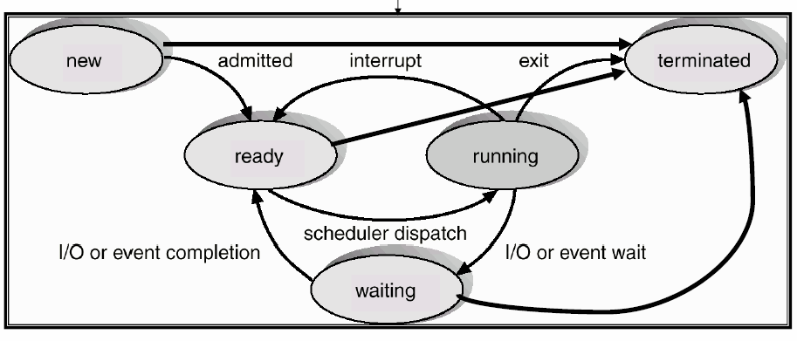

3.1. Child Processes

When an application is running in MS-DOS, it can use the EXEC function to load and execute another program. When this parent application calls the second, child, program, the parent program is suspended, while the child process executes. When the child process is completed control returns to the parent, much like a procedural call.

3.2. Process States

MS-DOS has several functions for process state control. The functions for process control are listed below:

Generic State | MS-DOS Process | Function # (AH) | Parameters
New | Load and execute | 4Bh | 0  pointer to program name  pointer to LOADEXEC structure
Running | Execution | 40h | pointer to pathname to execute  pointer to parameter block
Ready | Load | 4Bh | 1  pointer to program name  pointer to LOAD structure
Waiting | Suspended
Terminated | Terminate Execution | 4Ch | process return code

3.3. Creating Processes
Creating child processes is accomplished through the LOAD_AND_EXECUTE and LOAD commands.
LOAD_AND_EXECUTE requires two parameters, the location of a program (with the suffix .COM or .EXE) to execute and a pointer to a LOADEXEC data structure. One hitch with process creation in MS-DOS O/S using the load and execute command is failure due to insufficient memory. When and executable file is created, by default it allocates up all the available memory. This leaves no memory available for the child process and DOS returns an error. It is therefore very important that the memory allocation for the parent is adjusted before attempting to create and run a child process.
Another problem with LOAD_AND_EXECUTE is that leaves the parent process with very little control over the child process. Unless a trap or interrupt is used for communication between parent and child, the parent process is suspended until the child process terminates. LOAD is used to allow the parent process to load the application program and execute additional operations before transferring control to its child process. LOAD requires two parameters for execution, the location of a program (with the suffix .COM or .EXE) to execute and a pointer to a LOAD data structure. This call only differs from the load and execute function by the pointer to the LOAD data structure instead of the LOADEXEC data structure. LOAD is used for creating semi-resident programs as well as redirecting application I/O, and loading several executable processes into memory so that there can be pseudo concurrent execution.
3.4. Terminating Processes
The termination function has the ability to not only terminate the process but it also passes a single byte back to the parent process that gives the termination code. The termination code can mean one of the following things:
Value in AH | Reason for Termination
0 | Normal Termination
1 | Terminated by Ctrl-C
2 | Terminated by Critical Error
3 | TSR Termination

The terminate process command does all of the following things upon termination:

-Flushes file buffers
-Closes files
-Restores the termination address to the address of the parent process
-Restores the address of the Break handler
-Restores the address of the critical error handler
-De allocates all the memory that the process reserved

4. Memory management

4.1 Conventional Memory

The 8086 processor had a limited memory space of one megabyte. The first half of the memory, which is about 0-640K, is used by the operating system and is also called low DOS memory. The second half of the memory, also known as high DOS memory, is used by peripheral devices such as video cards, network cards, ROM BIOS, and XT hard-disk controller cards. This is called conventional memory; a contiguous memory directly used by applications running on any Intel x86 microprocessor that runs in real mode under MS-DOS. Figure 4.1 shows an example of how conventional memory is set up.

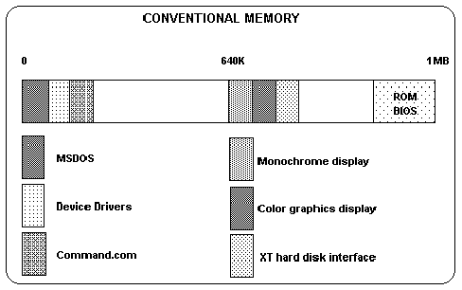 Fig. 4.1

4.2 Expanded Memory
The development of the 80286 processor in 1982 allowed for a new maximum size of 16 megabytes of RAM. MS-DOS still imposed the 640K limit to run programs, but many companies came up with ideas to use the space between 640K and 1MB. This idea is based on the bank switching techniques which seems like it copies blocks of data back and forth between areas of memory but that is the effect.
Special memory paging hardware was built into 80386 chips so it permitted the implementation of Expanded Memory Specification (EMS) in software. In doing so, extended memory can appear to be expanded memory to applications. Applications should be written to take advantage of EMS. EMS has the widest application support because of its longevity. Expanded memory is divided into 16 kilobyte pages, which are mapped into a predetermined area in the first megabytes of address space (the page frame) at the application’s request. EMS usually requires loading a device driver to manage application requests. Code can be executed from the page frame, which can be much larger than 64 kilobytes with some hardware configurations. Multitasking software takes advantage of this, as do programs which load their overlays into EMS. By switching in and out these 16K blocks of RAM, it could appear as though there was a large amount of memory available, all accessed through this expanded memory window. This became known as the LIM EMS standard. With the comings of the 80386/80486 computer, it has the ability to simulate expanded memory using a device driver, and does not need a special card to do this. Fig 4.2
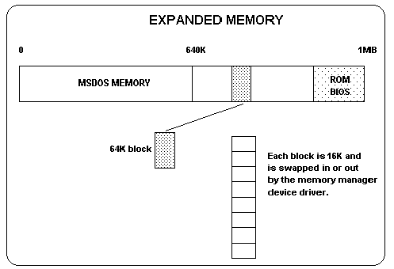 Fig. 4.2
4.3 Extended Memory

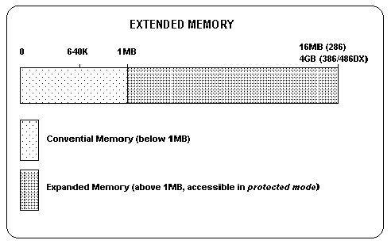 Fig. 4.3
When the 80-286/386/486 processor based machines were developed, it allowed these processes to gain access to larger RAM sizes. MS-DOS still required the 640K limit for DOS applications to force backwards compatibility with previous machines. For the 286 machine, the limit was 16 megabytes while the limit for the 80386/80486 was 4 gigabytes. Since the original 8086 processor was still limited to 1 megabyte of RAM, designers had to take a different approach to access the extra memory. Designing two processors inside a chip was the alternative to access the extra memory. The first processor was identical and performed the same as the original 8086 processor while the second processor had a wider range of functions and contained a larger memory capacity. Software is able to switch the chip into the new advanced mode if it is not the standard 8086 processor. See example 4.3. In real mode, these processors behave like an 8088 complete with the one megabyte address limit. Real mode allows PC users with 286 or 386 machines to run existing 8088 and DOS-based applications. In protected mode, however, these processors access memory beyond one megabyte and perform other advanced functions. As a result of the need to run 8088-based software, most of the world's 80386, 80486, and Pentium machines do not work at their full potential. Instead, they behave like faster versions of the original PC.
4.4 Upper Memory Blocks
Intelligent support chips were added to provide a sophisticated memory manipulation and management in the 80-286/386/486 computers, which is known as the AT Chip Set. When the AT computers came out, 1 megabyte of RAM was added on the motherboard for use by the processor. The AT chip provided 640K of memory in the lower one megabyte for the operating system, and the rest of the one megabyte as extended memory. As chips became larger and greater, more RAM was fitted into motherboards which made mapping complicated. Software was created to remap the unused memory space back into the memory between 640K and one megabyte. This space was used for the peripheral devices of the computer such as the network card and video card. This is called the Upper Memory Area. See Fig 4.4.
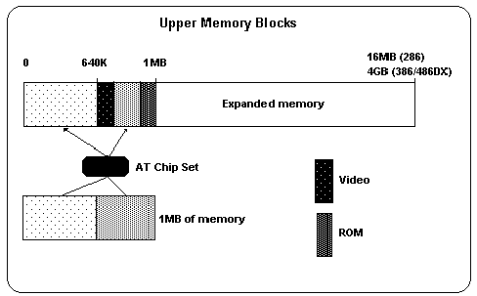 Fig. 4.4
4.5 The High Memory Area
The high memory area is found in the first 64K past the extended memory area. It is said that accessible in real mode and therefore could be accessed by MS-DOS. Its maximum size is 64K. People found this when Microsoft windows v3.0 was released they realized they had an extra 64K memory available for running application. This was a trick which exploited a design flaw in 286 or better processors.

5. Data Structures

5.1 Process Management Stacks and Vectors

Process management deals with the loading, execution, and termination of running programs. The processes are then loaded into a stack and executed one at a time. The operating system decides when to put things onto the stack. As said before, with TSR program, a number of vectors can be created on top of the stack to control process flow. The three most important functions that MS-DOS has to offer is program termination, terminate and stay resident, and execute program. Program termination is done with the function 4Ch. This is the normal termination procedure call used. It returns control back to the calling process, which is usually the OS. Terminate, but Stay Resident is done with the 3lh function call. These are usually referred to as the TSR programs. The execute program function is done with 40h. This is the most complex function and the most powerful. Functions can be loaded into memory and executed right away or can be loaded and executed in pieces, such as the overlay instructions (Hyde, 1996).

5.2 Memory Management and Linked Lists

MS-DOS uses a Single User scheme to handle memory management. The data structures associated with memory management are basically linked lists; where the head starts the file and the tail ends the file. A pointer has two parts, a data and a link part. The data is the actual data associated with that piece while the link is the part that shows where the next piece of data is. As you can see from the diagram below, memory is used linearly. The operating system is loaded into memory and new processes are allocated memory when needed. Because MS-DOS only operates in real mode, there was no memory protection. When a program was given memory space to work with, it had total control of all memory, including sections where the operating system was resident. A poorly written program could easily overwrite the operation system’s memory and lead to system crashes. Programs are given and released of memory with the ALLOC_MEMORY and FREE_ALLOCATED_MEM system calls (Newmarch, 1995)

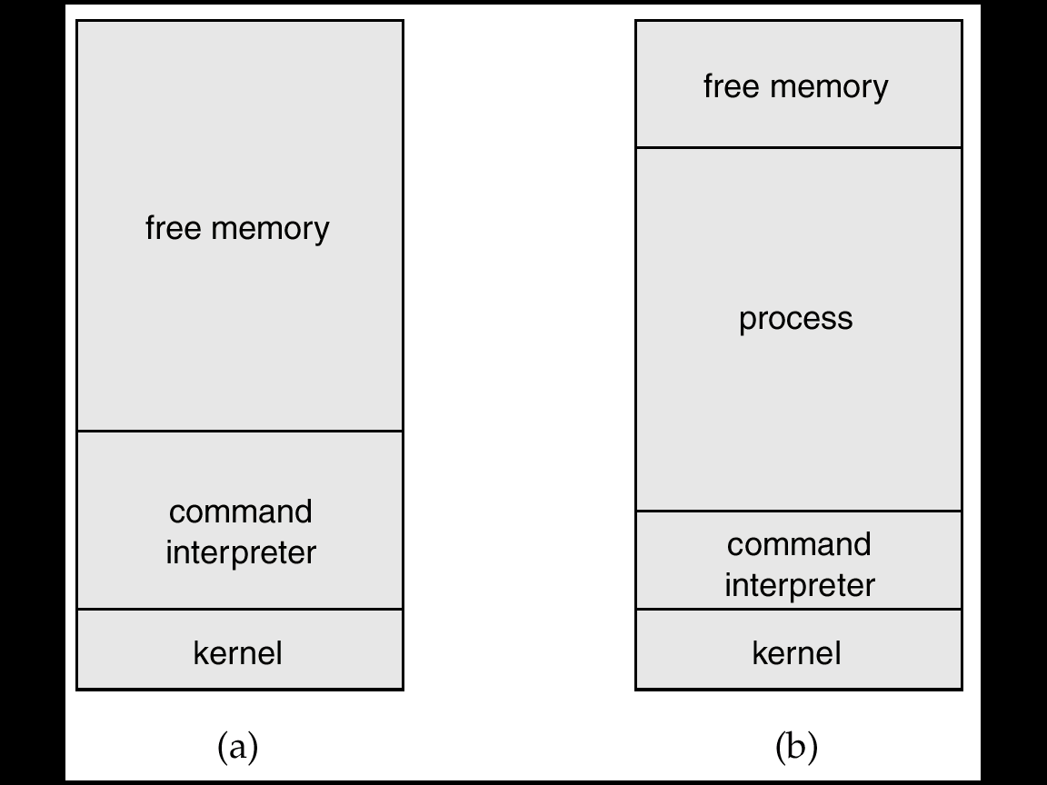

- Before the program is loaded into main memory

- After the program is loaded into main memory

If a program was too big to be loaded completely into memory, then certain pieces were loaded. The programmer had to know how to piece his program up and which parts were essential for starting. The main block of the program would always be resident while the other pieces would be loaded into memory later on. Certain parts would be loaded over other pieces in memory so that the program would have to constantly read and write to the memory. The individual pieces are known as overlays. MS-DOS commonly used overlay instructions (Newmarch, 1995).

5.3 File Management’s Data Structures

MS-DOS does not associate its files with a specific type. Group of commands can be put together to form batch files, which can be run to automate a group of commands. Compliers choose to open those batch files as text; and are written in all readable text (Stockton, 1996). There is nothing special about files in MS-DOS because they are all similar types of text files. Starting with MS-DOS2.0, file management became a lot easier. Some of the basic functions needed for file management are open, create, close, read, and write functions. Long file names were not supported in the earlier versions of MS-DOS but was that was fixed with the release of MS-DOS7.0 (Perkel, 1996). This is important because it allows the support of using absolute path file names.

Conclusion

We have come to understand that MS-DOS, though becoming one of the most popular operating systems, is definitely not one of the more technically superior. It did, however, fulfill the requirements of the time. MS-DOS was powerful enough to hold as the dominant operating system at the time until GUI’s were being developed. Since then, Windows NT and later have implemented virtual MS-DOS interfaces. Learning about MS-DOS provided some insight into the early era of modern operating systems. From our project, we have developed a better foundation of the operations and function of operating systems.
List of Acronyms Used

BIOS Basic Input/Output System
CP/M Control Process for Microcomputers
EMS Expanded Memory Specification
IBM International Business Machines
I/O Input/Output
LIM Lotus-Intel-Microsoft
MS-DOS Microsoft Disk Operating System
QDOS Quick and Dirty Operating System
RAM Random Access Memory
SMP Symmetric Multiprocessing
TSR Terminate and Stay Resident

References

Bellis, Mary (1996). “Inventors of the Modern Computer.” URL:
http://inventors.about.com/library/weekly/aa033099.htm

Brown, Brian (2000). “Learning MS-DOS, v4.0.” URL:
http://eserver.bell.ac.uk/mirrors/msdos/default.htm

Dew Associates (1998). “MS-DOS Memory Issues.” URL:
http://www.dewassoc.com/support/msdos/msdos_memory.htm

Hyde, Randall (1996). “The Art of Assembly Language Programming.” URL:
http://www.arl.wustl.edu/~lockwood/class/cs306/books/artofasm/toc.html

Microsoft (2003). “Overview of Memory-management Functionality in MS-DOS.” URL:
http://support.microsoft.com/kb/q95555/

Newmarch, Jan (1995). “Memory Management.” URL:
http://jan.netcomp.monash.edu.au/OS/l7_1.html

Perkel, Marc (1996) “MsDos 7.0 from Windows 95/98.” URL:
http://www.ctyme.com/msdos7.htm

Stockton, J (1996) “MS-DOS Batch Introduction Page.” URL:
http://www.merlyn.demon.co.uk/batintro.htm#DOS

Wikipedia (2005) “MS-DOS.” URL: http://en.wikipedia.org/wiki/MSDOS

