CS-550-1: Operating Systems
Fall 2005
PC-DOS/MS-DOS
By
James P. Sherrill

This work is JMU Compliant
Index
Introduction 3
Overview 3
Processor modes 7
Memory management 9
File management 10
Conclusion 10
Bibliography 12
Acronyms 13

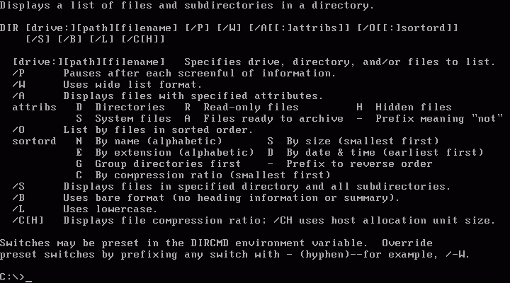
Image provided by Wikipedia at URL: http://en.wikipedia.org/wiki/DOS

Introduction:
Disk operating system (DOS) is an operating system (OS) recognized by many of the older generation of computer owners. Released in 1981, its uses/fame grew and it was implemented into most personal computers, becoming the background supporting Windows up to 2000 with Windows ME. This paper will discuss various aspects of DOS from its design in 1980 to its decline and eventual fall. Changes and improvements to DOS will be discussed in relation to the environment in which it was expected to work. Processor modes, privileged instructions, symmetric multiprocessing (SMP) and master/slave concepts will be discussed in reference to DOS. Finally, memory management and file management in DOS will also be discussed.

Overview:
In what environment did this operating system designed to work? Did it advance the state-of-the-art? Was it commercially and economically successful? Was it technically successful? What was done correctly and what was done poorly?
The original disk operating system, then called quick and dirty operating system (Q-DOS), was written by Tim Paterson when he worked for Seattle Computer Products (SCP). (Watt, p. 48) It took Paterson two months to create Q-DOS. (Watt, p. 48) Q-DOS was a clone of the Control Process/Monitor operating system for the 8086 processor (CP/M-86). (Viet, p. 629) However, Q-DOS was a work in progress, not a finished product. Patterson thought he would have time later in order to include multitasking. (Watt, p. 48) Although, in 1980 Paterson thought that 64 kilobytes (KB) of memory was enough for Q-DOS. (Watt, p. 48)
When Industrial Business Machine (IBM) was looking for an operating system for their personal computer (PC), they went to Digital Research Incorporated (DRI) for their CP/M-86, which IBM was unable to successfully acquire. (Watt, p. 48) Afterwards, Microsoft purchased Q-DOS from SCP and licensed it to IBM. This allowed IBM to have an operating system for its launch of the PC. (Wikipedia, MS-DOS)
The main two versions for this operating system for the PC were personal computer DOS (PC-DOS), made by IBM, and Microsoft DOS (MS-DOS). PC-DOS was a validated and packaged version of MS-DOS at least until version 5. Not much information was acquired after version 5, so no claim on the correlation between the two will be made. While PC-DOS came with PCs, MS-DOS was available on IBM compatible machines. The exception to this is when version 4 was released and Microsoft validated and packaged the IBM version. DOS is often used when there is virtually no difference between MS-DOS and PC-DOS. (Viet, p. 630) While there were other possible operating systems that were supported for the PC (e.g. CP/M-86), PC-DOS became the default operating system. (Viet, p. 629)
PC-DOS began as a 16-bit OS that ran on an 8-bit bus. (Viet, p. 630) PC-DOS did support 5.25 inch floppy drives, but it did not natively support hard drives. (Viet, p. 630) Having a maximum capacity of 640KB of Random Access Memory (RAM), version 2.0 of DOS supported hard drives as well as an increased capacity in the floppy drives. (Viet, p. 630)
By version 3.3, DOS could be used on a 286 Intel Central Processing Unit (CPU). This CPU allowed DOS to natively access a maximum capacity of 1MB of RAM. (Viet, p. 630) Memory manager was also included which transferred the operating system and other programs into upper memory. (Viet, p. 630) 5.25 inch floppies were now able to hold 1.2 megabytes (MB). 3.5 inch floppy drives as well as network support were now natively available. (Viet, p. 630)
Version 4.01 of DOS was released in 1988. Hard drive partitions were increased to 512MB. (Nesbitt, p. 83) It allowed hard disk files to exceed 32MB as well as well as incorporated a graphical user interface (GUI) shell. However, it was “flagged as a virus by some security software programs at the time.” (Watt, p. 49)

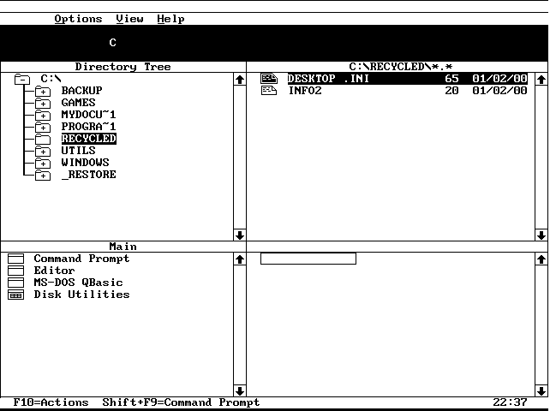
Picture provided by http://www.mvps.org/serenitymacros/images/dosshell.png

The fifth version of DOS was released for the 486 Intel CPU. It could work for the 386 and the 286 CPUs as well. The kernel for version 5.0 was roughly 5KB less than 4.01. (Nesbitt, p. 83) Partitions were able to be as large as 2GB and users were able to have “more than two hard drives and more than two floppy drives.” (Nesbitt, p. 83)
Task switching capabilities were included in version 5. (Nesbitt, p. 84) Task switching is important because it allows a task to be interrupted, set that task aside and start a new task. After the second task is finished, the first task, if desired, can be resumed.
Even though DOS was no longer the main focus for either Microsoft or IBM, there were still tens of thousands of users operating DOS. (Viet, p. 631) Neither OS/2 nor Windows forced a user away from DOS. Windows was a program that was executed from DOS. OS/2 allowed for duel booting with DOS.
Even after its decline from mainstream use, there were more releases of this operating system. MS-DOS 6 was the last full version to be shipped as a stand-alone version. MS-DOS 7 was embedded in Windows 9x. MS-DOS 8 was embedded into Windows ME. Similarly, there were PC-DOS 6 and a year 2000 compliant (Y2K) version called PC-DOS 2000. However, not much information was attained concerning these versions.
Although it was the dominant operating system of the 1980’s, DOS was never a state of the art operating system. It was written in two months as a clone of CP/M-86. It did not have multitasking support natively. While there might have been attempts to incorporate multitasking or multi-user ability into the OS, it was not apart of the official package.
Though not state of the art, DOS was technically successful because it did what it was designed to do. It helped IBM launch their PC platform. Its economical success provided a foundation for Microsoft to launch Windows. For all the success of DOS, it was a basic OS. It did not incorporate many concepts into its architecture because it did not need to. DOS did not support hard drives at first. I did not support more than one user. At first, the user had to be a superuser because there was no alternative. DOS support for features and concepts were added after there was a decided need for it. Expanding the memory is a good example of this. Memory was expanded after there was a need.

Processor modes:
What were the Processor modes and privileged instructions for DOS? Was it a uniprocessor or multiprocessor? Did DOS incorporate symmetric multiprocessing or master/slave?
DOS did have a protected mode by version 3. It also had a virtual mode at this time which could simulate an 8086 environment on a 386 CPU. Theoretically, this could be used to make a multi-user environment by having the super-user utilizing the unprotected mode and having a user utilize the protected mode. However, the 8086 CPU did not support these types of options. While there is a possibility this could have been resolved, Microsoft was developing Windows. Windows initially was an application that ran on top of DOS as a GUI. Windows expanded and eventually replaced DOS as the major OS.
Symmetric multiprocessing is an architecture where there are multiple, identical, processors in a system that shares the same memory. While it may have been possible for DOS to support SMP, there was no evidence to support any such claim. Each version of DOS was released with a single processor in mind to maximize its potential. However, DOS did support master/slave. Master/slave is simply a communication protocol. It helps with collisions between two devices by saying if device A is the master, and device B is the slave, then if both A and B are trying to communicate with the system at the same time, A will override B in priority.
Master/slave was used, but SMP was not. This brings up another question of how did DOS deal with memory management? For DOS, memory management was a simple process. There were constant efforts to increase its capacity due to programs exceeding the memory that what was available. The original name for DOS (Q-DOS) was appropriate because it was a quick and dirty OS.

Memory:

Overview of
System Memory
for DOS 5
Extended Memory
Area
Extended Memory  Area |  | 1088KB
High Memory
Area
High Memory  Area |  | 1024KB
Upper Memory
Area
Upper Memory  Area |  | 640KB
Base Memory
Area
Base Memory  Area |  | 0KB
As seen in Compaq, p. 5-2

The Upper Memory Area is used for system Read Only Memory (ROM), system hardware, video controllers as well as any Network Interface Controllers (NICs). The High Memory Area can be used to free up base memory for other programs by loading portions of DOS into it. To access anything beyond the High Memory Area, the system would have to go into protected or virtual mode. (Compaq, p. 5-3)

File management:
Acessing files leads to the final question. How was file management dealt with in DOS? Until Windows or OS/2 was used by people, file management was done on the PC in the console. People had to remember where they were in a system as well as where the file they wanted was located. Moving in the directory, though repetitive, was an easy process. However, the GUI provided by Windows or OS/2 made those systems popular. Instead of typing commands into a console, the GUI translated the user’s actions and mouse-clicks into commands. The use of icons in Windows and OS/2 were a big improvement over the DOS Shell.
A defragmenting utility was not a standard feature on the early DOS systems. The greater the number of fragmented files on a hard drive, the decrease in performance a system experiences while accessing that hard drive. What occurs when the system access a fragmented file is it will go to the block where the file begins on the hard drive, then read the file to the point where it fragments. There should be an indicator at this point where the next part of the file is located on the hard drive, and the reader will then search for that part. This will be continued until the entire file is read. However, if there was a defragmenting utility, as was eventually added to DOS, the file would be able to be read from the beginning till the end without having to wait for any length of time while the reader tried to find the rest of the file.

Conclusion:
Disk operating system was not a big project. It was not created using any design principles that are taught increase the probability of producing quality work as discussed in Secured Software Engineering. Even though it was created in two months, DOS contributed to computer science. From its inception as a basic operating system that was a work in progress, DOS grew to have hard drive partitions and more memory. IBM needed an OS for its launch of the PC and DOS was chosen. Although DOS was not state of the art, it was commercially and economically successful because it did what it was supposed to do.

Bibliography:
Compaq Computer Corporation (1992). MS-DOS Version 5: Reference Guide. USA: Compaq Computer Corporation.
Duncan, Ray (1991). Everything DOS should have been: DOS 5.0 loads in high memory, undeletes files, has on-line help and task swapping. PC Magazine, v10.n13, 35-39.
Eastwood, Alison. Microsoft's latest entry marks decade of DOS. Computing Canada, v17.n13, 1-3.
Glass, Brett (1991). MS-DOS 5: reigning OS improves its value. InfoWorld, v13.n27, 61-64.
Eiser, Leslie (1991). The story of Windows 3.0. (Microsoft's 'graphical interface'). Leslie Eiser. Technology & Learning, v11.n6, 14-17.
Nesbitt, Kenn (1991). What DOS 5.0 offers you! Data Based Advisor v9.n7, 82-84.
PC Magazine (1998). The History of Windows. (Microsoft's GUI/operating system from DOS to Windows 98). PC Magazine, v17.n14, 105-115.
Rizzo, Tony (1987). A foundation for the next generation: Microsoft Operating System-2. Microsoft Systems, Journal v2.n2, 1-13.
Watt, Peggy (1991). PC-DOS, also 10, has its own storied past. InfoWorld, v13.n32, 48-49.
Wikipedia (2005). “MS-DOS.” URL: http://en.wikipedia.org/wiki/MS-DOS
Wikipedia (2005). “PC-DOS.” URL: http://en.wikipedia.org/wiki/PC-DOS
Wikipedia (2005). “DOS.” URL: http://en.wikipedia.org/wiki/DOS
Wilton, Richard (1989). DOS marches on. (version 4.0 has menu-driven interface and large disk partitions). PC Tech Journal, v7.n1, 98-108.
Veit, Stan (1995). What ever happened to...DOS? Computer Shopper, v15.n12, 628-630.
Acronyms:
CP/M-86: Control Process/Monitor for the 8086
CPU: Central Processing Unit
DOS: Disk Operating System
DRI: Digital Research Incorporated
IBM: International Business Machine
GB: GigaByte(s)
GUI: Graphical User Interface
KB: KiloByte(s)
MB: MegaByte(s)
MS-DOS: Microsoft DOS
NIC: Network Interface Controller
OS: Operating System
PC: Personal Computer
PC-DOS: Personal Computer DOS
RAM: Random Access Memory
ROM: Read Only Memory
Q-DOS: Quick and Dirty Operating System
SCP: Seattle Computer Products
SMP: Symmetric Multiprocessing

