The VMS Operating System
History and Technical Specifics

CS 450 (585)
Section 1
Fall 2002

Keith Gittings
Table of Contents
Section 1—History 2
1.1 “One Platform, one operating system, one network.” 2
1.2 Star and Starlet 2
1.3 What’s in a name? (OpenVMS vs. VMS) 2
1.4 Programming Language 3
1.5 VAX-11 and PDP-11 3
Section 2—Components of the VMS Layers 4
2.1 Layered Approach 4
2.2 VMS Kernel 4
2.3 I/O subsystem 4
2.4 System Services 4
2.5 The Record Management Services 5
2.6 Command Line Interpreter 5
Section 3—VMS Processes 6
3.1 Process Control Block 6
3.2 Process Quota Block 6
3.3 Process Scheduling 6
3.4 Round-Robin Scheduling 6
3.5 Priority-Scheduling and Real-Time Capabilities 6
3.6 Process Deletion 7
Section 4—Memory Management 7
4.1 Virtual Memory Allocation 7
4.2 The Pager 7
4.3 Pager Storage 8
4.4 The Swapper 8
4.5 Memory Allocation Unit 8
Section 5—Device Management 9
5.1 Driver Types 9
5.2 Device Drivers 9
5.3 Device Allocation and Assignment 9
5.4 Disk Block 9
Section 6—More Feature of VMS 9
6.1 VMS Lock Manager (Deadlock Handling) 9
6.2 Threads 10
6.3 Symmetric Multi-Processing 10
6.4 DECnet 10
6.5 Clustering 11
6.6 Hardware Platforms 11
Section 7—Windows NT and VMS 11
7.1 History 11
7.2 Similarities 11
7.3 Differences 12
7.4 Digital Responds 12
Section 8—Conclusion 12
Abstract
This paper will discuss the history and architecture of the VMS operating system from its inception in 1978 with the VAX architecture to its modern resurrection for the Alpha and Itanium systems. Furthermore, this paper will provide an overview of VMS and its associated technologies.

Section 1—History
The history of the Virtual Address extension (VAX) Virtual Memory System (VMS) Operating System spans nearly three decades. Developed by Digital Equipment Corporation, it was publicly released in 1978. The VMS operating system was developed in coordination with the release of the VAX computer. The VAX was to replace the aging 16-bit PDP-11 and marked the first 32-bit computer for Digital Equipment Corporation. VMS and VAX were developed together with coordination between the hardware and software engineers. This coordination produced a tightly integrated system that strove to maximize reliability, flexibility, scalability, and data integrity.

1.1 “One Platform, one operating system, one network”
The VMS operating system was designed to be a single operating system in reaction to the multiple operating systems that existed on the PDP-11. These operating systems included:

- RT-11. Used for real-time and laboratory work
- RSTS-11. Used for educational and small commercial time-sharing
- RSX-11. Used for industrial and manufacturing control
- MUMPS-11. Used in the medical system market
- DOS-11. The original PDP-11 operating system; essentially eclipsed by VMS.

VMS was to be the workhorse for all applications that were to run on the VAX. This attempt to have all applications, regardless of industry, run on a single operating system lead Digital Equipment Corporation to adopt the slogan “One Platform, one operating system, one network.” The “one network” was DECnet, which was shipped with the first VAX VMS systems. DECnet provided peer-to-peer networking and allowed for distributed computing among various VAX and other vendor systems. The VMS operating system also included a compatibility mode with the PDP-11 in order to appeal to the already established Digital computer base. The first VAX VMS system was installed at Carnegie Mellon University in 1978.

1.2 Star and Starlet
VAX-11/780 was code-named “Star” during its development and the operating system was named “Starlet”. This nomenclature remains today with the naming of library files for the VMS operating system (STARLET.OLB, etc.).

1.3 What’s in a name? (OpenVMS vs. VMS)
VMS and OpenVMS are two names for the same operating system. The VMS operating system was originally referred to as the VAX-11/VMS. Later, it was renamed VAX/VMS V2.0. More recently, when the operating system was ported to the Alpha platform (Digital’s 64 bit system), it was renamed OpenVMS for both the VAX and Alpha systems. The preferred names are “OpenVMS VAX” and “OpenVMS Alpha.” It will be known as OpenVMS for Pentiums 64-bit Itanium Processor when VMS is finally ported to the Itaniums.

According to Digital (now Compaq) the “Open” was added “in part to signify the high degree of support for industry standards such as POSIX, which provides many features of UNIX systems” (Compaq, 2001). POSIX (Portable Operating System Interface for UNIX) is a set of standards that enables easy porting of software to POSIX-compliant operating systems. OpenVMS’ license allows the user to run POSIX at no additional charge.

1.4 Programming Language
VMS was written in a variety of different languages. Figure 1-1 provides a sample of the various languages used to write VMS.

Programming Languages Used to Write VMS
Bliss | Macro | Ada
PLI | VAX and DEC C | Fortran
UIL | VAX | Alpha SDL
Pascal | 1 | MDL
DEC C | C++ | DCL
Message | Message
Figure 1-1. VMS Languages

Rumor has it that so many languages were used to prevent the Run-Time library from being unbundled; however, Digital denies this rumor.

1.5 VAX-11 and PDP-11
The original VAX system was often referred to as VAX-11. In this way, it associated with its predecessor, the PDP-11. The VAX-11 system and PDP-11 system shared many design elements and capabilities, such as byte addressing, similar I/O and interrupt structures, and identical data formats. They shared similar instruction sets and PDP-11 programs that did not need the extended features of the VAX could run in a compatibility mode. VAX, however, did offer many improvements over the PDP-11, which included extended virtual address space, providing additional instructions and data types, and adding new addressing modes. VAX also provided for a sophisticated memory management and protection mechanism and the new hardware assisted process scheduling and synchronization. The original manual for the VAX, published in 1982, lists the five specific goals of the VAX system:

- Maximal Compatibility with the PDP-11. Consistent with a significant extension of the virtual address space, this compatibility was a significant functional enhancement.
- High Bit Efficiency. Using a wide range of data types and new addressing modes, VAX-11 prevented program transfers from PDP-11 from growing significantly in size. Additionally, programs redesigned to exploit VAX-11 should get smaller, despite the extended virtual address space.
- A Systematic, Elegant Instruction Set. The orthogonally of operators, data types, and addressing modes enabled easy exploitation of the instruction set, particularly by high-level language processors.
- Extensibility. The instruction set is designed so that new data types and operators can be included efficiently and consistent with the currently defined operators and data types.
- Range. The architecture should be suitable throughout the entire range of PDP-11 computer system implementations currently sold by Digital Equipment Corporation.
VAX VMS proved an excellent operating system whose influence persists twenty-five years later.

Section 2—Components of the VMS Layers
2.1 Layered Approach
Like many, or perhaps most, modern operating systems, VMS was designed through a layered approach. Figure 2-1 illustrates the layering structure used by the VMS operating system

.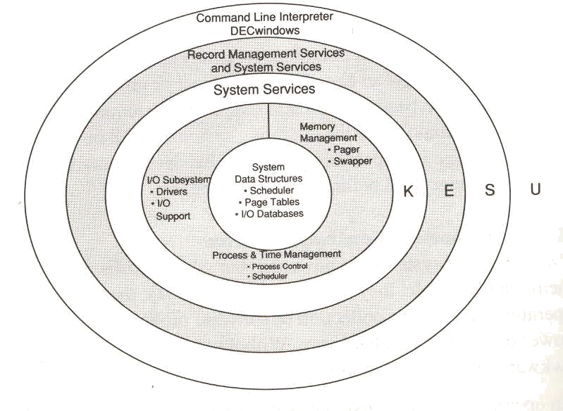
Figure 2-1. VMS Operating System Was Designed Using a Layered Approach (Bynon, 1990)

2.2 VMS Kernel
The Kernel of the VMS consists of three components: input/output (I/O) subsystem; the job scheduler; and memory management. These three components provide a majority of the resource-oriented tasks of the operating system.

2.3 I/O subsystem
The I/O subsystem of the VMS kernel provides a collection of device drivers (low-level, hardware-specific programs) and several key system services. These system services handle responsibilities such as servicing device interrupts and logging device time-outs and errors. One key system service is $QIO, which is responsible for reading and writing physical devices on behalf of software requests. This system service is used by all the outer layers to access the device drivers.

2.4 System Services
The next layer in a VMS system is the System Services layer. This layer consists of procedures that the operating system uses to perform basic functions, such as coordination of I/O, resource allocation, and inter-process communication. The majority of System Services are called on behalf of running process, however they may also be called for general programming use.

2.5 The Record Management Services
VMS provides a set of generalized procedures for general data management services, known as record management services (RMS). RMS provides for creating, deleting, writing, and reading files. There are two distinct levels of RMS. The first level is the RMS routine itself; the second is the ancillary control processes (ACPs). ACPs are separate processes on the system that perform mass storage transactions. The ACPs are used to prevent conflict among processes. RMS is able to support a wide variety of file structures—the preferred type is ODS-2.

2.6 Command Line Interpreter
The outermost layer of the VMS architecture is the command line interpreter. This layer serves as an interface between the user and the operating system. There are many command line interpreters available for the VMS system. In addition, a graphical user interface (GUI) also is available for the VMS operating system, known as DECwindows. DEC is an acronym for Digital Equipment Corporation. Figure 2-2 provides a screenshot of the OpenVMS GUI, which is based on the original DECwindows:

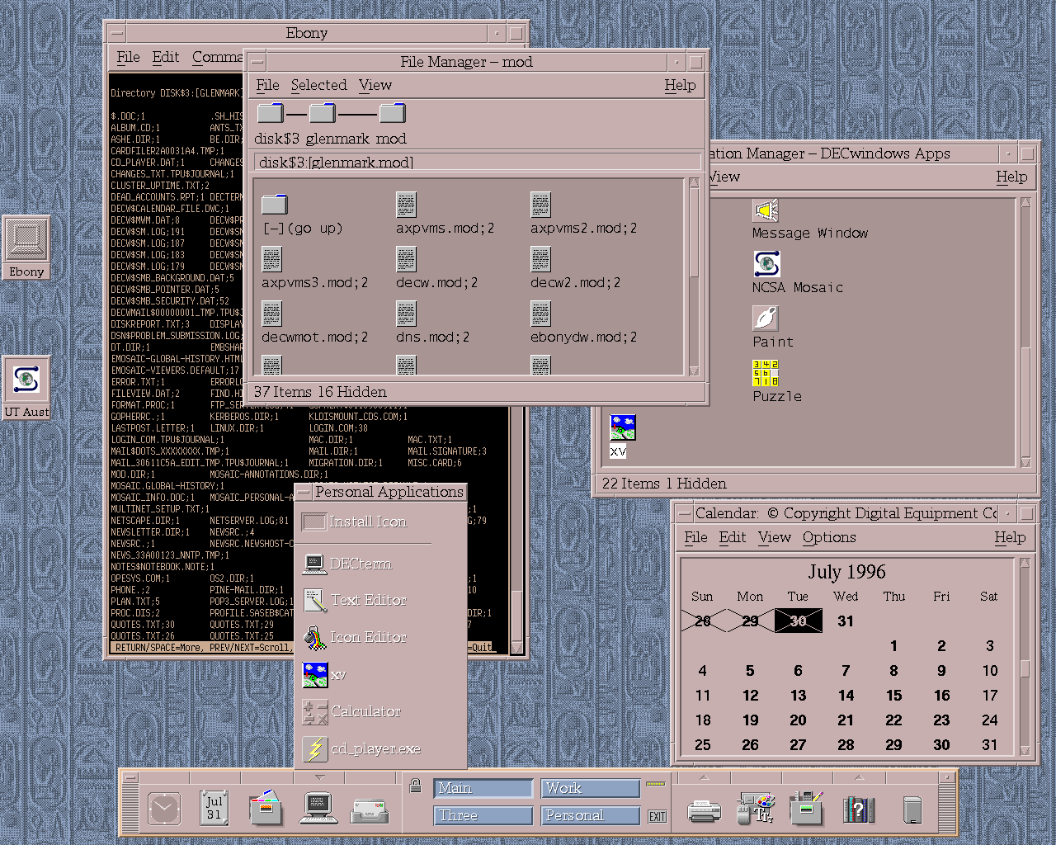
Figure 2-2. The OpenVMS GUI Is Based on the Original Decwindows

Section 3—VMS Processes
3.1 Process Control Block
Each process in the VMS operating system is assigned a process control block (PCB) at the time of its creation. The process keeps its PCB until the process has ended or been removed. Then the PCB is reallocated to the memory pool. The PCB specifies the scheduling state (see Section 3.3), the process priority (see Section 3.5), privileges, user identification code (UIC), username, and process ID.

VMS performs Data Protection to prevent potentially dangerous instructions from being executed. VMS accomplishes this task by assigning a privilege to every process. VMS currently has 35 privilege states, divided into seven general categories.

The UIC identifies a process in terms of access to system objects, such as files and devices. The PID identifies the active process on the system.

VMS supports a null PCB for a null process. The null PCB is used as a placeholder so that every system pointer points to a valid PCB, even if no process is associated with it. VMS also has cascading termination. In this way, if a parent process terminates, all its children also will be terminated.
3.2 Process Quota Block
VMS Quotas are used by VMS to control allocation of system resources such as CPU, memory, and Input/Output. These quotas protect against having too many programs trying to access the CPU at the same time and eliminates the possibility of a process having unlimited memory allocated to it. System services define the quotas in the PQB at process creation time.

3.3 Process Scheduling
Once the PQB and PCB are loaded for a process, the process is then placed into the scheduler database. Process, or job, scheduling is the busiest component of the VMS kernel. The Process Scheduler is responsible for selecting processes for execution by continuously checking process state, priority, and time quantum.

3.4 Round-Robin Scheduling
The process scheduler utilizes a round-robin scheduling algorithm based on a time quantum. This time quantum can be set in increments of 10-milliseconds. When a new process is scheduled, the time quantum value is placed into the process header. Every 10 milliseconds this value is decremented by the VMS clock interrupt service routine. When the time quantum value is zero, a quantum end is signaled and a new process is then scheduled.

3.5 Priority-Scheduling and Real-Time Capabilities
VMS also allows for priority-scheduling, which directly correlates to its scheduling. Processes are scheduled according to their software priority, which ranges in value from 0 to 31, with 31 designated as the highest priority. Processes designated 0 to 15 are considered time-share (normal) processes while processes designated 16-31 are considered real-time processes.

Time-Sharing processes are given a base priority of four, which allows the time-sharing process to work in a round-robin fashion. In this manner, a process maintains control of the CPU until it is pre-empted by a higher priority process. It then enters a wait state or its time quantum expires. In addition, a time-sharing process may have their priority boosted, to assist it, if it has been waiting for a resource. A process can be boosted a maximum of six priority levels. Usually, I/O-bound processes tend to be boosted while CPU-bound process generally operate near their base.

Real-Time processes differ from time-sharing processes. Real-time processes do not get boosted. Real-Time processes operate as they would in a normal real-time system. This means that a real-time process is only pre-empted when a process with higher priority arrives, or the process enters a wait state. Real-time processes are not scheduled using round-robin scheduling and therefore no regard is given to time quantum.

3.6 Process Deletion
VMS allows processes to delete themselves once they have performed their appointed tasks. Processes also can be instructed to delete themselves by other processes if those processes have appropriate privileges. First, the process is marked for deletion and a kernel mode asynchronous system trap (AST) is queued to the appropriate process. The process is then called to delete itself regardless of the process that called for the deletion.

Section 4—Memory Management
Memory Management is the most complicated component of the VMS kernel. It is comprised of a swapper and page fault handler. The main responsibilities of the memory manager consists of the following:

- Distributing physical memory among parts
- Translating virtual addresses to physical addresses
- Permitting selective sharing among processes
- Protecting memory.

4.1 Virtual Memory Allocation
One of the greatest achievements of the VAX VMS system is it ability to work with Virtual memory. Virtual memory is the ability of a system to address more memory than the system has physically. VMS assigns as much memory as a process could possibly need and then indexes that memory into pages. When a page is needed it will be loaded into physical memory. When more memory is needed, pages will be swapped in and out of memory. VMS uses a system known as demand-page memory management.

4.2 The Pager
The Pager, also known as the page fault handler, is an exception service routine that handles page faults and is responsible for bringing virtual pages into physical memory when they are required by a process. When a process demands a memory page that is not loaded into memory, a page fault is generated. The page fault is handled by the pager, which takes on the responsibility of loading the page into memory and then updating the page table accordingly.

4.3 Pager Storage
When a process is being executed, the program’s pages are stored in pager storage. This pager storage is a combination of main memory, referred to as file cache and secondary storage, referred to as page file. Additionally, the pager maintains a page map that maintains the location of the page in pager storage. The file cache is a small portion of memory that is used to maintain pages most recently paged out. The file cache helps improve performance by making available recently used pages that are frequently called again. A call to the file cache is referred to as a soft-page fault, while a call to the page file is referred to as a hard-page fault. When main memory becomes completely filled or has reached its process quota, it becomes necessary to write the page back to the page file before a new page can be loaded.

4.4 The Swapper
The swapper is a separate process in the operating system that is responsible for swapping in process. The swapper differs from the pager, which is responsible for moving pages in and out of memory, in that it is responsible for moving entire processes in and out of memory. The swapper works with the same criteria as the scheduler. This means that the swapper checks the priority of the processes and gives preference to those with higher priorities. These differences are highlighted below in Figure 4-1.

Swapper | Pager
Perform Conventional I/O | Perform Conventional I/O
Maximum read/write in a single I/O operation | Maximum read/write in a single I/O operation
Supports programs with potentially large address spaces | Supports a large number of concurrent processes with limited physical memory
Works on Pages | Works on Processes
Process-wide function that moves pages in and out of memory | System-wide process that moves process in and out of memory
Exception Service Routine | Separate Process
Activated by page fault interrupt | Hibernates until called for swapper activity
Figure 4-1. While the Pager Moves Pages in and out of Memory,
the Swapper Moves Entire Processes

4.5 Memory Allocation Unit
The minimum unit of memory allocation, the memory page for VMS VAX, is 512 bytes. 512 bytes also matches the minimum disk block size: 512 bytes. OpenVMS Alpha, however, has a variable memory page size, which can range in size from 8192 bytes (8 kilobytes) to 64 kilobytes. For compatibility , a 512-byte area of memory under OpenVMS Alpha (equivalent in size to an OpenVMS VAX memory page) is referred to as a “pagelet”. Because of the variable nature of OpenVMS Alpha, programs with hard-coded constants for the memory page size should always assume a page size of 64 kilobytes.
Section 5—Device Management
5.1 Driver Types
A VAX system comprises many I/O devices, such as disk drives, tape drives, and terminals. VMS is responsible for assigning who, when, and for how long a process should receive a device. The management system establishes policy, keeps track of the devices, and maintains device drivers. VMS manages devices as three distinct types:

- Dedicated devices allocate a device to a process until the process releases or terminates it. These are the most common devices because items like printers, monitors, and tape drives do not work well when used by several processes.
- Virtual devices extend the limitations of dedicated drivers by allowing multiple processes to virtually use the device. An example of this is when a printer enables simultaneous use by spooling print jobs. Spooling allows virtual devices to buffer I/O requests until the device is disengaged and can be used.
- Shared devices are used to enable concurrent multi-processes. Shared drivers are more complicated than dedicated drivers and are used for devices such as disk drives. Shared devices are able to be used by multiple processes simultaneously.

5.2 Device Drivers
Device drivers allow low-level hardware control and allow the devices to appear uniform to the rest of the system. Additionally, device drivers provide tables that interact between the I/O system and drivers to assist in presenting a standard interface. Device drivers are developed in two layers: a communication layer, known as a class driver; and a device layer, known as a port driver. The class driver implements specific VMS protocol while the port manager implements device-specific properties.

5.3 Device Allocation and Assignment
VMS uses device channels to identify and assign devices. Each device is given a specific channel. Once the device is assigned a channel, it is then allocated to a process that maintains control of that device until it is unallocated. Shared devices utilize ACPs. When a process is finished using a device, the I/O channel is unassigned. If the process is deleted, the channels are closed.

5.4 Disk Block
A disk block is the minimum unit of disk storage allocation in OpenVMS. Under OpenVMS VAX and OpenVMS Alpha, the disk volume block size, unlike memory page size, is consistent with each block, containing 512 bytes.

Section 6—More Features of VMS
6.1 VMS Lock Manager (Deadlock Handling)
VMS handles deadlock states by starting a timer whenever a process block is waiting for a resource. If the request is still blocked 10 seconds later (or some period of time) VMS will then start a deadlock detection algorithm. This is part of the VMS lock manager, which can be described in three steps:

- Deadlock suspicion. A process becomes “suspicious” when a requested lock does not resolve in a given period of time.
- Deadlock detection. “Suspicious” processes are searched by the lock manager and determined to be deadlocked. A deadlock can only be detected after it has been classified as ”suspicious.“
- Choose a “Victim.” Once a deadlock is detected, the lock manager arbitrarily chooses a process to send the error status—SS$_DEADLOCK. It is then the responsibility of the “victim” process to resolve the deadlock.

6.2 Threads
VMS offers threading ability using DECthreads. This allows for user- and kernel-level threading. VMS offered kernel-level threading in 1995 in response to windows NT, [which already provide for kernel-level threads], and therefore kernel-level threading on the Alpha systems was introduced in version 7.0. DECthreads provides an IEEE POSIX 1003.1c-1995 standard (or pthread) interface and allows for production of multiple threads within one process. These threads execute within a single address space; therefore, a process's threads can read and write the same memory locations. Since the threads access the same memory locations, the program must use synchronization objects, such as mutexes and condition variables, to ensure that the shared memory is accessed correctly. DECthreads allows for the use of these synchronization objects. In addition, the VMS allows for multiprocessing with different threads executing on different processors.

6.3 Symmetric Multi-Processing
VMS supports the ability of multiple threads that can be run on multiple processors. One way that VMS accomplishes this task is through the use of a data structure known as per-CPU databases. The per-CPU databases record and manage processor-specific information and assign each CPU a number between 0 and 31. A particular bit is set indicating that a CPU is either idle or occupied. When that bit is cleared it signals that the CPU is free and should repeat its attempt to select a process to execute.

6.4 DECnet
DECnet was available with VAX and VMS V1.0 and was an affordable method to enable networks. It was designed onward from V1.0 in five distinct phases, as shown in Figure 6-1.

DECnet provided for peer-to-peer networking, which differed from other networks that only provided for terminal-to-host connections and was a major step towards the client/server computing model. DECnet linked DIGITAL and other vendor systems in a flexible modular network. By the fourth version of DECnet, Ethernet capabilities provided the ability to extend the network into a full local area network. In addition, Digital, Intel, and Xerox set Ethernet as the standard for local area networks. Eventually, by the fifth release of DECnet, TCP/IP and OSI were incorporated into the DECnet standard.

Phase I | Supported point-to-point (directly wired connections) and task-to-task (customer applications could be coded to talk to each other over the networking protocols).
Phase II | Added remote file access and general task access (i.e., an application could invoke general command procedures on a remote system). This version of DECnet was supported by VMS V1.0; thus VMS had remote file access built into the base file system from day one.
Phase III | Added routing, which eliminated the need for a directly wired connection between two systems to allow them to interact via DECnet. Rather, network traffic could be forwarded between two systems by one or more intervening routing nodes. It also provided SET HOST.
Phase IV | Added Ethernet support. Ethernet eliminated the requirement for point-to-point wiring, allowing many systems to be connected to a single wire in a local area network. Phase IV also provided a larger address and the concept of areas (analogous to telephone area codes), thus allowing a network to grow to as large as 65,000 nodes.
Phase V | Incorporated OSI standard to networking into DECnet. This supported unlimited address space/nodes when using OSI addressing. It could support 100,000 nodes if using large local files.
Figure 6-1. VAX VMS DECnet Was
Developed in Five Phases
6.5 Clustering
One of the important aspects of VMS is its Clustering ability. VMS was one of the first operating systems to allow clustering and is capable of supporting up to 96 different systems. These systems are not required to be VMS and the clustering allows multiple computers to behave in such a manner that they behave as a single computer.

The VMS clustering is known as VAXcluster, or VMScluster. Clusters share multiple systems to share processing, job queues, print queues, and disk storage, either over a special computer interconnect (CI) bus or over Ethernet (called a LAVC, for local area network VMS cluster).

6.6 Hardware Platforms
VMS is available for the VAX and Alpha Platforms manufactured by Compaq. Currently, work on porting VMS to the Intel’s Itanium processor is underway. VMS was never officially ported to work on the Pentium-class processors.

Section 7 - Windows Nt and VMS
7.1 History
In April of 1993, Microsoft released an operating system it dubbed Windows NT (new technology). However, the controversy of how much of this “New Technology” was new and how much of it was “borrowed” from VMS arose.

The controversy stems from the hiring of David Cutler, one of the chief architects of the VMS operating system. David Cutler had originally threatened to leave Digital in 1981. In order to retain Cutler, Digital gave Cutler about 200 hardware and software engineers and allowed him to work on a new hardware project known as Prism with an operating system known as Mica. In 1988, Digital canceled this project and Cutler and about 20 of his top engineers left for Bill Gates and Microsoft. Some critics contend that Cutler left with more than engineers, the source code for Mica.

In August 1988, Cutler began working on a new operating system called Windows NT. David Cutler has acknowledged that the acronym WNT was a pun on VMS (obtained by shifting each letter one position in alphabetical order, as the name of the villainous computer HAL in the film 2001: A Space Odyssey is popularly believed to have been derived from IBM).

7.2 Similarities
Regardless of Microsoft’s desire to present NT as a completely original operating system enough similarities exist to conclude the case. Some say that “those similarities could fill a book. In fact, you can read sections of VAX/VMS Internals and Data Structures (Digital Press) as an accurate description of NT internals simply by translating VMS terms to NT terms.” (Russinovich, 1998)
Similarities exist in terminology used by both operating systems. Below in Figure 7-1 is a list of similar terms used by both VMS and NT.

VMS Term | NT Term
Interrupt Priority Level | Interrupt Request Level
Asynchronous System Trap | Asynchronous Procedure Call
I/O Request Packet | I/O Request Packet
Bug Check | Bug Check
System Service | System Service
Paged Pool | Paged Pool
Nonpaged Pool | NonPaged Pool
Look aside list | Look aside List
Section | Section
Figure 7-1. VMS and NT Terminology Similarities (Russinovich, 1998)

Similarities do not only exist in terminology there are also similarities in design implementation. For example NT uses 32 priority levels and demand-paged memory in the same manner as VMS. Highlighted below in Figure 7-2 is a list of implementation similarities existing in both operating systems

VMS | NT
32 Process Priority Levels | 32 Process Priority Levels
Process Scheduler never lowers process priority below application’s programmed level | Process Scheduler never lowers process priority below application’s programmed level
Boosts priority levels | Boosts priority levels
Supports SMP | Supports SMP
Uses demand-paged virtual memory management scheme | Uses demand-paged virtual memory management scheme
Implements asynchronous packet-based I/O commands | Implements asynchronous packet-based I/O commands
Monitor | Performance Monitor
Figure 4-1. Implementation Similarities in Windows NT and VMS

7.3 Differences
There are also some differences and things that VMS eventually took from
NT. For example, NT was written completely in C and the entire VMS kernel had to be rewritten in C to enable Microsoft to use it. Also NT supported kernel-level threads in NT a few years prior to VMS finally supporting them in 1996 with VMS V7.0.

7.4 Digital Responds
Digital engineers immediately noticed the similarities between NT and VMS and brought this to the attention of management. Instead of suing. Digital reached an agreement with Microsoft. This agreement required that Microsoft help train Digital NT technicians, required Microsoft to promote NT and Open-VMS as two pieces of a three-tiered client/server networking solution and promised to maintain NT support for the Alpha processor. There was also a small cash payout of around 65 to 100 million dollars.

Section 8—Conclusion
The VMS operating system has been a leader in dependable and efficient operating systems for more than 25 years. VMS was one of the first to offer many technologies, such as Virtual Memory, Symmetric Multi-Processing, and Clustering. With the acceptance of new technologies, such as TCP/IP and Kernel-level threads, VMS positions itself to be around for many more years. When Digital was purchased by by Compaq many thought that VMS was doomed to be a relic; however, with the Alpha machines and the porting to the Intel Itanium, it appears that VMS has quite a future in store.

Bibliography

Bader, William (2002). “DEC VAX History” URL:
http://williambader.com/museum/vax/vaxhistory.html

Berlind, David (2001)/ “Compad: VMS is alive, well
and kicking” URL: http://techupdate.zdnet.com/techupdate/stories/main/0,14179,2819065,00.htm

Bynon, David (1990). Mastering VMS. Horsham,
PA: Professional Press, Inc. QA76.76.063 B965 1990

Compaq (2001). “Nothing Stops it” URL:
http://www.openvms.compaq.com/openvms/20th/index.html

McCoy, Kirby (1990). VMS File System Internals.
Digital Press. QA 76.76 .O63 M385 1990

Russinovich, Mark (1998). “Windows NT and
VMS: The Rest of the Story. “ URL: http://www.winntmag.com/Articles/Index.cfm?IssueID=97&ArticleID=4494

