M.I.T. Exokernel Operating System

CS 450-2 Operating Systems
Fall 2002

Billy Lehner
Steven Petzinger

Table of Contents

Item Page

Purpose 3

Introduction 3

History 4

Exokernel Principles 4

Resource Protection 5
Multiplexing the CPU 5
Multiplexing Main Memory 6
Multiplexing the Stable Storage 6
Performance 6

Advantages of Xok/ExOS 8

Costs of Xok/ExOS 8
Conclusion 9
Bibliography 10

Purpose

We hope to expand our knowledge of the course material by exploring the exokernel operating system. We will examine how this new architecture works and investigate its performance.

Introduction

An operating system is the interface between applications and physical resources of the computer. Traditional operating systems have a large kernel that creates high-level abstractions of these resources. Fixed, high-level abstractions hurt application performance because there is no single way to implement an abstraction that is best for all applications. Relational databases and garbage collectors sometimes have very predictable data access patterns, and their performance suffers when a general purpose page replacement algorithm such as least recently used (LRU) is imposed by the operating system (Engler, 1995). These abstractions hide information about physical resources and in essence define a virtual machine upon which applications execute. This virtual machine cannot be replaced or modified by untrusted applications. This design is inefficient for three reasons: it denies applications the advantages of domain-specific optimizations, it discourages changes to the implementations of existing abstractions, and it restricts the flexibility of applications builders because new abstractions can only be added by awkward emulation on top of existing ones (Engler, 1995).

The exokernel interface was inspired by the fact that the lower the level of a primitive, the more efficiently it can be implemented, and the more latitude it grants to the implementers of higher-level abstractions (Engler, 1995). An analogy can be found between Reduced Instruction Set (RISC) processors, which are faster than the more complicated higher-level CISC instructions. Another analogy is that between low-level Assembly code compared to high-level programming languages like C++ or Java. The low level Assembly code is faster and only does exactly what needs to be done, in much the same way that exokernels are more efficient than monolithic or microkernel operating systems. The exokernel operating system architecture extends the traditional hardware interface by granting application-level management of low-level physical resources. Application programmers can create and use specific abstractions of their choice instead of inefficient generic abstractions that cannot be extended or replaced. As a result, performance, flexibility, and functionality of applications are improved significantly. Virtual memory, interprocess communication, disk and network I/O are all such abstractions that are implemented in a more efficient manner than on other operating systems. As an example, application-controlled file caching can reduce application running time by as much as 35% (Cao et al 1994). “Applications know better than operating systems what the goal of their resource management decisions should be and therefore, they should be given as much control as possible over those decisions” (Engler, 1995).

The job of the exokernel is to securely multiplex all available hardware while maintaining protection of these resources at a fine-grained level. Library operating systems (LibOSes) work on top of the exokernel interface, importing kernel information and data structures as needed for memory management, process scheduling, and I/O. This process can be represented graphically as follows:
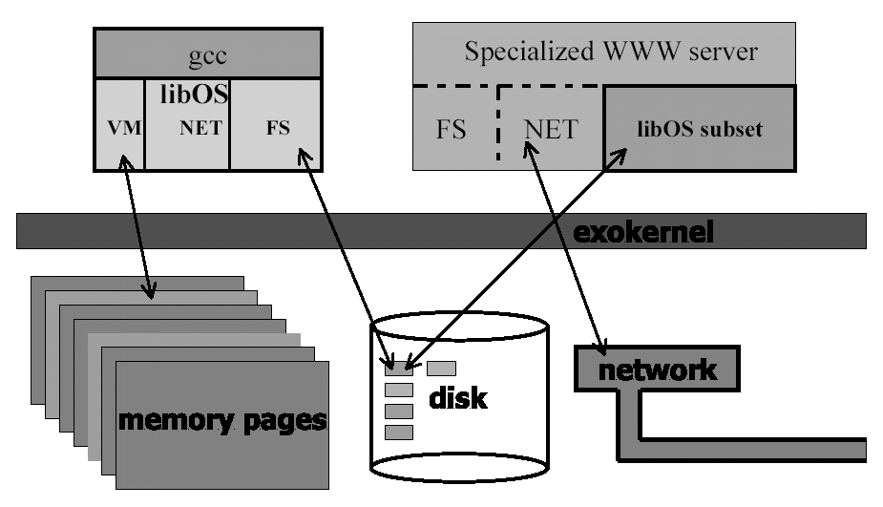

Figure 1: The Exokernel Architecture (Engler, 1998).

The exokernel does not have to be aware of how these resources are implemented at the libOS level. Application programmers choose only those library operating systems that they want so that they are able to implement abstractions in the way that they want to, and they only import those libraries that they are going to use. LibOSes can be smaller and more specialized than in-kernel implementations, because they need not multiplex a resource among competing applications with widely different demands.

History

In 1995, Dawson Engler, Frans Kaashoek, and James O’Toole proposed an initial draft at The ACM Symposium on Operating Systems Principles (SOSP) conference. They continued their research at M.I.T. and wrote Xok and ExOS, which is a prototype kernel and library operating system for x86 computers. Research is still being conducted at M.I.T..

Exokernel Principles

“The goal of an exokernel is to give efficient control of resources to untrusted applications in a secure, multiuser system” (Kaashoek, Engler, et. al., 1997). Furthermore, exokernels should avoid resource management; they should only manage resources to the extent that require protection (management of allocation, revocation, and ownership) (Engler, 1995). One way to do this is to provide applications with a virtual machine, but the extra layer of communication can be costly. Exokernels export hardware resources instead of emulating them, which allows for simpler and faster implementations. Exokernels use three techniques to export resources securely. 1) By using secure bindings, applications can securely bind to hardware resources and handle events. 2) By using visible resource revocation, applications participate in a resource revocation protocol. 3) By using an abort protocol, an exokernel can break secure bindings of uncooperative applications by force (Engler, 1995).

Exokernels must give library operating systems maximum freedom in managing physical resources while protecting them from each other; a programming error in one library operating system should not affect another library operating system. To do this, an exokernel performs three tasks: it tracks ownership of resources, ensures protection by guarding all resource usage or binding points, and revokes access to resources. In addition, since libraries are not trusted by an exokernel, they are free to trust the application. For example, if an application passes the wrong arguments to a library, only that application will be affected.

Resource Protection

Secure binding is a protection mechanism that decouples authorization from the actual use of a resource. This allows for the existence of hardware abstractions. This is important because many of the resources protected by traditional operating systems are themselves high-level abstractions—for example, files consist of metadata, disk blocks, and buffer cache pages, all of which are guarded by access control on high-level file objects. The protection checks involved in enforcing a secure binding are expressed in terms of simple operations that the kernel can implement. These operations allow the kernel to protect resources without understanding them. A frequently used hardware secure binding is the translation lookaside buffer (TLB). When a TLB fault occurs, the mapping of virtual to physical addresses in a library operating system’s page table is performed and then loaded into the kernel and used. Secure bindings can be implemented by downloading code into the kernel. The code is invoked on every resource access or event to determine ownership and the actions that the kernel should perform. Downloading code into the kernel allows an application thread of control to be immediately executed on kernel events. The advantages of downloading code are that potentially expensive crossings can be avoided and that this code can run without requiring the application itself to be scheduled (Engler, 1995).

Multiplexing the CPU

A process in Xok is called an environment. An environment consists of accounting information, the page table, locations of code to run when certain events happen (upcalls), and any other custom data (dependent on the libOS author). Process (or environment) scheduling works very similar to that of a traditional OS, with the exception that the process is notified whenever it is about to gain or lose the processor. This allows a process to save or restore its own registers. The kernel multiplexes the CPU by dividing it into time slices of a fixed number of ticks. An environment may then allocate time slices in order to be scheduled on the processor.

Multiplexing Main Memory

Multiplexing main memory is a rather straightforward process in Xok, as it only has to guard memory accesses between competing libOSes rather than from within a single libOS. Xok exposes the capabilities of the hardware to libOSes, including all MMU protection and dirty bits as well as many kernel data structures such as free frame lists and inverse page mappings. Access to these structures allows an application to have maximum control over paging and virtual memory. When a libOS allocates a physical memory page, the exokernel records the owner and permissions of the allocating process. Thereafter, the exokernel guards every access to the physical memory page from other libOSes by requiring that a valid capability be presented by the requesting libOS. When the exokernel detects a page fault of any kind (read-only page, page not present, etc.) it propagates the fault up to a user level (libOS) fault handler.

Multiplexing the Stable Storage

Xok uses XN, its native file system, to provide libOSes with access to stable storage at the level of disk blocks, with the goal of determining the access rights of a requesting process to a given disk block as efficiently as possible. Consistent with the exposing of low-level hardware primitives, XN exports to the libOS disk structures including a buffer cache registry and free maps.

Each libOS contains one or more Library File Systems (LibFSes). Multiple libFSes can be used to share the same files with different semantics. The task for the exokernel is to give libFSes as much control over file management as possible while still protecting files from unauthorized access. The default libFS for Xok/ExOS is the Co-locating Fast File System (C-FFS). It is designed to be faster than in-kernel file systems. C-FFS extends the functionality of XN by downloading code into the kernel. It then uses exokernel functionality to embed inodes in directories, co-locate related files together on the disk, and fetch large chunks of disk on every read (Kaashoek, Engler et. al., 1998).

Performance

All experiments were performed on the same hardware. A 200-MHz Intel Pentium Pro processor with a 256-Kbyte on-chip L2 cache and 64-Mbyte of main memory was used to compare how fast various operating systems could complete specific benchmarks. The ExOS library provides a user-level and extensible implementation of an UNIX operating system; therefore, most UNIX applications like gcc, perl, and telnet compile and work without modifications using ExOS. “Normal applications benefit from an exokernel by being linked against an optimized libOS, thus even without modifications they still profit from an exokernel” (Engler, 1998). The following figure demonstrates the relative performance of unmodified UNIX applications on different operating systems:

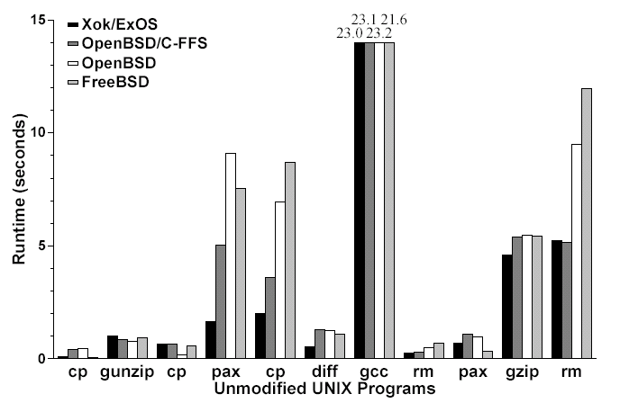
Figure 2: Unmodified Application Performance (Engler, 1998)

In addition, the following figure from M.I.T.’s testing indicates that the Cheetah web server optimized for Xok performs eight times faster than NCSA or Harvest:
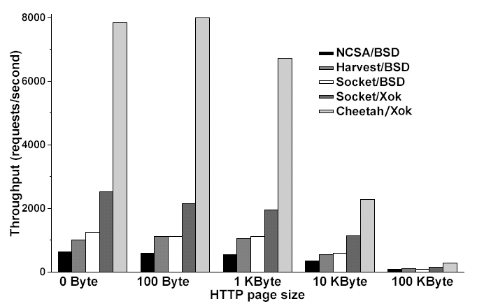
Figure 3: Optimized Application Performance (Engler, 1998)

Still, no general purpose operating system would be complete if it could not handle multiple applications running concurrently and potentially using resources greedily. M.I.T.’s tests for this area showed that, even under those circumstances, global performance was at least as good as monolithic operating systems when running unmodified applications, and significantly better when one or more of the applications was optimized:
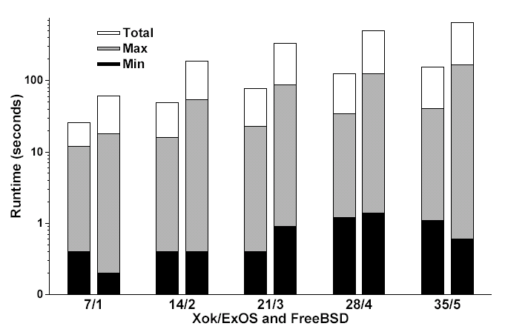
Times are in seconds and on a log scale. number/number refers to the total number of applications run by the script and the maximum number of jobs run concurrently. Total is the total running time of each experiment, Max is the longest runtime of any process in a given run (giving the worst latency). Min is the minimum.

Figure 4: Global (System) Performance (Engler, 1998)

Good global performance even with unmodified applications is because the exokernel mediates the allocation and revocation of resources and still has the ability to enforce any global policy that a traditional operating system can (Engler, 1998).

Advantages of Xok/ExOS

M.I.T.’s research in Xok/ExOS indicates clear advantages to using the exokernel architecture (Engler, 1998). First, exposing kernel data structures proved to be a powerful way to allow applications to manage their own resources while still maintaining protection. The exokernel mediates access to the hardware primitives and can therefore enforce any global policy for protection that a traditional OS can. Second, the CPU interface is an essential component in Application-level resource management, as applications are notified when they will gain or lose the processor and therefore can perform scheduling-related functions previously performed only by the kernel. Third, libraries are simpler to develop than kernels. “The “edit, compile, debug” cycle of applications is considerably faster than the “edit, compile, reboot, debug” cycle of kernels” (Engler 1998). Moreover, untrusted code lends itself to faster development than trusted operating system code, as a bug in a library does not propogate to the entire system and the libOS can actually be debugged independently from the exokernel.

Costs of Xok/ExOS

There are also some costs associated with Xok. First, design of the exokernel interface is not simple. It requires difficult choices as to how to balance the power one wants to give the applications with the protection needed. M.I.T.’s kernel interface design for Xok went through several iterations before they agreed on a suitable implementation. Second, there is information loss associated with performing resource-management tasks at the application level. For instance, since virtual memory is handled by the libOS, Xok is not able to distinguish which pages were used to cache disk blocks and which pages are used for virtual memory.

Conclusion

Exokernels started to be discussed in the mid to late 1990’s as a way to improve operating system performance and flexibility by providing applications with the capability to manage their own resources. Since then exokernels have undergone development on DEC workstations as well as the PC. Xok in particular was designed for x86 computers by M.I.T. from the years 1995-97. The research provided great insights into the clear advantages of exokernels as well as the costs. Performance experiments were carried out on Pentium computers and demonstrated that not only unmodified UNIX programs performed as well on Xok as on other monolithic UNIX systems, but also that when aggressive applications were optimized using a libOS, performance of these applications could increase up to eight-fold or more. Finally, global system performance on Xok was equal or better than that of its UNIX cousins.

Only a few development issues remain to be addressed to make Xok a commercially viable operating system, and the only reason these issues have not been addressed is because the exokernel project is academic in nature and have simply not been undertaken as further projects. Over time, however, we foresee certain commercial companies using the architecture within server environments, as this is where performance is most visibly improved. While it is feasible that exokernels take hold in the server market in this manner, it remains nonetheless doubtful that any but a few end users and developers will abandon their Unix and Windows operating systems in favor of Xok or equivalent in the near future. What is more likely is that a Linux kernel absorbing some features of the exokernel architecture is developed, and a company such as Red Hat exploits the opportunity increased application throughput and global performance. This way, the switch to an exokernel-based system would be seamless to the end user and accepted by the application developer because of the increased flexibility in development.

Bibliography

Cao, P., Felten, E. W., Li, K. (1994). “Implementation and Performance of
Application-Controlled File Caching.” Symposium on Operating System Design and Implementation.
Engler, Dawson R. (1995). “Exokernel: An Operating System
Architecture for Application-Level Resource Management” M.I.T. Department of Electrical Engineering and Computer Science.
Engler, Dawson R. (1998). “The Exokernel Operating System Architecture.” M.I.T.
Department of Electrical Engineering and Computer Science.
Engler, Dawson R., Kaashoek, Frans M. et. al. (1998). “Exokernels (or, making the
operating system just another application library).” M.I.T. Lab for Computer Science. URL: http://amsterdam.lcs.mit.edu/exo/exo-slides/sld001.htm

Kaashoek, Frans M., Engler, Dawson R. et. al. (1997). “Application Performance and
Flexibility on Exokernel Systems”. Symposium on Operating Systems Principles (SOSP) 1997 conference.
M.I.T. Lab for Computer Science (LCS) Parallel and Distributed Operating Systems
(PDOS) group (1998). “M.I.T. Exokernel Operating System: Putting the Application in Control.” URL: http://www.pdos.lcs.mit.edu/exo.html

Pinckney, Thomas (1998). “Internal Structure of Xok/ExOS.” M.I.T. Laboratory for
Computer Science. URL: http://www.pdos.lcs.mit.edu/exo/exo- internals/internals.html

