IBM’s OS/390

CS 351 - Operating Systems.

Spring 2001
Section 2

Group Members:
Ashleigh Blair
Matthew Ducker
Robert O’Donnell
Val Singkarlvanich
CJ Wilkerson

I. OS/390 Overview

The OS/390 operating system is an offspring of the S/390 platform. Currently in its second version, OS/390 offers the same superior reliability, performance, scalability, and cost efficiency as the S/390 operating system, but allows companies to have more flexibility in creating and managing their business applications.
The OS/390 operating system gears itself to the e-business market, providing client/server integration into the Internet. Because IBM continues to improve the capabilities of OS/390 so that it can continue to meet the needs of its clients, new features are constantly becoming available as additions to the kernel OS. The current version of OS/390, V2R10.0 offers many features that are not included in the base operating system services. These features allow companies to customize their systems to fit their companies’ needs. Examples of these extra features include:
- BDT File-to-File- BDT File-to-File allows users at one OS/390 system in a SNA network to copy data sets to or from another OS/390 system in the network. This feature is related to the element BDT
- BDT SNA NJE- BDT SNA NJE allows users to transmit jobs, output, commands, and messages from one computer to another within a SNA network. This feature is related to the element BDT
- C/C++ with Debug Tool
- C/C++ without Debug Tool
- DFSMSdss- DFSMSdss is a DASD data and space management tool
- DFSMShsm- DFSMShsm is a DASD storage management and productivity tool for a managing low-activity and inactive data
- DFSORT- DFSORT sorts, merges, and copies data
- GDDM-PGF- GDDM-Presentation Graphics Feature (PGF) is a set of programs for creating presentation material in a variety of styles
- GDDM-REXX- GDDM-REXX is a productivity tool that enables programmers to prototype GDDM applications and to create small routines and utility programs quickly and easily
- IBM Communications Server NPF- IBM Communications Server NPF provides a printing function that reroutes print data to the IP network
- IBM Communications Server Security Level 3- As with the other two IBM Communications Server security features, this feature provides authentication and security services in a TCP/IP network environment, supporting packet filtering, tunnels, and NAT. The difference is that it provides the highest level of security
- Infoprint Server- Infoprint Server allows you to print files on OS/390 printers from any workstation that has TCP/IP access. This feature was called OS/390 Print Server when it first became part of OS/390 in R5. In OS/390 R8, it received its current name
- OCSF Security Level 3- OCSF Security Level 3, in conjunction with base element Cryptographic Services, provides weak (40-bit) and strong (56-bit and greater) software cryptographic services, a data library service provider, certificate library service providers, trust policy service providers, and hardware cryptographic services

While the OS/390 operating system has not yet taken over the computer industry, it is making its mark on prominent e-business companies. Over 90% of the worlds largest 1000 corporations are running the OS/390 as their central operating system. These companies are running OS/390 on Hitachi, Fujitsu, IBM S/390, or Amdahl hardware. PeopleSoft, Lotus Domino, SAP R/3 and close to 1,400 other Independent Software Vendors are taking advantage of OS/390 and what it has to offer the business world by delivering and expounding upon OS/390 technology.

II. Scheduling
At any point in time, computer system resources are busy processing the tasks for individual jobs, while other tasks are waiting for the resources to become available. To control the flow of which jobs get processed in which order, an operation need a scheduler. In OS/390, jobs management and divided into two parts: Job Entry System (JES) and the base control program (BCP). In summary, JES manages jobs before and after running the program, while the base control program manages them during processing. In this report, we will focus on JES, since it is the part that user will have a closer interaction with.

Job Entry System (JES) is one of the base elements in OS/390. It retrieves jobs into the operation system, schedule them for processing, and control their output processing. To understand JES, we first must know Houston Automatic Spooling Priority (HASP), an earlier version of job management system, which is what JES is based on. HASP is defined as: “a computer program that provides supplementary job management, data management, and task management functions such as: scheduling, control of job flow, and spooling.”

Depends on the computer system, IBM provides two JESs to chose from: JES2 and JES3. If the system only has a single processor, JES2 and JES3 perform similar functions, which are: reading jobs into the system, converting them to internal machine-readable form, selecting them for processing, processing their output, and purging them from the system. However in case of a multi-processor system, JES3 will give a better performance. That is because while each JES2 processor controls its own job input, job scheduling, and job output processing, JES3 centralized control over its processing functions through a single global JES3 processor. This results in: increased job-scheduling control, deadline scheduling capabilities, and increased control by providing its own device allocation.

To understand the phases of job processing in OS/390, look at the image below:

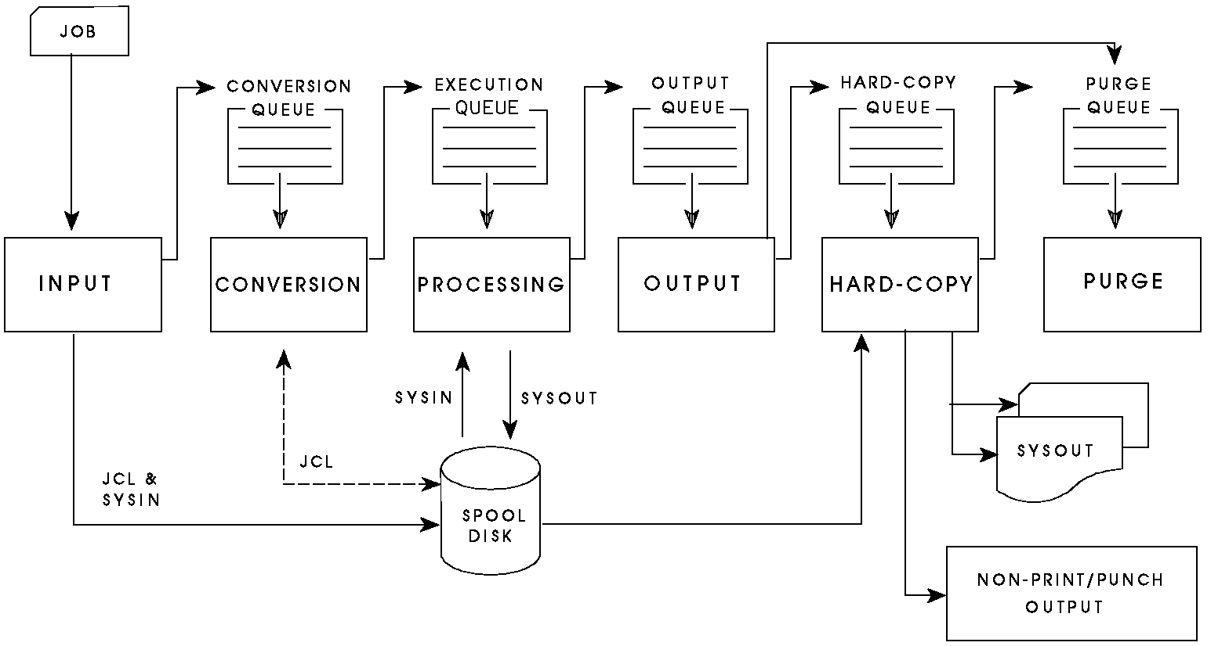

Here are some places where job schedule queue occurs:
- Waiting to run - conversion queue
- Currently running - execution queue
- Waiting for their output to be produced - output queue
- Having their output produced - hard-copy (print/punch) queue
- Waiting to be purged from the system (following completion of all processing) purge queue.

During the conversion phrase, a converter program is used to analyze each job's JCL statements. The converter takes the job's Job Control Language (JCL) to code job control statements into converter/interpreter text that job scheduler can recognize. JCL is a programming language used to code job control statements. This is what the system programmer can use to set priority of jobs. Because JES2 supports multiple converters, which means the conversion may get done simultaneously, and jobs may not always be processed in a first-in-first-out (FIFO) order.

In the processing phase, JES selects jobs that are waiting from the job queue.
By examining the current status of all jobs on the queue, JES2 can schedule the flow of jobs through the system. JES uses initiators to process the jobs on the job queue. An initiator is “a system program that starts a job to allow it to compete for system resources with other jobs that are already running.” Classes that are assigned to the initiator and the priority of the queued jobs are what initiators use to determine which jobs to select from. However, there maybe times when all initiators are busy, and job processing might not get processed in a reasonable amount of time, this is where an additional function takes place. JES uses priority aging as the additional scheduling function. Priority aging can help ensure that jobs that have been waiting will have a chance to run before those new jobs. The longer the job waits, its priority become higher, and yield the greater chances of being selected to run.

In the output phase, JES analyzes the characteristics of the job's output in terms of its output class and device setup requirements. JES then groups datasets with similar characteristics. These characteristics are what the hard-copy phase use to determine which order to process the job.

When a job process has completed, JES releases the spool space assigned to the job, this allows the free space available for new jobs to get allocated. JES then issues a message to the operator indicating that the job has been purged from the system.

III. Memory Management

The memory management subsystem is one of the most important parts of the operating system. In the OS/390 there are three levels of memory managed by the operating system: central storage, expanded storage, and page data sets on disk. OS/390 organizes real storage, or central storage, into 4096 byte page frames. The Real Storage Manager allocates storage on the basis of demand by assigning frames from an available frame queue, also known as AFQ. Frames are assigned when the length of the queue falls below the threshold or when the queue cannot meet the need for frames. OS/390 implemented the idea of expanded storage to accommodate inactive pages. Expanded storage is addressable only as pages and is not accessible to the I/O subsystem or normal CPU instructions. Central storage manages itself based on the most recently used algorithm and workload priority. Pages with low priority or not recently used are paged out to expanded memory. OS/390 uses a more efficient paging system as well. Pages that need to be paged out are grouped together and written out as a block in one I/O. This is called block paging and it is more efficient that normal paging in its use of I/O. Also, when the OS/390 swaps out, it swaps out all of the pages need for a job in one operation, which reduces the amount of paging activity.

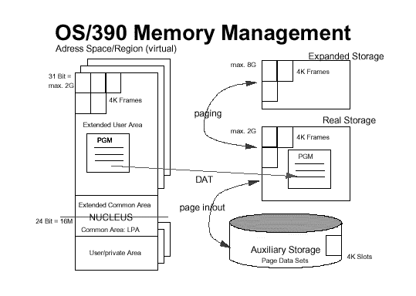

IV. File Management
The file management system is the subsystem of an operating system that manages the data storage organization on disk, and provides services to processes related to file access. In particular the file management system tries to provide data management services, guarantee the validity of the data, enforce a data protection policy, allow concurrent access to the data, and at the same time offer good data acess speed and data trasfer rate.
The OS/390 file management system uses a heirarchical approach. All files are members of a directory, and each directory is in turn a member of another directory at a higher level in the heirarchy. At the top of the heirarchy is the root directory.
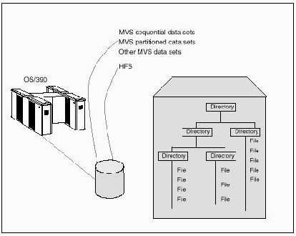
The OS/390 heirarchical file system views the entire file heirarchy as a collection of heirarchical file system data sets (HFS data sets). In most of the operating systems the compilation of data is commonly called a file. In the OS/390 operating system it is known as a data set. The data set is the fundamental unit of data management in OS/390. It is linked to a label entry (known as a Data Set Control Block, DSCB) in the area of each disk volume that is reserved for such entries. Usually, permanent data sets are also catalogued. These cataloged data sets can be found and retrieved by name only, without knowing which volume it is on.
Files in the hierarchical file system are referred to as a HFS file. HFS files are byte-oriented, rather than record-oriented, as are MVS data sets. The figure below shows an HFS residing on an SMS managed volume with a non-HFS data set, and shows the directory tree structure of an HFS.
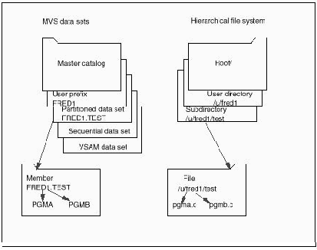
Additional file systems can be added to the HFS file system as a subset. The directories of the file system contain files and/or other directories. The directories are structured like an upside-down tree, with the root at the top and branches hanging down one or more levels. In addition to directories, there are four types of files that can exist in the HFS file system: (1) regular files, (2) character special files, I/O devices, (3) a FIFO special file, and (4) a symbolic link reference to the original file.
V. Processor Management
Much of the processor management for the OS/390 operating system has been discussed in the scheduling section of this paper. The processes that are being used in the operating system consist of specific jobs. A job is made up of a call of one or more programs and making the necessary data available. A job as a whole is usually considered a single transaction with a single purpose. Job Control Langauge (JCL) is a specific language for the definition of such jobs.
Each time a job is submitted, one needs to tell OS/390 where to find the appropriate input, how to process that input, and what to do with the resulting output. JCL is used to convey this information to OS/390 through a set of statements known as job control statements. A JOB statement and an EXEC statement are the minimum control statement requirements of every job. A JOB statement marks the beginning of a job and assigns a name to the job. Security, accounting, identification information, and other administrative information are provided in the JOB statement. Contained in each job, the control statements are grouped into job steps. A job step comprises all of the control statements to run on program. If a job needs to run more than one program, the job would contain a different job step for each of those programs. To mark the beginning of a job step, to assign a name to the step, and to identify the program or procedure to executed in the step, an EXEC statement is used. In order to customize the way the program executes, various parameters can be added to the EXEC statement.
VI. Processor Modes, SMP
It is impossible to examine the IBM OS/390 in isolation from its hardware. Its tandem evolution with its underlying hardware make considerations and features like processor modes, instructions and multiprocessing in the OS/390 inseparable from the computer itself. Often a discussion of OS/390 processor support will, then, invariably become a discussion of processor power and processor configurations in the S/390 family of mainframes in general.

There is a lot to say about processing power and configurations in the S/390. Its "air-cooled CMOS processors" seem to be objectively unparalleled in terms of raw number crunching. This may not be surprising when one considers that the S/390 is narrowly designed in the tradition of mammoth mainframe systems and not to play Solitare. That the S/390 is not a feasible desktop system does not, however, diminish its market niche: despite the S/390’s recent revenue downturn in the 1990s, many supporters still claim that up to 90% of mission-critical data is held on an S/390 system. While such a claim may be questionable, the S/390 systems are undeniably well-endowed when it comes to processor architecture and a high level of data security that is at least partially attributable to the CPU and its available CMOS cryptographic coprocessor. While the daily use of the S/390 may be limited in a world where computers are in blenders and video game systems, it is not hard to imagine where such features would still be useful: financial systems, giant web servers and high-end databases.

In terms of computing power, some examples may be in order. Standard processor upgrades can include both horizontal growth and vertical growth. Horizontal growth involves replacing the current processor with another designed for that same system architecture. Vertical growth involves adding brand new processors next to current ones. The result of vertical processor growth is what is known as a clustered architecture. The "linear scalability", or the ability to efficiently add new processors onto a current system, measures the relative capability of a system as a clustered architecture. A system's linear scalability, in other words, determines the efficiency of processor addition. This is where the S/390 does have advantages: in terms of vertical growth, it has near-perfect linear scalability. This means that if a cluster of 8 third-generation processors are running at 500 MIPS, and a cluster of 16 third-generation processors may run at 1100 MIPS, a cluster of 24 third-generation processors may run at 1700 MIPS

There is a limit to vertical growth, however, because with each new processor added to the system some small amount of computing power is necessarily sacrificed for the sake of synchronization. At a certain point simply adding new processors may become inefficient. The benefit of the S/390 is its high ceiling for vertical growth and the power of the individual processors. This makes up for many of its remaining limitations. A system of 32 second-generation S/390 processors can perform approximately 2,260 IMS-TM/DB2 transactions/second or 135,000 transactions/minute. A comparable system of third generation processors in a collection of servers known as a "parallel sysplex" have a capacity of approximately 4,240 IMS-TM/DB2 transactions/second or 250,000 transactions/minute. This is more than any other system in existence. By comparison the top performing UNIX system, the AIX 6000 S80 server, has a rating of 135,815 tpmC; but a comparable cluster of S/390 sixth generation processors is assumed to exceed 1,000,000 tpmC.

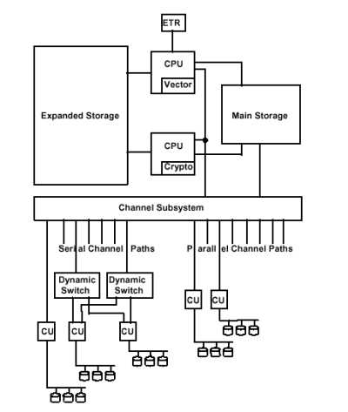
The development of these facilities has taken some four decades, beginning on April 7, 1964 with the first OS/360 system developed by Gene Amdahl, Gerry Blaauw and Fred Brroks. The system was so named because of its "universal", 360 degree applicability. The OS/360 was originally a uniprocessor, single-user batch system, but by 1968 had evolved into the first two-way SMP, concurrent batch system in existence. By 1970 the S/370 had developed and featured interactive time sharing. By 1971 the OS/VS1 had emerged and featured concurrent batch processing, full interactivity, mixed workload management, and transaction and database management. From this point until around 1982 IBM spent time improving the storage capabilities and memory addressing of the S/390; then, in 1983, they released the 3084 system featuring the first four-way SMP architecture. In 1987 they released the 3090 system with the first six-way SMP architecture. This was also the first system to feature the logical partitioning system PR/SM. By 1993 the ES/9000 system emerged and featured an eight-way SMP architecture. That same year IBM introduced a new ES/9000 with the first ten-way SMP architecture. In 1994 IBM switched its primary mainframe building block to Complementary Metal Oxide Semiconductor technology with the 9672. In 1998 the 9672 featured a fifth generation S/390 processor that could perform more than 1000 MIPS. The latest version of the S/390 system featured a copper-technology twelve-way SMP architecture with a 2 x 8 way L2 cache and a cryptographic coprocessor. Up to 32 of these servers may be clustered together into what is known as a Sysplex. In late 2000 IBM announced the new zSeries 900 system with 64-bit addressing and a 16-way core that could perform around 2,500 MIPS. Many mainframe users are calling the vSeries 900 the G7 S/390, although IBM has recently shown an interest in supporting Linux as an alternative for the S/390.

There are several interesting features of the current S/390 architecture. As shown in the above diagram, I/O devices are attached to the channel subsystem through control units via channel paths. This channel subsystem directs the flow of information between I/O devices (shown below) and the main system storage. FIG 1 also shows an area of expanded storage that is accessible by all CPUs on the system. But in order to keep the CPU operations secure each S/390 features a hardware partitioning system called Processor Resource/System Manager, or PR/SM. Each logical partition within PR/SM is nearly isolated from all other partitions and can run its own individual workload. This facilitates separate installations and helps restrict user access to essential or high security facilities.

Each CPU can also contain an integrated cryptographic facility (see above diagram again.) This facility contains special instructions set aside from the rest of the processor that specifically supports identification, key management and data protection. Compared to software implementation, this "coprocessor" improves security performance by a factor of 19 when generating 512 bit RSA keys (the standard for public key encryption.) The impetus behind such robust security features lies, again, in the focus of the S/390 market: financial-transaction and bulk-encryption environments. It is also interesting to note that the fourth generation and later processors each feature double operation execution. This means that each instruction is executed twice, in parallel. The system then compares the results of these operations and reperforms them if a mismatch occurs. The third generation and later also offered dynamic replacement of failing processors. This also applies, from the G3 on, to the System Assist Processor, which manages the storage and I/O section of the server.
Bibliography

Howe, Denis (1996). “Free Online Dictioanry of Computing: Mainframes.”
URL: http://foldoc.doc.ic.ac.uk/foldoc/index.html

Howe, Denis (1999). “Free Online Dictionary of Computing: OS/390.” URL:
http://foldoc.doc.ic.ac.uk/foldoc/index.html

IBM (2001). “OS/390 V2R10.0 elements and features.” URL:
http://www-1.ibm.com/servers/s390/os390/os390elefeat.html

IBM (2001). “OS/390 V2R10.0 JES2 Introduction.” URL:
http://publibz.boulder.ibm.com/epubs/pdf/has1a810.pdf

IBM (2001). “OS/390 V2R8.0-V2R10.0 JES3 Introduction.” URL:
http://publibz.boulder.ibm.com/epubs/pdf/iat1a710.pdf

IBM (2001). “VisualAge and OS/390: Building applications for e-business.” URL:
http://www-4.ibm.com/software/ad/platforms/os390.html

IBM (2001). “z/Architecture Principles of Operation.” URL:
http://publibz.boulder.ibm.com/epubs/pdf/dz9zr000.pdf

Phelps, J. (2000). “S/390 Becomes the IBM zSeries 900.” URL:
http://gartner.jmu.edu/research/ras/93600/93623/93623.html

Spruth, Wilhelm G. (2000).“OS/390 Internet Services.” URL:
http://www-ti.informatik.uni-tuebingen.de/os390/qrx0010.htm

