TWOFISH ENCRYPTION ALGORITHM

CS–627: Cryptology
Fall 2004

Horatiu Paul Stancu

Table of contents

Introduction…………………………………………………………………. | 1
1. Twofish Design …………………………………………………………… | 1
1.1 Simplicity……………………………………………………………… | 2
1.2 Performance…………………………………………………………... | 2
1.2.1 Performance Tradeoffs…………………………………………. | 3
1.3 Conservativeness……………………………………………………… | 4
2. Twofish Design Goals …………………………………………………….. | 4
3. Twofish Cipher Detailed Presentation ………………………………….. | 5
3.1 The Key-dependent S-boxes………………………………………….. | 5
3.2 The MDS Matrix……………………………………………………… | 6
3.3 Pseudo-Hadamard Transformation(PHT)………………………….. | 6
3.4 Feistel Networks………………………………………………………. | 6
3.5 Round description…………………………………………………….. | 7
4. Cryptanalysis of Twofish…………………………………………………. | 9
5. Performance of Twofish………………………………………………….. | 9
Conclusion……………………………………………………………………. | 10
Bibliography

Introduction

Between 1972 and 1974 NIST issued the first public request for an encryption standard. As a result DES became the accepted encryption standard. Although this algorithm was very popular, it has always been surrounded by controversy as many cryptographers objected to the “closed-door” design of the algorithm. There was also a suspicion that NSA planted a “back-door” in the algorithm, as NSA modified it before it was standardized, although none was able to prove this until now.
Furthermore the key length of DES became to small for acceptable commercial security, so as a interim solution Triple-DES was used for a while because it provided increased security.
Responding to the desire to replace DES with stronger and more reliable algorithm, NIST announced another public request for an encryption standard, called Advanced Encryption Standard(AES), in 1997.
Twofish is one of the candidates that made it to the final round of the AES program.

1. Twofish Design

Twofish is a 128-bit symmetric block cipher and can accept a variable-length key up to 256 bits. The cipher is based on a Feistel network, has 16 rounds, a bijective F function made up of four key-dependent 8-by-8-bit S-boxes, a fixed 4-by-4 maximum distance separable matrix over GF(2⁸), a pseudo-Hadamard transform, bitwise rotations, and a well designed key schedule.
The algorithm can be optimized for use with regard to the hardware platform:
- An optimized implementation of Twofish can encrypt on a Pentium Pro at 16.1 clock cycles per byte
- An 8-bit smart card implementation encrypts at 1660 clock cycles per byte.
The algorithm can also be implemented in hardware using 14000 gates. The round function and the key schedule were designed to permit a wide variety of tradeoffs between key setup time, gate count, speed, software size and memory.
The algorithm has been extensively cryptanalyzed to prove that it is secure and resistant to known attacks. The designers have managed to mount an attack on 6 rounds with 2⁴¹ chosen plaintexts and 2²³² effort.
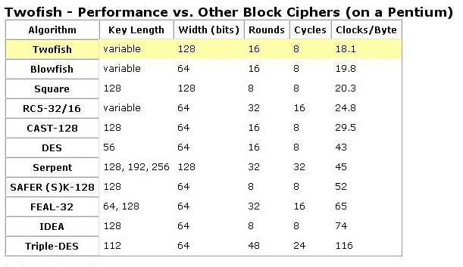

(Bruce Schneier, http://www.schneier.com/twofish-performance.html)

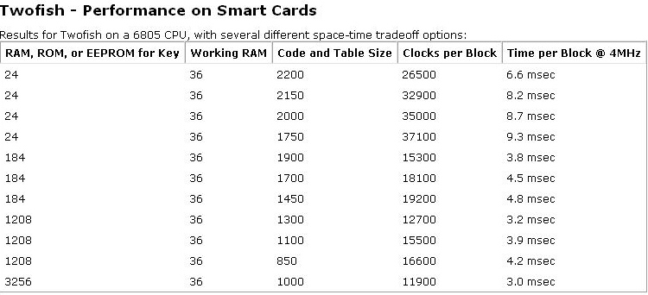

(Bruce Schneier, http://www.schneier.com/twofish-smart-cards.html)

Twofish was designed by Bruce Schneier, John Kelsey, Doug Whiting, David Wagner, Chris Hall, Niels Ferguson. They tried to implement in their design the following principles:
- Simplicity – all the design elements of the algorithm have a clear reason or function
- Performance – they compared all the different option on the basis of relative performance
- Conservativeness - they left a margin for error and they provided more security than required while trying to design against attacks that are not yet known

1.1 Simplicity

The designers wanted to have the round function simple enough to be kept in their heads. Also experience shows that complicated round functions are harder to analyze and rely on for security than simpler ones.
The simplicity goal was achieved by:
- Reusing Primitives – They reused the same primitives(8-by-8-bit key-dependent S-boxes, subkey XORs) in multiple parts of the cipher. The differences were in the key material used in each case.
- Reversibility – Twofish encryption and decryption round functions are slightly different, but they are built from the same blocks, so it is easy to build hardware or software modules that perform encryption and decryption without duplicating much functionality.

1.2 Performance

The cipher was designed so that it can be evaluated on basis of performance. In the past the cipher designs used to compete on the number of rounds in the cipher.
The designers of Twofish considered that these kinds of metrics are not good measures of performance. Instead they used the speed of the cipher(cycles per byte encrypted) as a performance indicator. Because the NIST’s AES contest platform of choice was the Intel Pentium Pro, the authors concentrated on that platform, but they also included other 32-bit CPUs as well as 8-bit and 16-bit CPUs.

1.2.1 Performance Tradeoffs

Twofish’s round function encrypts at 20 clock cycles, so the 16 rounds lead to 320 clock cycles per block encrypted. Any change to the round function was evaluated in terms of increasing or decreasing the number of rounds, so that performance would be kept constant:
- If they had added a data-depended rotation to the output of the two matrices in each round, this would have added 10 clock cycles to the round function on a Pentium and two clock cycles on a Pentium Pro; so in order to keep the performance constant they would have to decrease the number of rounds to 11 from 16
- If they had removed the one-bit rotation, this would have saved the equivalent of one Twofish round
- If they had defined the key-dependent S-boxes using the whole key instead of half of it this would have meant that key setup time would have doubled on high-end machines and the encryption speed on memory-poor implementations (where S-boxes can not be precomputed) would have halved, which would have lead to the reduction of round to 8 to afford this.

In all this cases the question is if the modified number of round for this improved cipher would be better or more secure than the previous design. As it can be easily observed from this examples the analysis is dependent on the microprocessor architecture the algorithm is compared on. Although the authors designed this algorithm for the NIST AES program which had as the default microprocessor architecture the Intel Pentium they tried to keep in mind the 8-bit smart card and hardware implementations. The final design that was submitted reflects the choices and the tradeoffs they had to make in order to design a highly performant algorithm which would be compatible with different hardware platforms and smart card implementations.

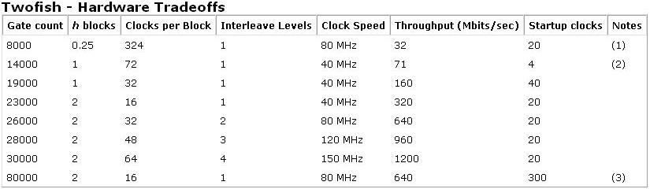
(Bruce Schneier, http://www.schneier.com/twofish-hardware.html)
1.3 Conservativeness

During the decade before Twofish cipher was designed there has been an extensive interest and effort in designing ciphers that would be resistant to known attacks. Many of them have a designed based on theory, and many of them have been broken using newer cryptanalysis techniques.
The Twofish design team tried to make this cipher resistant against both known and unknown attacks. Even if designing it to be resistant against attacks that are not known is impossible, overengineering and conservative design gave them enough confidence in the security of Twofish.
The design elements of the cipher reflect this:
- Twofish uses the Feistel network, which is probably the most studied block-cipher structure, instead of something newer like an unbalanced Feistel network or a generalized Feistel network
- Twofish does not use multiplication mod 2¹⁶ + 1 or data-dependent rotations for non-linearity
- Twofish uses some newer structures like MDS matrices and PHTs, but only for diffusion
- The key-dependent S-boxes are used because they offer protection against known statistical attacks
- The 16 rounds of the cipher are far more than their analysis was able to brake
- Twofish has a strong key schedule design to prevent related-key and weak-key attacks
- The one-bit rotations prevent the attack based on the byte structure

2. Twofish Design Goals

Twofish was designed to meet NIST's general design criteria for AES [NIST97b], which are:

- Key lengths: 128 bits, 192 bits, and 256 bits.
- A 128-bit symmetric block cipher.
- Efficiency, both on the Intel Pentium Pro and other software and hardware platforms.
- No weak keys.
- Flexible design:
  - accept additional key lengths
  - suitable for a stream cipher, hash function, and MAC.
  - implementable on a wide variety of platforms and applications
- Simple design: ease of analysis and ease of implementation.

To increase the capabilities and the security of the Twofish algorithm the designers have also imposed the following performance criteria on their design:

- Accept any key length up to 256 bits
- Encrypt data in less than 500 clock cycles per block on an Intel Pentium, Pentium Pro, and Pentium II, for a fully optimized version of the algorithm.
- Be capable of setting up a 128-bit key in less than the time required to encrypt 32 blocks on a Pentium, Pentium Pro, and Pentium II.
- Encrypt data in less than 5000 clock cycles per block on a Pentium, Pentium Pro, and Pentium II with no key setup time.
- Not contain any operations that make it inefficient on other 32-bit microprocessors.
- Not contain any operations that make it inefficient on 8-bit and 16-bit microprocessors.
- Not contain any operations that reduce its efficiency on proposed 64-bit microprocessors; e.g., Merced.
- Not include any elements that make it inefficient in hardware.
- Have a variety of performance tradeoffs with respect to the key schedule.
- Encrypt data in less than 10 milliseconds on a commodity 8-bit microprocessor.
- Be implementable on a 8-bit microprocessor with only 64 bytes of RAM.
- Be implementable in hardware using less than 20,000 gates.

(Bruce Schneier, John Kelsey, Doug Whiting, David Wagner, Chris Hall, Niels Ferguson,1998)

3. Twofish Cipher Detailed Presentation

A closer look at the Twofish cipher reveals these design elements:
- The Key-dependent S-boxes
- The MDS Matrix
- Pseudo-Hadamard Transformation
- Feistel Networks

3.1 The Key-dependent S-boxes

The S-boxes are one of the key design elements of Twofish. These S-boxes have the following characteristics:
- They are different one from another
- Each is defined with two, three, or four bytes of key material
- The four S-boxes output four bytes
- As they are dependent on half of the key there should be few or no pairs of keys that result in the same S-boxes
- A small change of even 1 bit in the key should lead to extremely different S-boxes
- A few or none keys should cause the S-boxes resulted to be “weak”, which means that they might have high-probability differential or linear characteristics or even an simple algebraic representation

3.2 The MDS Matrix

The MDS Matrix is used as the main diffusion mechanism for the four bytes outputted by the four S-boxes. This is realized by multiplying this output with the MDS Matrix, which has the following properties:
- A change in any input byte is guaranteed to change all four output bytes
- A change in two input bytes is guaranteed to change at least three output bytes
- Preserves the number of bytes changed even after the rotation in the round function
- has fixed coefficients
- For software implementation the multiplication is implemented using four lookup tables each containing 256 32-bit words, so that the coefficients used in the matrix do not affect performance
- Twofish does not use the inverse of this matrix for decryption
- No row of the matrix is a rotation of another row or column of the matrix
- It maximizes the minimum binary Hamming weight of the output differences over all single-byte input differences

3.3 Pseudo-Hadamard Transformation(PHT)

This operation was chosen to produce a fast and efficient operation on the Pentium CPU family using the LEA(load effective address) opcodes.
To optimize the performance of Twofish a version of the code used for encryption and decryption can be “compiled” for any given key and then insert the round subkeys as constant values in LEA opcodes in the instruction stream.
The alternative to using the PHTs would have been to use eight key dependent S-boxes instead of four and an 8-by-8 MDS matrix instead of a 4-by-4 one. Although this would have been easier to analyze and would have had nicer properties, PHTs have been chosen because the alternative would have been much slower in all implementations of the Twofish and would not be worth it.
Given two inputs, a and b, the 32-bit PHT is defined as:

a’ = a + b mod 2³²
b’ = a + 2b mod 2³²
(Bruce Schneier, John Kelsey, Doug Whiting, David Wagner, Chris Hall, Niels Ferguson,1998)

3.4 Feistel Networks

A Feistel network is a general method of transforming a function into a permutation. The function was discovered by Horst Feistel and originally used in the design of Lucifer. The function was widely known and after its use in the DES. Since then it has been used in many block ciphers developed: FEAL [SM88], GOST [GOST89], Khufu and Khafre [Mer91], LOKI [BPS90, BKPS93], CAST-128 [Ada97a], Blowfish [Sch94], and RC5 [Riv95].
A Feistel network is based on the Feistel function(F function) which is a key dependent function that maps and input string into an output string. The F is always non-linear and can be non-surjective:

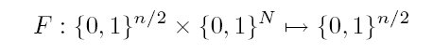
(Bruce Schneier, John Kelsey, Doug Whiting, David Wagner, Chris Hall, Niels Ferguson,1998)

where
n – the block size of the Feistel Network
F – is a key dependent function which takes n/2 bits of the block and N bits of a key as input and produces an output of length n/2 bits
For each consecutive round, the “source block", which is the input to F, and the output of F is XORed with the “target block". Then the two blocks swap places for the next round. The purpose of the XOR and swap operations is to use a F function, which can even be a weak encryption algorithm, and iterate it repeatedly to create a strong encryption algorithm. Two rounds in a Feistel network are called a “cycle”. After a cycle every bit of the text block has been modified once. The number of rounds of a Feistel network in an encryption algorithm is usually directly proportional to the strength of the algorithm. More rounds means a stronger encryption algorithm. Twofish is a 16-round Feistel network and uses a bijective F function.

3.5 Round description:

The basis of the Twofish encryption algorithm is the Feistel structure with 16 rounds and additional whitening of the input and output.
Before the encryption begins the plaintext is prepared to be encrypted by dividing it into four 32-bit words. After that they are whitened by XOR-ing them with four key words. This is followed by sixteen rounds.
Figure 1 shows an overview of the Twofish encryption algorithm.

- The two words on the left are used as input to the g functions after the rotation by 8 bits of one of them
- The g function consists of four byte-wide key-dependent S-boxes, followed by a linear mixing step based on an MDS matrix
- The results of the two g functions are combined using a Pseudo-Hadamard Transform (PHT), and two keywords are added
- One of the words on the right is rotated by 1 bit and then both of them are XORed in to the results on the left
- The left and right halves are then swapped for the next round
- After 16 rounds, the swap of the last round is reversed, and the four words are XORed with four more key words to produce the ciphertext

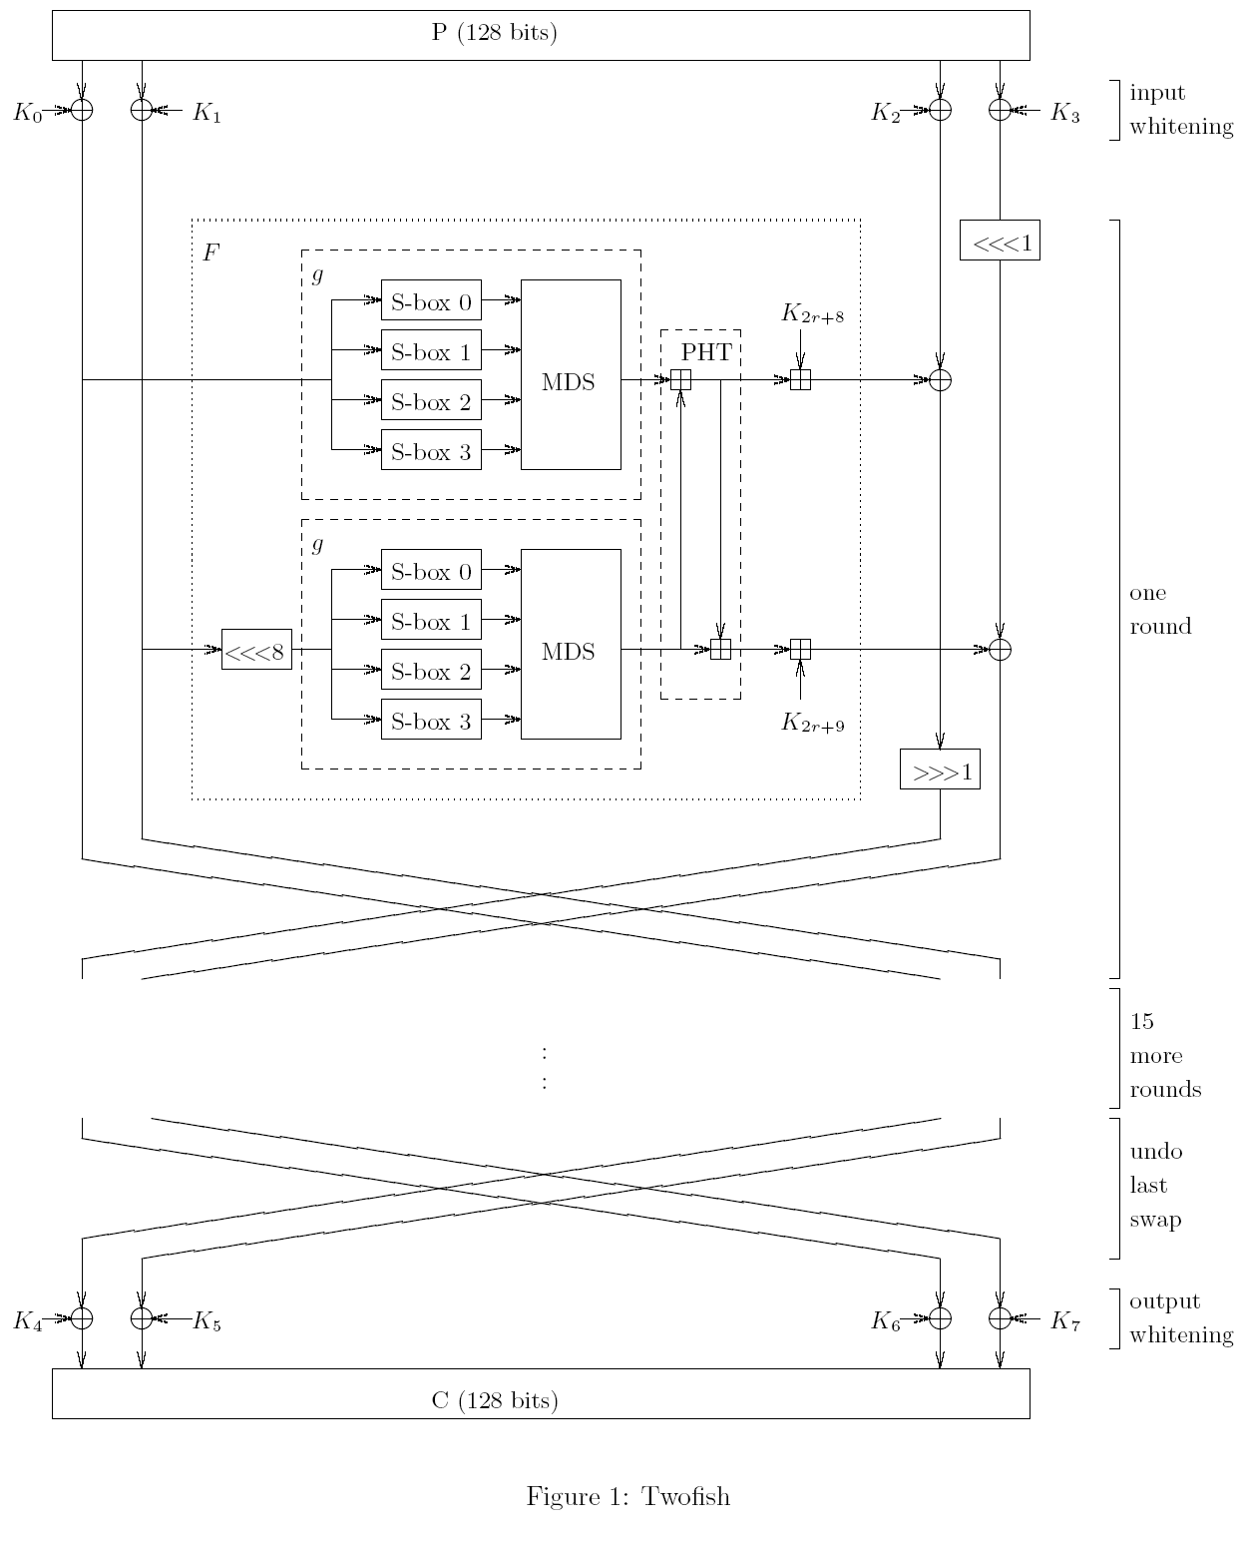
(Bruce Schneier, John Kelsey, Doug Whiting, David Wagner, Chris Hall, Niels Ferguson,1998)

4. Cryptanalysis of Twofish

The developers of Twofish have spent over one thousand man-hours cryptanalyzing Twofish. These are the most important findings of their cryptanalysis of Twofish:
- A successful chosen-key attack against Twofish requires choosing 160 bits of a pair of keys, and needs 2³⁴ work, 2³² chosen-plaintext queries, and 2¹² adaptive chosen-plaintext queries so that 10 rounds Twofish can be broken.
- The meet-in-the-middle attack on standard Twofish requires 4 rounds, 256 known plaintexts, 2²²⁵ memory and 2²³² work.
- The successful differential attack on standard Twofish can break 5 rounds with 2²³² work and 2⁴¹ chosen-plaintext queries
- There is also a successful meet-in-the-middle attack on 11 rounds Twofish with fixed S-boxes, no 1-bit rotations and no whitening which requires 2²²⁵ memory, 256 known plaintexts and 2²³² work. The differential attack on this nine rounds Twofish needs 2⁴¹ memory, 2⁴¹ chosen plaintexts and 2²⁵⁴ work
- The related-key attack against 10-round Twofish without whitening needs 2¹⁵⁵ related-key queries, 2¹⁸⁷ work, and for every one of the 2¹⁵⁵ keys it requires 2¹² adaptive chosen plaintexts and chosen 2³² plaintexts.
Based on these results we can say that the most efficient attack against Twofish is the brute force attack as for 128-bit key it needs 2¹²⁸ complexity, for 192-bit key it requires 2¹⁹² complexity and for 256-bit key the complexity is 2²⁵⁶.

5. Performance of Twofish

Twofish has been designed to be efficient and compatible with a wide variety of platforms like:
- 32-bit CPUs
- 8-bit smart cards
- dedicated VLSI hardware
Maybe one of the algorithm’s most interesting features, which enables different implementations to improve the relative performance of the algorithm, is that it allows several levels of performance tradeoffs on:
- encryption speed
- key setup
- hardware gate count
- memory use
- other implementation parameters
All options can also be combined, and these tradeoffs don’t affect the mathematics of Twofish. Here are the main key lengths and options that can be set for Twofish and their influence on the performance of the algorithm:

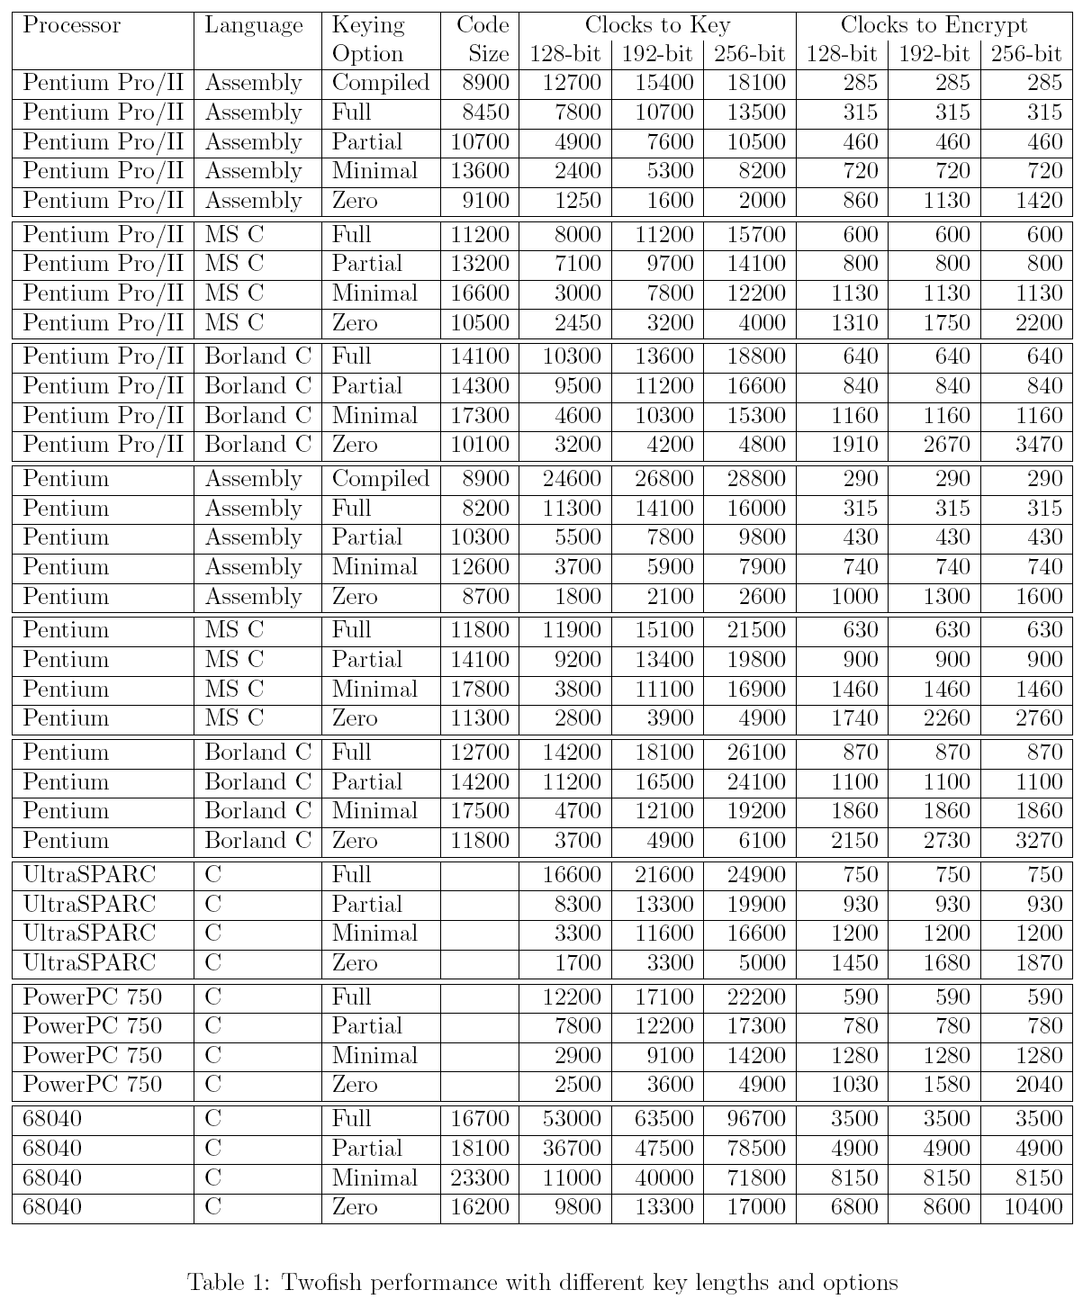
(Bruce Schneier, John Kelsey, Doug Whiting, David Wagner, Chris Hall, Niels Ferguson,1998)

Conclusion

Twofish is one of the algorithms which made it to the final 5 algorithms selected by NIST to become the AES standard. Although it was not selected as the best algorithm in this final, it is nevertheless one of the most advanced and secure symmetric block ciphers in use today, and can be always considered as a very good alternative to AES.
Bibliography

- (Bruce Schneier, http://www.schneier.com/twofish-brief.html)
- (Bruce Schneier, John Kelsey, Doug Whiting, David Wagner, Chris Hall, Niels Ferguson,1998, http://www.schneier.com/paper-twofish-paper.pdf)
- Schneier, Bruce, Kelsey, John, Whiting, Doug, Wagner, David, Hall, Chris, Ferguson, Niels(1999). The Twofish Encryption Algorithm. A 128-Bit Block Cipher. New York, NY: Wiley Computer Publishing. ISBN 0-471-35381-7

