An Installation Guide of PGP
On Windows 2000

CS 627
Spring, 2002
Taotao Zhao

An Installation Guide of PGP
On Windows 2000

PGP, created by Philip Zimmermann, stands for Pretty Good Privacy. It is the standard program for secure e-mail and file encryption on the Internet. PGP is free software and is widely used. There are different versions that run on a variety of platforms. The following is an installation guide of PGP 6.5.8 on Windows 2000.

1. How PGP Works

PGP is based on the public-key cryptography system. Therefore, a PGP keys has the public key part and the private key part. A user uses the public key to encrypt messages or files and uses the private key to decrypt them. The public key can be published on the Internet or be given to any contacts directly. Anyone who wants to send a message to the user can use user’s public key to encrypt it and the user will use the private key to decrypt it. The user can collect other people’s public key and store them on PGP keyring. PGP provides both confidentiality and authentication for emails and files.

2. System Requirements for Installation

To install PGP 6.5.8 on a Windows 2000 system, you will need,

•Windows 2000
•32 MB RAM
•16 MB hard disk space

3. Download Instruction

Before you download PGP 6.5.8, you must make sure you have a zip utility loaded on your computer. You may follow the following steps to download PGP from the Web:

1) Go to the Web site http://www.pgpi.org
. Click "Download" option
2) Click "PGP"
3) Click “Windows 2000”
4) Click “PGP 6.5.8”
5) Choose nearest site to you and click
6) Select "save to disk“
7) Just put it in “desktop” for convenience. After downloading, you will see
“PGPFW658” sitting on your desktop. Close the Web.

4. Installation Instruction

Now, you have “PGPFW658” on your computer. Double click “PGPFW658” and open it.
After the file unzipped, click the “Install” option. The PGPfreeware 6.5.8 Setup program will guide you through all its instructions.

1) First you will see the Welcome window, click “Next”
2) The PGPfreeware 6.5.8 Software License Agreement window appears. Click “Yes”
3) The User Information window (see Figure1) appears. Enter you name and
company. You can enter whatever you want. Then click “Next”
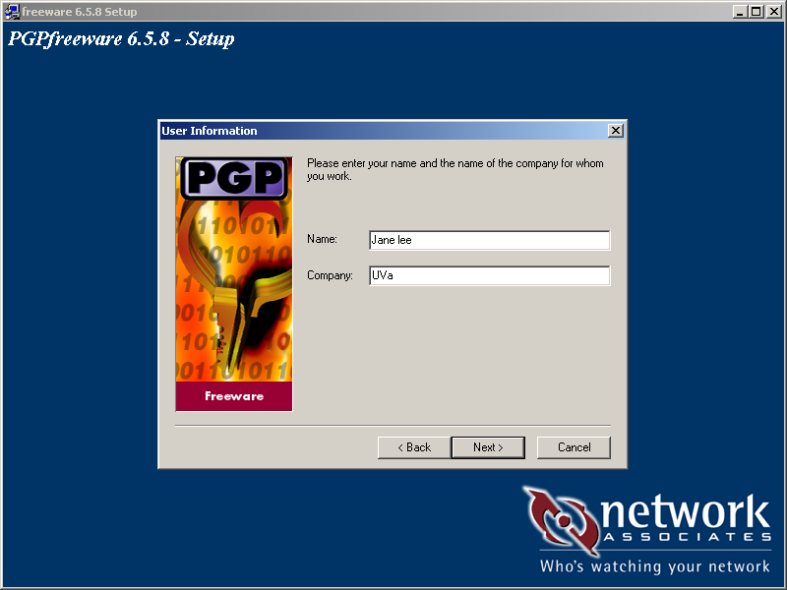

Figure1 The User Information window

4) The Choose Destination Location window (see Figure 2) appears. It is easy to install
PGP to the default folder, so just click “Next”
5) The Select Components window (see Figure 3) appears. If you have Microsoft
Outloook, Outlook Express or Eudora on your computer, you can choose those
components. You can choose the default setting, which includes them all. It will have
no harm. Click “Next”
6) The Ready to Start Copying Files window (figure 4) appears. It shows the current
settings. If you want to make changes, you can click “Back”. Otherwise, click “Next”
7) The dialogue box Do you have existing keyrings you wish to use appears. If you
installed another version of PGP in your computer before and you want to use that
keyrings, you can click “Yes”. Otherwise, you click “No”
8) Last it will ask if you want to launch PGP Keys. If you do not want to do it now, you
can uncheck the checkbox and wait to launch PGP keys by using PGPtray later.
9) Click “finish” to complete the PGP installation

Figure 2 The Choose Destination Location window
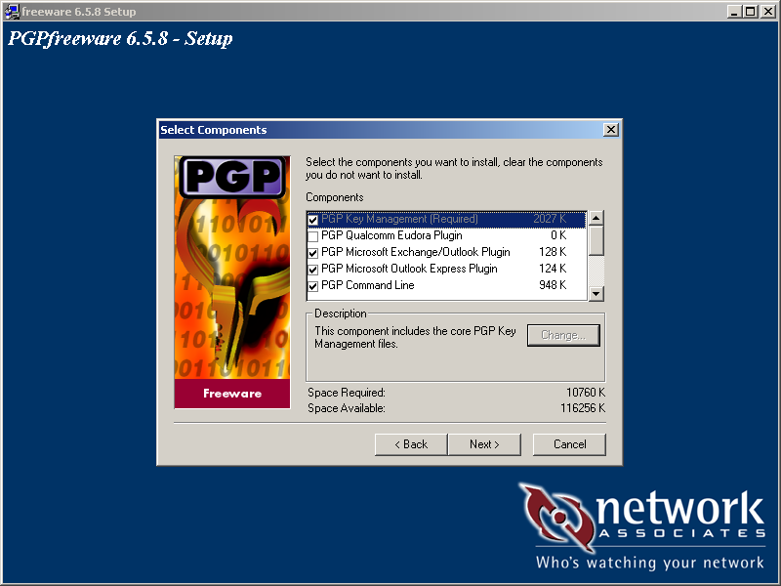

Figure 3 The Select Components window

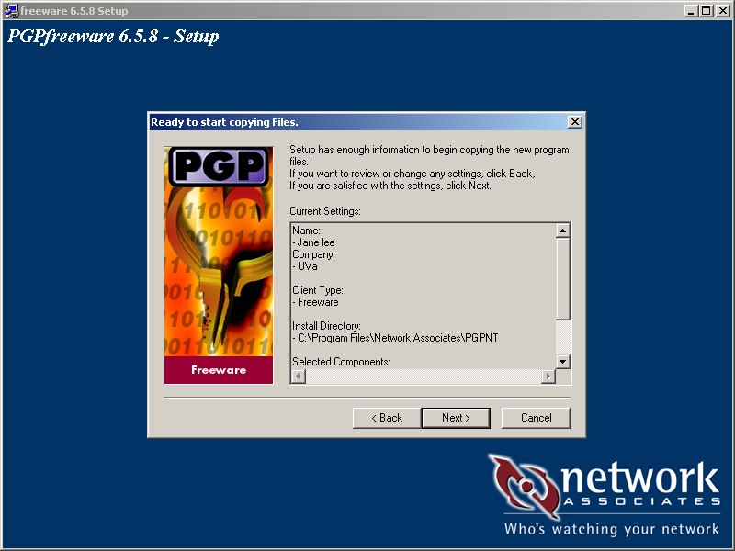

Figure 4 The Ready to Start Copying Files window

5. How to Create a Key Pair

If you chose to launch PGP keys during installation, the “ Key Generation Wizard” window (see Figure 5) will appear after you click “finish”. If you did not choose to launch PGP keys during installation, you may use Start menu to launch PGP keys. That
is, on the Task bar, click the Start button, then click Programs and PGP and select PGP keys. Then follow the Key Generation Wizard to create a key pair.

1) The Key Generation Wizard window appears. Click “Next”
2) It will ask you to enter your full name and email address. You may not
enter your email address, but you need to enter your name. Please See Figure 6. After
entering your name and email, click “Next”.
3) It will ask you to choose Key Pair type. You can choose Diffie-Hellman/DSS or RSA.
Please see Figure 7. After choosing Key Pair, click “Next”
4) It will ask you to choose a Key Pair size. If you choose RSA, then you may choose
- bits because larger keys are more secure. If you choose Diffie-Hellman/DSS,
then you may choose Custom (4096 bits). However, larger keys are slower. Please see
Figure 8. After entering your choice, click “Next”
5) It will ask you to choose Key Pair expiration. Choose Key pair never expires. Please
see Figure 9.

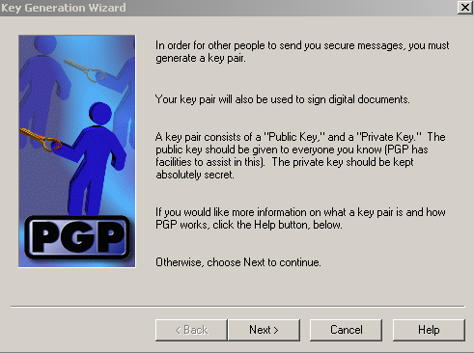

Figure 5 The Key Generation Wizard window
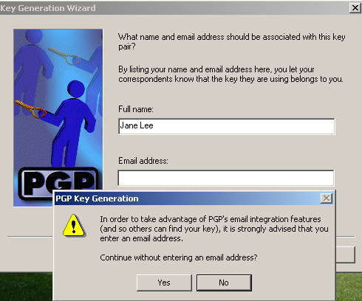

Figure 6 Enter your name and email address

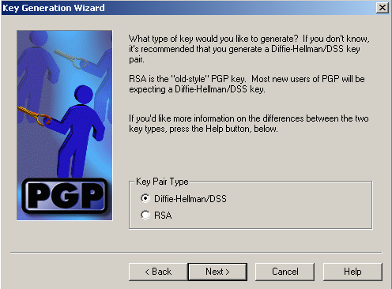
Figure 7 Choose Key Pair type
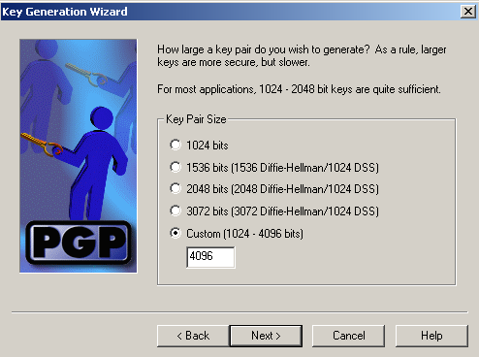

Figure 8 Choose key Pair size

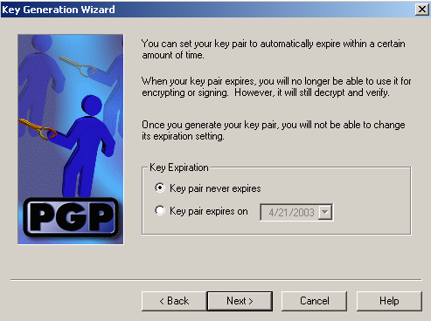

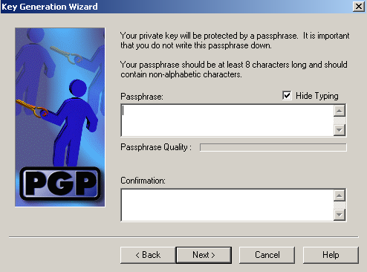Figure 9 Choose Key Pair expiration

Figure 10 Enter a passphrase

6) It will ask you to enter a passphrase. The choice of a good passphrase is extremely
important. You should choose one very secure but also easy to remember. If you forget
your passphrase, you will not be able to decrypt your messages and files any more.
You will have to generate a new Key Pair with a new passphrase. Please see Figure 10.
After entering your passphrase, click “Next”
7) It will ask if you want to send your key to the servers. You may choose not. You can
do it by using PGP keys if you want to send you key to servers later. Click “Next”
8) Click “Finish” and your key will be ready and will appear in your keyring box.

6. How to send your public key by email

To send your public key by email, follow the steps below:

1) Click over the PGPtray icon (see Figure 11)
2) Using your left-hand mouse button to select PGP keys and the PGP keys window
opens (see Figure 12)
3) Find your key and right click on it, then select “Copy”
4) Use your normal email program, and paste the key into the message text box
5) Email to the person you want to give your key to.

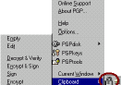

Figure 11 PGPtray

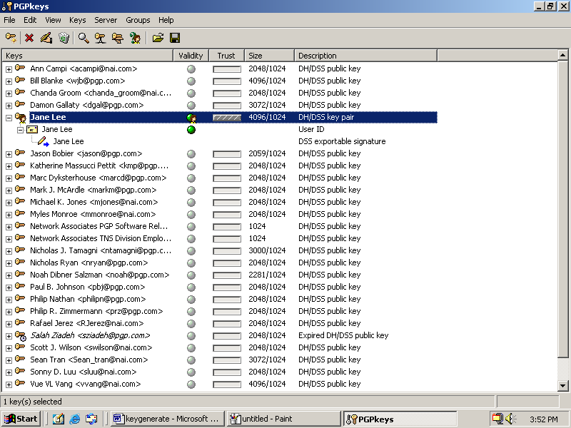

Figure 12 The PGP Keys window

7. How to Add Other’s Public Keys to Your Keyring

The common way to get a key is from a text message or bulletin board. When you get a key from a text message or bulletin board,

1) Highlight the key including all of the leading and ending dashes.
2) Click the right mouse button, and select “Copy”
3) Right click on your PGPtray icon and click “Clipboard”
4) Click “Edit” and select “Paste”
5) The “Select Key(s)” window will appear and click “import”

8. How to Encrypt a Message

When you want to send an encrypted email message, you need to use your public key to encrypt it.

1) Write a message using your email program
2) Click on the PGPtray icon and select Current Window and Encrypt & Sign (see
Figure 13)

3) PGP opens a menu so you can select whose key you want to use

4) When you have found the key, 'drag and drop' it into the "recipient" space and click
OK
5) It will ask you to enter your passphrase, after that you click OK
6) PGP pastes the encrypted message over the original in your mail program, and you
then send it in the normal way.

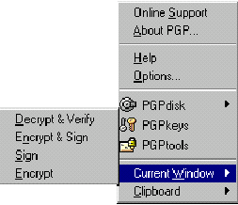

Figure 13 PGPtray’s Current Window

9. How To Decrypt a Message

When you have received an encrypted email message, you need to use your private key to decrypt it.

1) Click once over the encrypted message contents
2) Click on the PGPtray icon and select Current Window and Decrypt & Verify.
3) PGP will ask for your passphrase because it needs your private key to read the
message. Enter your passphrase and PGP will decrypt the message for you.

10. How to Encrypt an Attachment

When you want to send an encrypted email attachment,

1) Click the icon of the file (or folder) you wish to encrypt.
2) Right click on the file’s icon.
3) From the drop menu select "PGP", then select "Encrypt” or “Encrypt & Sign”
4) Select the key you wish to use to encrypt the file and drag it to the box below, and
release it.
5) Click "OK". The file is now encrypted and will be saved in the directory where the
original file was.
6) Delete the original unencrypted file for security

11. How to decrypt an Attachment

When you have received an encrypted email attachment,

1) Download and save the encrypted attachment to desktop
2) Right click the saved file icon
3) From the drop menu select "PGP", then select "Decrypt" or “ Decrypt & Verify”
4) Type your passphrase, then click "OK"
5) The decrypted file appears on the desktop. You can use the appropriate program to
open the file and read it. For example, if it is a MS Word file, you choose WinWord to
open it.

References

• User’s Guide, PGP Freeware for Windows 95, Windows 98 and Windows NT and
Windows 2000, Version 6.5 & 7.0 , http://www.pgpi.org/doc/6.5,
http://www.pgpi.org/doc/7.0
• Installation of PGP on Windows machine,
http://www.vigay.com/cgi-bin/r?a=pgp-windows
• PGP Installation and use for Dummies,
http://www.theinternet.cc/pgp4dummies/main.htm
• http://www.nai.com/products/security/freeware.asp

