International Data Encryption Algorithm

CS-627-1
Fall 2004

By

How-Shen Chang

Table of Contents:

Introduction 2
Description of IDEA 3
Key Generation 3
Encryption 4
Decryption 6
Modes of operation 6
Weak keys for IDEA 6
Implementation 7
Applications 8
Conclusion 9

Introduction

The Data Encryption Standard (DES) algorithm has been a popular secret key encryption algorithm and is used in many commercial and financial applications.
Although introduced in 1976, it has proved resistant to all forms of cryptanalysis. However, its key size is too small by current standards and its entire 56 bit key space can be searched in approximately 22 hours [1].
International Data Encryption Algorithm (IDEA) is a block cipher designed by Xuejia Lai and James L. Massey of ETH-Zürich and was first described in 1991. It is a minor revision of an earlier cipher, PES (Proposed Encryption Standard); IDEA was originally called IPES (Improved PES). IDEA was used as the symmetric cipher in early versions of the Pretty Good Privacy cryptosystem.
IDEA was to develop a strong encryption algorithm, which would replace the DES procedure developed in the U.S.A. in the seventies. It is also interesting in that it entirely avoids the use of any lookup tables or S-boxes. When the famous PGP email and file encryption product was designed by Phil Zimmermann, the developers were looking for maximum security. IDEA was their first choice for data encryption based on its proven design and its great reputation.

The IDEA encryption algorithm
- provides high level security not based on keeping the algorithm a secret, but rather upon ignorance of the secret key
- is fully specified and easily understood
- is available to everybody
- is suitable for use in a wide range of applications
- can be economically implemented in electronic components (VLSI Chip)
- can be used efficiently
- may be exported world wide
- is patent protected to prevent fraud and piracy

Description of IDEA

The block cipher IDEA operates with 64-bit plaintext and cipher text blocks and is controlled by a 128-bit key. The fundamental innovation in the design of this algorithm is the use of operations from three different algebraic groups. The substitution boxes and the associated table lookups used in the block ciphers available to-date have been completely avoided. The algorithm structure has been chosen such that, with the exception that different key sub-blocks are used, the encryption process is identical to the decryption process.

Key Generation

The 64-bit plaintext block is partitioned into four 16-bit sub-blocks, since all the algebraic operations used in the encryption process operate on 16-bit numbers. Another process produces for each of the encryption rounds, six 16-bit key sub-blocks from the 128-bit key. Since a further four 16-bit key-sub-blocks are required for the subsequent output transformation, a total of 52 (= 8 x 6 + 4) different 16-bit sub-blocks have to be generated from the 128-bit key.
The key sub-blocks used for the encryption and the decryption in the individual rounds are shown in Table 1.

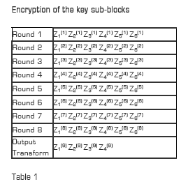

The 52 16-bit key sub-blocks which are generated from the 128-bit key are produced as follows:

- First, the 128-bit key is partitioned into eight 16-bit sub-blocks which are then directly used as the first eight key sub-blocks.
- The 128-bit key is then cyclically shifted to the left by 25 positions, after which the resulting 128-bit block is again partitioned into eight 16-bit sub-blocks to be directly used as the next eight key sub-blocks.
- The cyclic shift procedure described above is repeated until all of the required 52 16-bit key sub-blocks have been generated.

Encryption

The functional representation of the encryption process is shown in Figure 1. The process consists of eight identical encryption steps (known as encryption rounds) followed by an output transformation. The structure of the first round is shown in detail.

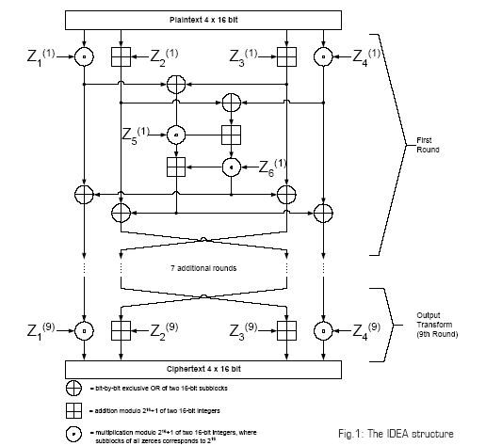

In the first encryption round, the first four 16-bit key sub-blocks are combined with two of the 16-bit plaintext blocks using addition modulo 2¹⁶, and with the other two plaintext blocks using multiplication modulo 2¹⁶ + 1. The results are then processed further as shown in Figure 1, whereby two more 16-bit key sub-blocks enter the calculation and the third algebraic group operator, the bit-by-bit exclusive OR, is used. At the end of the first encryption round four 16-bit values are produced which are used as input to the second encryption round in a partially changed order. The process described above for round one is repeated in each of the subsequent 7 encryption rounds using different 16-bit key sub-blocks for each combination. During the subsequent output transformation, the four 16-bit values produced at the end of the 8th encryption round are combined with the last four of the 52 key sub-blocks using addition modulo 2¹⁶ and multiplication modulo 2¹⁶ + 1 to form the resulting four 16-bit ciphertext blocks.

Decryption

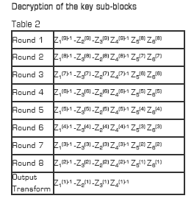

The computational process used for decryption of the ciphertext is essentially the same as that used for encryption of the plaintext. The only difference compared with encryption is that during decryption, different 16-bit key sub-blocks are generated.
More precisely, each of the 52 16-bit key sub-blocks used for decryption is the inverse of the key sub-block used during encryption in respect of the applied algebraic group operation. Additionally, the key sub-blocks must be used in the reverse order during decryption in order to reverse the encryption process as shown in Table 2.
Modes of operation

IDEA supports all modes of operation as described by NIST in its publication FIPS 81. A block cipher encrypts and decrypts plaintext in fixed-size-bit blocks (mostly 64 and 128 bit). For plaintext exceeding this fixed size, the simplest approach is to partition the plaintext into blocks of equal length and encrypt each separately. This method is named Electronic Code Book (ECB) mode. However, Electronic Code Book is not a good system to use with small block sizes (for example, smaller than 40 bits) and identical encryption modes. As ECB has disadvantages in most applications, other methods named modes have been created. They are Cipher Block Chaining (CBC), Cipher Feedback (CFB) and Output Feedback (OFB) modes.

Weak keys for IDEA

According to Daemon’s report [6], large classes of weak keys have been found for the block cipher algorithm IDEA. IDEA has a 128-bit key and encrypts blocks of 64 bits. For a class of 223 keys IDEA exhibits a linear factor. For a certain class of 235 keys the cipher has a global characteristic with probability 1. For another class of 251 keys only two encryptions and solving a set of 16 nonlinear boolean equations with 12 variables is sufficient to test if the used key belongs to this class. If it does, its particular value can be calculated efficiently. It is shown that the problem of weak keys can be eliminated by slightly modifying the key schedule of IDEA.
In [4], two new attacks on a reduced number of rounds of IDEA are presented: truncated differential attack and differential-linear attack. The truncated differential attack finds the secret key of 3.5 rounds of IDEA in more than 86% of all cases using an estimated number of 2⁵⁶ chosen plaintexts and a workload of about 2⁶⁷ encryptions of 3.5 rounds of IDEA. With 2⁴⁰ chosen plaintexts the attack works for 1% of all keys. The differential-linear attack finds the secret key of 3 rounds of IDEA. It needs at most 2²⁹ chosen pairs of plaintext and a workload of about 2⁴⁴ encryptions with 3 rounds of IDEA.

Implementation

Although IDEA involves only simple 16-bit operations, software implementations of this algorithm still cannot offer the encryption rate required for on-line encryption in high-speed networks. Software implementation running on a Sun Enterprise E4500 machine with twelve 400MHz Ultra-Hi processor, performs 2.30 x 10⁶ encryptions per second or a equivalent encryption rate of 147.13Mb/sec, still cannot be applied to applications such as encryption for 155Mb/sec Asynchronous Transfer Mode (ATM) networks.
Hardware implementations offer significant speed improvements over software implementations by exploiting parallelism among operators. In addition, they are likely to be cheaper, have lower power consumption and smaller footprint than a high speed software implementation. The first VLSI implementation of IDEA was developed and verified by Bonnenberg et. al. in 1992 using a 1.5 CMOS technology [7]. This implementation had an encryption rate of 44Mb/sec. In 1994, VINCI, a 177Mb/sec VLSI implementation of the IDEA algorithm in 1.2 CMOS technology, was reported by Curiger et. al. [5, 11]. A 355Mb/sec implementation in 0.8 technology of IDEA was reported in 1995 by Wolter et. al. [10]. The fastest single chip implementation of which we are aware is a 424Mb/sec implementation of 0.7 technology by Salomao et. al. [9]. A commercial implementation of IDEA called the IDEACrypt coprocessor, developed by Ascom achieves 300Mb/sec [2].
A high performance implementation of the IDEA presented by Leong [8] uses a novel bit-serial architecture to perform multiplication modulo 2¹⁶ + 1; the implementation occupies a minimal amount of hardware. The bit-serial architecture enabled the algorithm to be deeply pipelined to achieve a system clock rate of 125MHz. An implementation on a Xilinx Virtex X CV300-4 was successfully tested, delivering a throughput of 500Mb/sec. With a X CV1000-6 device, the estimated performance is 2.35Gb/sec, three orders of magnitude faster than a software implementation on a 450MHz Intel Pentium II. This design is suitable for applications in online encryption for high-speed networks. The results of Leong’s experiment are summarized in Table 3.

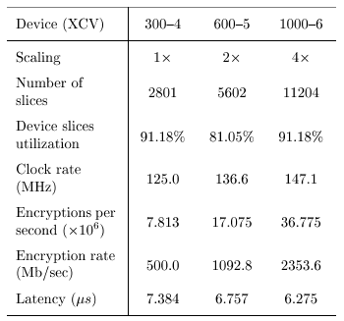
Table 3. Results of Leong’s experiment on different devices

Applications

Today, there are hundreds of IDEA-based security solutions available in many market areas, ranging from Financial Services, and Broadcasting to Government. IDEA is the name of a proven, secure, and universally applicable block encryption algorithm, which permits effective protection of transmitted and stored data against unauthorized access by third parties. The fundamental criteria for the development of IDEA were highest security requirements along with easy hardware and software implementation for fast execution.
The IDEA algorithm can easily be embedded in any encryption software. Data encryption can be used to protect data transmission and storage. Typical fields are:

– Audio and video data for cable TV, pay TV, video conferencing, distance learning, business TV, VoIP
– Sensitive financial and commercial data
– Email via public networks
– Transmission links via modem, router or ATM link, GSM technology
– Smart cards

Conclusion

As electronic communications grow in importance, there is also an increasing need for data protection. Encryption ensures that:

– Only authorized persons can access information.
– Data cannot be amended or manipulated by unauthorized persons.
– Unbreakable crypt system warrants military strength security level.
When PGP (Pretty Good Privacy) was designed, the developers were looking for maximum security. IDEA was their first choice for data encryption based on its proven design and its great reputation. Today, there are hundreds of IDEA-based security solutions available
RSA Security goes on to say that IDEA was analyzed to measure its strength against differential cryptanalysis. The analysis concluded that IDEA is immune to that technique. In fact, there are no linear cryptanalytic attacks on IDEA, and there are no known algebraic weaknesses in IDEA. The only weakness of note was discovered by Daemen: using any of a class of 2⁵¹ weak keys during encryption results in easy detection and recovery of the key. However, since there are 2¹²⁸ possible keys, this result has no impact on the practical security of the cipher for encryption provided the encryption keys are chosen at random. IDEA is generally considered to be a very secure cipher and both the cipher development and its theoretical basis have been openly and widely discussed.
IDEA is a patented and universally applicable block encryption algorithm, which permits the effective protection of transmitted and stored data against unauthorized access by third parties. With a key of 128 bits in length, IDEA is far more secure than the widely known DES based on a 56-bit key. The fundamental criteria for the development of IDEA were military strength for all security requirements and easy hardware and software implementation. The algorithm is used worldwide in various banking and industry applications. They predestine the algorithm for use in a great number of commercial applications.

Bibliography

[1] Electronic Frontier Foundation, “DES challenge III broken in record 22 hours," January1999.
(http://www.eff.org/Privacy/Crypto/Crypto_misc/DESCracker/HTML/19990119_deschallenge3.html).

[2] Ascom, IDEACrypt Coprocessor Data Sheet, 1999. (http://www.ascom.ch/infosec/downloads/IDEACrypt Coprocessor.pdf).

[3]H. Bonnenberg, A. Curiger, N. Felber, H. Kaeslin, and X. Lai, “VLSI implementation of a new block cipher," in Proceedings of the IEEE International Conference on Computer Design: VLSI in Computer and Processors, pp. 501-513, 1991.

[4] J. Borst, L.R. Knudsen and V. Rijmen, Two Attacks on Reduced IDEA, Advances in Cryptology - EUROCRYPT 1997, Springer-Verlag (1992), pp. 1-13

[5] A. Curiger, H. Bonnenberg, R. Zimmerman, N. Felber, H. Kaeslin, and W. Fichtner, “VINCI: VLSI implementation of the new secret-key block cipher IDEA," in Proceedings of the IEEE Custom Integrated Circuits Conference, pp. 15.5.1-15.5.4, 1993.

[6] J. Daemen, R. Govaerts, and J. Vandewalle, Weak keys for IDEA, Advances in Cryptology - Crypto '93, Springer-Verlag (1994), pp. 224-231

[7] X. Lai, J.L. Massey and S. Murphy, Markov ciphers and differential cryptanalysis, Advances in Cryptology - Eurocrypt '91, Springer-Verlag (1992), pp. 17-38.

[8] M.P. Leong, O.Y.H. Cheung, K.H. Tsoi and P.H.W. Leong,
“A Bit-Serial Implementation of the International Data Encryption Algorithm IDEA,” 2000 IEEE Symposium on Field-Programmable Custom Computing Machines, IEEE (2000), pp. 122-131.

[9] S. L. C. Salomao, V. C. Alves, and E. M. C. Filho, “HiPCrypto: A high-performance VLSI cryptographic chip," in Proceedings of the Eleventh Annual IEEE ASIC Conference, pp. 7-11, 1998.

[10] S. Wolter, H. Matz, A. Schubert, and R. Laur, “On the VLSI implementation of the international data encryption algorithm IDEA," in Proceedings of the IEEE International Symposium on Circuits and Systems, vol. 1, pp. 397-400, 1995.

[11] R. Zimmermann, A. Curiger, H. Bonnenberg, H. Kaeslin, N. Felber, and W. Fichtner, “A 177Mb/sec VLSI implementation of the international data encryption algorithm," IEEE Journal of Solid-State Circuits, vol. 29, pp. 303-307, March 1994.

