Installation and User Guide for Gregory Braun’s Blowfish 2000

By

Robert Moncrief

Table of Context

Title Page
Windows 2000 Installation Guide 3
Window ME Installation Guide 6
Windows 98 Installation Guide 8
Users Guide 10
Explanation of Options 13
FAQ (Frequently Asked Questions) 17

Installation Guide

*Note: this blowfish implementation is free to try, but if you decide to keep using it you should submit the $25 registration fee.

Windows 2000 Installation

The First thing you need to do for all the installations is to download the program, which is a self extracting zip file from the web site, http://www.gregorybraun.com/BlowFish.html. You can save the file to your desktop for easier use. Once you have downloaded the file, quit all other applications and double click on the BlowFish_Setup icon.
When you start the program, the screen below and to the right will appear. To proceed with the installation, click ok

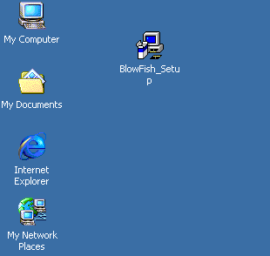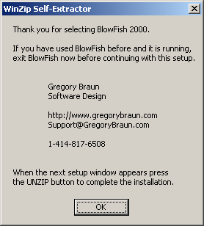

When you click ok, the next window will appear which is a self-extracting zip screen.

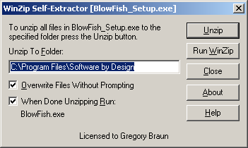

Select the folder that you would like to install the to or use the default and press unzip. After the file completes it’s extracting of the files, the following message will appear

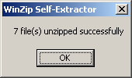

Click ok. After you do this, the program will load. There will be a logo displayed which I was not able to capture. Next, an options screen will appear. You can select what ever you would like, I will explain them later in the paper what each one does.

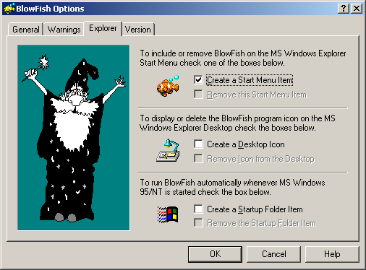

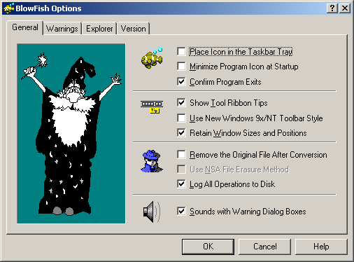

Click ok. Software is ready to use

Windows ME installation

The First thing you need to do for all the installations is to download the program, which is a self extracting zip file from the web site, http://www.gregorybraun.com/BlowFish.html. You can save the file to your desktop for easier use. Once you have downloaded the file, quit all other applications and double click on the BlowFish_Setup icon.
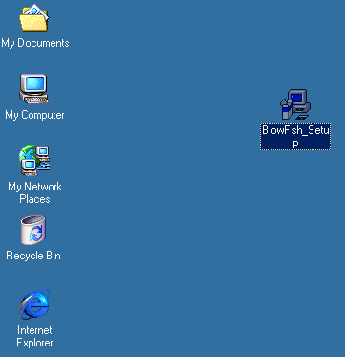
When you start the program, the screen below will appear. To proceed with the installation, click ok
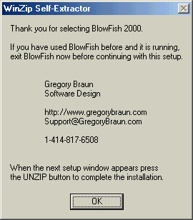

When you click ok, the next window will appear which is a self-extracting zip screen.

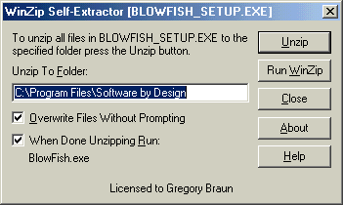

Select the folder that you would like to install the to or use the default and press unzip. After the file completes it’s extracting of the files, the following message will appear.

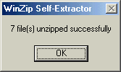

Click ok. After you do this the program will load. There will be a logo displayed which I was not able to capture. Next, an options screen will appear. You can select what ever you would like, I will explain them later in the paper what each one does.

Windows 98

The First thing you need to do for all the installations is to download the program, which is a self extracting zip file from the web site, http://www.gregorybraun.com/BlowFish.html. You can save the file to your desktop for easier use. Once you have downloaded the file, quit all other applications and double click on the BlowFish_Setup icon.
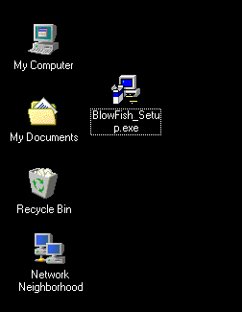

When you start the program, the screen below will appear. To proceed with the installation, click ok
When you click ok, the next window will appear which is a self-extracting zip screen.

Select the folder that you would like to install the to or use the default and press unzip. After the file completes it’s extracting of the files, the following message will appear.

Click ok. After you do this the program will load. There will be a logo displayed which I was not able to capture. Next, an options screen will appear. You can select what ever you would like, I will explain them later in the paper what each one does.

User Guide

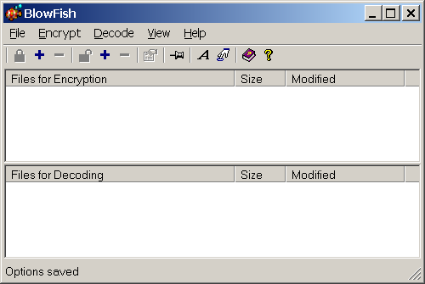

To Encrypt

Open the folder with the file that you wish to encrypt. Drag the file over to the blowfish window and release it in the top half of the application under the heading "Files for Encryption". After you release the mouse the file will appear.

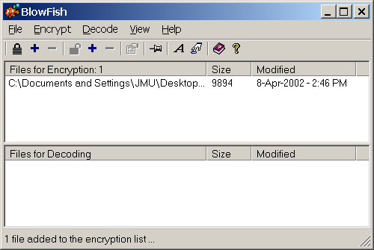

You can encrypt several files at once. But they will be encrypted with the same key. Alternatively to dragging and dropping, you can click the plus sign next to the locked padlock and the windows interface for selection a file will come up for you to choose a file.

After you have selected all the files that you want to encrypt with the same key, press the locked-padlock button in the upper left of the application. Blowfish will ask you for a key, and to confirm that key.
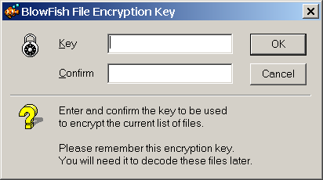

After you enter the key twice, hit ok. This will activate the program and have it encrypt the file(s) that you have selected for encryption.

To Decrypt.

Open the folder with the file that you wish to decrypt. Drag the file over to the blowfish window and release it in the bottom half of the application under the heading "Files for Decoding". After you release the mouse the file will appear.
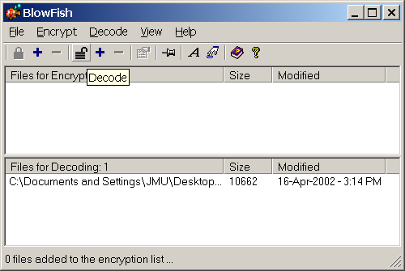

You can decrypt several files at once. But they will be encrypted with the same key. Alternatively to dragging and dropping, you can click the plus sign next to the unlocked padlock and the windows interface for selection a file will come up for you to choose a file.
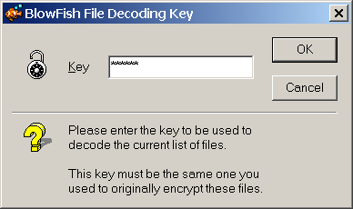

After you have selected all the files that you want to encrypt with the same key, press the open-padlock button in the upper left of the application. Blowfish will ask you for the key and then press ok. The program will decrypt everything that was encrypted with that key. If there are files that were not encrypted with that key, it will display a widow with the files
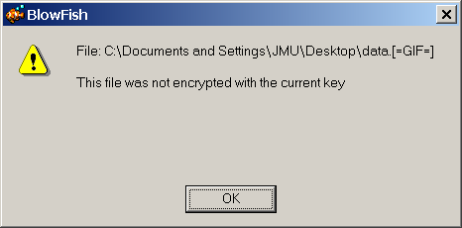

Explanation of Options

Application security

You can choose to have a password on the application itself. This would prevent a user from being able to use the application at all. To set a password after the initial installation, go to file, access and the following screen will appear.

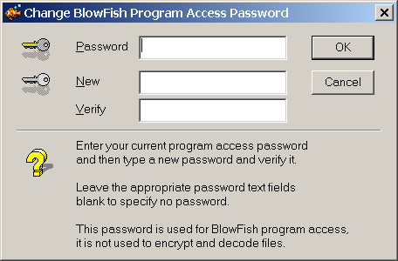

Program options

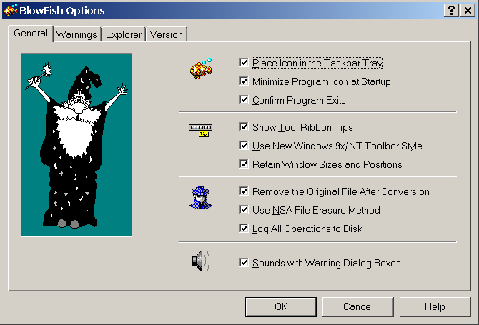

Place Icon in the Taskbar Tray
This puts the program in the taskbar next to the time; from there, with one click you can launch the application rather than having to search for it.

Minimize Program Icon at Startup
With this selected, the program will not appear when you first start it, or if you have you computer launch it at start-up, instead it will sit in the toolbar until you are ready to use it.

Confirm Program Exits
This displays a popup window to make sure you really want to quit. You can turn this option off here, or on the exit screen.
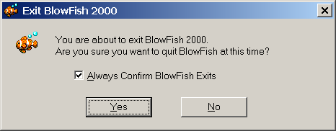

Show Tool Ribbon Tips
The tool tips are the little windows that popup if you leave the mouse on one of the tools for a couple seconds. You see an example below to add a file to decrypt.
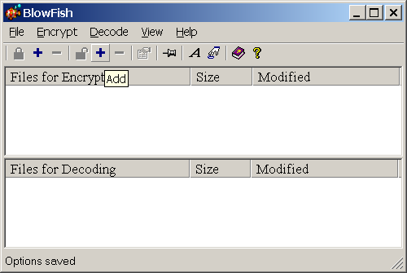

Use New Windows 9x/NT toolbar style
The pictures above and below are the two different styles. The one below is the old style where all the icons on the toolbar are in boxes, where as the one above, the icons are not enclosed in a box for each one, rather just 1 box unless you scroll over them
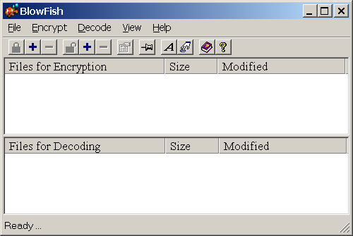

Retain Window Sizes and Positions
This will keep the information from the last time the program was used and when you restore it, the program will use the previous information to restore to.

Remove the original file after conversion
This is a security option. If you don't want a file to have both an encrypted and an unencrypted file on the machine, then check this. Checking will have the program delete the file after it makes the encrypted copy. You would not use this if you just wanted to send the file and you weren't worried about the file on the computer you are using.

Use NSA file erasure Method
This option will make sure it erases the original file completely. The implementation of this is the overwriting of the space 6 times by all ones and all zeros alternating. This should stop most resurrection utilities from being able to read data. It will take a longer time for the extra writing to the heads

Log all operations to Disk
This option will log all the files that were encrypted and decrypted. It also states the time and if everything went all right.

Sounds with Warning Dialog
Check this one if you want sounds to be played went alerts popup
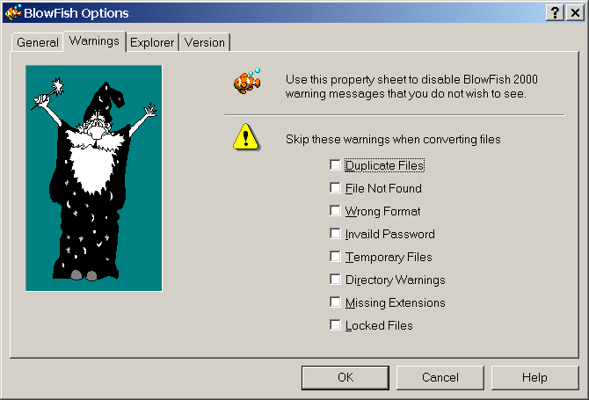

Icon Options
With the following screen you can choose if you want an item on the start menu or not, a shortcut in the desktop, and or the program to be put in the startup folder.

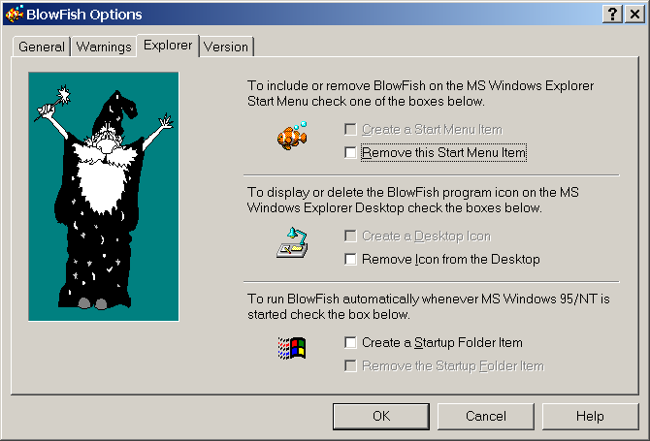

Frequently Asked Questions

How do I make my application secure?
To password protect this program, click on the file menu, and go to access, a screen will popup and ask you for the password, new, and verify. If you have no password at this time, then leave the password blank. Enter the password that you want to use in the new and then retype it in the verify space. When you click ok, the password will be set to protect your program.

How do I protect my files from a software attack on the disk?
There are two levels of security that this program additionally offers. The first is to erase the original file, and the second is to write over the file 6 times with 1’s and 0’s alternating to protect the deleted information for a software attack. To turn these features on, go to the file menu and press options. Go to the General tab and the first box you need to check is the “Remove the Original File After Conversion”, after you click the check box, the line below it, “Use NSA File Erasure Method” will become available to be checked. You want to check that box also to get the best security. Click ok to go back to the main screen.

Where can I get the latest updates?
To get the latest version, go to the web site http://www.gregorybraun.com , to check your version, click file, options, and click on the version tab and that screen will tell you whet version of the program you have. Click ok to go back to the main screen.

How can I add/remove the BlowFish Item from the start menu?
To add or remove the BlowFish item from your start menu, click on file, options and click on the Explorer tab. Click the appropriate check box to add or remove the item. Click ok to go back to the main screen.

How can I add/remove the BlowFish icon from the desktop?
To add or remove the BlowFish icon from your desktop, click on file, options and click on the Explorer tab. Click the appropriate check box to add or remove the icon. Click ok to go back to the main screen.

How can I set BlowFish to start when windows boots up?
To add or remove the BlowFish icon from your desktop, click on file, options and click on the Explorer tab. Click the appropriate check box to have BlowFish start automatically or not. Click ok to go back to the main screen.

How can I turn off the message asking me to confirm that I want to quit?
To make blowfish not confirm that you want to exit the program, click on file, options and click on the General tab, you will see a check box with the description “Confirm Program Exits” if you uncheck this the program will exit without prompting you if you are sure you want to exit. Click ok to go back to the main screen.

How can I make BlowFish keep the position and window size that I choose?
To make blowfish retain information about size and position, click on file, options and click on the General tab, you will see a check box with the description “Retain Window Sizes and Positions” by checking this blowfish will remember these setting and restore to them. Click ok to go back to the main screen.

How can I turn off the sounds when a warning pops-up?
To turn off the warning sounds when warning dialogs appear, click on file, options and click on the General tab. At the bottom of the screen, the last checkbox, states “Sounds with Warning Dialog Boxes” if you uncheck this then there will be no alerts sounded. Click ok to go back to the main screen.

Where can I find additional help?
On the main screen to the right of the toolbar you will see a purple book, if the information in this user guide doesn’t give you all the information that you want, please click on that icon and the windows help will come up with help for the blowfish program.

Can I set the program to ignore certain warning messages?
To turn off certain warning messages, click on file, options and click on the Warnings tab. Check any warnings that you do not want to be bothered with. Click ok to go back to the main screen.

Can I change the font style and size?
Yes, by going to the main screen, there is a Capital letter A on the tool bar, if you click that a screen will popup that will allow you to change the settings for the fonts.

Is there an easier way to get to the option menu?
There is a shortcut on the toolbar, if you press the button that looks like a hand with a finger extended to press a key, by pressing this the options menu will come up.

