The Expansion Bus

By:
Ryan McKenica
Dan Hummell
Valerie Grinblat

CS350 Spring 2002
Section 2

TABLE OF CONTENTS:

Introduction….………….…………………..………..……………….……..1

PC/XT….………….………….……………..………..…………………..….1

Figure 0.1: 8-bit card….………….…………………..………..…………….1

PC/AT….………….…………………..………..…………………..……..1-2

ISA….………….…………………..………..…………………………..…..2

Figure 0.2: 16-bit card………….…………………..……………………..…2

MCA….………….…………………..………..…………………………..2-4

Figure 1.1………….………………………………………………...………4

EISA………….……………………………………………………...………5

VESA………….…………………..………………………………………6-7

Figure 2.1: The VESA/VL Bus Connector………………...………..………6

PCI………….…………………..…………………………………………7-8

Figure 2.2: PCI Bus Connection………….…………………………………7

Figure 2.3: PCI Bridge Diagram………….…………………..…………..…8

Bus Comparison Chart………….…………………..…………………….…9

Glossary………….…………………..…………………………………..…10

References………….…………………..………………………………..…11

Adding power and performance to a PC is what technology was all about during the early 1980s. An expansion bus is just what the technology industry needed. What IBM wanted to develop was something that enabled the user to plug things into the machine to enhance its operation.

PC/XT Bus

- Three electrical grounds
- Five pins supply voltages around computer
- Twenty address lines
- Eight data lines
- Ten pins for interrupts
- Several special-purpose pins

62 PINS USED BY PC/XT BUS (Brady, Hardware Bible: 1992)

The PC/XT bus was released in 1981 by IBM. This bus’s addressing capabilities was limited to the 8-bit level of the processor and was also completely controlled by it. This bus was intended to be used for additions, which there was not any room for on the motherboard. Lines were also added on the bus for signaling interrupts for input/output ports. Depending on how many tasks the system was busy with; the data transfer could be a maximum speed of 2.38 Mbps.⁴

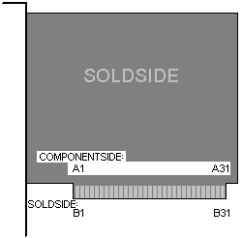
Figure 0.1: 8-bit card ⁵

AT Bus

The PC bus after a while, could not handle what the public really needed. The PC had limited memory handling and the width of its data path was quickly outdated. A hybrid, the AT bus was developed. It was designed to take into account newer advances in technology. It was designed with two separate oscillators. This allowed the microprocessor and expansion bus to be run on different clocks with different speeds. After a few more years, computers became much faster, but expansion boards were still limited to 8 Mbps.

There were a few physical differences between the PC and the AT bus. There were four more address lines and 8 more data lines, in other words, a second connector. It also included more interrupt and DMA control lines. It was backwards compatible and was also a smooth bridge towards the 16-bit data bus. ⁷

ISA Bus

A new processor called the 286 came out which was designed to run at 8MHz. It also was able to contain a 16-bit data bus. In 1984, the modern ISA (Industry Standard Architecture) bus came out that could take advantage of this 16-bit addressing limit. Now it could accept twice as many interrupts and DMA channels as the PC/AT bus.

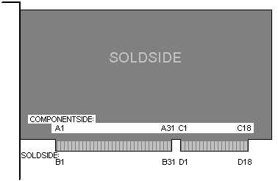
Figure 0.2: 16-bit card ⁵

One of the problems with the ISA bus is that each device behaves as if it had complete access to the system resources because it does not have a central registry to allocate system resources. When using multiple add-in boards this lack of a registry can cause severe difficulties. Another problem is that there are a limited number of available ports and interrupts on the system. A company called Quatech solved this problem by developing drivers that allowed several devices to share the same interrupt. This driver kept track of where the interrupt was coming from. ⁶

Micro Channel Architecture (MCA) Bus

In 1987, IBM developed Micro Channel Architecture bus. This was the first 32-bit bus for the personal computer. During development for this bus, IBM did not make the MCA bus compatible with ISA buses. IBM would change the standard of the bus and the way computers were designed. The difference between bus speed and microprocessor speed was limiting with a bus locked at an 8 Mhz. rate. IBM was inspired by a multitude of the best ideas derived from the mainframe computers used in the big office buildings. One of these ideas was the concept of bus mastering with full-prioritized authorization. The design of the MCA bus gave IBM an edge to an industry without a 32-bit expansion standard. The cost of manufacturing would rise in some aspects but create many benefits in terms of speed, signal enhancement, more data, and more addresses.

The creation of this design would make PC and AT buses obsolete. Many manufacturers and users had much dismay to a bus that was not molded from the PC and AT buses. Manufacturing and upgrading to this new design would be very costly. Despite this costly modification, the PC and AT buses needed to go because the slow speed of the bus created a huge performance limit, especially on the 80386-based computers. IBM, being the creator of the PC bus, was possibly the only company that could make a new standard for the PC bus. According to IBM, the designing for the MCA bus began as early as 1983. There are features on the AT bus that show some the design of the Micro Channel.

The creation of the Micro Channel produced a set of redefined standards fir linking an assortment of circuit elements and internal peripherals. Micro Channel Architecture identifies the size and physical arrangement of the bus connectors, the signals they carry, and the logical function to know how the system runs.

The creation of Micro Channel Architecture began a new way of designing computers. IBM’s new bus was designed with smaller connectors and smaller surface mount components because of the diminished size of expansion boards. Less power was required for the new boards because of the surface mount components. This allowed for less heat and the miniaturization. Users were very pleased to have a computer that took up less desk space as computers became smaller. Overall, the smaller boards cut costs for the manufactures because less material was needed to build the new design. A glass-epoxy base was used to build the boards. Even though cost of materials was reduced, the labor put into building these boards outweighed the price for materials.

IBM was able to reduce interference by designing the boards with the many grounds close to the high frequency digital signals. This was possible by changing the layout of signals on the Micro Channel. Every fourth pin had an electrical ground. This turned out to be a huge benefit for IBM because getting FCC certification was often a big problem in designing these boards. The new layout of the signals also allowed for faster operation speed for the expansion boards. This is because the bandwidth of the bus was increased allowing for higher frequencies and data rates. Finally, the limit of 8 Mhz. bus speeds was pushed to 10 Mhz. with the first Micro Channels. The new design also allowed for extra data lines, more address lines, and new features such as channels for audio and video information. In FIGURE 1.1, the dimensions of new design can be compared to the old PC and AT designs.

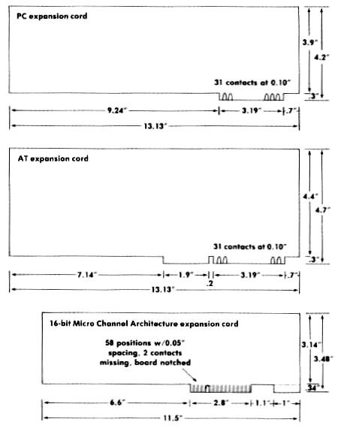
FIGURE 1.1

By adding 16 data lines to the Micro Channel, the width of the bus data path was increased to 32 bits. This allows for access to I/O devices, memory, and other components connected to the bus to be accessed twice the speed. The address bus was also extended to 8 more bits, increasing the address lines to 32 instead of 21 lines. On the AT bus the addressable memory was 16 megabytes. The new improved MCA bus allowed for 4 gigabytes of addressable memory.

The added speed and bus width allowed for new features for the PC. With a 16- and 32-bit Micro Channel design, analog audio signals of medium fidelity, such as synthesized music or voices, was integrated into the bus structure. The new bus design also permitted analog noise levels up to 50 millivolts against a maximum analog signal of 2,500 millivolts. The signal-to-noise ratio is 32 dB. Then MCA bus design allowed audio signals to independently be processed from the expansion cards on the channel.

Extended Industry Standard Architecture (EISA) Bus

IBM put a patent on the MCA bus, trying to corner the market. This motivated nine companies, called the “Gang of Nine,” to unite to develop a comparable architecture. The nine companies included: AST Research, Compaq Computer Corp., Epson, Hewlett-Packard Company, NEC, Olivetti, Tandy, Wyse, and Zenith Data Systems. This design would be out of the control of IBM and allow other companies to survive the competition. The new design incorporated the best ideas already used in bus design. This included bus mastering, automated setup, and interrupt sharing. One added feature was the new data-transfer modes. ²

The EISA committee had hoped to develop a design that molded from the original AT bus since IBM abandoned the AT-bus standard. The developers of EISA decided to make a design that was at heart backward compatible with the AT bus. This would save money for the manufactures and companies that invested billions into old architecture. Some compromises had to be made to make this possible and a new type of connector was necessary to make the architecture work.

The EISA expansion boards were the exact same dimensions as the AT boards, but some specific changes were made to make sure that future products were compatible with PC boards. The expansion connector for the EISA design would ensure backward compatible with PC-bus cards and allow 32-bit expandability of EISA peripherals. The new connector added 90 new connections without increasing the dimensions of the connector. The new connector had a two-tier design that was a changed specification from the original EISA design. Originally, the connector consisted of a two parallel connectors. This design was proved deficient. The new design for the connector attained compatibility and full 32-bit expandability by branching out vertically instead of horizontally.

Some of the benefits of the EISA design was the plug & play feature that the MCA design had. This became a standard as dipswitches and other physical components to configure the card became obsolete. This allowed for the user or manufacture to plug the expansion card in and not worry about setting the configuration. Another benefit of the EISA specification was the capability for ISA cards to work on the EISA slots. IBM neglected this feature and in result made the MCA design useless to manufactures and users already accustomed to the ISA-based systems.

Like the MCA design, the EISA design had addressing enhancement. The EISA has an address bus of 32-bit, holding 4 gigabytes of addresses. Another feature added to the EISA design was bus width signaling. Sometimes the 32-bits of the data bus is not required for data transfer. In this design, four signals were made to indicate which bytes of the double-word of data on the bus were significant. One other feature of the EISA is the new transfer modes. EISA has signals assigned to bus connections. These signals can sustain burst-mode data transfers, known as MBURST and SLBURSTS. The signals can also handle fast data transfers, START and CMD. In addition, the signals could slow down to the bus to with wait states. ⁷
Disadvantage the EISA was the cost of an EISA-based system is much higher than the older and later designs. Today there is not many EISA-based cards so EISA has become obsolete with new bus designs. Today, with VESA local bus and PCI, the EISA bus is not widely used because of its limit of bus speed and cost.

VESA Local Bus (VLB)

The VESA local bus or VL bus was developed by the Video Electronics Standards Association (VESA). VESA was a large group of companies that produced displays and display adapters¹. They developed the VL bus because high-speed devices had out grown the ISA bus³. Video and other components could not fit the required data through the low throughput of the ISA bus. The VL bus was mainly used for high-speed video cards, but is also used for SCSI adapter cards, LAN cards, hard disk controllers, and other high-speed devices¹. The IBM 80486 was the first computer to utilize the VL bus on its main circuit board. The VL bus can be used as a local video bus or an expansion bus².

The VL bus has a 32-bit data width, 32 address lines, and runs at a speed up to 33MHz. This high speed and high data width, allowed it have a throughput of up to 250 MB/sec. The increase of the data width and the speed made the transfer rate of the VL bus eight times faster then the 16-bit ISA bus³. The slot for the VL bus has the 16 bits for the ISA slot plus an additional 16-bit extension² (see Figure 2.1).

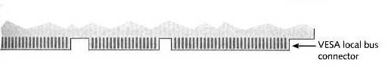
Figure 2.1: The VESA/VL Bus Connector²

The VESA organization set goals for the VL bus specification to allow it to be used by anyone and to be expandable for future upgrades. They wanted it to have a low cost and to be based on as much existing technology and chipsets as it could³. Also, they wanted it to be software transparent and to have an open standard³. The result of these goals was the VESA-Bus specification that specified the mechanical, physical, timing, and protocol details³. The design of the VL bus allowed it to be easily intergraded into ISA, EISA, or MCA system boards. Because of the load VESA devices put on the bus and the CPU, they are limited to how many can be on the system board. VESA recommends that you have less than two VESA devices running at 33Mz (or slower), one VESA device running at 40Hz, and no VESA devices running at 50Hz on your system boards at the same time³.

Since the VL bus connector uses the existing 16-bit ISA connector plus an additional 16-bit VL connector the slot can be used for both types of connectors (not at the same time). Interestingly, VESA devices use the ISA part of the slot only for power connections and use the VL part of the slot for all the signals³. This unique feature means that the expansion card can use the ISA connectors for other purposes³. Some manufactures intergraded to different devices into one expansions card. For example, they could use the VESA part of the slot for a hard disk controller and the ISA part of the slot for a floppy disk controller³. The ability to have two devices on one expansion card limited the need for extra expansion slots in earlier PCs. Today many devices that were on expansion cards are now incorporated directly on the main system board.

VESA had plans to increase the data width of the VL bus to 64 bits³. The increase in bus width would allow for more devices to be put on the bus³. The success of the PCI bus ended these attempts to further develop the VL bus. Despite the advantages of the VL bus over 16-bit ISA bus, the PCI bus has become the current standard for a general-purpose bus.

PCI Bus

The peripheral component interconnect (PCI) was developed by the Intel Corporation in 1993. The PCI bus is commonly used in PCs, Macintosh and workstation computers. If functions as a data path between the CPU and peripheral devices. The PCI bus was originally designed to speed up display graphics on Intel computers³. However, its standard allowed for it to be used by other devices that required high bandwidth³. In addition the PCI bus has all the same signals as the older ISA bus that allows a PCI adapter card to emulate older devices¹. The advantages of the PCI bus over the VESA bus are the reason why the current general-purpose bus is the PCI bus. These advantages are not really seen with the 80486 processor, but are definitely apparent with the Pentium proccessors³.

The PCI bus has a 32-bit data width, 32 address lines, and runs at a speed up to 33MHz. This high speed and high data width, allowed it have a throughput of up to 264 MB/sec. Also, at this speed the PCI bus can deliver four bytes of data in 30 nanoseconds¹. One advantage the PCI bus has over the VESA bus is that devices connected to the PCI bus can run at speeds different then the CPU¹. Another difference between the PCI bus and the VESA bus is that PCI expansions slot are much shorter the VESA slots (even shorter then ISA slots) and it is set further off the edge of the system board² (see Figure 2.2).

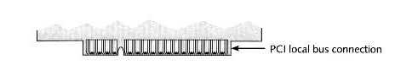
Figure 2.2: PCI Bus Connection²

The PCI bus has numerous features that are available when it is used with Pentium class processors. First, PCI devices can be self-configuring and operate in a Plug and Play mode¹. Second, the PCI bus uses a safe circuitry that allows two devices to share the same interrupt request¹. When an interrupt is shared, the system responds to an interrupt by call the device driver for each device associated with that IRQ¹. Then the drivers poll their respective adapter cards to determine if there is any pending activity that requires a response¹. There is only a slight loss of efficiency when interrupts are shared, but not enough to be concerned¹.

The PCI bus has a direct connection to the memory bus allowing it to control the traffic. The connection between the memory bus and the PCI bus is called the PCI Bridge². The PCI bus is an intermediary between the expansion buses and the system bus. The PCI Bridge lets the PCI bus to control traffic from the expansion buses as well as its own devices² (see Figure 2.3).

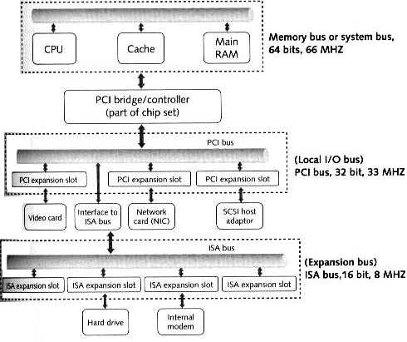
Figure 2.3: PCI Bridge Diagram²

The PCI bus is standard in most all personal computers and workstations sold today. It supports numerous devices giving them high bandwidth and quick access to memory and the CPU. The only function of the PCI bus that has been taken over by a new bus types is its video display adapter card functions. Today, most all video cards are either incorporated into the main system board or are on the AGP bus. However, the PCI bus still remains the most used general-purpose bus since the original ISA bus.

Bus Comparison Chart²

Bus | Bus Type | Data Path  in Bits | Address  Lines | Bus Speed  in MHz | Throughput
PCI | Local I/O | 32 | 32 | 33,66 | Up to 264 MB/sec
VESA or VLB | Local video  or expansion | 32 | 32 | Up to 33 | Up to 250 MB/sec
MCA | Expansion | 32 | 32 | 12 | Up to 40 MB/sec
EISA | Expansion | 32 | 32 | 12 | Up to 32 MB/sec
16-bit ISA | Expansion | 16 | 24 | 8.33 | 8 MB/sec
8-bit ISA | Expansion | 8 | 20 | 4.77 | 1 MB/sec

GLOSSARY:

Expansion bus – A bus that does not run synchronized with the system clock.

Local bus – A bus that operates at a speed synchronized with the CPU speed. A local bus is designed to allow fast devices quicker and more direct access to the CPU.

Local I/O bus – A local bus that provides I/O devices with fast access to the CPU.

REFERENCES:

1. Gilbert, H (1995). “I/O Bus”
URL: http://sophia.dtp.fmph.uniba.sk/pchardware/bus.html

2. Andrews, Jean(2000) Guide to Managing and Maintaining your PC. Cambridge, MA.
Thomas Learning ISBN: 0-619-00038-4

3. Storrs,Phil (1998). “PC Bus standards” URL:
http://members.iweb.net.au/~pstorr/pcbook/book2/busses.htm

4.Quatech, “Connect with Reliability” URL: http://www.quatech.com

5. AskJeeves, “ISA (Technical)” URL
http://www.askjeeves.com/main/metaAnswer.asp?t=m&s=a&en=directhit&o=0&frames=True&url=http%3A%2F%2Fask%2Edirecthit%2Ecom%2Ffcgi%2Dbin%2Fredirurl%2Efcg%3Furl%3Dhttp%3A%2F%2Fsunsite%2Etut%2Efi%2Fhwb%2Fco%5FISA%5FTech%2Ehtml%26qry%3Disa%2B%252B%2Bbus%26rnk%3D4%26cz%3D1027d37026480789%26src%3DDH%5FAsk%5FSRCH%26u%3D0079462336&ac=31&pt=ISA+%28Technical%29&dm=http%3A%2F%2Fsunsite%2Etut%2Efi%2Fhwb%2Fco%5FISA%5FTech%2Ehtml&io=3&qid=53F09B7C3DE0D6499AEEE5B7E766EF20&back=ask%3Disa%2B%252B%2Bbus%26ori%3D0%26qsrc%3D0%26meta%3D1&ask=isa+%2B+bus&dt=020422194229

6. PcKits “Introduction: ISA” URL: http://www.ctv.es/pckits/tISA.html

7. Rosch, Winn L. (1992) Hardware Bible: Second Edition. New York, NY. Brady
Publishing ISBN: 0-13-932260-4

