IEEE 1394

“Firewire”

CS 350 Computer Organization
Spring 2002
Section 2

Daniel Armentrout

Stuart Fischer

Jason Kidd
Jason Neisz

Table of Contents:

Section 1: Overview Page 1
Section 2: Specifications Page 4
Section 3: Applications Page 7
Section 4: Future Page 10
Bibliography: Page 13
IEEE 1394 Fire Wire

Introduction

IEEE 1394 is the industry standard for the scalable, flexible, easy to use, inexpensive interface that allows for fast transfers between removable peripherals and personal computers. IEEE 1394 was originally created to be a universal interconnect among many different devices to eliminate the need for large number of IO connecting media. The integration of ports and the space saved not to mention the savings in cost and complexity are major players in advancing this hardware. ³
IEEE 1394 is also known by the names ILink and Fire Wire. Apple computer corporation version is called Fire Wire while Sony and other corporation’s version is called ILink. ²

Current Technology

Peripheral Interface

Typically IEEE 1394 interfaces with some sort of interface card or add-on circuitry that can be plugged into an expansion slot located on the motherboard of a personal computer to provide IEEE 1394 capabilities to a computer that would otherwise be without. ² These cards mostly come in PCI however there are SCSI versions as well as others available as well. ¹
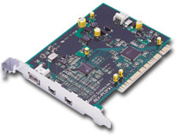

The photograph above is of a PCI expansion card for IEEE 1394

Connecting media
The media the 1394 specification uses looks somewhat similar to the media used for USB peripheral devices but is nothing like USB whatsoever. IEEE 1394 devices are integrated usually with a 6-conductor cable containing two separately shielded twisted pairs of wire for data transmission and also contains two power conductors and an overall external shield. The power wires (8 to 30 volts DC, 1.5 Amps) supply power to certain devices that require it. There are also some devices that use a smaller connecting end such as digital cameras and camcorders. The connectors use only 4 pins rather than the six to save space on the device. The 4 pin connectors are designed mostly for battery powered devices because the power wires are not available to a device only the data transmission wires are used with the 4 pin plug. Cables can be purchased with a 4 pin connector on one end and a 6 pin connector on the other. ¹
IEEE 1394 cables are limited to about 4.5 meters in length before signal distortion due to attenuation and other interference begins to occur. However the use of IEEE 1394 in networking will definitely require distances greater than 4.5 meters to be attained. Greater distances can be reached by reducing the speed of the bus. Plans are in the works for lengthening distances between nodes even farther. ¹

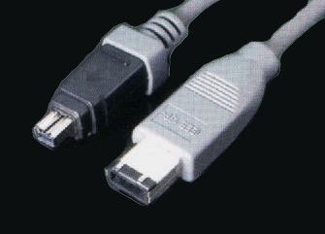

The above photograph is of a 1394 cable with a 6 pin and 4pin end.

1394 Bus.

IEEE 1394 is a bus. This allows for devices connected by 1394 to share a linear electronic path on which they can share information and other data. When connecting devices with 1394 cables you are connecting them to a 1394 bus. ³
Daisy chaining is also supported in 1394. This allows one device to be wired to another device to be wired to another device etc. The signal is received by all the devices and the devices respond accordingly. A device can either choose to relay the signal it receives on to the next device or it can choose to change it. 1394 supports up to 64 devices daisy chained together. ¹
IEEE 1394 is also peer-to-peer. This is an excellent quality for 1394 because it allows devices to communicate with one another without the need for a computer. So you could transfer data from a hard drive without the need for computer assistance as well as hook too cameras together and dub from one to the other without any computer. This also allows for multiple devices to share the same resource without any need for special support in any of the devices. ¹
The standard also supports Hot Swapping. ² This allows users to plug in devices with a 1394 cable without having to restart the computer or device that you are using.
The speed of IEEE 1394 is by far greater than any of its competitors. At a maximum speed of up to 400 Mbps, IEEE 1394 is many times faster than the more common USB interface that comes standard on most all computers these days.

History of IEEE 1394

The IEEE is the largest professional technical society in the world. Founded in 1884 in the United States by several electrical engineers, today has over 320,000 members in 147 countries. The IEEE sponsors many different technical events as well as publishing almost 25% of the planet’s technical journals in electrical, electronics, and computer engineering and computer science. ¹
Apple invented Fire Wire in the early 1990s. Later it was adopted by the IEEE Trade Association where it became known as the new and exciting name of 1394. The name Fire Wire that was invented by Apple is still used by the corporation. Others have adopted the name i.Link trademarked by the Sony Corporation. The name 1394 comes for the specification that defines the technical traits of the interface. ³
The 1394 Trade Association was formed in 1994 to make possible the acceptance of 1394 by consumer electronics. The IEEE 1394 Trade Association refer to themselves as The Multimedia Connection. ¹

Benefits and shortcomings

Benefits

The speed of IEEE 1394 far exceeds any of the competition, namely USB. This makes the technology ideal for an interface between high end digital electronics to exchange data. Another important feature of 1394 is its ability to Hot Swap and Daisy Chain. These two features make sending and receiving data amongst peripheral extremely easy. A major benefit of IEEE 1394 is its peer-to-peer capabilities. The ability to attach devices and exchange data without the need for a computer is an excellent feature. Another important feature of the 1394 specification is providing a power source in the media so a device attached to with a 1394 cable need not have to depend on an external power source, rather, it can get power from the 1394 cable.

Shortcomings

There are many benefits to the 1394 technology but it also suffers several shortcomings as well. IEEE 1394 has been used largely to connect devices in a peer-to-peer manner, it is still not robust enough to operate as a true network interface.² One reason USB has not caught on and become much more popular is much of the general public have no need for the interface yet. USB is sufficient for the moment mainly because the size of data transfers from peripherals (such as keyboards, mice and digital still cameras) don’t require such high throughput. While this isn’t a shortcoming for 1394 it is a reason the many computer companies haven’t started including the interface on their personal computers.

IEEE Specifications

IEEE 1394-1995

This document is the original specification for IEEE 1394 “FireWire”. It outlines every aspect of IEEE 1394’s form and operation from cable shielding parameters to device addressing modes. The main points of this document are summarized below. The complete IEEE 1394-1995 specification is available only from IEEE.

Bus Architecture

The Bus architecture used in IEEE 1394 is a serial implementation of the IEEE 1212 standard architecture which features control and status registers that are well defined and standardized addressing and transactions. The designers decided to use this architecture in order to make it compatible with other IEEE busses. It is also noteworthy that this bus is similar to the memory bus in terms of logical architecture. Address assignment for peripherals is done automatically.
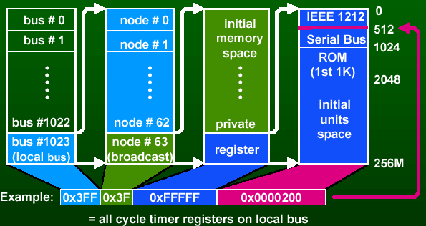(An example of IEEE 1212 addressing)

Data Delivery Methods

There are two modes for data delivery that IEEE 1394 operates in. They are asynchronous and isochronous. Asynchronous delivery is used when the reliability of the data is more important than it’s timeliness. With asynchronous delivery, the delivery of the data is guaranteed no matter how long it takes and it will retry delivery if necessary. This type of delivery makes sense for data storage devices and output devices. Conversely, isochronous delivery focuses on timeliness over accuracy. Data that arrives late is deemed useless and no retry is made. Isochronous delivery is more appropriate for control devices since we want our applications to react instantly to our commands.

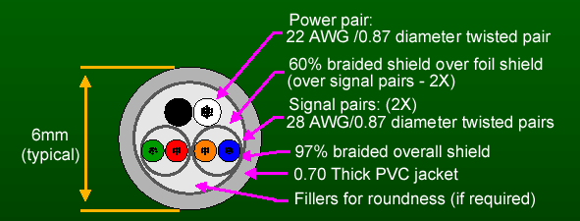The Cable

The figure above gives us a cross-section of a typical “FireWire” cable. The cable for IEEE 1394 exists in two forms. The one shown above is a six-conductor cable containing four conductors for data transfer (split into pairs called TPA and TPB) and two conductors to act as a power supply. The other form omits the power supply conductors and includes only the two pair of data transfer wires. The length of these cables is limited to 4.5 meters because the signals degrade too far after that distance. Thicker wires allow for greater distances. This cable allows for the transmission of data at 400 Mbit/sec.
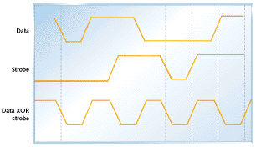
This cable design also allows for the use of “Data Strobe Encoding”. In this cable, TPA transmits the strobe signal and receives data and vice-versa for TCB. Data strobe encoding allows the clock signal to be extracted more easily and reliably than with other busses. However, since the signals are using the same sets of wires, only one signal (data or strobe) can change at any one time.

IEEE 1394A

Several improvements were made for the first upgrade to IEEE 1394. These were made in order to make the technology more efficient. One notable improvement was to speed up the arbitration process. This is the process by which the devices access the bus. IEEE 1394A implements 3 new types of arbitration.

Ack acceleration

This eliminates a few steps in the standard arbitration process allowing the device that was next in line to send its data packet immediately after the acknowledgement character (ack) is received. In the original version, after the ack was received, there was a short time interval before the next device would send its information in order to ensure that nothing would interfere with the transmission of the ack. In IEEE1394A, the device sends its data packet immediately after the ack is received instead of waiting decreasing the amount of time the bus is inactive.

Fly-by arbitration

This is a process by which data packets are concatenated allowing multiple devices to send and receive data simultaneously. Previously, when two or more devices sent data at the same time, the device with lower priority was simply denied and would have to send again after the other device was finished. Now, if the senders have parent-child relationships, (the child device or “node” is plugged into the parent device instead of directly into the port) then the data packets will be encoded and concatenated so that both are able to send their data. .

Priority arbitration

By assigning any unused request opportunities (there is support for 64 nodes each with its own request opportunity) to devices that are more likely to need them, we can speed up the operation of the bus.

IEEE 1394B

The changes made in IEEE 1394B have to do with increasing the speed of the bus. The changes were compatible with all previous versions of the technology. They allowed for much faster data transmission (800, 1600, and 3200 Mbit/sec. Previous was 400 Mbit/sec). Longer distances were also supported. These changes have to do primarily with the cable used for various applications. For example, fiber-optic cable replaced electric conductors for high-speed, long-distance applications. UTP5 cable is now used for long-distance, lower speed applications. This is the same time of cable as is used for 100 Mbit/sec Ethernet connections.

IEEE 1394 Applications

Peripherals

One of the most common uses of FireWire is to connect digital cameras and video cameras to computers. FireWire is very fast an efficient compared to previous applications that used USB ports. Besides video cameras, any device that deals with a lot of data is a good candidate for FireWire instead of USB.

Many new high tech digital cameras provide FireWire jacks that allow images and movies to be transported onto a hard drive much faster than traditional applications.⁵ Companies also offer FireWire card readers that accept the older and slower cards used in less expensive cameras. You can connect a FireWire card reader to your computer and then plug the slower card from your camera. This results in a fast transfer of data without buying a new FireWire camera. Speed on these cameras can be very important because picture and video files can be large.
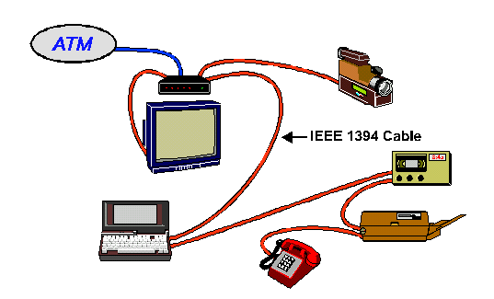

Scanners are also beginning to use FireWire over USB in order to get faster performance. This allows images to be uploaded faster and more efficiently. Most inexpensive scanners are still using USB but the market is beginning to lean towards FireWire. Umax Technologies is currently producing a $99 scanner that uses FireWire. ³

Computer hard drives and optical burners are also beginning to use FireWire. A hard drive that uses FireWire is useful because it can increase your storage capacity and make it much faster and efficient to move information from one computer to another computer.

Networking

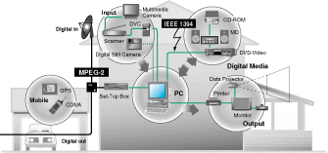

Firewire allows uninterrupted data exchange between many devices such as computers, televisions, VCR's and various computer peripheral devises. IEEE 1394 also allows users to interconnect devices that require different transfer rates.¹ This means that devices purchased today will be able to work on the same line with faster devices in the future. This makes it a perfect candidate for home networking. Users can interconnect many devices on one line and easily incorporate future technology.

Firewire provides "hot plug" capability that will be helpful for testing a network. This allows the wire to be connected and disconnected while the device is still turned on. This is convenient and more efficient because devices can be left on if the user needs to test the new network and make changes.
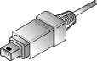
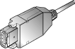
IEEE 1394 cable design is very simple and effective. This makes networking much easier because there are fewer cables to worry about and simple plug-in styles are used. Devices that require digital, audio, or video can all be connected by one simple wire.

There is a single-chip switch that was developed to improve the networking capabilities of IEEE 1394.² This switch was developed NEC Corp. and is designed to make a 1394 network behave more efficiently than a regular bus. ² The switch is targeted towards users that operate at a very high bandwidth, namely audio and video recording studios. It will most likely be implemented into home networks in the future. This will be useful because connecting devices to a 1394 line can cause disruptions to other devices that are connected to the same line. The switch will eliminate this because the disruptions will be isolated and will not affect the rest of the line. ²

Industrial Applications

Given the speed and simplicity of firewire, it is not surprising that industrial applications are implementing its use into several areas. Applications that require a constant bandwidth and high flow of data will benefit the most. Digital video streaming images, the transfer of content critical commands, and file transfers are applications in which firewire is being used. ⁴ With a transfer rate of 400 Mb/sec, firewire allows a fast transfer of critical data.

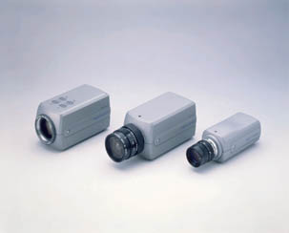
Three Sony industrial cameras are pictured here. These cameras have 1394 imaging technology and are used for high-resolution industrial applications. ⁴ Cameras like this are replacing older cameras in video streaming, machine inspections, and microscopic scientific inspection. These cameras provide improved resolution, speed, and the amount of data that can be transferred is increased dramatically. They have the ability to capture an image and immediately send it to any other device on the network in one pass. The cameras can be linked together or to other devices.

Many manufacturing companies are taking advantage of the high-speed data transfer offered by firewire. High-speed data transfer allows electrical and optical sensors to quickly detect and report defects or changes during fast mass production. The "hot plug" feature can be utilized by companies to quickly swap out bad equipment with little downtime and loss of productivity.

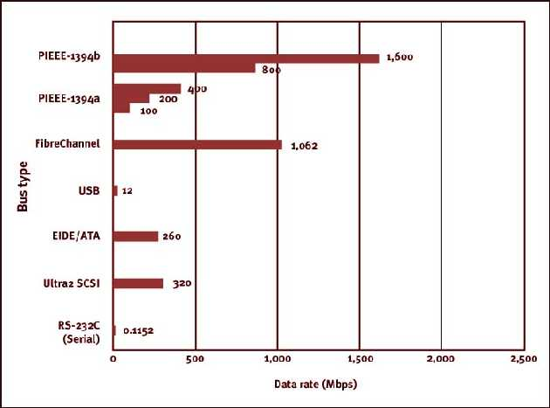

The future of the IEEEa 1394 (firewire) standard looks promising, but has some tough competition. The newly released Universal Serial Bus 2 (USB2) has a maximum transfer rate of 480 Mbps, which beats the current transfer rate of firewire by 80 Mbps. However, the 1394 trade association has another card up their sleeve called IEEE 1934b. This will be the successor to the firewire interface and be backwards compatible. It will require the use of a bilingual adapter that will connect to the six pin connector for the IEEE 1934b standard and then link this connecter to the IEEE 1395a type connector. The picture below gives a visual representation of the bilingual, IEEE 1394a, and IEEE 1394b connectors.

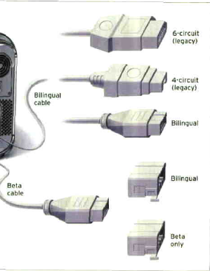
The new firewire standard will have a sustained transfer rate of 800 Mbps leaving USB2 behind in the dust. If this isn’t enough speed, there is a way to use high implementation that allows sustained transfer rates of up to 3200 Mbps. This can be done with the use of current Category five cabling, plastic optical fiber, and multimode fiber. Multimode fiber will be required for companies that need the fastest speeds. For long distances, it is essential to use optical cable rather than copper because of its ability to transmit at higher speeds over distance. The typical operating distance for firewire using optical cable will 100 meters, while copper cable can only handle these speeds at a distance of 4.5 meters or less.
The new firewire interface not only offers speed improvements, but also other unique features as well. One feature that stands out is firewire’s ability to communicate without a computer. You can connect firewire devices together without going through a computer, a feature that USB2 lacks. Firewire is also better for video because it allows dedicated bandwidth for streaming data. USB on the other hand shares its bandwidth, and therefore you can’t set aside any for certain devices. One thing USB does have going for it is that it costs less money.
The future of the firewire interface is not just limited to the computer market, but to the consumer electronics market as well. According to Snider, the chairman of the 1394 trade association, firewire offers everything digital video interface (DVI) does and then some. The DVI for consumer electronics can be found today in high definition televisions. The DVI interface is like a point-to-point connector that delivers uncompressed digital video streams. Even though this may sound like a good thing, it can’t keep up with the advanced features of firewire. One problem with DVI and televisions is the fact that it requires the television to have an interface for each extra device, such as a VCR, camcorder, etc… However, firewire can link several devices together using only one interface, therefore making connecting home devices a snap. Imagine how nice it would be to be able to connect a VCR with just one plug. This also greatly increases the ability of home networking devices look more probable. The DVI interface does allow copy protection by never letting the user make any copies at all. However, the 1394 standard provides three options for copyrighted audio and video, which are “Copy Once”, “Copy Never”, and “Copy Freely”. This gives the user more rights, while protecting the rights of the artists. Currently, the prices of high definition televisions hit hard on your bank account if you choose to buy one. Even after you pay all this money, you won’t be able to record in digital format because DVI does not support copying. This means that if you get digital channels on your TV and want to record in digital you won’t be able too. However, high definition televisions that incorporate the 1394 standard will have the ability to record in digital. This feature is also attractive for people interested in video editing. They have the ability to plug in their digital camcorders that use the firewire interface straight into their television. Firewire is a robust interface that has the ability to allow devices to share high definition video, audio, IP traffic, and other information. This gives firewire the ability to interlink different consumer electronic devices and perhaps control them all from your computer in the future. Firewire HDTV’s are just starting to show up on the market with home networking support. The picture below shows an add for a Mitsubishi HDTV that has IEEE 1394 interface on it and provides the user with a graphical user interface that can be used to control all IEEE 1394 A/V devices connected to it by remote control.

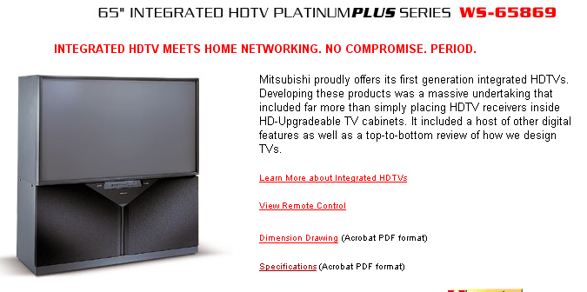
Firewire started off in the computer market, and its future looks promising in the computing world. With the advanced features of IEEE 1394 and the upcoming blazing speeds of 1394b, firewire will most likely gain steam in the hard drive market. Firewire hard drives are external and are easy to travel with and offer the ability to plug into someone else’s computer who has a firewire port. There are already 160 gigabyte firewire hard drives and this number is expected to increase. You can currently find hard drives that use USB costing the same price as firewire hard drives per gigabyte. One reason that USB hard drives have been clinging on is the fact that IBM and compatible computers have been slow to incorporate firewire into their motherboards. Devices such as DVD-RAM drives are also starting to offer firewire versions. Firewire is currently dominating the digital camcorder market and video editing market, due to its features over USB. This is likely to continue because even USB2 can’t incorporate these features without major changes to its architecture and bus.
Firewire also has future use in laboratories. With the great number of devices scientists use, firewire might be the answer to link all these devices together. Scientific devices tend to incorporate a lot of uniqueness from device-to-device. Data collection with firewire interfaces would make it easier for devices to communicate, with each other or to a computer. It would also make it easier to integrate new COTS devices or new devices in a laboratory. Legacy devices that are too valuable to replace could be connected to other firewire devices by a bridge between the two. The picture below shows a future network of firewire devices in a laboratory.

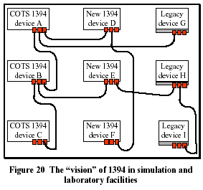

IEEE 1394 has the potential to finally bridge the gap between consumer electronic products and computers. With the increasing popularity of firewire in both of these markets, there has to come a point in time when they interconnect. Even in laboratories, firewire is taking shape. The various ways firewire can be used seems endless. This makes firewire an interesting technology to keep an eye out for in the future because it seems that in a couple of years, we will all be using it.

Bibliography

Section 1
[1] “1394, High Speed Digital Interface”. (2002) http://www.askfor1394.com/
[2] Anthony Cataldo (2000). “NEC aims 1394 switch at high-bandwidth nets” http://www.eetimes.com/story/OEG20000810S0005
[3] “1394 Trade Association Homepage”. (2002) http://www.1394ta.org/

Section 2
“Fundamentals of Firewire”. (1999) http://www.embedded.com/1999/9906/9906feat2.htm
Teener, Michael Johas. (1998) “1394 Technical Summary”. http://www.iol.unh.edu/training/1394/1394overview.pdf
Teener, Michael Johas. (1998) “1394a & b Technical Summary”. http://www.iol.unh.edu/training/1394/1394ABoverview.pdf

Section 3
[1] “1394 -- New Interface for the Digital Network Age". (2002) http://www.sel.sony.com/semi/ieee1394wp.html
[2] Anthony Cataldo (2000). “NEC aims 1394 switch at high-bandwidth nets” http://www.eetimes.com/story/OEG20000810S0005
[3] “1394 Trade Association Homepage”. (2002) http://www.1394ta.org/
[4] "IEEE-1394 Speeds up data exchange". (2002) http://www.eetasia.com/ART_8800009539_499481,499491.HTM
[5] "Quick Overview of IEEE 1394". (2001) http://skipstone.com/overview.html

Section 4
Snider, James. “The future of CE Networking is 1394 Not DVI.” Semiconductors 25 Mar. 2002: 20.
“Future Wire: Latest Version of Firewire Standard to Boost Speeds, Connectivity.” Macbeat Feb. 2002: 18+.
Valentino, George. “IEEE-1394: An Emerging Interconnection System for Future Simulations.” Systran Corporation (1998): 1-9.
“Is Firewire the Future of Consumer Electronics?.” PC World.com 5 Sept. 2000 <http://www.pcworld.com/news/article/0,aid,18334,pg,1,00.asp>
“Mitsubishi Integrated HDTV.” 2001 URL: <http://www.mitsubishi-tv.com/WS65869.html>

