Overview

Over the past several years, the need for fast, efficient, and large capacity data storage has become increasingly prevalent. As corporate and commercial web sites have the need to process larger and larger amounts of information, the very real and costly risk of failure necessitates new and innovative tools and methods to prevent such potential catastrophes. Today’s world is one based on information, and protecting that information from being lost or compromised is critical.

Once it became evident that simply having a large number of hard disks didn’t provide the type of reliability and performance that complex data systems required, a desire for a fault-tolerant, scaleable and powerful solution arose. Enter RAID, or Redundant Array of Independent Disks. The term RAID, first used by researchers at the University of California – Berkeley, refers to the concept of multiple interconnected hard disks that are treated as single drives, and implemented with various techniques that provide greatly increased speed, reliability, and capacity of data storage systems.

There was a time that this technology was available exclusively in expensive, high-end server systems. However, with the introduction of inexpensive RAID controllers, it inserted itself into the mainstream commercial market. Many computer enthusiasts also implement some form of RAID technology in their systems for private use, whether it be a hardware or software RAID solution.

Basics of RAID

There are a few basic concepts and terms one should be familiar with when dealing with RAID technologies. When the term drive arrays is used, it refers to a collection of hard disks grouped together in either a physical or logical fashion. It is important to understand the differences, as physical arrays can be divided or brought together to form a single logical array or multiple logical arrays. These logical drives are perceived by the operating system as a single disk. These distinctive groupings allow for complex, nested RAID implementations. Also, the integral element in any RAID system is the controller. This mechanism can either be a physical hardware component or a software implementation, as is commonly found in lower-end, typically consumer systems. The responsibility of the RAID controller, whether it happens to be a hardware device or software, is to control I/O communications between the disk arrays and the operating system. Next I will introduce the main techniques used in RAID implementations.

Mirroring

This basic data redundancy technique consists of two or more disks that “mirror” each other. Meaning, as the term implies, that the two disks hold exact copies of the same data. This technique can be implemented across any number of drives or disk arrays, the only restriction being that number must be a power of two, for obvious reasons. In this implementation, data is written to and read from the mirrored drives simultaneously. The benefit of this technique is that in the event of a single disk failing, the system can continue to operate as there are two copies of the data. Consequently, recovery is relatively simple as the data is simply rebuilt by reading from the disk mirror. The disadvantage of this particular method is that the simultaneous writing to the mirrored disks reduces performance and limits parallelism. However, this method provides better read performance, for while one drive is being used to read the data, the other drive is free to handle other requests. Below is a simple diagram illustrating a mirrored disk array.
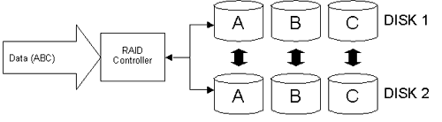

As with the other RAID techniques, using the mirroring solution depends on several factors, including cost of downtime, performance needs, and budget constraints. The alternative to mirroring is a method introduced in the next section, known as parity.

Parity

The other data redundancy technique used in RAID systems is parity. Parity in RAID is similar to the concept of parity in memory. To demonstrate the basic concept of RAID parity, consider this example: You have N number of data elements. You would then use those N data elements to create a parity element, and end up with N + 1 total data elements. In the event that one of those N + 1 data elements is lost, recovery is possible, granted that N number of elements remain. This parity element is typically created using a logical XOR (exclusive OR) operation. Using this parity data if a piece of data is lost , it can be easily recovered so long as there remain N – 1 elements ( excluding the parity data). For example:

10101010 XOR 11111111 = 01010101
11111111 XOR 01010101 = 10101010
10101010 XOR 01010101 = 11111111

You’ll notice that as long as you have two out of the three binary strings, you can create the missing string by applying the XOR operation to the two existing binary strings. This is the concept behind parity. The benefit of the parity technique is the fact that only one copy of the data needs to be kept, as opposed to mirroring, though with parity the level of fault tolerance is not as high. The main limitation on parity, however, is that with complex parity-creation algorithms there is greatly increased processing overhead introduced, as the parity data has to be computed with every read/write operation that takes place. Therefore a hardware RAID controller is necessary, due to the strain that such processing would place on the CPU. Another disadvantage of parity is the greater complexity in data recovery than in mirroring.

Striping

The last, and perhaps most useful RAID method to discuss is striping. Striping refers to the technique of distributing data across all the drives in an array. This parallelism allows for greatly increased read/write performance, as the controller can read/write the data to all the drives simultaneously. There are two levels of striping, and each divides the data differently for distribution. The first is known as byte-level striping, and involves breaking up the data into individual bytes, although some implementations use a 512 byte division. The bytes are then written to all the drives in the array at the same time, so if the data is divided into 8 bytes, and there are four drives in the array, the first 4 bytes are written to one of the four drives, respectively, and then the fifth byte is written to drive 1, sixth byte to drive 2, and so on. The alternative method is known as block level striping, in which the data is broken up into predefined block sizes, also called the stripe size, and distributed the same way as the byte level method. Determining the stripe size is not an exact science, but there are trade-offs between using a smaller or a larger stripe size. Using a smaller stripes size, the data is distributed across more drives, thus increasing parallelism, and consequently transfer performance. A larger stripe size has the opposite effect as smaller sizes, but the randomness of each position of data is reduced, also having a positive effect on performance. Experimenting with stripe sizes is the best method for determining the appropriate technique for your specific system.
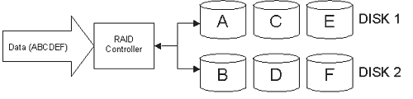
As the above diagram illustrates, the data is broken up into six pieces (ABCDEF), and each is written to one of the six disks in the two arrays. Remember that the more drives you have in this implementation the better, as the data is transferred in 1/Nth (where N is the number of drives) the time it takes to transfer the same data from a single drive. In the following sections we will explore the different level of RAID, and how each utilizes these techniques we’ve just discussed.

RAID 0

The first of the RAID levels is, not surprisingly, RAID 0. RAID 0 uses the striping technique to distribute data across N number of drives, greatly improving I/O performance. However, RAID 0 is not generally thought of as a true RAID implementation, as it has no fault-tolerance. That is, if just one of the disks in the array were to fail, all data in the array is lost. The major benefit to this method however is its simple design, implementation and relatively inexpensive cost to build. Below is a simple diagram showing how RAID 0 works.

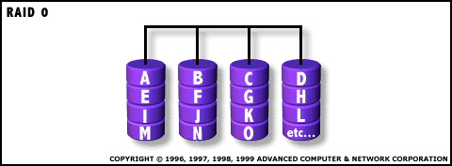

RAID 1

This implementation utilizes mirroring as its dictating method. In this case copies of the same data are kept on two separate drives, also known as duplexing. Since in the event that one drive fails, the system can continue to operate by reading from the other drive, this RAID level is fault-tolerant. However, RAID 1 is normally used either in low-end servers, as there is no real performance gain from mirroring ( in fact, with ECC, which will be discussed later, there maybe a decrease in performance with this technique) , or is implemented in systems where data redundancy is the integral issue, not speed. The following diagram illustrates the concept of RAID 1.
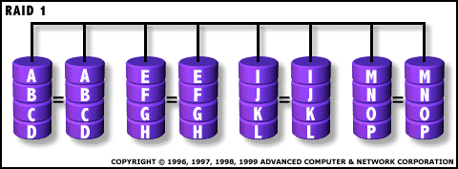

RAID 2

Where as RAID 0 and RAID 1 have focused on speed and data redundancy, RAID 2, 3, and 4 enter into the 3rd purpose of RAID setups: data consistency. Suppose you had a RAID 1 implementation that had 3 disks and when you went to retrieve data from the array the disks contained [1000 1101₂](a) [1000 1100₂](b) and [1000 1101₂](c). The data from (b) isn't consistent with the copies from (a) or (c). The question is what do we do when we encounter this kind of error. The semi-obvious solution that comes to mind is to assume that (b) is incorrect and correct (b) to match (a) and (c), but this is a dangerous assumption to make since (b) could be correct and (a) and (c) erroneous. This is where parity enters into the RAID scene.

Parity is handled in RAID 2 by the process known as Hamming Code ECC. Hamming Code works off of an Even Parity system. This works by taking a piece of data, such as [1000101₂] and then adding the individual bits together 1+0+0+0+1+0+1 = 3. Since 3 is odd, we make our 8th parity bit a 1 to make the sum of the bits even, thus our 7-bit word becomes 8-bit word with parity [10001011₂]. This 8th bit allows us to determine whether the word is correct or corrupt, we simply add the 8 bits. If the total is even, then it's good, if it's not, we've got garbage. This is all well and good but the problem with a single parity bit is that even if we know that our word is erroneous we have no way of determining which bit is incorrect or even worse, what if 2 bits or 4 bits or 6 bits got flipped, then our word would still be even but it would be incorrect. This limitation is called the Hamming Distance.

This Hamming Distance affects our ability to not only detect but to correct errors in our data. This is why practical applications of Even Parity work on a more complex system using multiple parity bits, such as in this example.

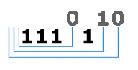
Figure 1: 7-bit Parity Example
This graphic shows the Parity system used in RAID 2. We have 4 bits of data and 3 bits of parity data that make up our 7-bit word. This scheme works on similarly to our 1-bit parity above, but if the data we are evaluating is odd we assign a 0 to the parity bit to indicate it's 'odd-ness' and a 1 to indicate 'even-ness'. Thus in our example, in our first data section [111₂] is odd and is assigned a 0, in the second section [11101] is assigned an even 1, and the third section [111011] is assigned an odd 0. As you can see, as we increase the size of our data words the number of parity bits we require also. If we where to have, say, a 64-bit word then we would need 8 parity bits. This is a lot of space for just data consistency and recovery information.
In most implementations of RAID 2 each bit is directed to a disk so in the 64-bit word example I mentioned above you would need 72 disks to accommodate our word and its parity bits. This appetite for disks is the main reason that RAID 2 doesn't exist in commercial implementations and isn't financially viable. Also as one might conclude from the 7-bit word example above when you have small word lengths, such as 4-bits in the example, you have to have a large ratio of parity bits. The transaction speed you achieve with RAID 2 is also very slow, approaching speeds you could get a single disk.

But even with these numerous disadvantages RAID 2 did have a few things going for it; namely that it allowed for 'on-the-fly' correction of data, very fast data transfer rates are possible, and utilizes a much simpler controller design than RAID 3, 4, and 5. These few advantages did allow RAID 2 to find a few small niche roles in mainframes and other large scale, large capital roles in the past. But now RAID 3 and RAID 4 have superseded RAID 2.

RAID 3

RAID 3 operates on in a similar but simpler manner to RAID 2. While RAID 2 used the somewhat complex Parity Hamming I described in detail in the RAID 2 section, RAID 3 uses a simpler XOR calculation to create parity data. XOR or eXclusive OR is a basic Boolean logic operator that is very simple to implement and fast.

XOR Truth Table
A XOR B |  | Result
0 | 0 | 0
1 | 0 | 1
0 | 1 | 1
1 | 1 | 0

As you can see from the table above XOR is very simple to understand, it is only true if A or B is true but not both. This process can be used to calculate XOR results to multi-bit pieces of data as well, for example XOR-ing [0101₂](a) and [0011₂](b) would result in [0110₂]. The real value to this XOR method of parity lies in the ease at which we can recover missing or corrupted data. As long as you have your result and one of your original pieces of data you can reconstruct what the other one was. For example say you had two bytes of data striped over two disk with a third disk for the XOR parity data and something happens to your data on disk (A), as long as your (B) disk and parity disk are okay you can recover the lost portion of data from disk (A) by reversing the mathematical operation you did to obtain the parity data; i.e. you have the (a) data missing [????₂] and the (b) data is okay [0011₂] and the parity data is still intact [0110]. We then XOR (b) and parity byte and we get (a) as our result. As you can see this is a very simple and fast process that allows for much better performance and a data to parity ratio then RAID 2 and it's Hamming Code. The fact that our parity data can be recovered by just (b) and the parity data means that the large number of parity drives used in RAID 2 can be reduced to one in RAID 3.

The main advantage to RAID 3 is the high Read/Write data transfer rates. The other advantage to this RAID configuration is that independent disk failures don't grind the system to a stop or result in data loss. RAID 3 does have disadvantages though, such as: the transaction rate being slowed by the parity process so that performance is only equivalent to a single disk system at best and the controller to manage this RAID setup is fairly complex, and that it is also very resource intensive and difficult to do as a software solution. In real world implementations of RAID 3 the data is usually striped at the byte size with chunks ranging from 32 - 512 bytes. This large data size allows for high performance but the fact that on every write we have to also write to the parity drive no matter the amount of the data being written, on high I/O systems this can cause a bottleneck in the parity writes queue. With these pros and cons RAID 3 is primarily used for video production, high-end video and image editing, and other uses that require high throughput of data.

RAID 4

RAID 4 can best be described as a mutation of RAID 3. RAID 4 uses the same XOR parity technique as RAID 3 but instead of striping the data byte by byte across the array of disks, in RAID 4 places entire files on a drive and creates the parity information on a sector-by-sector basis.

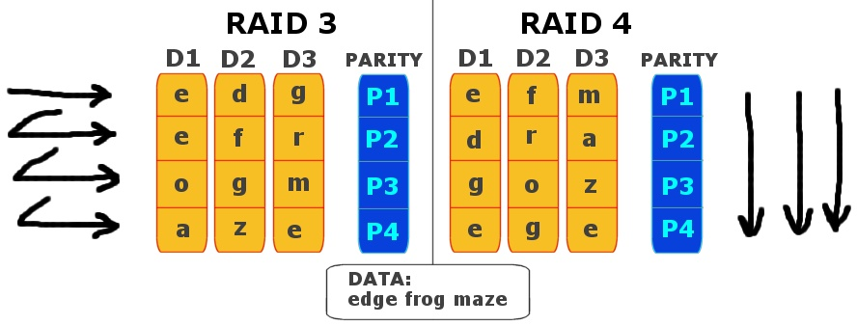
Figure 2 - RAID 3 vs. RAID 4

This method has one huge advantage over RAID 3, an extremely high read rate while have consistency in that data. This high read rate is achieved since you can read multiple files at once. The down side to this high read rate is that writing is quite slow since parity data has to be written whenever anything is written since any time a file is changed on one of the drives you have to record new parity data for all of the data blocks the file takes up. But while this is a bottleneck if your system does a lot of writing, it is a huge benefit if the system is mainly used for reading, like say a web server or similar system where you do substantially more reading than writing.

RAID 4 has several disadvantages that over shadow this huge advantage, namely: the extremely complex controller, the previously mentioned low write speeds, and data recovery in inefficient in event of a disc failure. The bottlenecks of RAID 4 can't be overlooked in most situations and we are forced to consider a different RAID configuration such as RAID 5.

RAID 5

RAID level 5 storage is accomplished using data striping and parity. Each group of disks has at least one virtual parity disk, although it is also able to utilize more than one. Multiple parity disks can be used to improve read performance. Moreover, RAID 5 is characterized to have excellent read performance, due to the ability to transfer larger chunks of data. This task is accomplished since the controller can potentially be reading from multiple disks simultaneously, thus, significantly improving the amount information that can be read at one time. Read performance is in fact, comparable to that of RAID 0. However, one of the biggest disadvantages of RAID 5 is the slow to modest write performance. All in all, “Level 5, depending on implementation and the controller in use, can offer (1) a data read transaction rate as formidable as any RAID level (even RAID 0 when one talks about the real word as opposed to theory), (2) a somewhat equally impressive write transaction rate, and (3) an impressive aggregate transfer rate” (Anderson, 1).

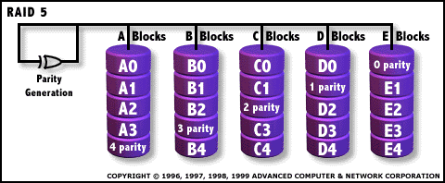

RAID 6

RAID level 6 is simply RAID 5 taken one step further. The major improvement in this method of storage is the added fault tolerance by using a two-dimensional parity scheme. In fact, “RAID 6 provides for an extremely high data fault tolerance and can sustain multiple simultaneous drive failures” (AC&NC, 1). Furthermore, “Now it's possible for more than one drive to fail simultaneously, and have the ship still stay afloat” (Anderson, 1).

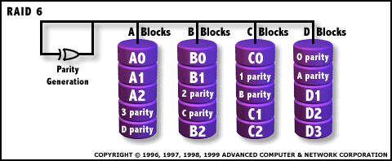

RAID 7

Despite being extremely expensive, RAID 7 offers some of the highest of any RAID performance. According to Anderson, “With level 7, you basically have an implementation of RAID 4 with an added special seasoning: all I/O transfers are asynchronous, independently controlled and cached including all host interface transfers” (2). Included among the added features is the high speed x-buses. Moreover, “Overall write performance is 25% to 90% better than single spindle performance and 1.5 to 6 times better than other array levels” (AC&NC, 1). Along with write performance, RAID 7 improves access times as reads to files as reads have “high cache hit rate” (Anderson, 2).

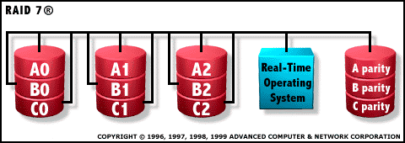

RAID 10

The last three main levels of RAID carry much of the same characteristics. For example, they all combine the uses of two more primitive levels to create a more complex and powerful system. One of these popular RAID levels is referred to as level 10. It is created by utilizing a striped array that is composed of mirrored segments. Remember from the earlier explanations that a RAID level 0 is a striped array, and a RAID level 1 is mirrored. Consequently, level 10 is also known as level 0/1. The diagram below illustrates this concept.
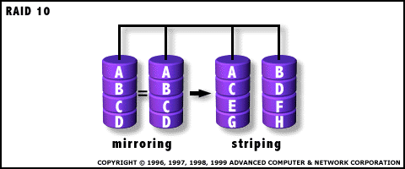
By combining striped arrays and mirrored arrays in this fashion, one achieves the high I/O advantages associated with level 0 and 1. However, since each drive is mirrored, the normal consequences of parity are eliminated. In addition, the system becomes more reliable in the case of faults. Information is easily retrieved by accessing a mirrored drive. Level 10 RAIDs are very expensive.

RAID 53

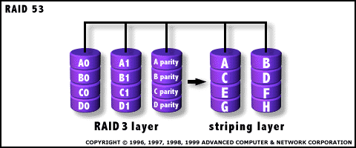
Another advanced RAID level is number 53. This system can be broken down into a RAID 0 (striped) array whose parts are RAID 3 arrays. Therefor, level 53 achieves the high level of data transfer rates associated with RAID 3 arrays, as well as the high I/O capability related to a RAID 0 system. Combing the two effectively creates a RAID 3 system with better overall performance. To go along with a very high cost, however, is the fact that drive capacity is lost because individual byte striping associated with RAID 3 arrays.

RAID 0 + 1

The final major level of RAID systems is known as 0+1. This is very similar to level 10 in the sense that both use RAID levels 0 and 1. However, a 0+1 system features a mirrored array (RAID 1) with each segment being striped (RAID 0). Level 0+1 is characterized by gaining the great level of data transfer resulting from having many RAID 0 segments. Although it is also very expensive, it eliminates the risk of loss of data that occurs when a RAID 0 array experiences failure of one drive.

Conclusion

Over the years RAID systems have grown in complexity and popularity, and while we have defined several major RAID implementations, there are a multitude of different techniques to use in order to build high-performance, lightning-fast, and powerful data storage systems using the methods we’ve discussed. With price tags ranging from under $100 for simple IDE/Software RAID solutions to $25,000+ systems used in large corporate and government network servers, RAID is not for the masses...not yet. Overall, RAID technologies were a huge step forward in the computing industry and will continue to dominate the data processing/storage industry for years to come.

