The Pentium 4
Processor

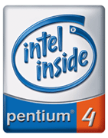

Author: Michael Ferris

Extra Credit Paper for CS 350
Dr. Abzug
Spring 2001

May 10, 2001

