A Brief Run Down of the Pentium 4

Intel’s Pentium 4 processor is said to be the only real advancement since the Pentium Pro processor. The Pentium 4 is Intel’s highest performing processor on the market right now, designed with the most advanced technology to take advantage of today’s and tomorrow’s advancement in the Internet and e-Business, gaming (with a concentration on the 3D aspect), and other large scale, high-end applications. The Pentium 4 is built on the new Intel NetBurst micro-architecture, the Intel 850 chipset, and dual channel RDRAM. These will be explained in detail below. The Pentium 4 is currently available in 1.3 GHz, 1.4 GHz, 1.5 GHz, and 1.7 GHz. The Pentium 4 processor is expected to excel in not only home PC’s, but workstations and business PC’s.

The Chip and Motherboard

The Pentium 4 is much larger than its predecessor, the Pentium 3. Built on the same .18-micron process as the Pentium 3, the Pentium 4 is comprised of a new 423-pin socket and accompanied by 42 million transistors. Since the processor is so large, it puts off a lot of heat that needs to be dispersed properly, protecting the chip from heat sink damage. This is done with a metal cap that covers the processor. Also as a result in the increased size of the chip it is very ‘power hungry’. This has been fixed by the ATX spec and a new power supply connector, as well as new heat sink retention. The power supply connector is now a 4-pin, 12V, ATX specific connector. On the Intel D850GB motherboard, it is located right next to the processor.
Though the chip does suck down the power and puts off a tremendous amount of heat, it does cool itself very well. Using a fan over the processor itself and by the aluminum and copper ‘shield’ that covers the processor cools itself so well that after extensive testing of a system, the processor does not even burn a finger.
The Pentium 4 requires the use of the most recent form of memory, RDRAM. Intel’s motherboard for the Pentium 4 requires the RIMMs to be installed impairs. The most popular configuration is two 128 MB RIMMs and two terminator RIMMs. The terminator RIMMs are simply ‘blanks’, they just fill in the empty slots. Below are pictures that show the new improvements to the motherboard and connectors.

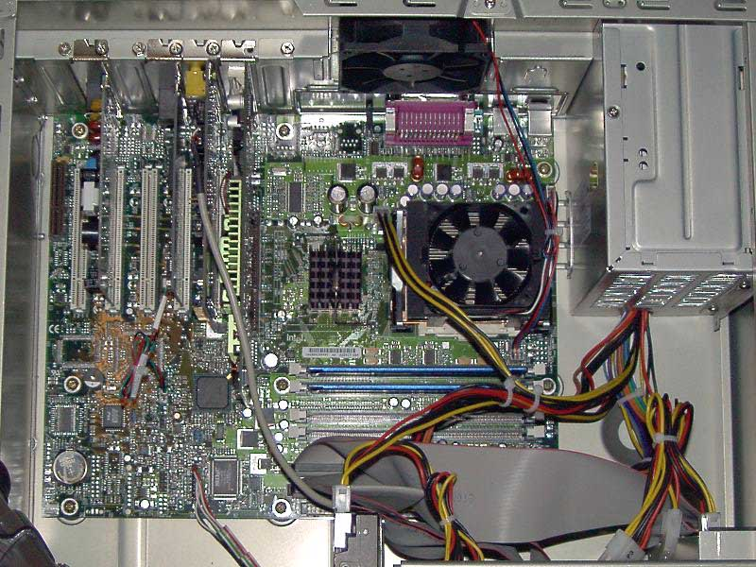
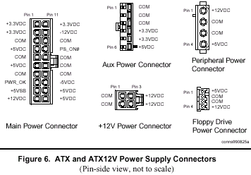
Features of the Pentium 4 and the 850-chip set

As mentioned earlier, the Pentium 4 has several advanced features in the architecture from its predecessors. The first of these advancements is a 400 MHz system bus for single processor configurations. The system bus provides a connection between the Pentium 4 and the platform. The dual RDRAM channels at 3.2 GB provide maximum performance. The next feature is the dual RDRAM channels. These provide 3.2 GB of memory to the processor. High memory paired with efficiency delivers balanced platform support and memory necessary to pull out the full potential of the Pentium 4. Next is the AGP4X graphics interface. The AGP4X allows memory access at over 1 GB which is double that of the previous AGP platforms. The AGP4X combined with the Pentium 4 processor jumps into the next generation of the 3D world. Another improvement is the addition of two USB controllers at 24 Mbps spread over four separate USB ports. This is an increase over the previous 12 Mbps spread over anywhere from one to four USB ports. The Pentium 4 architecture also incorporates the latest audio feature, AC97. The AC97 provides six channels of audio for the came effect as that of the newest version of Dolby Surround Sound 6.1. It allows for enhanced quality of sound and for full surround sound capability. A LAN Connection Interface (LCI) has also been added. This ensures a flexible approach to Internet access using a modem, Ethernet connection, and Ethernet connection with a LAN. Another added feature are the Dual Ultra ATA/100 controllers that support the fastest interface for data transfer to various storage devices. Finally, the addition of the Communication and Networking Riser (CNR). This allows for a flexible system configuration that can be updated via a modem card, sound card, or networking card.
Another major upgrade is in the new Intel 850 chip set. This has been split into two areas, the 82850 Memory Controller Hub (MCH) and the 82801BA I/O Controller Hub (ICH2). The 850-chip set incorporates all of the advancements to the Pentium 4 plus an upgraded hub architecture with the option of P64H. This increases the I/O bandwidth and allows for better synchronization and multitasking of media-rich applications. Below are pictures of the architectures.

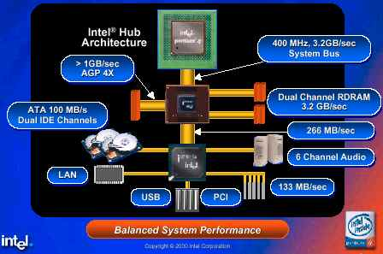

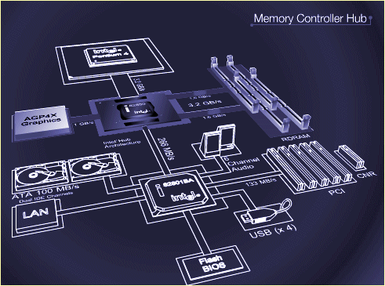

Features of the new NetBurst Micro-Architecture

The Pentium 4 processor is built on a new and improved architecture, the NetBurst Architecture. A new addition is that of a bigger queue that stores and processes instructions at the fastest possible rate, which in turn allows much higher clock speeds. The next addition is that of the Streaming SIMD (Single Instruction Multiple Data) Extensions (SSE2 SIMD). This SIMD consists of 144 new instructions, including SIMD double precision floating point calculations, SIMD 128-bit integer calculations, and a new cache and memory instructions. The addition of this feature increases calculations important to Internet computing such as video, encryption, and imaging. Another improvement is the Advanced Dynamic Execution. This elaborates on the Dynamic Execution features of the prior p6 architecture found in the Pentium Pro, Pentium 2, Pentium3, Celeron, and Xeon chips. Below are pictures of the NetBurst architecture. Below is picture of the new NetBurst Architecture.

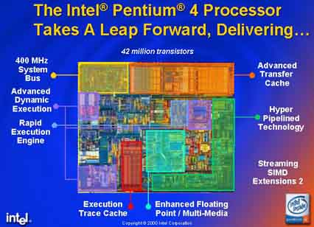

The NetBurst architecture has a pair of Arithmetic Logic Units (ALU’s) that are used for certain forms of integer arithmetic. These units have been clocked at twice the processors clock speed. This new architecture also incorporates an execution trace cache. The execution trace cache sort of takes the place of a conventional L1 cache and caches micro-operations instead of the x86 form of instructions. Another feature is a better and more efficient L2 cache at 256K. Though Pentium 4’s L2 cache is the same as the Pentium 3’s L2 cache, the Pentium 4’s is more advanced by sending data on every clock cycle.

