INTRO:
Dynamic Random Access Memory, or DRAM, consists of rows and columns of memory cells. Each memory cell is made up of a capacitor and a transistor. The transistor is the “on-off” switch for the cell’s memory chip, which could change the amount of electrons stored in the capacitor. Access transistors called ‘sense amps’ are connected to the each column and provide the read and restore operations of the chip. Since the cells are capacitors that discharge for each read operation, the sense amp must restore the data before the end of the access cycle. Moreover, it is the charge of the capacitor that enables the cell to store one bit of data. For example, a level of charge at or above 50% represents a 1 in that bit. Likewise, a level of charge below 50% represents a 0. The cells are addressed via row and column decoders, which in turn receive their signals from the Row Address Strobe (RAS) and the Column Address Strobe (CAS) clock generators. A typical memory access would occur as follows. First, the row address bits are placed onto the address pins. After a period of time the RAS signal falls, which activates the sense amps and causes the row address to be latched into the row address buffer. When the RAS signal stabilizes, the selected row is transferred onto the sense amps. Next, the column address bits are set up, and then latched into the column address buffer when CAS falls, at which time the output buffer is also turned on. When CAS stabilizes, the selected sense amp feeds its data onto the output buffer.
Ultimately, it is the smaller size and lower cost that explains why DRAM is still used. Using SRAM (Static Random Access Memory) instead would significantly improve performance. However, it would make the cost of even 64 MB of RAM too high for mainstream consumers.

TYPES OF DRAM

Asynchronous

By implementing special access modes, designers were able to eliminate some of the internal operations for certain types of access. The first significant implementation was called Page Mode access. Using this method, the RAS signal is held active so that an entire “page” of data is held on the sense amps. Only cycling CAS can then repeatedly clock in new column addresses. This provides much faster random access reads, since the row address setup and hold times are eliminated.
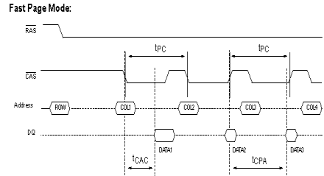
Fast Page mode improved upon the original page mode by eliminating the column address setup time during the page cycle. FPM DRAM, or Fast Page Mode Dynamic Access Memory activated the column address buffers on the falling edge of RAS (rather than CAS). Moreover, FPM DRAM locates bit by column and row and then moves on to the next bit after it is read. Fast Page mode became the most widely used access method for DRAMs, and is still used on many systems. Furthermore, maximum data transfer is 176 MB/second to the L2 cache. The benefit of FPM memory is reduced power consumption, mainly because sense and restore current is not necessary during page mode access. Though FPM was a major innovation, there are still some drawbacks. The most significant is that the output buffers turn off when CAS goes high. The minimum cycle time is 5ns before the output buffers turn off, which essentially adds at least 5ns to the cycle time.
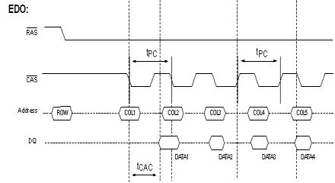
The last major improvement to asynchronous DRAMs came with the HyperPage mode, also known as Extended Data Output (EDO RAM). This innovation was simply to no longer turn off the output buffers upon the rising edge of CAS. In essence, this eliminates the column precharge time while latching the data out. This allows the minimum time for CAS to be low to be reduced, and the rising edge can come earlier. The overall result is EDO has the ability to access entire blocks of memory, instead of only one byte at a time. In addition to a 40% or greater improvement in access times, EDO uses the same amount of silicon and the same package size. EDO has been shown to work well with memory bus speeds up to 83MHz with little or no performance penalty. If the chips are sufficiently fast (55ns or faster), EDO can be used even with a 100MHz memory bus. In fact, the top of the line EDO RAM has an access time of 45ms. Also, EDO DRAM allows for a maximum transfer rate to L2 cache of 264 MB/sec. One of the best reasons to use EDO RAM is that all of the current motherboard chipsets support it with no compatibility problems, unlike much of the synchronous memory now being used.
Taking EDO technology one-step further, Burst Extended Data Output (EDO DRAM) gave the additional feature of burst mode. Burst mode exists when the memory module assumes control of the bus and uses that bus exclusively to transfer data back and forth to the hard drive(s).
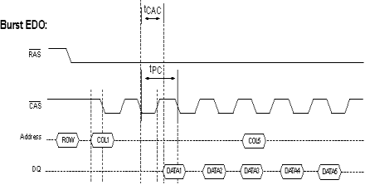
Furthermore, this “burst” transfer rate much faster than normal transfer rates. All in all, burst mode is an advancement over page mode, in that after the first address input, the next 3 addresses are generated internally, thereby eliminating the time necessary to input a new column address.

Synchronous
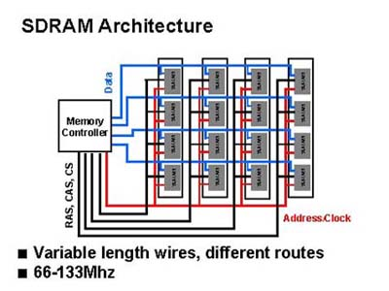
Synchronous Dynamic Random Access Memory, or SDRAM, gives the system the capability of getting information every clock cycle. With synchronous control, the DRAM latches information from the processor under control of the system clock. Furthermore, the system clock is the only timing edge that needs to be provided to the DRAM. This eliminates the need for multiple timing strobes to be propagated. The inputs are simplified as well, since the control signals, addresses and data can all be latched in without the processor monitoring setup and hold timings. Similar benefits are realized for output operations as well. Another important difference between synchronous and asynchronous DRAM is that SDRAM chips are officially rated in MHz, rather than nanoseconds (ns) so that there is a common denominator between the bus speed and the chip speed. The SDRAM speed is determined by dividing 1 second (1 billion ns) by the output speed of the chip. As far as the transfer rate to L2 cache is concerned, SDRAM modules allow for approximately 528 MB/sec. Also, the original SDRAM modules were designed for 66 MHz and 83 MHz bus operation. Due to some of the delays introduced when having to deal with the various synchronizations of signals, the 100MHz chips produce a module that operates reliably at about 83MHz, in many cases. These original SDRAM modules are now called PC66, to differentiate them from those conforming to Intel’s PC100 specification. The PC100 SDRAM was built with the intended purpose of operating at 100 MHz to coincide with the improved system bus speed, which had just reached 100 MHz as well. Later on, the faster PC133 SDRAM memory modules were also released.
It was not long after SDRAM had been around before Enhanced SDRAM was introduced. ESDRAM is essentially SDRAM, plus a small amount of SRAM cache which allows for lower latency times and burst operations up to 200MHz. Just as with external cache memory, the goal of a cache DRAM is to hold the most frequently used data in the SRAM cache to minimize accesses to the slower DRAM. One advantage to the on-chip SRAM is that a wider bus can be used between the SRAM and DRAM, effectively increasing the bandwidth and increasing the speed of the DRAM even when there is a cache miss. Nevertheless, ESDRAM comes at a noticeably higher price than SDRAM since it has not only DRAM but more expensive SRAM as well. Likewise, the cost of ESDRAM is in general as much as four times that of SDRAM, thus not making it easily targeted towards the mainstream market.
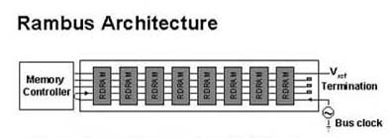
Dynamic Rambus DRAM, or DRDRAM, is the newest type of memory to hit the market and it is taking the computer industry by storm. Despite advances made to the refresh rate, which is now as high as 800 MHz, the biggest improvement made to DRDRAM is the wider bus width, now at 64 bits. Previous SDRAM used a much smaller 16 bit wide bus. Unfortunately, both Intel and Rambus, Inc. have a strong hold on the rights to manufacture these chips. Other manufacturers wanting to use DRDRAM technology must pay a royalty fee to do so. In addition, Intel and Rambus, Inc. remain very inflexible towards any changes made to the DRDRAM architecture.
Finally, moving in a somewhat different direction than Rambus, Inc., eighteen of the leading memory manufacturers, such as IBM, NEC and Texas Instruments, are counting on the future of SyncLink DRAM, or SLDRAM. Unlike DRDRAM, the design for this type of memory is royalty free, due to the fact that it is an open-industry standard. In addition, SLDRAM has a 16-bit data path that refreshes at 400 MHz. Moreover, some engineers working on the development of SLDRAM have predicted that the output operation may even increase from 400 MHz to 800 MHz within a few years.

CONCLUSION:
As technology continues to lead to advancements in computer architecture, one can only expect the performance to improve accordingly. Likewise, computer memory, or more specifically Dynamic Random Access Memory, will improve, as transfer rates keep getting larger while refresh ratings increase. FPM DRAM, by providing the basic ideals for dynamic memory storage, paved the way for current DRAM architecture. Moreover, the memory module designs of today, such as DRDRAM and SLDRAM, may very well be the basis of future DRAM technology.

BIBLIOGRAPHY:

Kozierok, Charles M. (2001). “Dynamic RAM (DRAM).” URL:
http://www.pcguide.com/ref/ram/typesDRAM-c.html.
Tyson, Jeff (2001). “How Computer Memory Works.” URL:
http://www.howstuffworks.com/computer-memory.htm.
Tyson, Jeff (2001). “How Random Access Memory (RAM) Works.”
URL: http://www.howstuffworks.com/ram.htm.

