This work complies with the JMU Honor Code.

Forensic Analysis of a Windows 2000 Server Operating System
CS585F Fall 2002
Joshua Young

Introduction
This paper outlines techniques for conducting a forensic analysis on a computer running a Windows 2000 Server operating system in the context of a criminal investigation. While there are many law topics that must be considered in an actual investigation (such as evidence handling procedures, crime scene management, etc.), this paper focuses on the analysis portion and only touches on the other topics where appropriate. Since many of the software tools used for this analysis require a license to be purchased for use, limited demonstration versions were used instead. All tools used are included in Appendix A.
It is difficult to conduct an analysis without some goal in mind. Instead of an elaborate scenario, and to allow for the most coverage, the goal for this analysis is to take a Windows 2000 computer and attempt to determine two broad categories of information: the nature of its use and what data it might contain. Since I had only one system, it acted as both my target and analysis machine. Obviously this would never do in a real situation, but it proved adequate in most cases to test the tools and show the methodology of an actual analysis. A description of the system is included below as part of the analysis.

First Contact
The first step in my analysis was to look at the physical evidence itself. Pictures were taken of the machine, the room, and all other physical evidence (disks, external storage media, etc.) A digital camera was used so the pictures could be immediately confirmed. Care was taken to include angles that showed how the cables were connected, hardware serial numbers, software registration numbers, and overviews of the room from numerous vantage points. Figure 1 shows an example of the quality of the pictures obtained with my digital camcorder. After documenting the room and its contents untouched, the rest of the physical evidence was examined for any obvious information, especially passwords written down. I searched any place I could find that a user might hide a written password, such as the underside of the keyboard, the sides of the monitor, the desk drawers, inside books, etc. Once the search was complete, the information
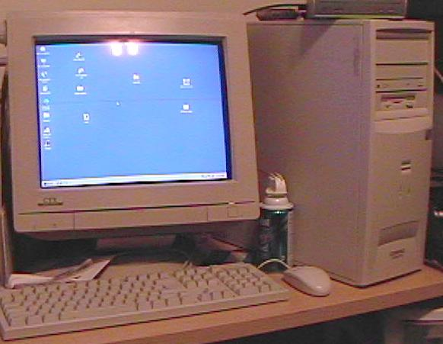
Figure 1: Overview picture of home computer.

would need to be processed. Specifically, serial numbers of hardware and software should be checked. Where software is registered, it is possible that a court order could force the vendors to release any customer information, including passwords that they have on file. Concerning the additional evidence that is collected and its analysis, I do not explicitly cover it going forward. To avoid considerable repetition I only focus on the main computer and its hard drive. However, the techniques discussed for analyzing the main computer would work for other common media types as well. A complete analysis would involve searching each of the media captured in the same manner as the main computer. With the external evidence collected and processed, the focus shifted to the computer system itself.
One of the main guidelines in an analysis is to do as little analysis on the actual machine as possible. Ideally, the system should be immediately imaged and all analysis done on copies of the original. In practice, this is not always possible to do. Where analysis must be done on the physical machine itself, every attempt should be made to make as little impact on the system as possible. If changes are made to the original media, these changes and the reasons behind them should be documented. With this in mind, I considered two scenarios.

Hacking the Box
At first I assumed the computer to be off. In the text “Computer Forensics Incident Response Essentials”, it makes the claim that if you have the physical media, you can access the logical media. Forcing your way into it is “straight forward”. While there is some truth to this, I found it more problematic than the book made it out to be. The technique described for getting into a Windows NT box was to boot the machine from some manner of boot disk, capture the SAM file that contains the NT password hashes, and then crack the hash file on your analysis machine using a product such as LophtCrack. It’s desirable that the boot disk not make any changes to the system (although at this point, you should be working on a copy. I describe the copying process later). Two recommendations were given in the book. The first was a DOS boot disk with NTFSPro on it. This software allows the Dos boot disk to mount NTFS partitions. The evaluation version mounts them read-only, which is preferable for the forensic analyst. However, I could not get this software to function. I managed to create the boot disk, but when I tried using it to boot the system I got unhandled exception errors that prevented me from continuing. As an alternative, I tried creating a Linux boot disk using the Bootable Business Card. Using this I was able to boot the machine, mount the NTFS disk, and mount the floppy drive. I was then able to capture the SAM file to disk using the standard Unix cp command. However, when I attempted to crack this SAM file using LophtCrack, it did not work. The message dialog that explains the reason is shown in figure 2. LophtCrack appears to run, but the password is never cracked. I tested it by attempting to crack a known password with a dictionary file that contained the password. It failed. I confirmed that it was the encryption causing the problem by testing LophtCrack with unencrypted hashes (obtained with admin permissions). In this run LophtCrack cracked the password in seconds. I also tried capturing the Windows 2000 Hashes via an Emergency Repair disk as well, but these were syskey encrypted as well. LophtCrack wasn’t able to do anything with them.

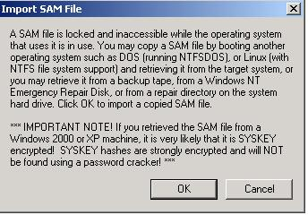
Figure 2: LophtCrack result.

The one bright spot is that the Linux boot disk did allow me to bypass the built in NT security and look at any unencrypted file on the file system. However, at best this is limiting, and it is simple enough for the user to turn on file system encryption that will thwart even this. Further, I could not find any other method of hacking into a Windows 2000 machine. In the end, with a Windows 2000 machine that is off, I found no way of getting into it other than the old techniques of password guessing, finding passwords written down, or getting the passwords from the owner.

Dealing with a Running System
Feeling rather unfulfilled after trying to hack a box that was off, I decided to try the scenario where the computer was on. The main question here is when and how to turn the machine off. Most research I read advocated pulling the plug directly. However, since this wasn’t a scenario where the machine was known to be under attack, I didn’t feel it was necessary to turn it off immediately. After my experience with hacking the machine when it was off, I felt it was more important to gather what information I could with it still on. I opted to do two things before pulling the plug.
The first thing I did was capture the RAM as best I could. I used the program Winhex to do this. While this program comes with an installable version, I found that running the install wasn’t necessary on a Windows 2000 machine. If I installed the program on a machine, I could then copy the installation folder to a floppy. The program could be run directly from the floppy, even on another Windows 2000 machine. This minimizes the impact on the machine we are analyzing. However, this was still a tradeoff decision. It is possible that this could make minor changes to the hard drive (via virtual memory). It certainly changes the contents of the RAM to some degree. However, I decided having what was still in memory was more likely to contain valuable, useable information about what this computer was used for. A screenshot of the capture is shown in figures 3.1 and 3.2.

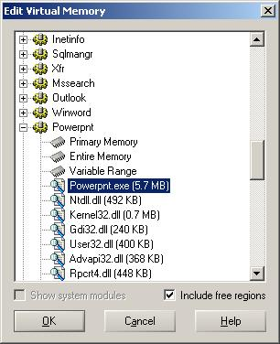
Figure 3.1. When doing a RAM capture Winhex allows you to select which part of the virtual memory to map.
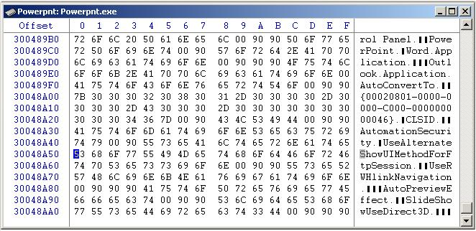
Figure 3.2. This is a screen shot of the section of RAM being used by my Powerpoint application.

The next thing I wanted to do was capture the unencrypted password hashes. I used a program called PWDump2, again from a floppy disk. This program captures the unencrypted hashes from a machine and writes the output back to the floppy. It requires administrative rights to get the hashes, so I had to assume the user was logged on with sufficient privileges. Again, this was a tradeoff decision. I decided to trade very minimal change (if any) to the hard drive in for the ability to get all of the user passwords on the system. If called into question in courts, this utility is distributed with its source code. Experts could be found to testify that it was not doing any significant change to the hard drive or password hashes.
After capturing the RAM and password hashes, I opted to pull the plug on the machine. While some make arguments that this may leave the operating system in an unstable state, I decided it was worth the risk. In my experience, Windows 2000 is very capable from recovering gracefully from a sudden loss of power, and the risk of lost information via cleanup programs or custom traps was a greater risk.

Capturing High Level System Information
Once the computer was off, I wanted to see what I was dealing with. I again used the Bootable Business card to boot the system with the hard disk mounted as read only. I obtained the main computer parameters (speed, memory, etc.) and the partitioning scheme of the computer. This would help me prepare the resources I would need to copy the hard drive. Figure 4 contains the findings.

Figure 4: System Main Parameters

Genuine Intel Pentium II
Speed: 348.49 Mhz
Cache: 512Kb
Main Memory: 129,835,008

FDisk
Device Boot Start End Blocks ID System
/dev/hda1 * 1 832 6289888+ 7 HPFS/NTFS

Copying the Hard Drive
The next step in my analysis was to make a copy of the hard drive. In the above scenarios, this would be done immediately if the computer was off, or right after the plug was pulled if the computer was on. Here it is very important to make a bitwise copy of the drive, thus preserving any deleted or fragmented data. I also saw recommendations from several sources to wipe the destination drive you will be using. I did not really understand this recommendation, since a bitwise copy should overwrite the space on the destination drive. However, it couldn’t hurt and might help when trying to convince a jury that what I found wasn’t something left there by me. There are many software tools available that handle secure wiping. I chose to use a tool called QuickWiper. While I did not wipe an entire drive, I did sample the wipe program by wiping the free space in a file. Figurers 5.1 and 5.2 show the results of this process.
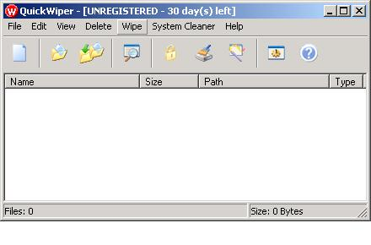
Figure 5.1. A screenshot of the Quickwiper utility

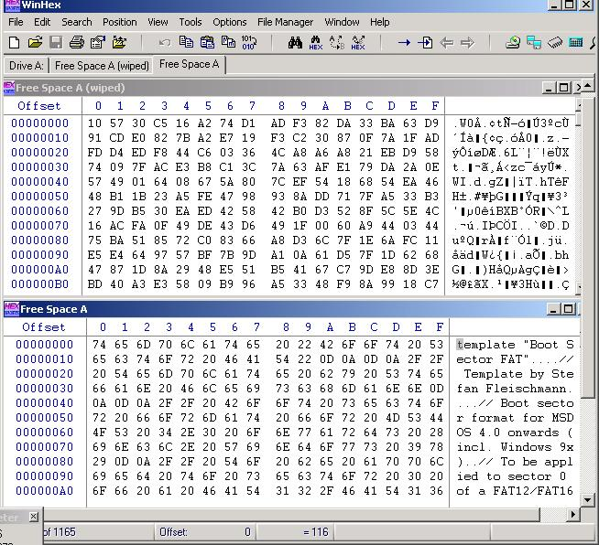
Figure 5.2. A screenshot showing the before and after of a Quickwipe operation.
To make the bitwise copy, many programs are available. The dd utility in linux is freely available and mentioned in much of the literature I found. Winhex is able to do this as well. Unfortunately, this was one step I was not able to perform hands on. I did not have the hardware available to do the full copy. Instead, I installed the software and examined the feature right up to the point where the copy is made. The procedure would be to take the source and destination drives and attach them to a machine, boot the machine using a bootdisk, and do the copy. Figure 6 shows the Winhex screenshot of the step before copying.
Once the image is made, it is a good idea to hash it multiple ways and get it time-stamped via a service like Digistamp. As an example, I hashed an .iso image file using both MD5 and CRC, via the WinHex tool. Figure 7 shows the results of the hash.

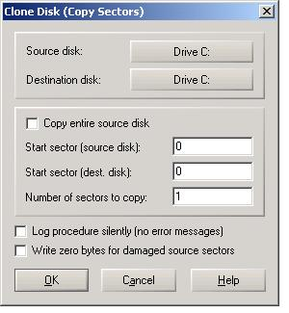
Figure 6. Screen shot of the clone utility in WinHex

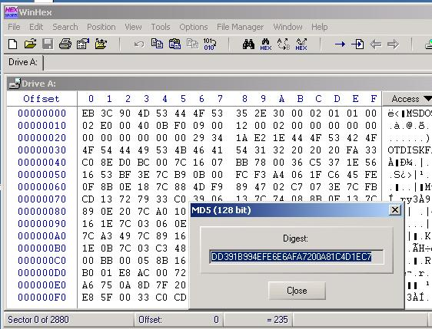
Figure 7. Results of the MD5 hash on a small image file.

Cracking the Passwords
Next I cracked the SAM file obtained via PWDump2. As of this writing, the latest version of LophtCrack does not support brute force cracking in its demo version. For this reason, I used LophtCrack version 2.5 demo. A screenshot of the crack is shown in figure 8. As a reference for performance, a password cracked via the dictionary is done in minutes. A brute force attack against an 8 character password containing only letters and numbers took just over 18 hours to complete on my machine.

Analysis Strategy
I decided to do my analysis on a Windows Machine for two reasons. First, it is the operating system I am most comfortable with. Second, I was able to find more tools to assist me designed to run on a windows platform. I categorized my analysis into four major types of information.
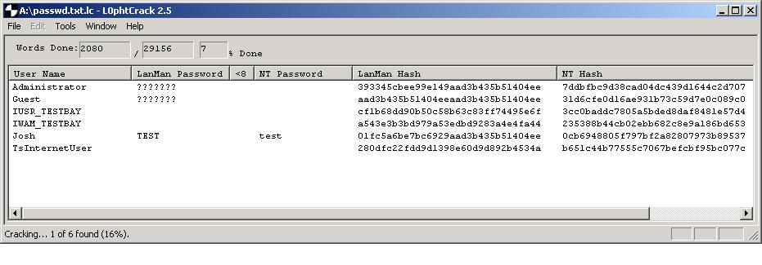
Figure 8. Screenshot of a LophtCrack session in progress.

Configuration: This would be the major determining factor in answering the question “What was this computer typically used for.” By configuration, I set out to look at the system settings, the network settings, and what programs and services were installed on this machine.
Regular Documents: Assuming there haven’t been steps taken to hide data on the computer, this would be the major determining factor in answering the question “What data is contained on the computer.” The main thing to search for here is common document formats, images, email, zipped files, keyword searches, and specific document searches based on the installed programs found in the configuration analysis. For example, if Microsoft money if found to have been installed now or in the past, there is a good chance that there is a Microsoft Money file somewhere on the machine containing financial information.
Deleted Documents: This may or may not lead to valuable information, but is an avenue that must be explored to be thorough.
Hidden Information: If steps have been taken to hide data on the machine, this is where we hope to expose it.

Configuration Settings:
In addition to the main settings recovered using the Linux boot disk, there are several other places to check for system settings. The main area for Windows 2000 is the computer management application found in settings/control panel/administrative tools/. The other applications in the control panel should be examined as well. While each setting should be reviewed, special care should be taken to note things like the Date/Time settings. If it’s incorrect, time settings on files and email could paint an inaccurate picture. Some other things to pay special attention to are:
Is IIS installed? If so, are there web sites or ftp sites running.
Is this a specialty server, ie Email, DNS, DHCP, Terminal Server, etc.
Log Files:
Figure 9 shows a screen shot of the computer management application.

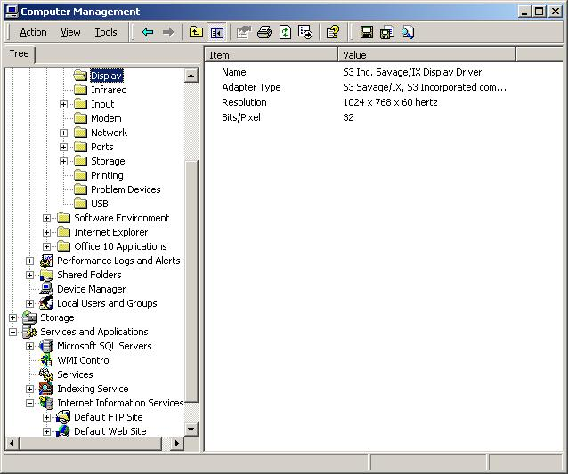
Figure 9: Computer Management Application in Windows 2000

Simple network configuration can be found via the IPConfig command. The output from this command is shown in figure 10. More thorough network setting can be found under settings/control panel/network and dial-up connections. The main thing to look for here is any info that can lead you to the user’s service provider (if they have an internet connection). Contact that service provider immediately and advise them not to delete their logs. Other things to take note of are virtual private networks, protocols installed, and whether or not it has multiple IP addresses configured.

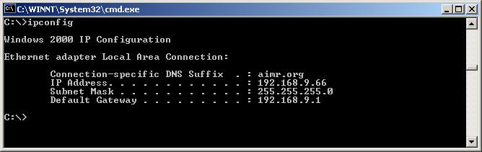
Figure 10. Output of the IPConfig command

To determine what applications are installed, it is advisable to look in several places. First, the ‘control panel/add remove programs’ menu item will show a high level view of what’s installed now. However, since not every program has an installation routine that adds itself to the registry, you’ll have to look through each file as well. This can also give clues to applications that were installed and erased. Since the only visual clue you’ll have to determine if a file is an application is the extension, you can speed the search by using the dir command and searching for files with the extensions exe (executable), com (command), bat (batch file), zip, tar, gzip, rar, cab (compressed files), msi (Microsoft installer file). Often times the uninstall does not delete every file and the application’s directory structure remains. It is also a good idea to do keyword searches in the registry. Many times programs that are uninstalled leave registry keys behind. Figure 11 shows a keyword search of the registry using regedit.
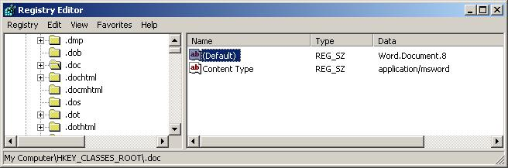
Figure 11. Keyword search in regedit. I searched for the string ‘word’, and this was the first hit.

Services are another type of executable program that should be examined. Since services run in the background and can be set to start automatically, they are an ideal place to put code containing traps for would be examiners. It is important to attempt to identify the origin of any services that is set to start automatically. Any service that cannot be identified as a known, common service should be considered to have the potential to be destroying information on startup.
Services are not the only thing that can launch on start-up. Regular applications can be set to auto-start by placing them in some known places. The two common places to look are the ‘start menu/startup folder’, or the registry setting found at the following locations: Under both HKEY LOCAL MACHINE and HKEY CURRENT USER, the keys Software/Microsoft/Windows/CurrentVersion/ run, runonce, and runonceex. Figure 12 shows the run key in the registry.
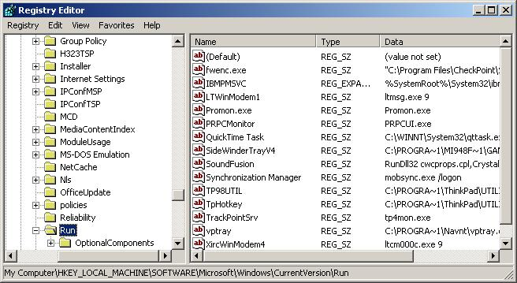
Figure 12: Shows some of the programs that are set to run when the operating system boots up.

Regular Data
Since I’m not yet looking for hidden data, the most common way to search for documents is by extension. Using the Dir command or the windows search feature are options available on all windows machines. Common file types can be found by doing a search on the phrase ‘Common File Types’ on any major web search engine. Some specific document types to look for are
Office Documents: doc, xls, ppt, wpd, …
Images: gif, jpg, jpeg, tiff, bmp, …
Sound files: wav, mp3 …
Movie files: mpg, mpeg, mov, asf…
PDF Files

The other common place to look for information is in email. The email application on the machine can typically be used. It is important to check the folder where attachments are stored as well. These are typically unencrypted and remain even if the email that contained them was deleted. Many email applications (most notably Microsoft outlook) also contain other sources of information, such as calendars. These should be checked thoroughly.
Many common commercial applications have the ability to password protect their documents. However, typically these encryption schemes are fairly easy to bypass. Several commercial applications can break the password protection on common file types. Additionally, passwords found via other sources (LophtCrack, .pwl files, written down) can be tried. Figures 12.1 and 12.2 show a screen shot of an application called Advanced Office 2000 Password Recovery that can crack common Microsoft document types. As an example, I used a word document created with Office XP and a simple open password using the default encryption scheme. The program cracked it within seconds. However, the Office XP version of word has an advanced settings section that allows the user to specify more secure password encryption. This time the program failed to crack the same password entirely.

Figure 12.1. Result of a test using Office 97/2000 encryption
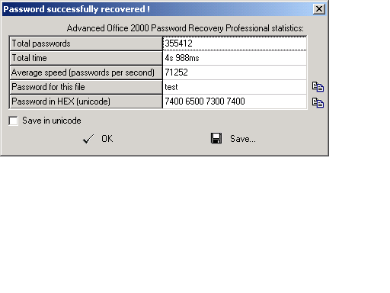
Figure 12.2: Screenshot of a crack in progress of an Office document
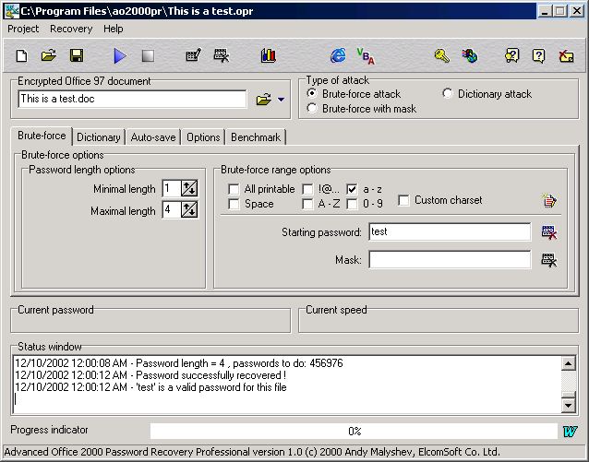

Data on internet usage can be valuable in determining recent activities of a user. The course text outlines many locations in the registry where this information should be housed. Many programs also advertise the ability to recover this information. However, I had no success when trying any of these techniques. In windows 2000, I could not find any autocomplete information stored in the registry in plaintext. I also could not recover history from .dat files as advertised by many programs. I tried both NetAnalyst and DataLifter. Neither produced any results. In the end, the only information I was able to recover was via the standard methods a user would use. I checked the history through the browser, and the auto complete by typing each letter in the address bar and recording the possibilities that came up for that letter. Cookies were recorded by looking in the cookies folder for each user.

Deleted Data
There are two primary methods for recovering deleted data. The first and simplest is to check the recycle bin. People often forget to empty this bin, and it can contain a tremendous amount of information. The second primary method is to use a utility to reveal the files that have been marked for deletion but have yet to be copied over. Norton Utilities is one of the most common tool used for this task, however the trial version does not work on NT Server variants. I used the facilities in WinHex to view and recover files. Figure 13 shows an example of Excel displaying a file created by Winhex that shows files that have previously been deleted but are recoverable.

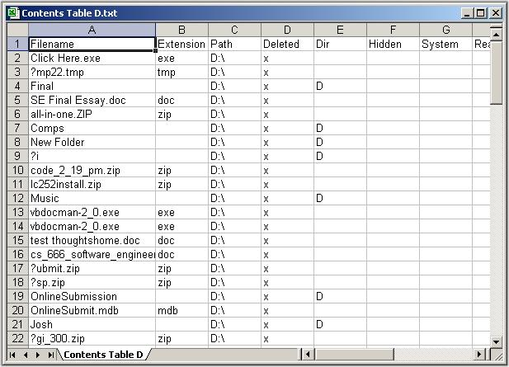
Figure 13. A list of all files in a given drive or directory. The deleted column shows if the file is still present or needs to be recovered.

A less helpful but still valuable indication of deleted files lies in the applications themselves. Many modern applications keep a list of recently opened files. These lists can contain information on files that previously existed. Even if these files are not recoverable, the name in and of itself may be valuable evidence in certain circumstances.

Hidden Data
There are several ways for a user to hide data. Some are more effective than others. The simplest, but least effective, is to mark a file as hidden in the windows operating system. However, these can be detected by simply going into windows explorer and changing the options to view all files.
A second rather primitive method is to change the file extensions on a file. Windows uses the file extensions to recognize the type of file. By changing it, it is no longer obvious to a user (or Windows itself) what type of file it is. If you suspect this is the case, it can often be thwarted by simply opening the document in its parent application. For example, opening a document with an unknown file type directly from Microsoft Word will render the contents correctly if it is any of words known document types. In the case of images, some programs will display them correctly regardless of extension. I tried two popular image processing applications. I tested them by taking a simple .jpg file and changing the extension to .dat. The first application, Thumbsplus, did not appear to pick up the unknown type. It didn’t detect it, and when pointed to it explicitly it showed the image as a large red X. LView pro, however, did pick up the file type and render it correctly. Figure 14 shows the screenshot of LviewPro.
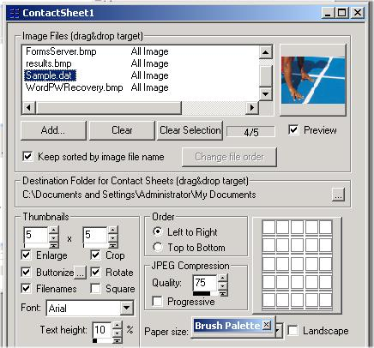
Figure 14: LviewPro picking up an image despite the data type being changed.

Another type of data hiding can be accomplished in NT using alternate data streams. Included in the NTFS file system for compatibility with the Macintosh Hierarchical File System (HFS), they provide a means for a savvy windows user to hide additional data on top of an already present file. While the typical file viewing mechanisms in windows don’t detect these alternate streams, there is freeware available that does. I used a freeware program called Lads to view some simple text streams I placed on the end of some files. The output is shown in figure 15.
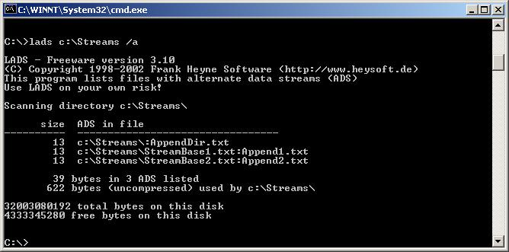
Figure 15: Output of lads on a directory containing streams. Notice that the directory has one appended to it, as well as the two files.

While in most cases a user must take action to hide their data, some data may be hidden by virtue of the fact that it simply hasn’t been physically overwritten. The slack space, free space, and unallocated space on a drive can all contain information that the user is unaware of. I again used Winhex for this task. Figure 16 shows a section of a capture of the free space of a drive. This can be saved to a file and searched for keywords or analyzed to see what text it might contain.
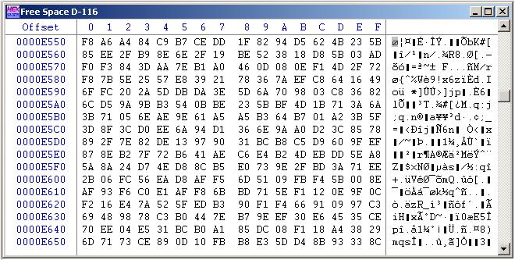
Figure 16: Free Space dump of a drive, viewed in Winhex

A more effective means of hiding data is to use staganography. This embeds data inside other, much larger files (typically picture, sound, or movie files). The host file is altered slightly to house the data, so slightly that it is typically undetectable by the naked eye. The bad news is that there aren’t any great ways to detect stegoed files. The best indicator I could find was to the presence of steganography software on the computer that is being analyzed. The good news is that research is being done and some detection techniques are showing promise. Steganalysis can produce patterns in images that are rarely found in naturally occurring images, and these are proving effective in detecting stegoed files. However, decoding the files is still not feasible without the password. While there are a plethora of tools available to hide data in a file, I could find none that detected or attempted to decode stegoed files.
The last method of data hiding I wanted to touch on was cryptography. Once reserved for academics and governments, very strong cryptography is now widely available and commonly used by regular users. Detection is problematic and breaking the encryption can be expensive to the point that it isn’t currently feasible to do. For users who really want to hide their information, this is still their best route and the forensic analyst’s biggest hurdle.

Conclusion
In the end, I was able to recover a tremendous amount of information about the computer using nothing but freely available tools and a regular desktop machine. However, many of the things advertised no longer work on windows 2000, and I suspect even fewer will work on the upcoming .NET Server. It seems in previous version of windows security has typically been either poorly implemented or ignored entirely. However, Windows 2000 has made significant improvements over its previous versions. In fact, with a little bit of knowledge a user can sufficiently protect a windows 2000 machine from nearly every attempt I made in this analysis.

Appendix A: My Forensics Toolkit
NTFSDosPro:
http://www.winternals.com/products/repairandrecovery/ntfsdospro.asp
Boot Disk that can mount NTFS partitions
LophtCrack: Versions 2.5 and 4.0
http://www.atstake.com/
Password Cracker for windows NT
LinuxCare Bootable Toolbox:
http://open-projects.linuxcare.com/
Boot CD that can mount NTFS partitions
WinHex: v 10.6
http://www.sf-soft.de/winhex/forensics.html
Hex Editor and Forensics tool.
PWDump2:
http://razor.bindview.com/tools/desc/pwdump2_readme.html
Tool used to get NT Password Hashes
fdisk: Standard on Linux Systems
Quickwiper:
http://www.quickwiper.com/
Secure erasing of windows files
Computer Management Console: Standard on Windows 2000 Server
IPConfig: Standard on Windows Computers
Advanced Office 2000 Password Recovery Professional:
http://www.elcomsoft.com/ao2000pr.html
Password Recovery Software
NetAnalysis: V 1.27
http://www.digital-detective.co.uk/
Forensic Internet History Software

DataLifter: V2.0
http://www.datalifter.com/
Forensic Support tools
ThumbsPlus: 5.01 -s
http://www.cerious.com/
Image Processor. Demo Version Available.
LView Pro: Version 2002
http://www.lview.com
Premium Image Processor. Demo Version available.
Lads: List Alternate Data Streams V 3.10
http://www.heysoft.de/nt/ep-lads.htm
Freeware that shows Alternate Data Streams on NTFS files
TextPad: Version 4.5
http://www.textpad.com/
General Purpose text editor for windows. Demo Version available.
Microsoft Excel: Version 2002
http://www.microsoft.com/office
Spreadsheet program shipped with Microsoft Office Suite

