Critical Elements of the IBM System 360

Jeff Schreibman

CS585: Computer Architecture
Summer 2002
TABLE OF CONTENTS

Introduction……...…………………………………………………………………………. 2

Critical Elements
Forward and Backward Compatibility……………………………………………... 2
Separation of Architecture and Implementation…………………………………… 4
Integration of Scientific and Business Efficiency………………………………….. 4
Extensive Use of Microprogramming………..…………………………………….. 5

Technical Details
The 360/370 Architecture………………………………………………………….. 6
The 360/370 Instruction Set Architecture………………………………………….. 6
Addressing Modes and Instruction Formats……………………………………….. 7
Operations on the 360/370…………………………………………………………. 8
Instruction Set Format…………………………………………………………….... 10
Common IBM 360 Instructions………………………………………………….… 11

Summary…………………………………………………………………………………… 12

Appendix A
Complete IBM 360 Instruction Set………………………………………………….13-16

Bibliography………………………………………………………………………………...17
Introduction

“The IBM’s System 360 was one of the most ambitious projects in the history of the computer industry”[Gifford and Spector'87, April].

This quote describes the innovative and bold nature of the project that created the IBM System 360. The project laid the groundwork for the giant corporation that IBM came to be. The IBM 360 was historically important due to its forward and backward compatibility (family concept and extensive instruction set), clear separation between architecture and implementation, integration of scientific and business efficiency, and extensive use of microprogramming (see Common Instructions on page 11 and Full Instruction Set in Appendix A). This paper will begin by discussing the IBM 360’s impact and move into technical information in the second half of the paper (pages 6-11).

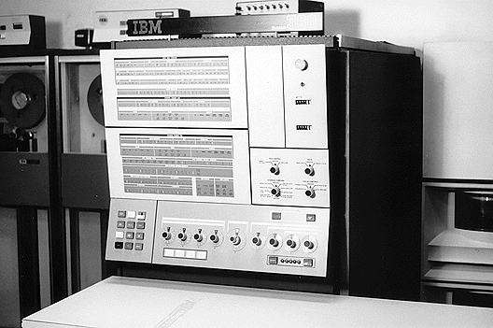
Figure 1 (Shustek) - IBM System/360– Look at the sheer size of it!

Forward and Backward Compatibility

The goal when creating the IBM 360 was to create a “family concept”, where for the first time a single ISA could be used with older and newer machines in the same family. This was an extremely important concept that allowed many IBM systems to be compatible with each other. This made the IBM line much more attractive to potential buyers. Customers would only need to worry about which IBM to buy to fit their current computing needs and not whether they would have compatibility issues within a family of computers.

In the early 1960’s, IBM had 6 or 7 incompatible lines of computers. The industry was building small and large computers (in terms of power) for business or scientific uses; most computers were built backward compatible, but forward compatibility was not ensured. Newer computer models could run programs from older models, but older models couldn’t run the new programs. There was no guaranteed forward compatibility in the market at the time. IBM wanted to create “general purpose” computers that were both forward and backward compatible. This would create economies of scale within the product line. Computers within the line could be compared with each other effectively, unlike before.

In doing so, they created small and large computers that could handle the same ISA. They had to find a middle ground between complicated and resource-intensive microinstructions that small computers couldn’t run effectively and simple instructions that didn’t utilize the large computers’ resources. The loss of efficiency in the computers due to compatibility design considerations was far overshadowed by the advantage of compatibility achieved between models. Hence, they could create software that fit a single product line and customers could choose their appropriate machine along this compatible line. In April 1964, IBM released a line of compatible computers with a performance range of 25 to 1. Eventually the family evolved into the 370(1970), 303x(1977), 43xx(1979), and 308x(1981), all with the 360 architecture and performance ranges upwards of 1000’s to 1.

The IBM 360 family of computers created the concept of the ISA (see Figure 2), where every machine had the same set of instructions, number of user registers, and behavior, and thus were binary compatible. The family had models at many different price and performance levels, but they were all object-code compatible with one another. Today, this idea of a family of computers at different performance and price levels is commonplace. Computers are individually configurable at both the hardware and software levels, as well as being compatible with many other similar computers. However, in the 1960’s and 1970’s, this idea was somewhat revolutionary and obviously reaped huge benefits for IBM in the following years. Prior to IBM’s 360 project (early 1960’s), which included a compatible ISA, every new model required new hardware and software (a complete overhaul!), not just the weakest piece of the system. The 360 opened mainframe computing to the world by introducing a family of compatible machines.

Figure 2 (Shaaban, 2002) - The Evolution of ISA’s (Instruction Set Architecture’s).

“Therefore upgrading was possible without having to rewrite the software that runs on the less capable model.”[Murdocca and Heuring'00]

Importantly, the advantage of this compatibility is the ease of upgrades (not having to replace the whole system) as well as the transferability of software.

“Compatibility would ensure that the user’s expanding needs be easily accommodated by any model. Compatibility would also ensure maximum utility of programming support prepared by the manufacturer, maximum sharing of programs generated by the user, ability to use small systems to back up large ones, and exceptional freedom in configuring systems for particular applications.”[Amdahl, Blaauw et al.'64] The preceding quote was by Gene Amdahl, one of the architects of the IBM 360, who was describing the advantages of compatibility. Certainly, having a family of computers with compatible pieces is easier for the customer as well as the company to deal with. A great number of possible problems were reduced due to the sheer similarity of the models. Users had an unparalleled level of compatibility at the time. They could choose the power and purpose of their computer without having to worry about compatibility issues (assuming they stayed within the IBM 360 line) that had plagued them in the past. Small, trimmed down workstations could then be used in conjunction with larger more powerful computers. Compatibility and portability of software turned out to be a revolutionary concept indeed. “[The compatibility] feature was responsible in large part for the great success of the IBM 360 series of computers.”[Murdocca and Heuring'00]

The major risk that IBM took was that they were trading performance for compatibility. By making the models compatible, the performance of the machines was reduced in that they had to be backward and forward compatible. This required special design considerations that didn’t maximize efficiency. Although efficiency was reduced at the time, this disadvantage was far overshadowed by the benefit of compatibility. A group of less efficient, yet compatible computers is certainly preferable to a group of incompatible and slightly more efficient computers.

Clear Separation Between Architecture and Implementation

Because computers in the IBM 360 line were going to be compatible by using the same ISA, they had to use separate implementations to achieve this. The various capabilities and resources of one computer in the line versus another required different implementations, while using the same ISA.

Previously, each computer had a separate architecture and implementation and, thus, was grouped together as both were needed to work correctly. One couldn’t swap around architectures and implementations; they were specific to each other, there was hardly any flexibility. Even if another computer had a similar implementation, but the architecture was different, they would still be incompatible. There was not a clear separation between architecture and implementation. When IBM used the same architecture throughout many different computers that then needed different implementations, a clear separation between architecture and implementation was created.

Integration of Scientific and Business Efficiency

Before the IBM 360, computers typically offered performance in either scientific or business constructs. The system was configured in a way to be efficient one way or the other, but generally not both. The IBM 360 offered integration of scientific and business programs into a general-purpose machine. This revolutionized the industry and arguably created the first personal computer of its type. The dual-purpose machine (business and scientific applications) again lent itself to compatibility among different models in that computers weren’t either strictly business or scientific in orientation.

The IBM 360 family of machines could run the same programs that were on separate computers earlier, but at different speeds. They could perform either more computationally heavy math programs favored by business or binary notations favored for scientific applications. From the advent of the IBM 360 on, mainframe computers were mainly general-purpose. Again, the tradeoff of performance for the ability to run business and scientific programs on the same machine was worthwhile. This program flexibility also added to the compatibility within the models in the IBM family at the time. One could be sure that another IBM model in the same family would be able to run the program, whatever type it was (business or scientific). K. Shustek, a writer for the Computer History Museum, reflects upon the success of this design decision in a piece called “"A Walk Through 'Visible Storage'", as follows:

“IBM was doing a booming business selling mid-sized computers for both business and scientific purposes. But by the early 1960s it had a looming crisis: it was building too many different kinds of computers. Each used different technology, software, engineers, salesmen, and support technicians. To consolidate behind a single uniform product line that could do both scientific and business computing at both small and large scale… the result was wild success: IBM dominated the mainframe computer industry for 20 years with the System/360.”[Shustek]

With the rise of the IBM 360, the organizational separation between scientific and business application personnel faded. This in turn had a distinct impact on the sociology of the field. Business people could utilize scientific applications and vice versa. This created many new business opportunities due to the flexibility that the IBM 360 offered over the other computer systems at the time. The impact of this design consideration is considered below from an article in The Communications of the ACM:

“System/360 was designed to be able to handle both decimal and binary formatted information, with both variable-fixed length and floating-point arithmetic capabilities. Since scientific users tended to use Fortran and business users tended to use Cobol, IBM designed and developed the PL/1 programming language in a an attempt to provide a programming bridge between the two communities.”[Gifford and Spector'87, April]
The goal of PL/I was to develop a single language usable for both business and scientific purposes. Although the language turned out to be too complex for practical use and didn’t have a long lasting impact, it represented an important conceptual breakthrough.

Extensive Use of Microprogramming

The architecture of the IBM 360 is built around microprogramming, or small programs of microinstructions. By using microprogramming, smaller and larger computers could accomplish goals of small micro programs with their own implementations and use whichever microinstructions best suited them (most efficiently, that is). This way the ISA is consistent, but separate efficient microprogramming techniques between models are the only difference. In order to accomplish this, there needs to be an extensive set of microinstructions that all of the different models of computers could use. Thus, the concept of a CISC (Complex Instruction Set Computing) architecture was created. Although complicated and extensive commands are available for the smallest in the line, these commands probably wouldn’t be used. They are, however, available because all computers in the line use the same instruction set. Compatibility is the benefit.

The CISC (Complex Instruction Set Computing) architecture has an extensive instruction set (see Appendix A for the complete instruction set) that allowed for flexibility and portability between different computers, which was a great breakthrough in the computer industry at the time.

IBM 360 was the first to distinguish between architecture and organization, as well. The same instruction set was used across a wide range of implementations, each with different cost/performance.
Technical Details (Hennessy & Patterson, 1990)

The 360/370 Architecture

The IBM 360 was introduced in 1964. Its official goals included the following:

1. Exploit storage-large main storage, storage hierarchies (ROM used for micro code).
2. Support concurrent I/O-up to 5 MB/second with a standard interface on all machines.
3. Create a general-purpose machine with new OS facilities and many data types.
4. Maintain strict upward and downward machine-language compatibility.

The System/370, first introduced in 1970, was a successor to System/360. System/370 is fully upward compatible with System/360, even in system mode. The major extensions over the 360 included:

- Virtual memory and dynamic address translation
- A few new instructions: synchronization support, long string instructions (long move and long compare), additional instructions for manipulating bytes in registers, and some additional decimal instructions
- Removal of data alignment requirements

In addition, several important implementation differences were introduced in the 370 implementations, including MOS main memory rather than core, and write able control store.

In 1983, IBM introduced 370-XA, the eXtended Architecture. Until this extension, first used in the 3080 series, the 360/370 architecture had a 24-bit address space. Additional bits were added to the program status word so that the program counter could be extended. Unfortunately, it was common programming practice on the 360 to use the high-order byte of an address for status. Thus, old 24-bit programs cannot be run in 32-bit mode (actually a 31-bit address), while new and recompiled programs can take advantage of the larger address space. The I/O structure was also changed to permit higher levels of multiprocessing.

The last extension to the architecture was ESA/370, introduced with the 3090 models in 1986. ESA/370 added additional instruction formats, called the Extended formats, with 16-bit opcodes. ESA/370 includes support for a Vector Facility (including a set of vector registers) and an extended (128-bit) floating-point format. The address space was extended by adding segments on top of the 31-bit address space: (a new and more powerful protection model was added as well.

The remainder of this section surveys the IBM 360 architecture and presents measurements for the workload. First, let's examine the basics of the 360 architecture, and then look at the instruction set formats and some sample instructions.
The 360/370 Instruction Set Architecture

The IBM System/360 is a 32-bit machine with byte addressability and support for a variety of data types: byte, halfword (16 bits), word (32 bits), doubleword (double-precision real), packed decimal, and unpacked character strings. The System/360 had alignment restrictions, which were removed in the System/370 architecture.

The internal state of the 360 has the following components:
- Sixteen 32-bit, general-purpose registers: register 0 is special when used in an addressing mode, where a zero is always substituted.
- Four double-precision (64-bit) floating-point registers.
- Program status word (PSW) holds the PC, some control flags, and the condition codes.
Later versions of the architecture extended this state with additional control registers.
Addressing Modes and Instruction Formats

The 360/370 has five instruction formats. Each format is associated with a single addressing mode and has a set of operations defined for that format. While some operations are defined in multiple formats, most are not. The instruction formats are shown in Figure 3. While many instructions follow the paradigm of operating on sources and putting the result in a destination, other instructions (such as the control instructions BAL, BALR, BC) do not follow this paradigm, but use the same fields for other purposes. The associated addressing modes are as follows:
- RR (register-register)-Both operands are simply contents of registers. The first source operand is also the destination.
- RX (register-indexed) The first operand and destination are a register. The second operand is the contents of the memory location given by the sum of a 12-bit displacement field D2, the contents of the register B2. and the contents of the register X2. This format is used when an index register is needed (and for most loads and stores).
- RS (register-storage)-The first operand is a register that is the destination. The third operand is a register that is used as the second source. The second operand is the contents of the memory location given by the sum of the 12-bit displacement field D2 and the contents of the register B2. RS mode differs from RX in that a 3-operand form is supported, but the index register is eliminated. This instruction format is used for only a small number of instructions.
- SI (storage-immediate)-The destination is a memory operand given by the sum of the contents of register B I and the value of displacement D1. The second operand, an 8-bit immediate field, is the source.
- SS (storage-storage) The addresses of the two memory operands are the sum of the contents of a base register Bi and a displacement Di. The first operand is the destination. This storage-to-storage operation is used for decimal operations and for character strings. The length field can specify a single length of I to 256, or two lengths, each from I to 16. A single length is used for string instructions, while decimal instructions specify a length for each operand.

The displacement in the RS, RX, SI, and SS formats is 12 bits and is unsigned.
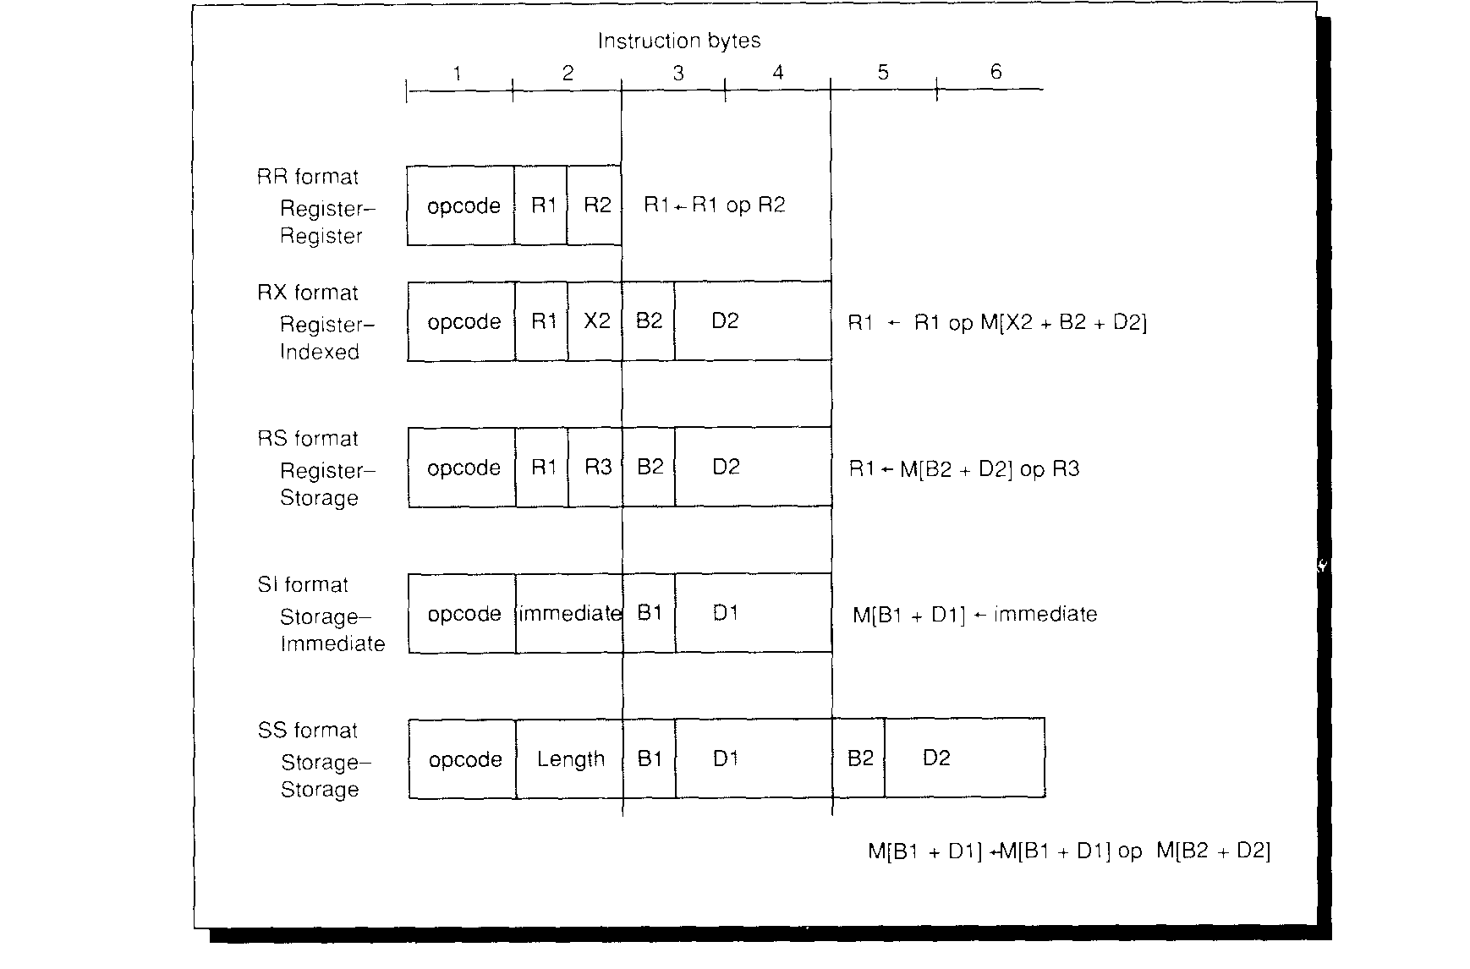
FIGURE 3 -The 360/370 instruction formats. The possible instruction operands are a register (R1, R2, or R3), an 8-bit immediate, or a memory location. The opcode specifies where the operands reside and the addressing mode. The effective addresses for memory operands are formed using the sum of one or two registers (called 131, B2, or X2) and a 12-bit unsigned displacement field (called D1 or D2). In addition, the storage-storage instructions, which are all string oriented, specify an 8-bit length field. Other instruction formats have been added in later architectural extensions. These formats allowed the opcode space to be extended and new data types to be added. For loads, stores, and moves only one source operand is used and the operation only moves the data. For SS instructions, the length is one greater than the value in the instruction.
Operations on the 360/370
Just as on the VAX, the instructions on the 360 can be divided into classes. Four basic types of operations on data are supported:
1. Logical operations on hits, character strings, and fired words. These are mostly RR and RX formats with a few RS instructions.
2. Decimal or character operations on strings of characters or decimal digits. These are SS format instructions.

3. Fixed-point binary arithmetic. This is supported in both RR and RX formats.

4. Floating-point arithmetic. This is supported primarily with RR and RX instructions.

Branches use the RX instruction format with the effective address specifying the branch target. Since branches are not PC-relative, a base register may need to be loaded to specify the branch target. This has a rather substantial impact: in general, it means that there must be registers that point to every region containing a branch target. The condition codes are set by all arithmetic and logical operations. Conditional branches test the condition codes under a mask to deter-mine whether or not to branch.

Some example instructions and their formats are shown in Figure 4. When an operation is defined for more than one format, separate opcodes are used to specify the instruction format. For example, the opcode AR (add register) says that the instruction type is RR; thus, the operands are in registers. The opcode A (add) says the format is RX; thus, one operand is in memory, accessed with the RX addressing mode. Figure 6 has a longer listing of operations, including all the most common ones: a full table of instructions appears in Appendix A.

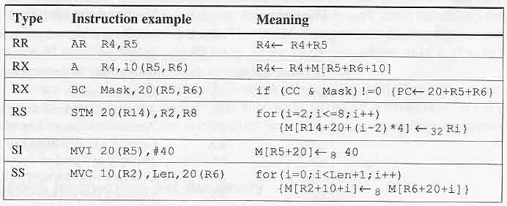

FIGURE 4 - Typical IBM 360 instructions with their meanings. The MVC instruction is shown with the length as the second operand. The length field is a constant in the instruction; standard 360 assembly language syntax includes the length with the first operand. The variable i used in the MVC and STM is a temporary.
Instruction Set Format

The format of IBM 360 instructions included half words (16 bits), full words (32 bits), and double words (64 bits). Their format is as follows (Note: S represents sign bit):
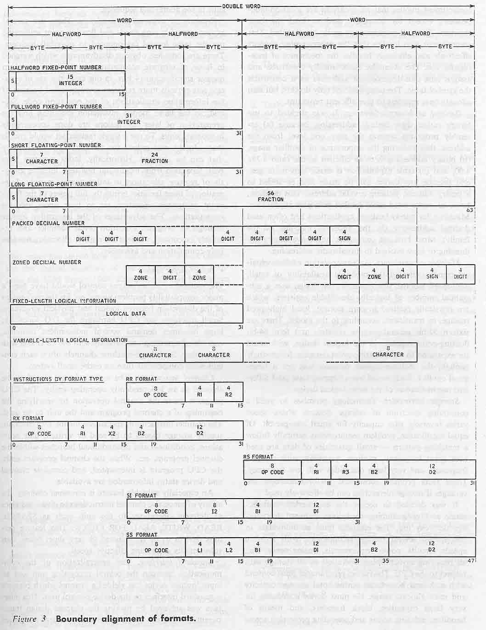
Figure 5 - [Amdahl, Blaauw et al.'64]
Common IBM 360 Instructions (Hennessy & Patterson, 1990)
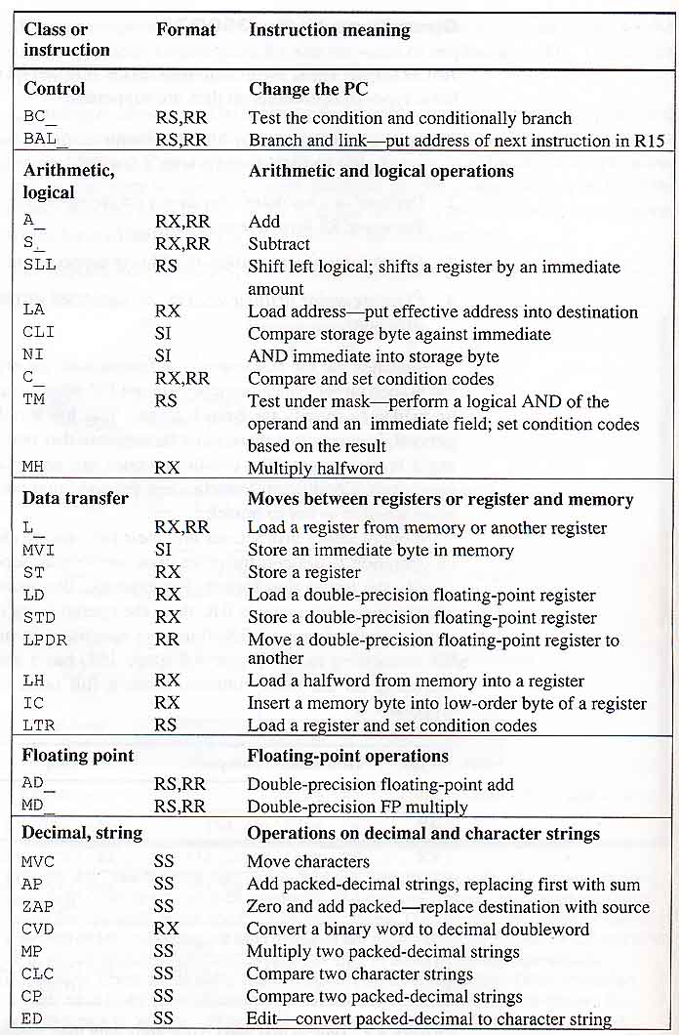
FIGURE 6 Most frequently used IBM 360 instructions. The underline means that the opcode is two distinct opcodes with an RX format and an RR format. For example A stands for AR and A.

Summary
When IBM created the 360 line of compatible general purpose computers in 1964, the computer world was changed forever. Many other companies would try and copy the IBM compatibility advantage, but no architecture would survive as long as the 360. The IBM 360’s architecture was so powerful and yet flexible that it is still compatible with many computers today and nearly the same architecture (it has been tweaked a little bit) is used in various IBM’s today. The IBM 360 architecture certainly stood the test of time due to its forward and backward compatibility (family concept and extensive instruction set), its clear separation between architecture and implementation, integration of scientific and business efficiency, and extensive use of microprogramming.
The IBM 360 was a fantastic business achievement indeed. In closing, we should examine an impressive quotation describing the lasting impact of the IBM 360 from a case study of the IBM 360/370 published in the Communications of the ACM. This type of staggering financial contribution from one product certainly shows the impact of the IBM 360 product line.

“In the 6 years from 1965-1971, IBM’s gross income increased 2.3 times from $3.6 billion to $8.3 billion and net earnings after taxes increased 2.3 times from $477 million to $1.1 billion. In 1982, the descendants of System 360 accounted for more than half of IBM’s gross income.” (Gifford and Spector, 1987)
Appendix A - Complete IBM 360 Instruction Set (Hennessy & Patterson, 1990)
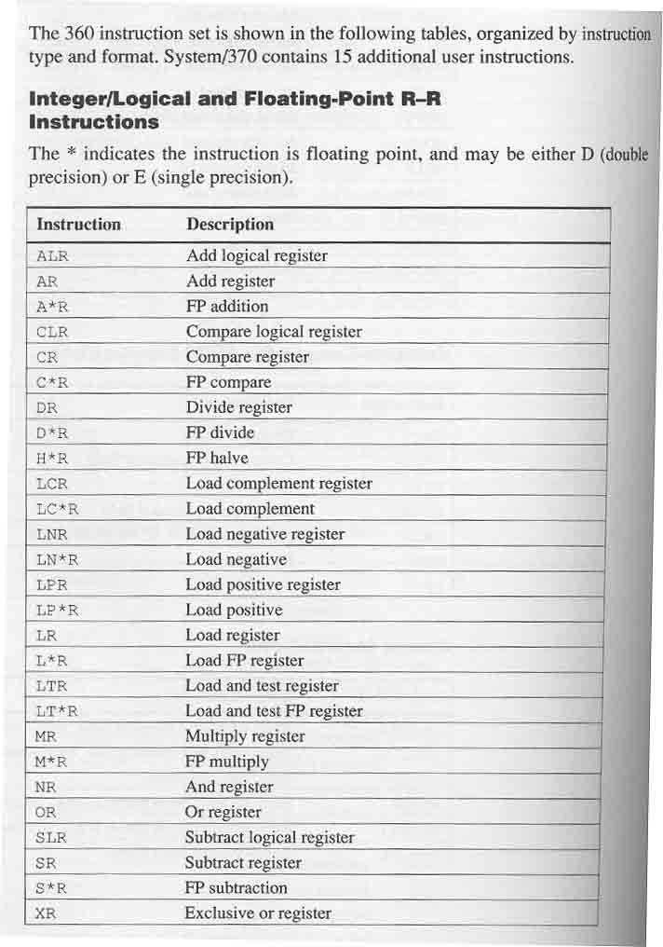
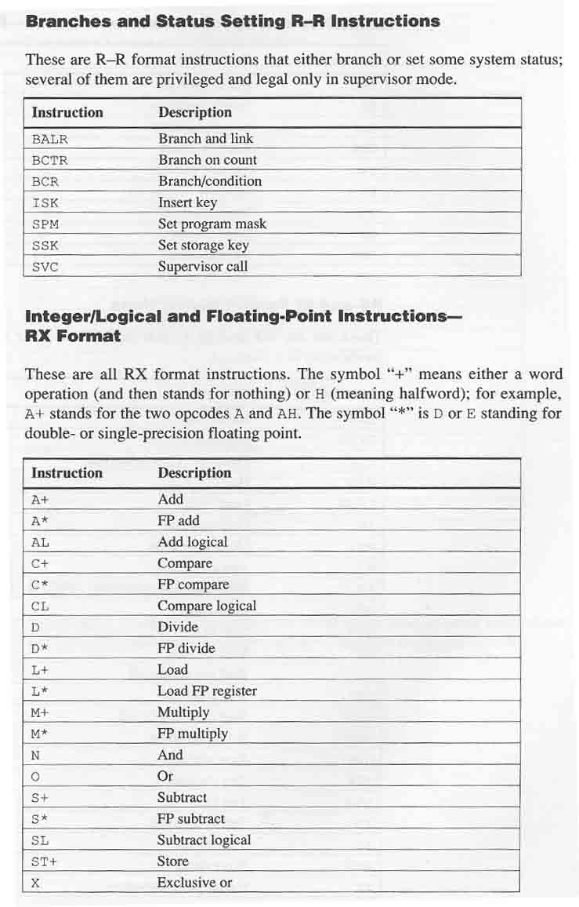
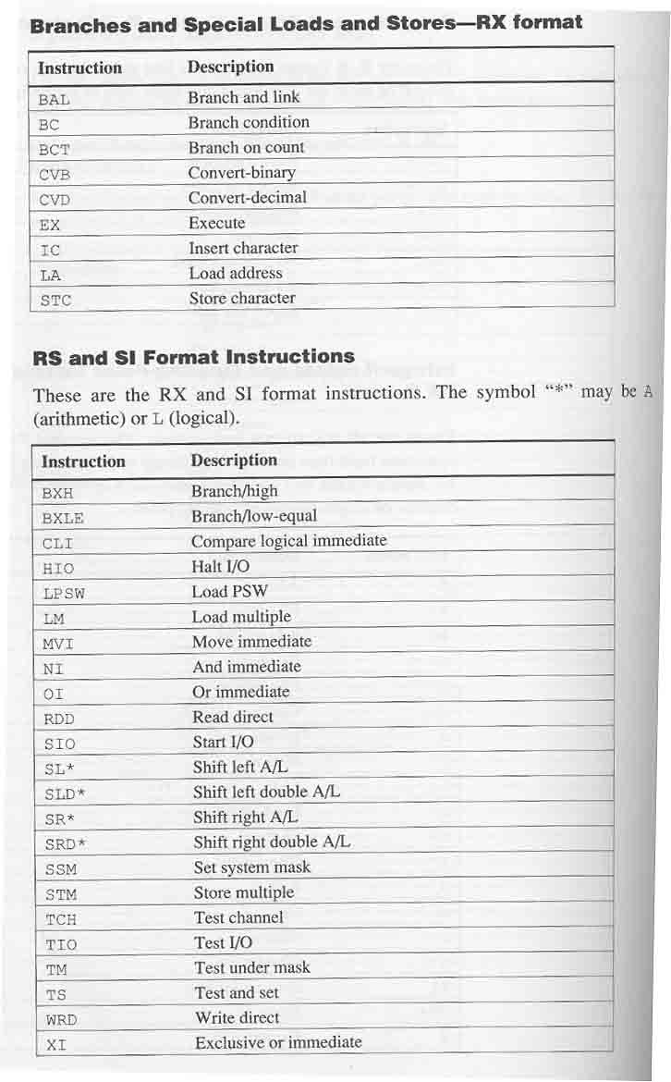
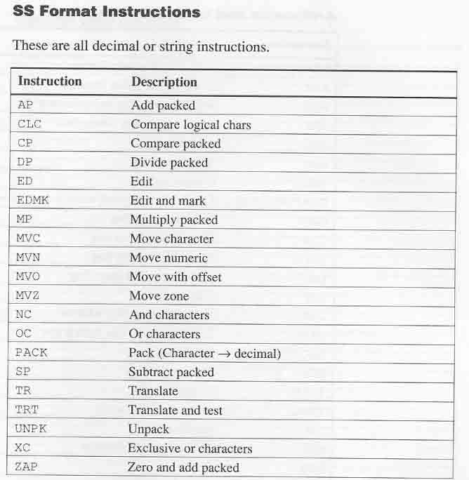

Bibliography

