Homework 7, Chapter 12: TCP
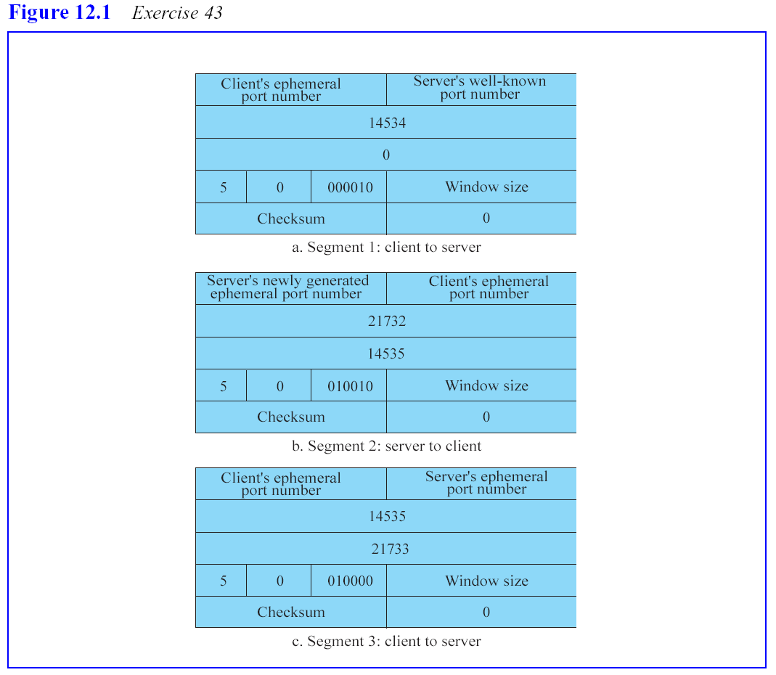
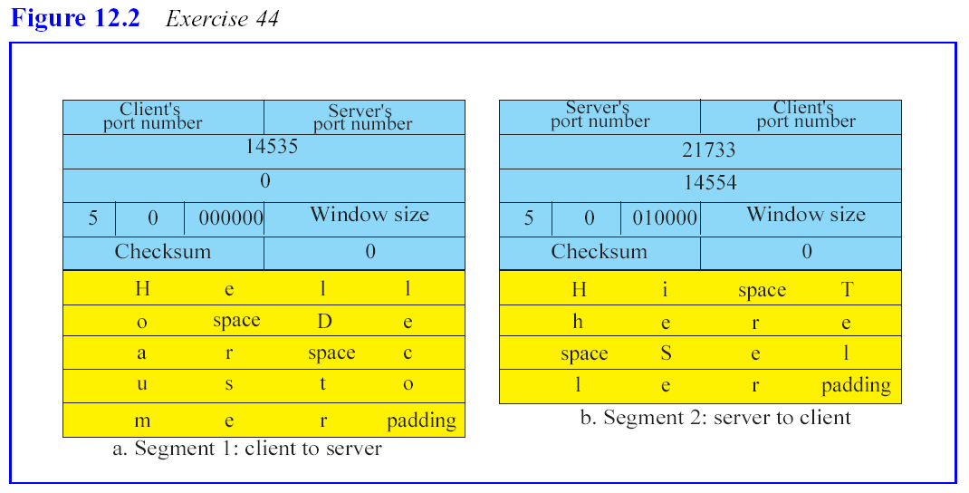
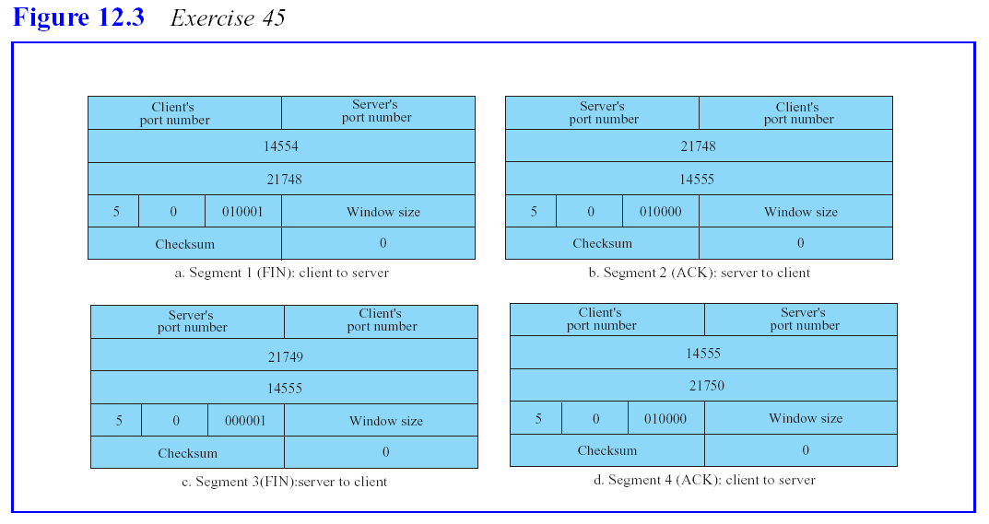

Exercise 55.
Here is a State Transition Diagram showing the progress of time, events (e.g. timeouts), as well as incoming and outgoing messages. Two of these diagrams could be put adjacent to each other linking the two parties of a TCP connection.

