Homework 11, Chapter 20

FTP
16. The client issues an active open for the control connection because the server,
which is always running, is waiting for a client with a passive open on this port.
The client must be the one to issue the passive open on the data port because it is
the client that initiates all of the communication via the control connection. If the
server were to issue a passive open on an ephemeral port number, it would have no
way to send that port number to the client.
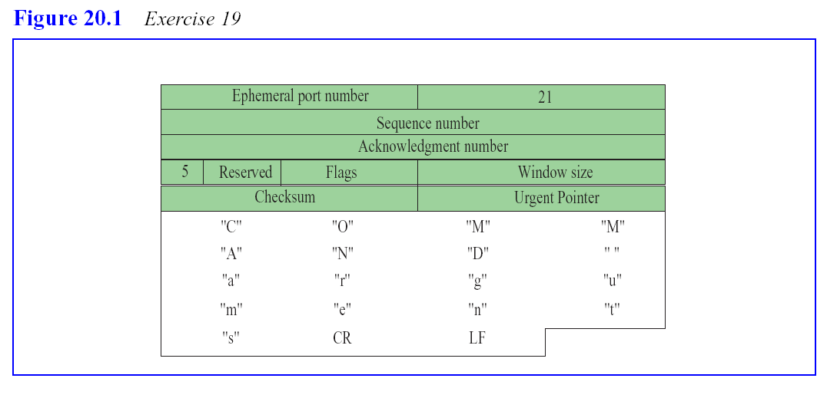
24. Server to Client: 220 (Service Ready)
Client to Server: USER forouzan
Server to Client: 331 (User name OK, password is needed)
Client to Server: PASS xxxx
Server to Client: 230 (User login OK)
(Client issues a passive open on an ephemeral port number)
Client to Server: PORT 1267
(Server issues an active open on the given port number)
Server to Client: 150 (Data connection will open shortly)
Client to Server: TYPE EBCDIC
Server to Client: 200 (Command OK)
Client to Server: STRU R
Server to Client: 200 (Command OK)
Client to Server: STOU /usr/user/report
Server to Client: 250 (Requested file action OK)
< Records of file are transferred from the client to the server >
Server to Client: 226 (Closing data connection)
Client to Server: QUIT
Server to Client: 221 (Service Closing)
If the file being transferred to the server already exists, the filename of the new file
will be made unique.

